Transport and Telecommunication Institute
Faculty of Computer Science
Numerical Methods in Computer Calculations
__________________________________________________________

Report

B.Sc. Computer Science

From: Alīna Karpeļceva, Andrew Grishin, Moritz Bösenberg
Student number: 53812, 53909 , 56655
Semester: 7, 7, 5
Date: 5/11/2013

Lecturer: Grakovskis Aleksandrs

- Tasks

- Create an algorithm with a coding language of your choice. The task is to solve a system of linear equations with the Gauss Elimination.

- Create an algorithm with a coding language of your choice. The task is to program an iterative algorithm (E.g. Newton method).

- Two arrays are given calculate the conditionality.

  - Algorithms

- Gauss Elimination

int I, J, K, K1, N;
N = Y.Length;
for (K = 0; K < N; K++)
{
K1 = K + 1;
for (I = K; I < N; I++)
{
if (X[I, K] != 0)
{
for (J = K1; J < N; J++)
{
X[I, J] /= X[I, K];
}
Y[I] /= X[I, K];
}
}
for (I = K1; I < N; I++)
{
if (X[I, K] != 0)
{
for (J = K1; J < N; J++)
{
X[I, J] -= X[K, J];
}
Y[I] -= Y[K];
}
}
}
for (I = N - 2; I >= 0; I--)
{
for (J = N - 1; J >= I + 1; J--)
{
Y[I] -= X[I, J] * Y[J];
}
}

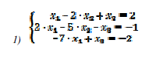
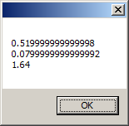

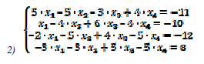

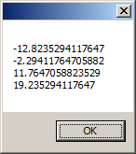

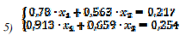

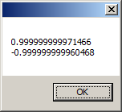

- Iterative algorithm
var omega = 1; //relaxation
var numOfIterations = 0;
int n = B.Length;
var x = new double[n];
var xPrev = new double[n];
do
{
numOfIterations++;
Array.Copy(x, xPrev, n);
for (int i = 0; i < n; i++)
{
double sum = 0;
for (int j = 0; j < n; j++)
{
if (j != i)
{
sum += A[i, j] * x[j];
}
}

var xZeidel = (B[i] - sum) / A[i, i];
x[i] = xPrev[i] + omega * (xZeidel - xPrev[i]);
}
}
while (!isFinished(x, xPrev, epsilon));
epsilon = (double)numOfIterations;
return x;
}

private bool isFinished(double[] x, double[] xPrev, double epsilon)
{
for (int i = 0; i < x.Length; i++)
{
if (Math.Abs(x[i] - xPrev[i]) > epsilon) return false;
}
return true;
}

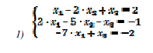
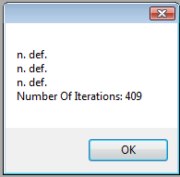

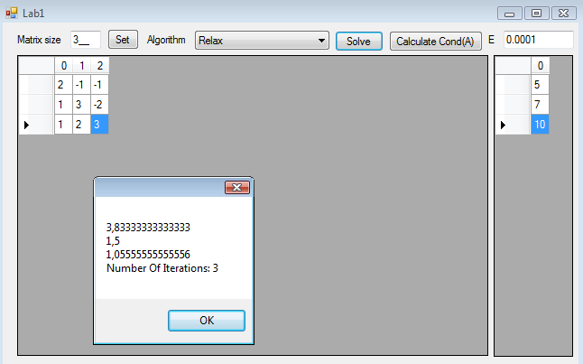
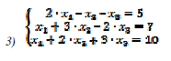
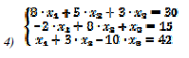

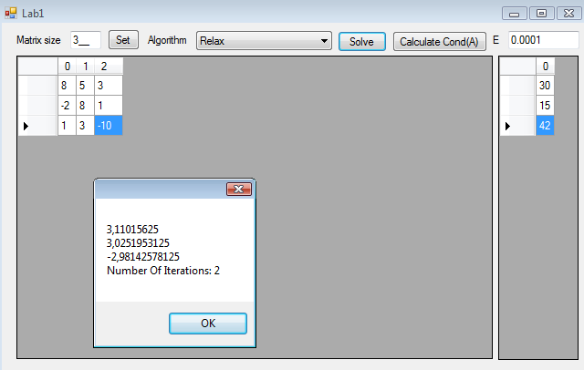
- Conditionality

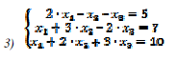
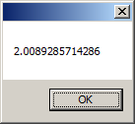

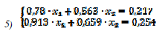

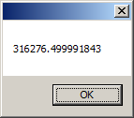

Conclusion:

Our group solved the tasks that were given by the lecturer. At first we programmed the algorithms in C#. After that we started to solve the given Tasks and calculated the system of linear equations with our algorithms.

We analysed time taken by both algorithms to solve the 2nd system:
Gauss:

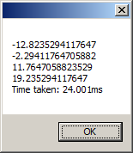

Relaxation method:

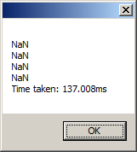

As we can see, the relaxation method did not solve the system, so the time taken by a large amount of iterations is a lot greater than for Gauss.

After the conditionality estimation for 3rd and 5th we can see that 3rd system is well conditioned (cond = 2 < 10) and 5th is very badly conditioned.

So, the error in 5th system calculation is a lot greater than in the 3rd system.

