# Exercise: Flexbox

Problems for exercises and homework for the ["HTML and CSS" course @ SoftUni](https://softuni.bg/courses/html-and-css). Submit your solutions in the SoftUni Judge system at <https://judge.softuni.org/Contests/3335/Flexbox>.

# Flexbox Layout

Create a web page like the following:

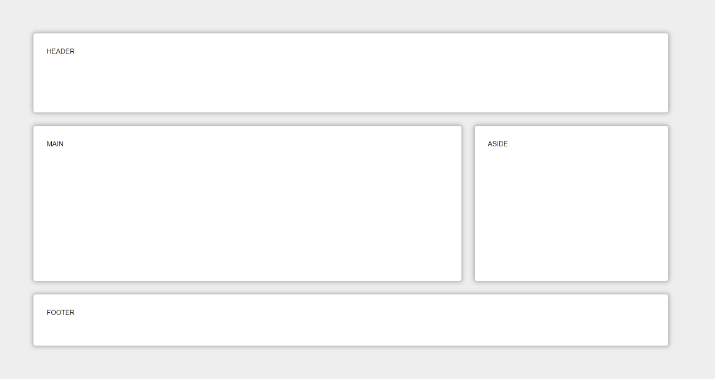

* Change the document **title** to "**Flexbox Layout"**

**Requirements**

* Create header, main, aside and footer elements
* <body>
  + background color - **#EEE**;
  + padding - **5rem**;
  + display - **flex**;
  + flex-wrap - **wrap**;
* Each element (**<header>, <main>, <aside>, <footer>**) must have:
  + padding - **2rem**;
  + background color - **#FFF**;
  + border-radius - **0.4rem**;
  + color - **#000**;
* **<header>** and **<footer>**
  + flex-basis - **100%;**
* **<main>**
  + flex - **8 1 40rem**;
* **<aside>**
  + flex - **2 1 20rem**;

## FlexModel Articles

Create a web page like the following:

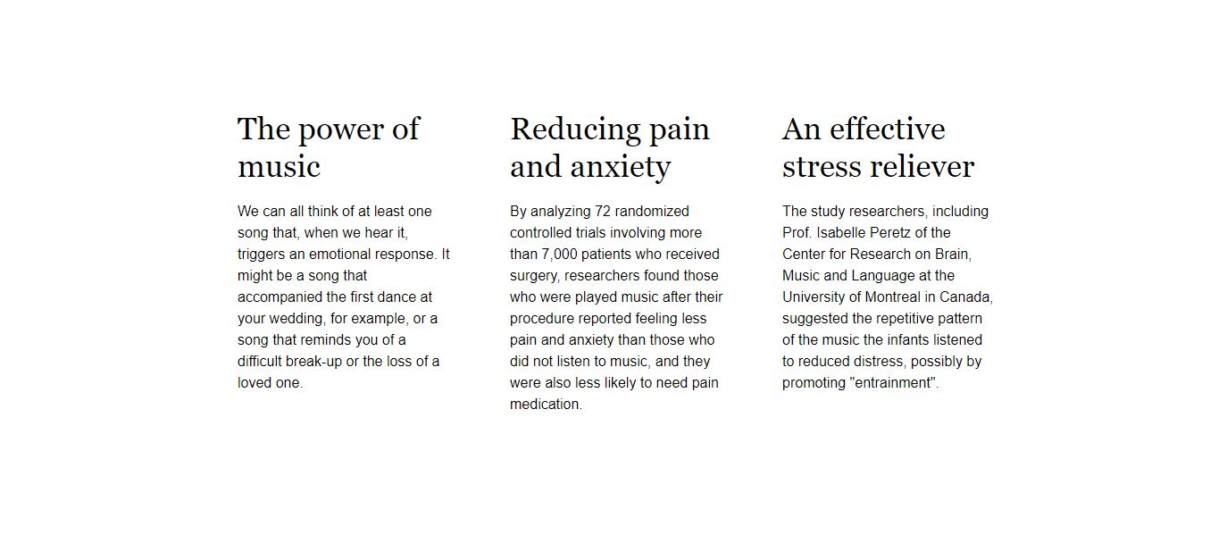

* Change the document **title** to "**Articles"**

**Requirements**

* Create a section with three articles inside
* The article should have a h2 title and a paragraph (p)
* Fonts
  + Font family Helvetica, sans-serif with line height 1.5 for the html
  + Font family Georgia, serif with line height 1.2 for the headings
* Change the section display property to flex and set justify-content: space-between
* Set on the section max-width 70vw

## ABC Game

Create a web page like the following:

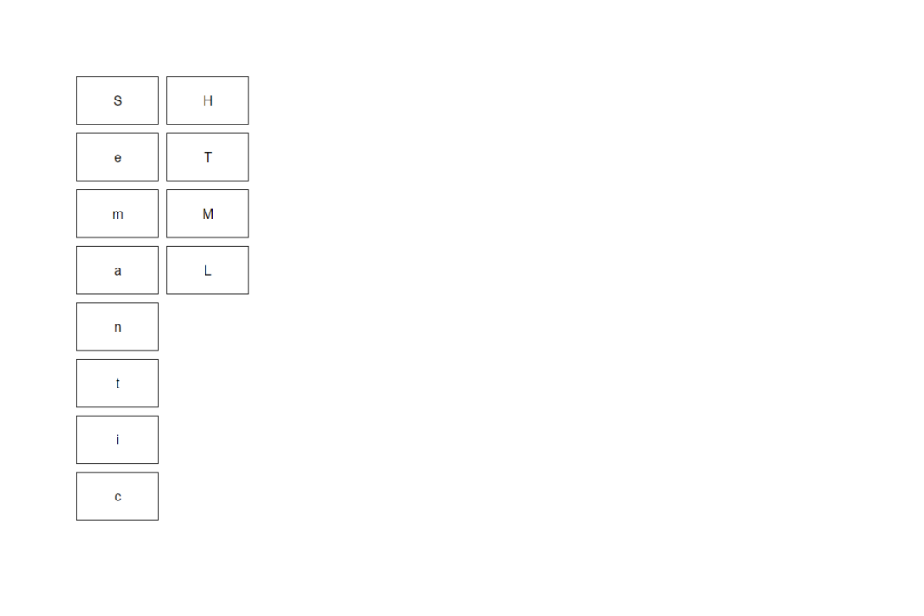

* Change the document **title** to "**ABC Game"**

**Requirements**

* Create a div with class container and twelve span tags inside
* Type the letters in the spans EXACTLY as they are in the file text.txt
* Use font-family: Helvetica, sans-serif, with font-size: 20px
* Change the div display property to flex and align the items in center
* Set on the div max-width: 15vw and height 35rem
* The span must have
  + Border width - 1px
  + Border color - black
  + Border style - solid
* To arrange the letters, use the **flex property order**

## Calendar

Create a web page like the following:

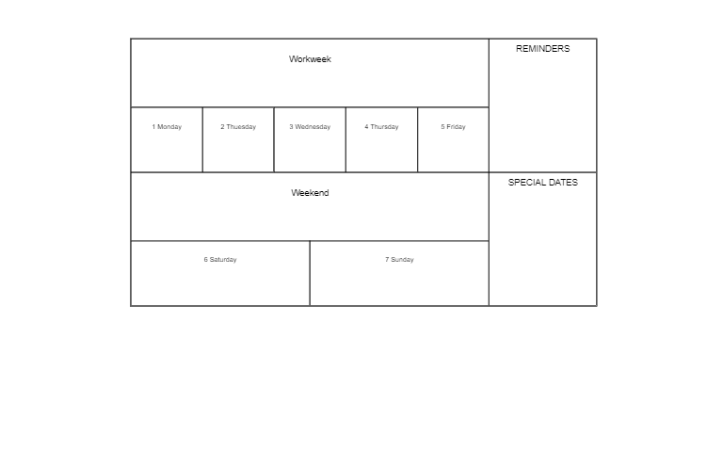

* Change the document title to "**Calendar**"

### Requirements

* Create a div with class **container** and two sections inside
  + First section has class week
  + Second section has class notes
* Use span tags for all content
* Change the div and sections display property to flex and align the items in **center**
* Set on the div max-width 65vw
* The span must have
  + Border width - 1px
  + Border color - black
  + Border style - solid
* For the section with class notes use the property flex-direction column
* Set on all HTML elements the property box-sizing: border-box

## Navigation Flexbox

Create a web page like the following:

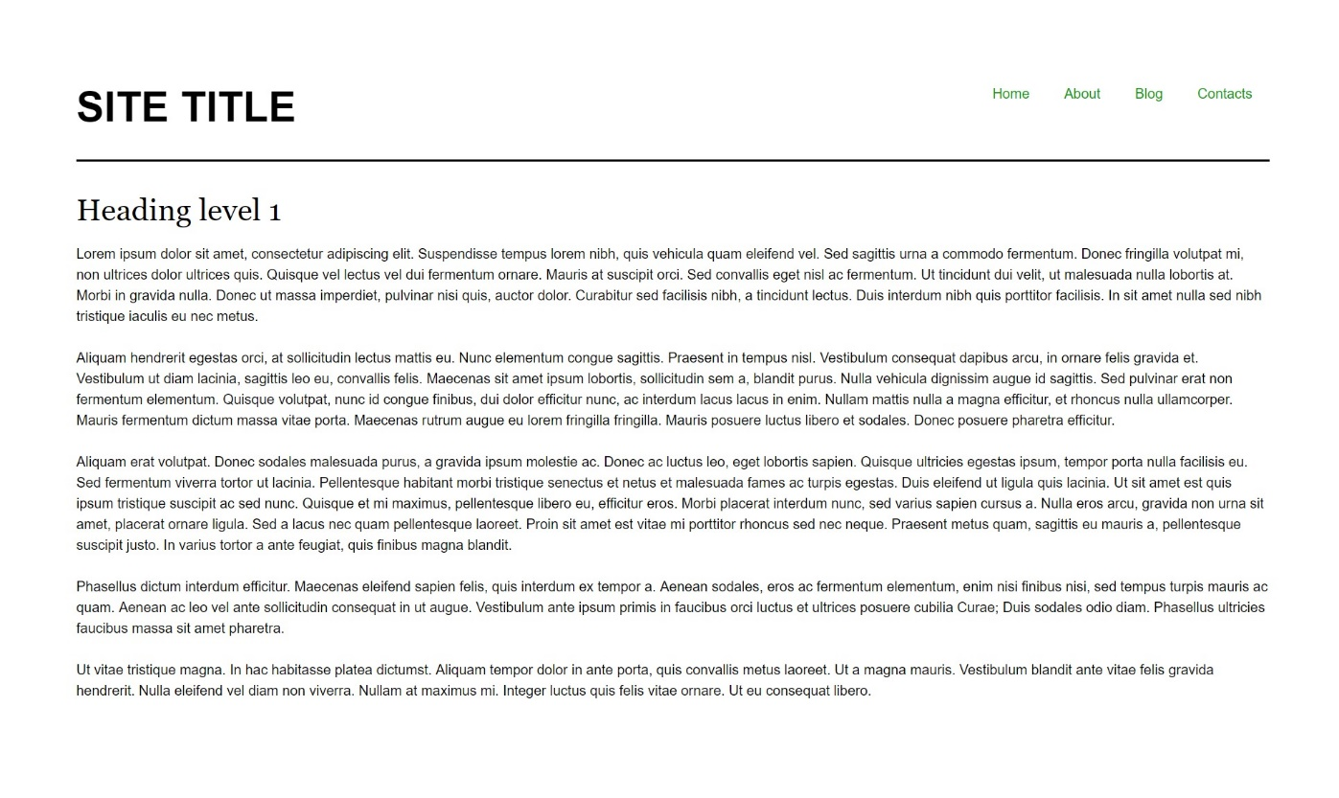

* Change the document title to "**Navigation - Flexbox**"

### Requirements

* Divide the **body** into header and main tag
* The **bottom** **border** in the header must have
  + Border width - 2px
  + Border color - rgb(0, 0, 0)
  + Border style - solid
* The **display** property of the header must be flex
* The **unordered** list in the header must have display property flex
* The **anchors** text color in the navigation must be rgb(0, 153, 0)

1. **Photo Gallery – Flexbox**

Create a web page like the following:

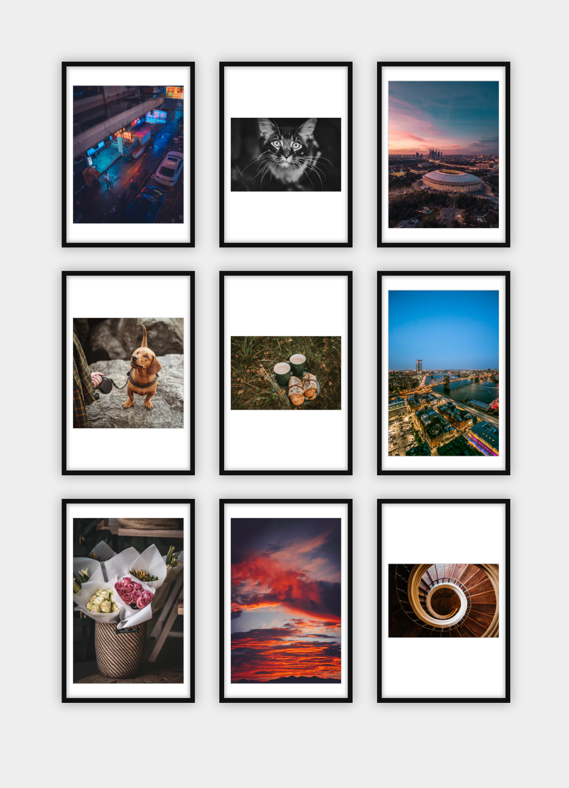

* Change the document title to "**Photo Gallery - Flexbox**"

### Requirements

* Add section with class gallery (section.gallery)
* Add **unordered lis**t with **list** items and **images** inside
* Change the body, ul and li display property to flex
* Set the **ul** property **justify-content** to be equal to **space-between**

1. **Blog Layout – Flexbox**

Create a web page like the following:

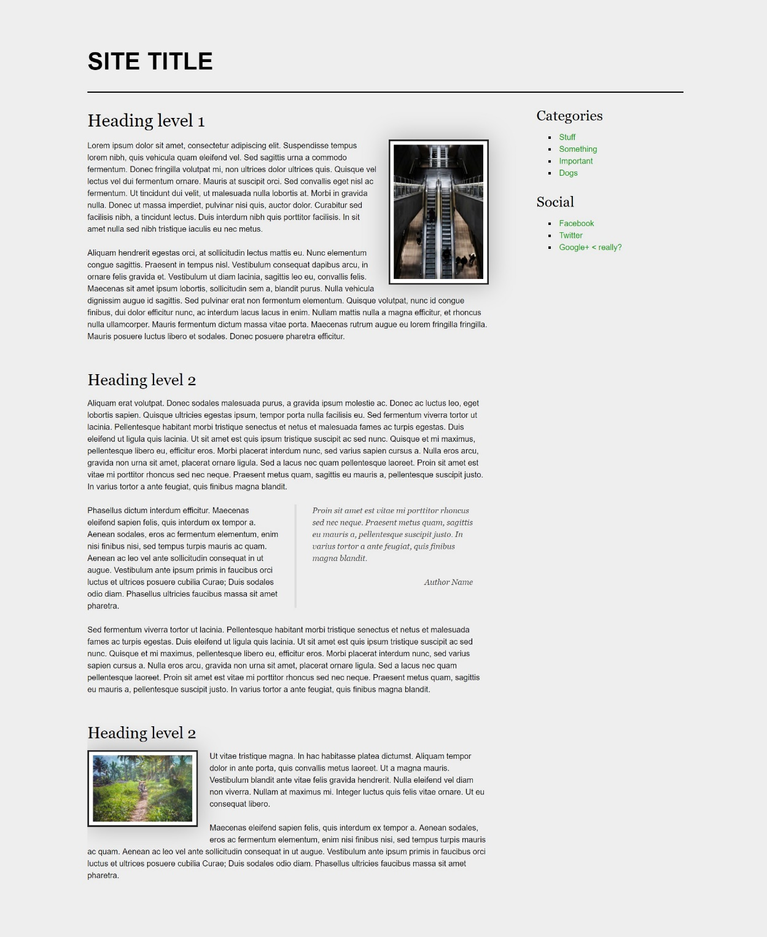

* Change the document title to "**Blog Layout - Flexbox**"

### Requirements

* The entire content must be in div container with **class** page (div.page)
* The page container (div) must be **flexed** and **wrapped**
* **Body** **background** color must be rgb(238, 238, 238)
* **Image** **background** color should be rgb(255, 255, 255)
* **Blockquote** font family must be Georgia, serif
* The **anchors** text **color** in the aside section must be rgb(0, 153, 0)
* Page **headings** font family must be Georgia, serif

1. **Sticky Footer – Flexbox**

Create a web page like the following:

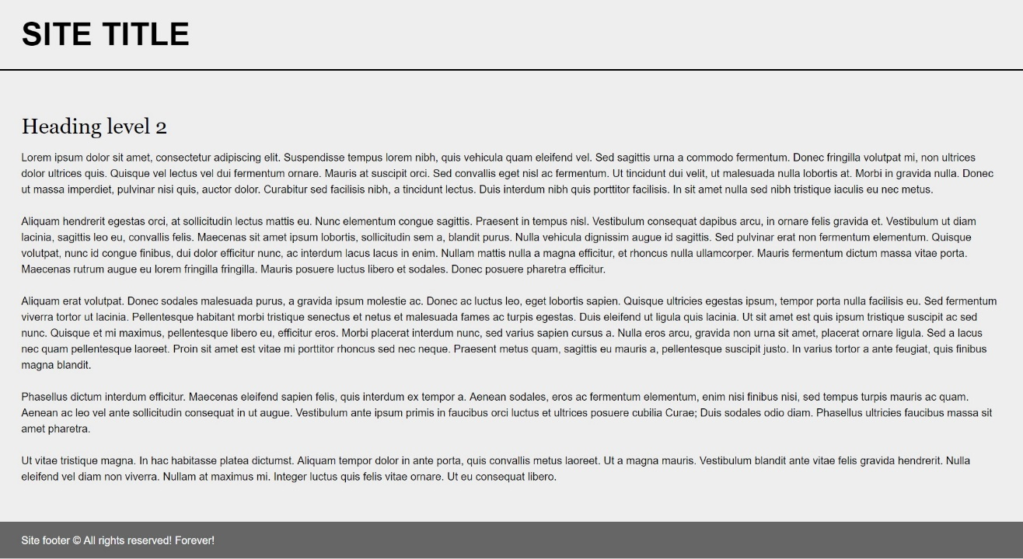

* Change the document title to "**Sticky Footer - Flexbox**"

### Requirements

* Divide your content into header, main and footer tags
* The **body** must have flex display property
* The **body** **background** must be rgb(238, 238, 238)
* Set **height** to the body: 100vh
* Font family Helvetica, sans-serif
* The footer should be at the bottom of the page
  + The footer text color must be rgb(255, 255, 255)
  + The footer background color must be rgb(102, 102, 102)

## Center Flexbox

Create a web page like the following:

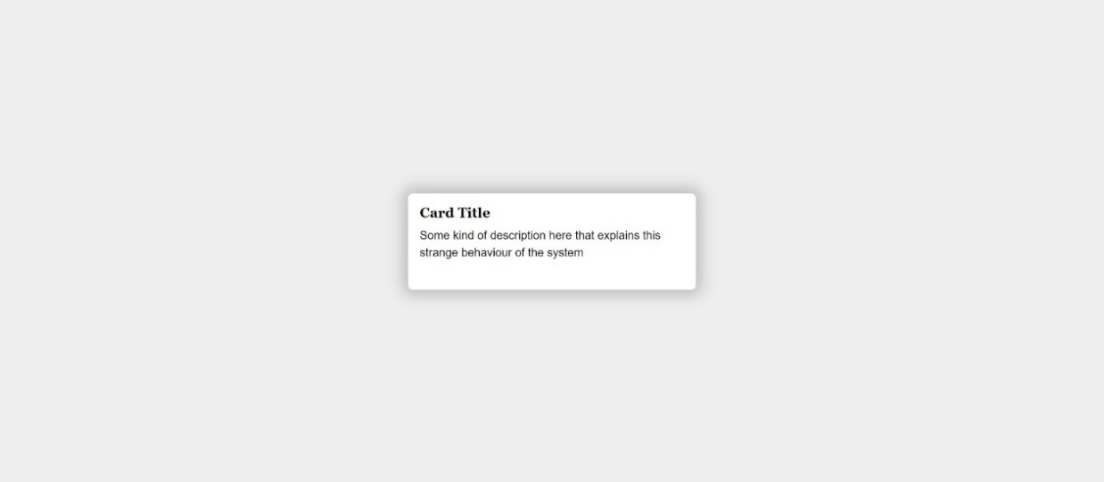

* Change the document title to "**Center Flexbox**"

### Requirements

* The **body** **background** color must be rgb(238, 238, 238)
* The body **display** property must be flex
* The content must be placed into **div** with **class** card (div.card)
  + The div background color must be rgb(255, 255, 255)

## Expanding Flex Cards

Create a web page like the following:

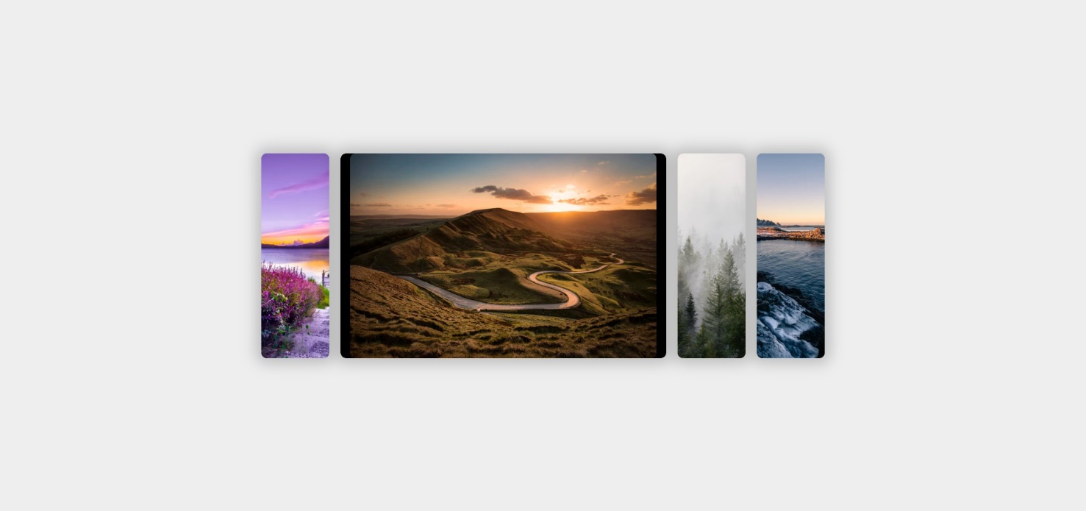

* Change the document title to "**Expanding Flex Cards**"

### Requirements

* Body background color must be rgb(238, 238, 238)
* The body display property must be flex
  + Align the items in **center**
* The entire page content must be inside section with class named container (section.container)
* The container display property must be flex

## Cards with CSS Columns and Flexbox

Create a web page like the following:

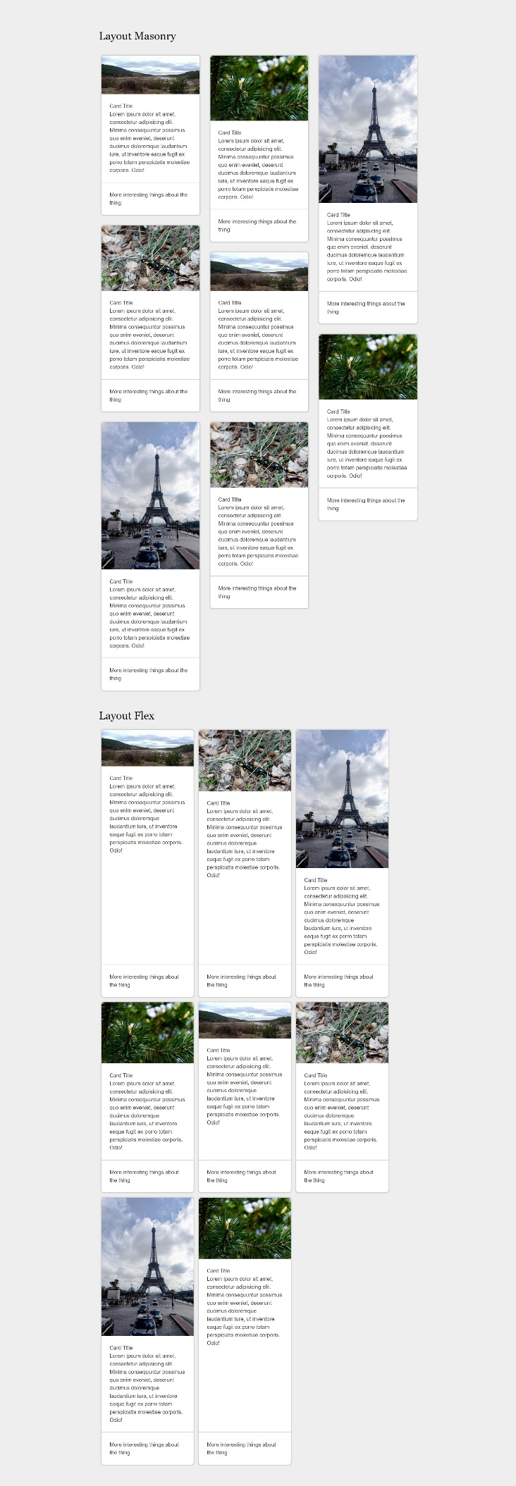

* Change the document title to "**Cards with CSS Columns and Flexbox**"

### Requirements

* Body **background** color must be rgb(238, 238, 238);
* Use h2 for the heading
* The content should be divided in two parts:
  + First part is container unit (div) with classes cards-layout and masonry
* Second part is container unit (div) with classes cards-layout and flex
* Every **"card"** has:
  + **img tag**
  + section
    - h3 tag
    - p tag
  + footer