
Software Requirements Specification
Version 0.1
April 07, 2019

Web Blog of SoftUni

Table of content
1.0. Purpose 2
1.1. Introduction 2
1.2. Scope 2
1.3. Glossary 2
1.4. Standards 2
2.0. Overall description 3
2.1. Project Scope 3
2.2. System Constraints 3
2.2.1. User Interface Constraints 3
2.2.2. Hardware Constraints 3
2.2.3. Software Constraints 3
2.2.4. Data Management Constraints 4
2.2.5. Operational Constraints 4
2.3. System Environment 4
2.3.1. Access Home Page 4
2.3.2. Design of Page 4
2.3.3. Home Page 4
2.3.4. User Registration 5
3.0. Requirement specifications 6
3.1. External interface specifications 6
3.2. Functional Requirements 7
3.2.1. Use Case 1 (Accessing the system) 7
3.2.2. Use Case 2 (Navigation Bar) 7
3.2.3. Navigation bar 7
3.2.3. Create article 7
3.2.4. Delete article 7
3.2.5 Search 7
3.3. Detailed non-functional requirements 7

1.0. Purpose

1.1. Introduction
This Software Requirements Specification provides a complete description of all the functions and specifications of the Softuni Blog.
The expected audience of this document is the faculty of Softuni, including the faculty who will use this system, committee members, and the developer. It will also server as a reference for Softuni students.

1.2. Scope
The Softuni blog is designed to run on the departmental server and to allow alums to fill out a survey form, create a new database entry, update an existing database entry, or contact another alum. To create, share and improve ideas.

1.3. Glossary
Term | Definition
GUI | Graphic User Interface
WSID | WorkStation Identification Number
CI | Configuration Item
DB | DataBase
Entry | Alum stored in the Alum Database
Html | Hyper text markup language
IEEE | Institute of Electrical and Electronic Engineers
QA | Quality assurance
SCMP | Software Configuration Management Plan
SDD | Software Design Document
SEI | Software Engineering Institute, Pittsburgh, Pa
SQAP | Software Quality Assurance Plan
SRS | Software Requirements Specification
Survey | Form filled out and submitted by an Alum using the CISWAAB.
Tbd | To be decided
Tbn | To be named
Web Site | A place on the world wide web
Alumni | Student of servant university

1.4. Standards
IEEE - The content and qualities of a good System Requirements Specification (SRS) are described and several SRS outlines are presented. This recommended practice is aimed at specifying requirements of software to be developed but also can be applied to assist in the selection of in-house and commercial software products.

2.0. Overall description

This section of the SRS describes the general factors that affect the product and its requirements. This section does not state specific requirements. Instead, it provides a background for those requirements, which are defined in detail in sections, and makes them easier to understand. This system will be completely web-based. An Internet connection is necessary to access the system.

2.1. Project Scope

Properly QA will be giving users access to statistical data, documentation and pictures of all University classes from past and future values, and a social networking aspect that allows users to communicate with each on a dedicated forum, or post information. This document deals with the social networking component.

2.2. System Constraints
The system constraints restrict options of design, behavior, appearance or operation.

2.2.1. User Interface Constraints
Using this system is fairly simple and intuitive. A user familiar with basic browser navigation skills should be able to understand all functionality provided by the system.

2.2.2. Hardware Constraints

The system should work on most desktops, laptop computers and smart phones.

2.2.3. Software Constraints

The system should work on every browser last version– Google Chrome, Firefox, Internet Explorer, Safari, Opera etc.

2.2.4. Data Management Constraints

There is a detailed description of the constraints of the data flow.

2.2.5. Operational Constraints

The system is limited by its operating server in terms of the maximum number of users and it can be supported at a given time.

2.3. System Environment
The Project has two active actors, normal user and registered user. All of them are accessing their parts from the internet. The Unregistered user can access the basic functionality of the project.

2.3.1. Access Home Page
The user must be connected to the Internet and connected to the SoftUni Web blog.

2.3.2. Design of Page

The pages should contain Header and Footer, which need to be equal for each page. Header should contain Register and Login links, which navigates to new page, where users can complete these operations. The home page should have header in dark blue. The abbreviation should stand in left at the top of the page. Footer should say that all rights for this site are reserved by our company.

2.3.3. Home Page

The page should have short description of the blog and its main functionalities. It should navigate to current article. The every user should have access to:
- “Hello World”
- “Pro Blog”
- “Blog Updated!’

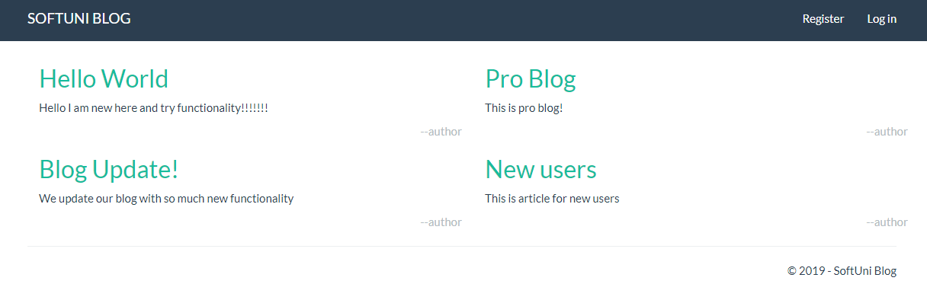

2.3.4. User Registration

At the left corner of the header should contains drop down menu. It should provide the user opportunities to Register or Log in.
The registration form should be present in the middle of the page. Register page must have button for registration, which to be active after user add some information in all 4 necessary fields:
- Email
- Full Name
- Password
- Confirm password
- Button “Register”

The Log in form should be present in the middle of the page. It should have basic functionality for Login by providing user name and password:
- Email
- Password
- “Remember me?” option button
- Button “Log in”

It could be add possibility to log in with Google account or Facebook.

3.0. Requirement specifications

3.1. External interface specifications
None

3.2. Functional Requirements

3.2.1. Use Case 1 (Accessing the system)

The system is accessed through the internet from its initial URL. It loads header, navigation bar and a home page.

3.2.2. Use Case 2 (Navigation Bar)

The navigation bar has navigational hyperlinks to the Register and Login. When user is successfully Log in, this link has to change to {username} page (My Account page).

3.2.3. Navigation bar

When user fill valid user name and password, he/she should be logged in the system. After successful log in user have to be redirected to Home page.

3.2.3. Create article

When the user is log in he can do some actions. He can create/delete/edit his own articles.

3.2.4. Delete article

The user cannot delete articles created from other users. If he tries to delete an article, there should be an error message:
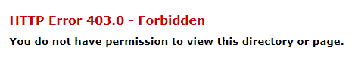

3.2.5 Search
There could be add functionality for search page.

3.2.6 Wrong user information
If the username/password is wrong there should be an error message.


3.2.7 Forgotten user information
New credentials functionality could be added.

3.3. Detailed non-functional requirements

Attribute Name | Attribute Type | Attribute Size
LastName | String | 30
FirstName | String | 30
Password | String | 12
EmailAddress | String | 20

