
Software Requirements Specification
Version 0.1
April 07, 2019

Web Blog of SoftUni

Table of content
1.0. Purpose 2
1.1. Introduction 2
1.2. Scope 2
1.3. Glossary 2
2.0. Overall description 3
2.1. Project Scope 3
2.2. System Constraints 3
2.2.1. User Interface Constraints 3
2.2.2. Hardware Constraints 3
2.2.3. Software Constraints 3
2.2.4. Data Management Constraints 4
2.2.5. Operational Constraints 4
2.3. System Environment 4
2.3.1. Access Home Page 4
2.3.2. Design of Page 4
2.3.3. Home Page 4
2.3.4. User Registration 5
3.0. Requirement specifications 6
3.1. External interface specifications 6
3.2. Functional Requirements 7
3.2.1. Use Case 1 (Accessing the system) 7
3.2.2. Use Case 2 (Navigation Bar) 7
3.2.3. Navigation bar 7
3.2.3. Create article 7
3.2.4. Delete article 7
3.2.5 Search 7
3.3. Detailed non-functional requirements 7

1.0. Purpose

1.1. Introduction
This Software Requirements Specification provides a complete description of all the functionsError: Reference source not found and specifications of the Softuni BlogError: Reference source not found.
The expected audienceError: Reference source not found of this document is the users of this system - faculty of SoftuniError: Reference source not found, students, and members of the project team that will implement and verify the correct functioning of the system. Error: Reference source not foundIt will also serveError: Reference source not found as a reference for Softuni students.

1.2. Scope
The Softuni blog is a web-based application hosted on a on a departmental server, that will allow users to create blog posts, update existing posts or contact other students through an intuitive, easy-to-use interface. To create, share and improve ideas. As a next phase it will have a corresponding Android application.

1.3. Glossary
Term | Definition
GUI | Graphic User Interface
WSIDError: Reference source not found | WorkStation Identification NumberError: Reference source not found
CIError: Reference source not found | Configuration ItemError: Reference source not found
DB | DataBase
Entry | Alum stored in the Alum Database
Html | Hyper text markup language
QAError: Reference source not found | Quality assurance
SCMPError: Reference source not found | Software Configuration Management PlanError: Reference source not found
SDDError: Reference source not found | Software Design DocumentError: Reference source not found
SEIError: Reference source not found | Software Engineering Institute,Error: Reference source not found Pittsburgh, Pa
SQAPError: Reference source not found | Software Quality AssuranceError: Reference source not found Plan
SRSError: Reference source not found | Software Requirements Specification
Survey | Form filled out and submitted by an Alum using the CISWAAB.
Tbd | To be decided
Tbn | To be named
Web Site | A place on the world wide web
Alumni | Student of servant university

2.0. Overall description

This section of the SRS describes the general factors that affect the product and its requirements. This section does not state specific requirements. Instead, it provides a background for those requirements, which are defined in detail in sections, and makes them easier to understand. This system will be completely web-based. An Internet connection is necessary to access the system.

2.1. Project Scope

This project is for a dedicated forum for social networking, designed to allow users to communicate with each other and post information This document deals with the social networking component.

2.2. System Constraints
The systemError: Reference source not found constraints restrict options of design, behavior, appearance or operation.

2.2.1. User Interface Constraints
Web application shall permit complete navigation using the keyboard alone, in addition to using mouse and keyboard combinations.
Using this system is fairly simple and intuitive. A user familiar with basic browser navigation skills should be able to understand all functionality provided by the system.

2.2.2. Hardware Constraints

The system should work on most desktops, laptop computers and smart phones.

2.2.3. Software Constraints

The system should work on every browser last version– Google Chrome, Firefox, Internet Explorer, Safari, Opera etc.

2.2.4. Data Management Constraints

There is a detailed description of the constraints of the data flow.

2.2.5. Operational Constraints

The system is limited by its operating server in terms of the maximum number of users that can be supported at a given time.

2.3. System Environment
The Project has two active actors, normal user and registered user. All of them are accessing their parts from the internet. The Unregistered user can access the basic functionality of the project.

2.3.1. Access Home Page
The user must be connected to the Internet and connected to the SoftUni Web blogError: Reference source not found.

2.3.2. Design of Page

The pages should contain Header and Footer, which need to be equal for each page. Header should contain Register and Login links, which navigates to new page, where users can complete these operations. The home page should have header in dark blue. The abbreviation should stand in left at the top of the page. Footer should say that all rights for this site are reserved by our company.

2.3.3. Home Page

The page should have short description of the blog and its main functionalities. It should navigate to current article. The every user should have access to:
- “Hello World”
- “Pro Blog”
- “Blog Updated!’

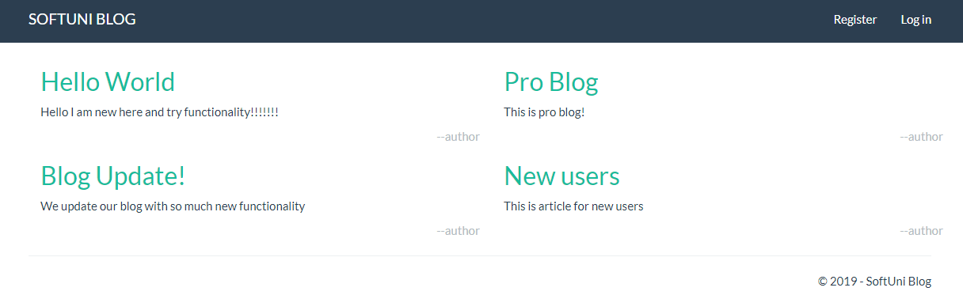

2.3.4. User Registration

At the left corner of the header should contains drop down menu. It should provide the user opportunities to Register or Log in.
The registration form should be present in the middle of the page. Register page must have button for registration, which to be active after user add some information in all 4 necessary fields:
- Email
- Full Name
- Password
- Confirm password
- Button “Register”

The Log in form should be present in the middle of the page. It should have basic functionality for Login by providing user name and password:
- Email
- Password
- “Remember me?” option button
- Button “Log in”

It could be add possibility to log in with Google account or Facebook.

3.0. Requirement specifications

3.1. External interface specificationsError: Reference source not found
None

3.2. Functional Requirements

3.2.1 Accessing the system

The system is accessed through the internet from its initial URL. It loads header, navigation bar and a home page.

3.2.2 Navigation Bar

The navigation bar has navigational hyperlinks to the Register and Login. When user is successfully Log in, this link has to change to {username} page (My Account page).

3.2.3 Log in

When user fill valid user name and password, he/she should be logged in the system. After successful log in user have to be redirected to Home page.

3.2.4 Create article

When the user is log in he can do some actions. He can create/delete/edit his own articles.

3.2.5 Delete article

The user cannot delete articles created from other users. If he tries to delete an article, there should be an error message:


3.2.6 Edit article

3.2.7 Search
There could be add functionality for search page.

3.2.8 Wrong user information
If the username/password is wrong there should be an error message.


3.2.9 Forgotten user information
New credentials functionality could be added.

3.2.10 Maximum length of attributes
Attribute Name | Attribute Type | Attribute Size
LastName | String | 30
FirstName | String | 30
Password | String | 12
EmailAddress | String | 20

3.3. Detailed non-functionalError: Reference source not found requirements
3.3.1 Performance requirements
3.3.2 Security requirements
3.3.3 Safety requirements
- Users shall be required to log in to the system for all operations
- The system shall permit only registered users to create or edit posts.
3.3.4 Software quality attributes
- availability
- maintainability
- usability

- Design and Implementation - use cases

