# QA Fundamentals Exam - 11 December 2022

# You are given a web application, an online store, and a rough specification regarding the requirements. Your task is to find the misconceptions in the specification, the broken functionalities, user experience problems ad security issues. You can use any tools for test planning, test execution, and bug reporting. But it's very important to document all your work in corresponding issues in the issue tracker you are given.

## Project Team Members

The Development Lead​, the lead of Design and Art, and the Project Manager are the project members​. Communicate well with them in the issue tracker and address issues to the relevant department.

## Software Requirements

## Introduction

## 1.1 Purpose

The purpose of this document is to present a detailed description of the Online Web Store application (hereinafter called Your Store, Store, or simply Project). It will explain some of the key features at a very high level.

## Scope

The document will cover the basic functionality on a high level regarding the Online Store. The user-management system, the Orders creation and operation, and its respective details. The administrative part – what the special user (Administrator) is not in the scope.

## Overall description

## 2.1 System environment

The Store has two active actors and one cooperating system. All of them are accessing their parts from the Internet. The Unregistered user can access the basic functionality of the project. One can view products and pictures. The Registered user can access some of the basic CRUD operations over the orders. One can create an order, edit its own orders, add and remove details from it.

## 2.2 Vocabulary

* + 1. **Home page**

The home page is the main page of the Store. The page consists of a navigation bar, swiper slide with products, and featured products. Here is an image of it:

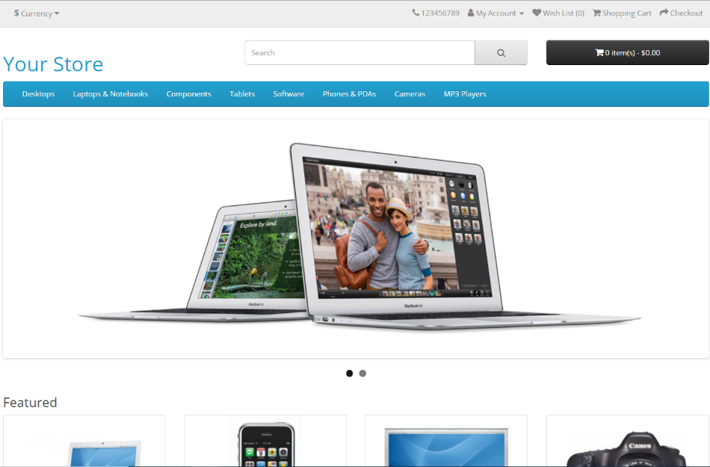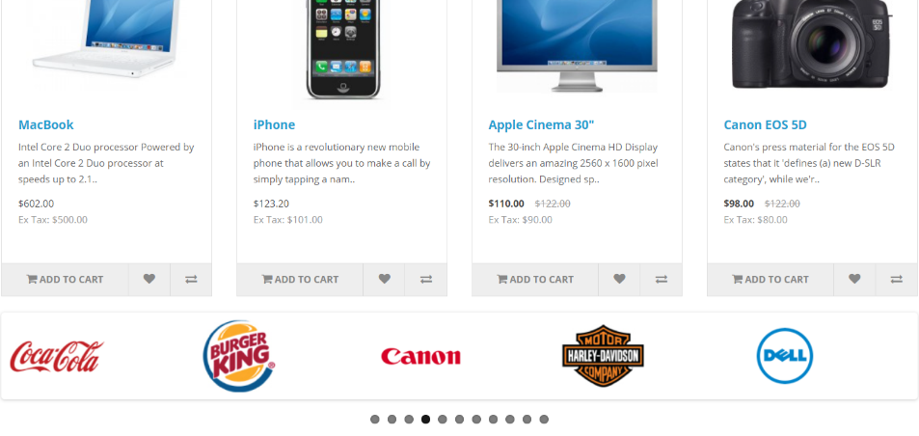

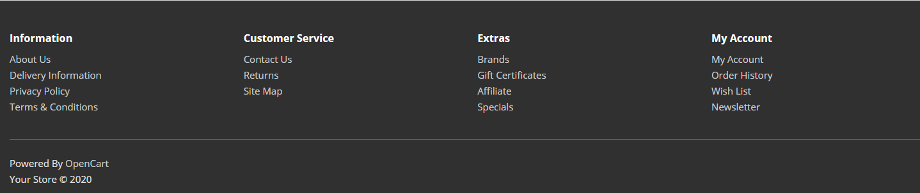 On the bottom of the page, there is a footer:

* + 1. **Product page ​**

The product page is the main information block regarding a product. It is accessible through clicking first one of the categories in the navigation bar, then clicking on a certain product from the category. The page should contain a picture of the product on the left and the right. There should be basic information about the product, its availability, price, a field for quantity, and the "Add to Cart" option. Here is an image of it:

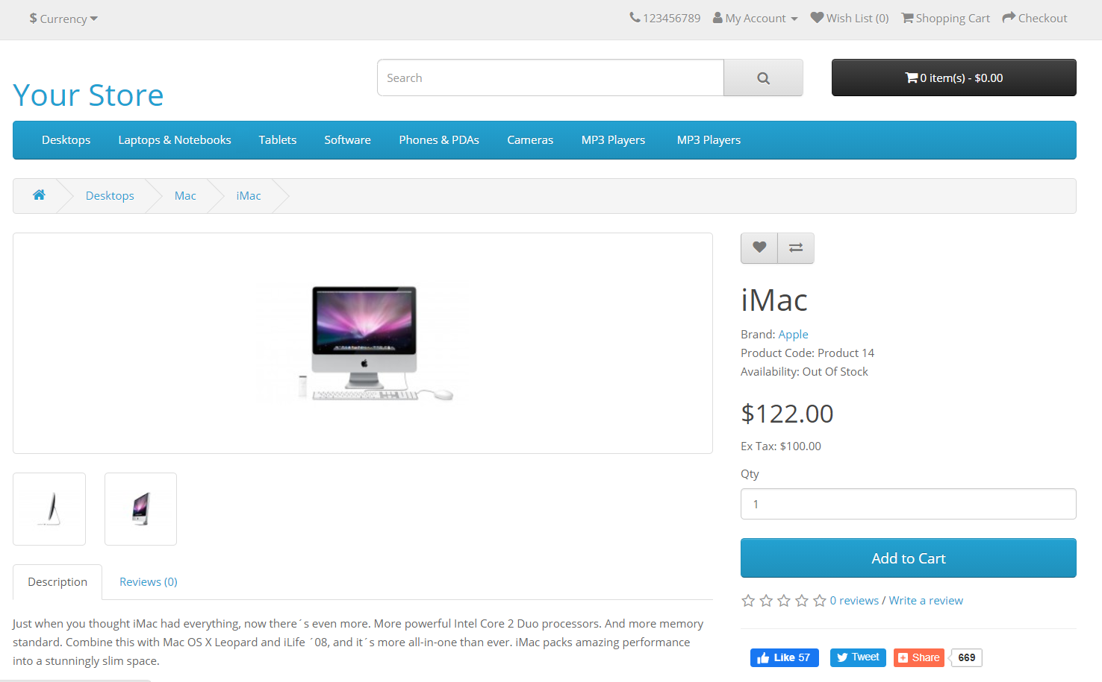

* + 1. **My Account page**

It is accessible through the navigation bar. It contains some information about the current account on the left and the other options menu on the right. Here is an image of it:

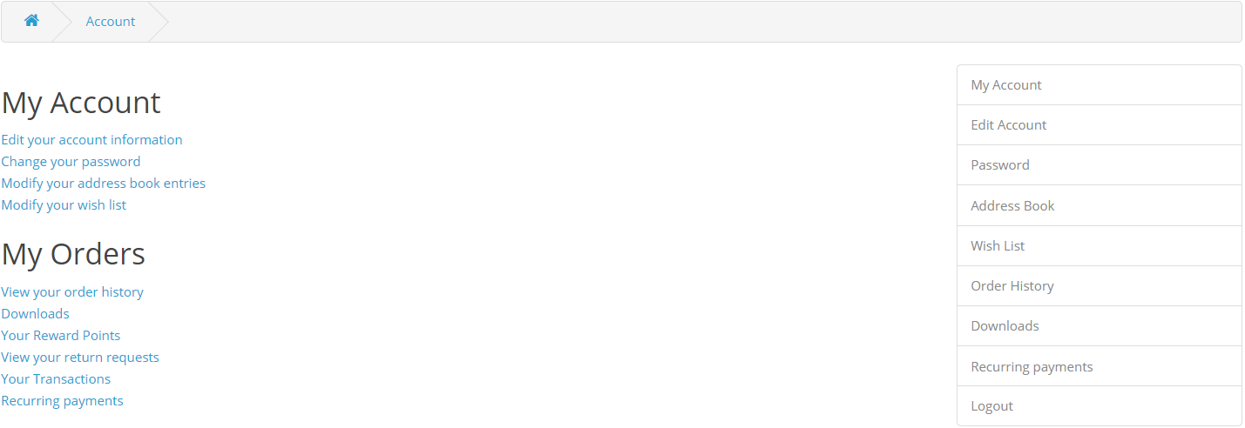

* + 1. **Site map page**

It is accessible through the home page footer under "Customer Service" options. It holds information for every functional link on the website. Here is an image of it:

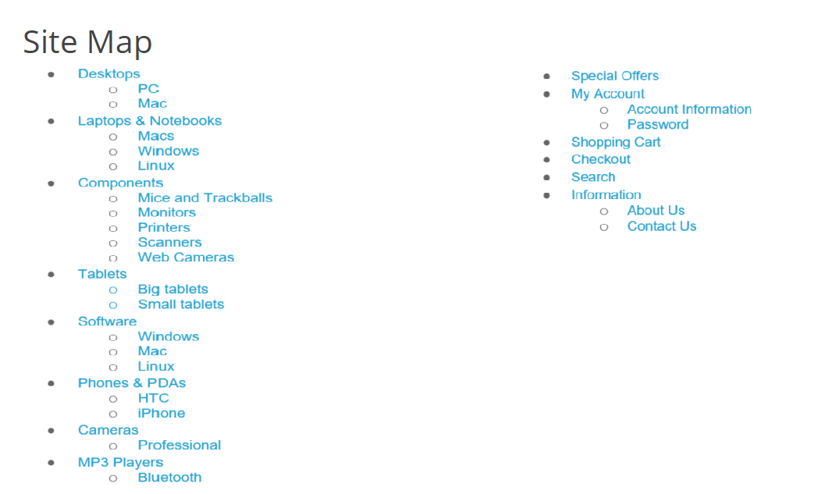

## 2.3 Functional requirement specification

Here is a list of the functionalities that are implemented and are in need of testing. The application has **much more logic implemented**, but you should **concentrate on testing only the given use cases.**

* + 1. **Use Case 1 (Accessing the system)**

The system is accessed through the Internet from its initial URL. It loads a header, a navigation bar, and a home page.

* + 1. **Use Case 2 (Navigation bar)**

The navigation bar has navigational hyperlinks to the Currency menu, My Account menu, My Wishlist, Shopping Cart, Checkout, and a working option to make an internet call to the displayed number.

* + - 1. **Navigation bar – User Management**

When the visitor is unregistered, the My Account menu should show the options "**Register**", "**Login**" and "**Anonymous** **shopping**". "**Register**" leads to the register form, "**Login**" to the login form, and "**Anonymous shopping**" redirects to the home page with a changed My Account menu – it looks the same as the menu for logged-in user. The options in the menu for logged users are: "**My Account**", "**Order History**", "**Transactions**", "**Downloads**", and "**Logout**".

* + 1. **Use Case 3 (Home page)**

The home page shows the product categories menu, the featured products, swiper with the official partners of the website, and a footer. The official partners are:

* Harley Davidson
* Dell
* Burger King
* Disney
* Starbucks
* Nintendo
* NFL
* Redbull
* Sony
* Coca Cola
  + - 1. **Home page – Product Categories (Navigation bar menu)**

The products navigation bar should contain the names of all product categories and subcategories:

* Desktops
  + PC
  + Mac
* Laptops & Notebooks
  + Macs
  + Windows
  + Linux
* Tablets
  + Big Tablets
  + Small Tablets
* Software
  + Windows
  + Mac
  + Linux
* Phones & PDAs
  + HTC
  + iPhone
* Cameras
  + Professional
* MP3 Players
  + Bluetooth
    1. **Use Case 4 (My Account Page (Logged in))**

This page presents information regarding the client's account. It contains two menus – one on the left and one on the right. The one on the left has the following sections and links:

* My Account
  + Edit your account information
  + Change your password
  + Modify your address book entries
  + Modify your wish list
* My Orders
  + View your order history
  + Downloads
  + Your Reward Points
  + View your return requests
  + Your Transactions
  + Recurring payments

The one on the right has the following sections and links:

* My Account
* Edit Account
* Password
* Address Book
* Wish List
* Order History
* Downloads
* Recurring payments
* Logout  
  + 1. **Use Case 5 (Site Map)**

This page offers a map to the website with all the pages in the application. It contains two vertical navigation menus – left and right.

The left one has the following sections and links:

* Desktops
  + PC
  + Mac
* Laptops & Notebooks
  + Macs
  + Windows
  + Linux
* Components
* Mice and Trackballs
  + Monitors
  + Printers
  + Scanners
  + Web Cameras
* Tablets
  + Big tablets
  + Small tablets
* Software
  + Windows
  + Mac
  + Linux
* Phones & PDAs
  + HTC
  + iPhone
* Cameras
  + Professional
* MP3 Players
  + Bluetooth

The right one has the following sections and links:

* Special Offers
* My Account
  + Account Information
  + Password
* Shopping Cart
* Checkout
* Search
* Information
  + About Us
  + Contact Us
    1. **Use Case 6 (Search)**

Clicking on Search right below the navigation bar allows for product finds by given keywords. If we have such products, we should show a list with the results. If no product is found, the following informative message should be displayed: "**No such product. Try again with some different keywords.**"

## Tasks

**1. Manual Tests Cases**

**1.1** You need to write at least **15** test cases.

**1.2** Every Use case should have at least **1** test case, specially written for it.

**2. Automated Test Cases**

**2.1** You need to automate at least **5** manual test cases using SeleniumIDE.

**2.2** Among those **5** automated test cases, at least **2** of them should be using INPUT actions.

**3. Bug Reports**

**3.1** You should find and describe at least **5** bugs.

**3.2** Among those **5** bugs, at least **2** of them should be with high priority or severity.

# Resources

The project is located at: <https://demo.opencart.com/>

## Exam Information

You are **allowed** to use any resources you have, such as the Internet, software.

You are **not allowed** to get help from other people: Skype, FB, email, talks, phone calls, etc., are forbidden.

Exam time: **4 hours**.