Specification for SU "Chernorizets Hrabar"  
(<https://su-vp.com/>)

**Начало**

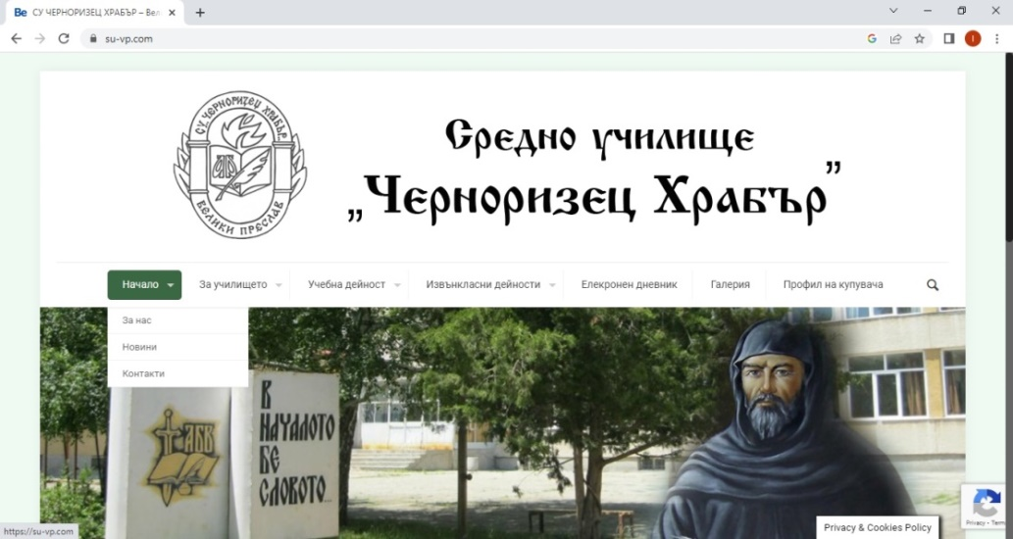

This dropdown menu provides the following options:

* **За нас:** Includes brief information about the school, its history, teaching staff, and achievements in various activities and initiatives.
* **Новини**: Current news and events.
* **Контакти**: The school's address, phone numbers, and email. Additionally, there is a contact form for inquiries, which includes the following mandatory fields marked with *:

Your Name*, Your Email*, Subject*, and Your Message*:

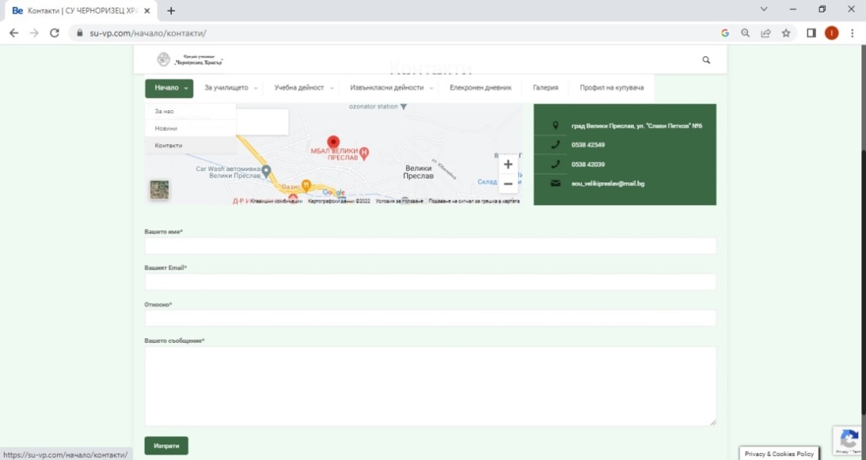

**За училището**

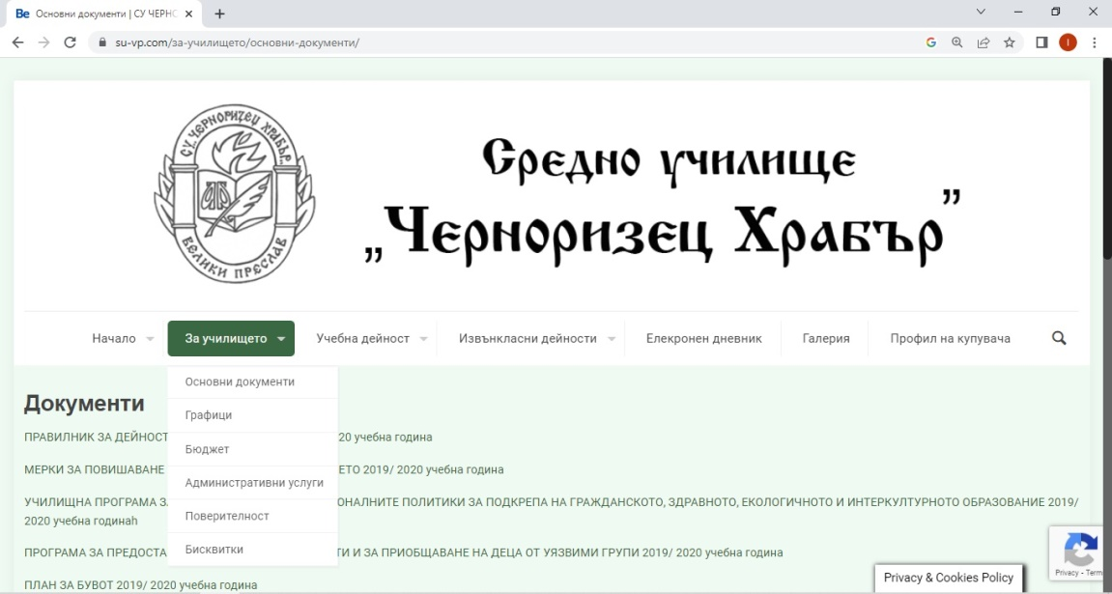

This dropdown menu provides the following options:

* **Основни документи**: Various types of regulatory documents (rules, school program, yearly plan, etc.).
* **Графици**: Includes different schedules.
* **Бюджет**: Various budgets and reports.
* **Администранивни документи**: A variety of documents and templates available for download.
* **Поверителност**: Authorization for personal data protection.
* **Бисквитки**: Policy on the use of cookies, details on the cookies used, and their management.

**Учежна дейност**

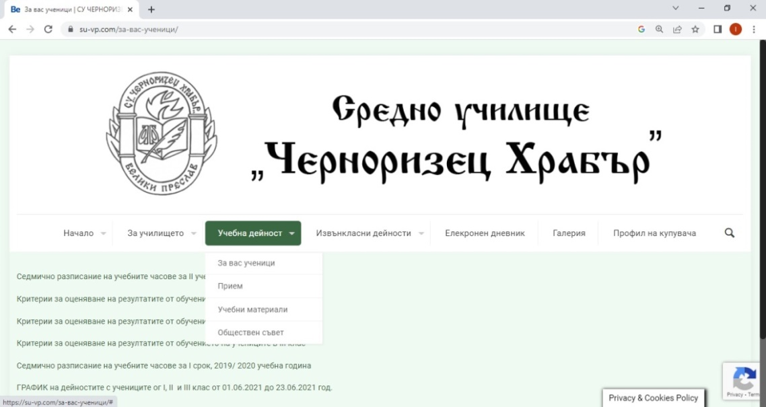

* **За вас ученици**: Includes the weekly schedule, various criteria, admission plans, and more.
* **Прием**: Information about admissions and an order designating the admissions team.
* **Учебни материали**: A variety of educational materials.
* **Обществен съвет**: Minutes from council meetings.

**Извънкласни дейности**

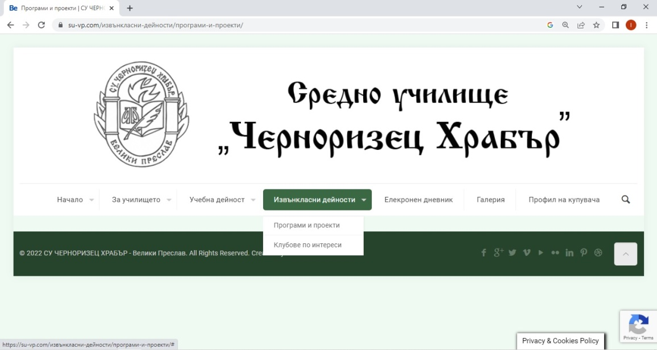

This dropdown menu provides the following options:

* **Програма и проекти**: Contains the program for the academic year as well as projects to be completed during the year.
* **Клубове по интереси**: Descriptions of various clubs (e.g., math club, cooking club, sports clubs, etc.).

**Електронен дневник**

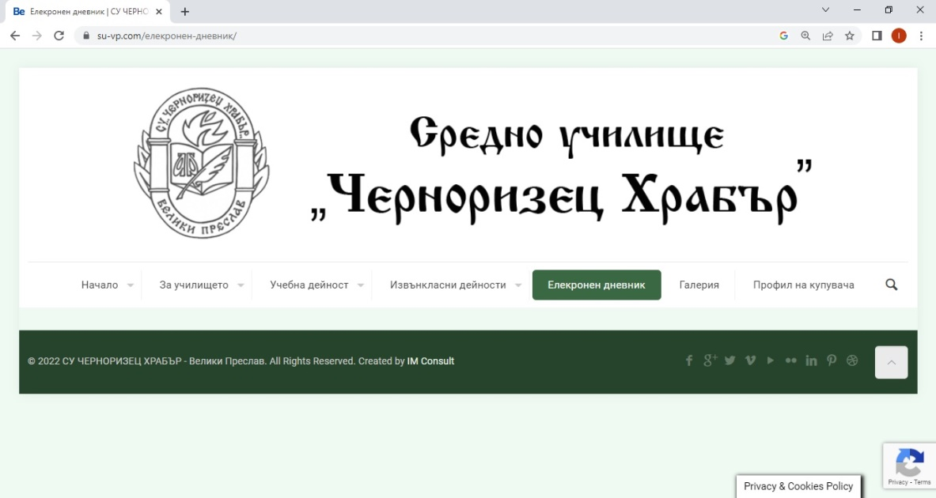

Allows parents to receive daily information about their children (grades, absences, feedback, homework).

**Галерия**

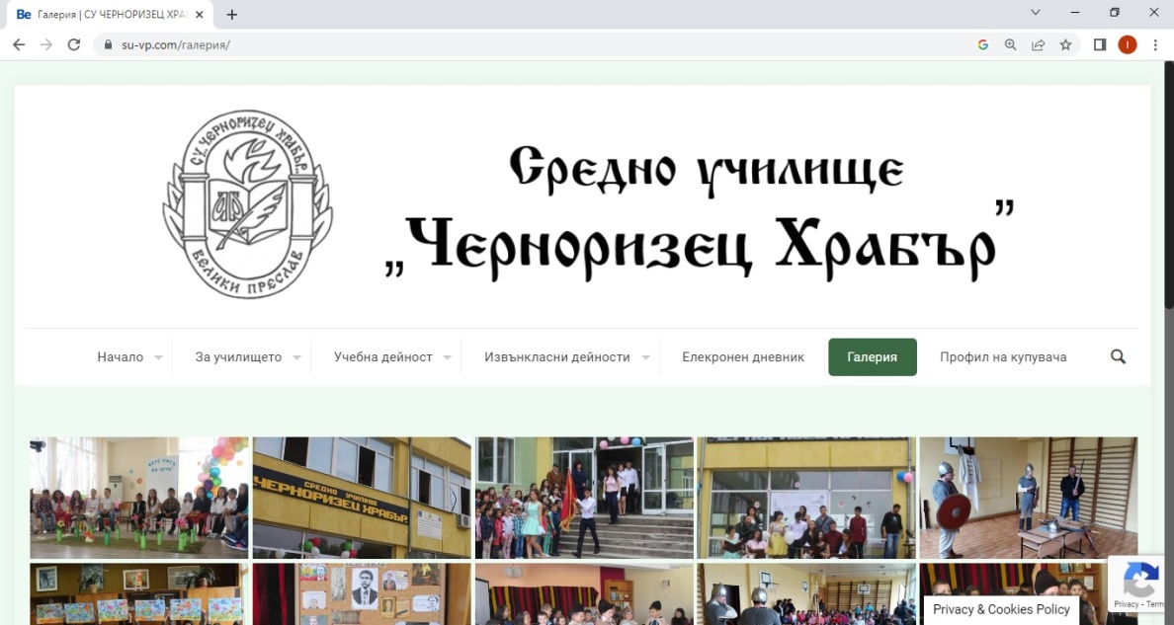

A rich collection of photos from classroom and extracurricular activities, as well as sports events (competitions, celebrations, etc.).

**Профил на куповача**

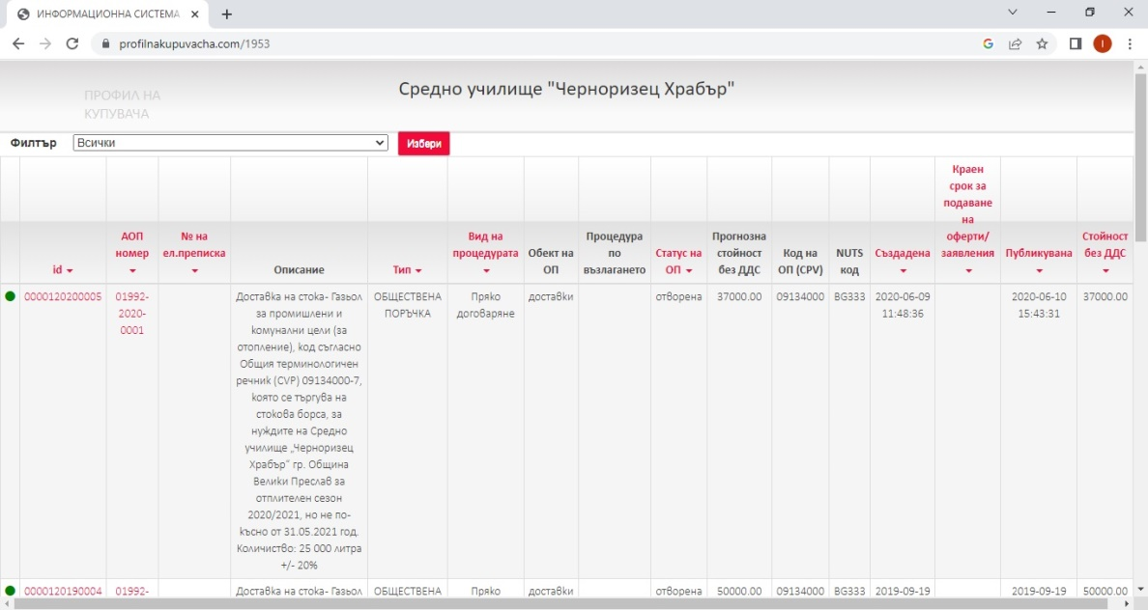

Redirects to another site containing information about various types of supplies.