ExternalInt

In this project, we practice using external interrupt on NUCLEO-L476RG. We activate the falling edge interrupt on the on-board push button (Blue) which is connected to PC13:
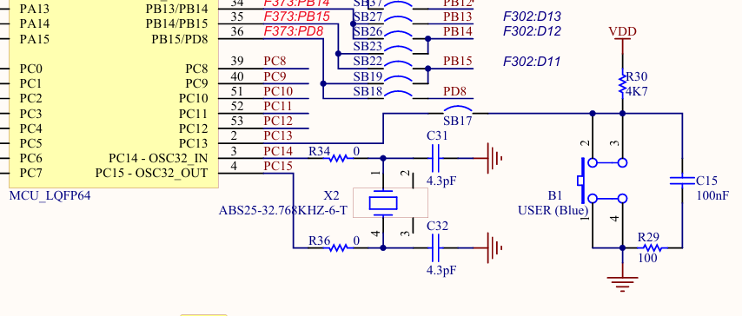

Then, we write an interrupt service routine function to toggle the on-board LED which is connected to PA5:

