INT_7_Segment

In This project we drive a two-digits seven segment which is connected to NUCLEO-L476RG board. It shows number 00 for the first time, and we use the on-board NUCLEO-L476RG push button (blue) to count the 7-segment up to 99 and coming back to 00.
We use external interrupt for this push button which is connected to PC13.

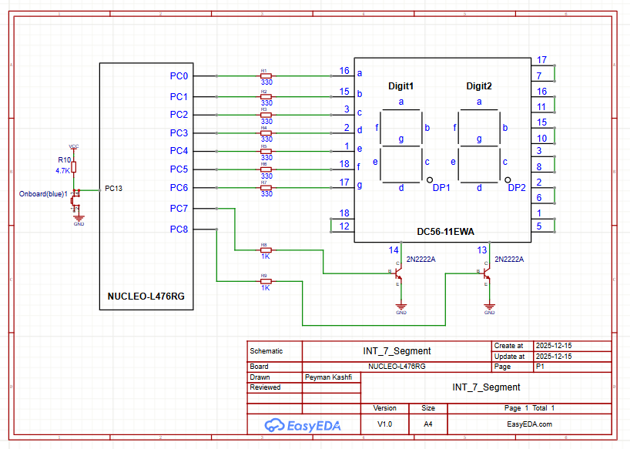
Displaying the number on 7-segment:
To drive this seven segment, we should configure the corresponding pins for each segment (a … f) and enable pin 14 (PC8 PC7 = 01) for digit 1 for a few milliseconds and then enable pin 13 (PC8 PC7 = 10) for digit 2 for a few milliseconds and repeat the process again. Note that for DC56-11EWA 7-segment, the pins 14, 13 are active low so to active the pins we should make the base of the corresponding transistor to logic 1.
I setup the clock to the maximum 80MHz and make PC8 … PC0 as GPIO output in the project .ioc file.

The following table shows the numbers to be set in ODR based on each segments SET/RESET:
Number to be displayed ↓ | PC6 | PC5 | PC4 |  | PC3 | PC2 | PC1 | PC0 | ODR
 | g | f | e |  | d | c | b | a
0. | 0 | 1 | 1 |  | 1 | 1 | 1 | 1 | 0x3F
1. | 0 | 0 | 0 |  | 0 | 1 | 1 | 0 | 0x06
2. | 1 | 0 | 1 |  | 1 | 0 | 1 | 1 | 0x5B
3. | 1 | 0 | 0 |  | 1 | 1 | 1 | 1 | 0x4F
4. | 1 | 1 | 0 |  | 0 | 1 | 1 | 0 | 0x66
5. | 1 | 1 | 0 |  | 1 | 1 | 0 | 1 | 0x6D
6. | 1 | 1 | 1 |  | 1 | 1 | 0 | 1 | 0x7D
7. | 0 | 0 | 0 |  | 0 | 1 | 1 | 1 | 0x07
8. | 1 | 1 | 1 |  | 1 | 1 | 1 | 1 | 0x7F
9. | 1 | 1 | 0 |  | 1 | 1 | 1 | 1 | 0x6F

First, we try to show number 19 on 7-segment. We define two variables MSD and LSD and assign them to the corresponding digits by dividing the number by 10 and calculating the divider and reminder (in this case 19 1 and 9). Then we send the first number (1) to the 7-Segment and enable digit 1 and wait for 10ms and then send the second number (9) to the 7-Segment and enable digit 2 and wait for 10ms and repeat the process in the while(1) loop.

Counting up:
We define an integer (count) and initialise to zero and the display it on 7-segment.
We enable external interrupt on PC13 falling edge and write a simple code inside the HAL_GPIO_EXTI_Callback() function to increase “count” variable. Once the push button is pressed, the “count” is increased and displayed on 7-segment. If the count equals to 99 it goes to zero again.

