Multi_Int
In this project, we paractice how the MCU handles multiple interrupts on the same line. Two push buttons connected to the PA6 and PA7 and we use EXTI9_5. We connect two LEDs to the PA11 and PA12 to respond to the interrupts triggered by the push buttons.
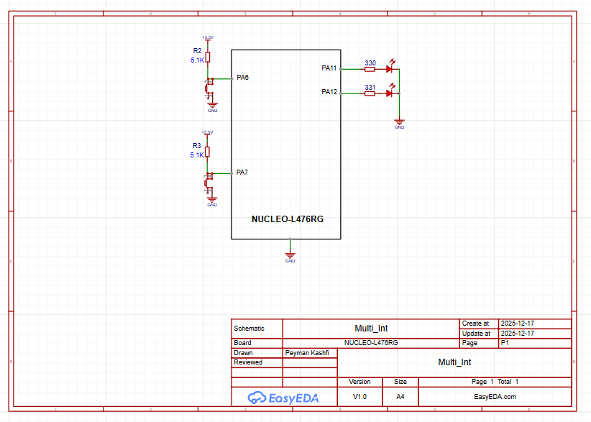
PA6 push button PA11 LED
PA7 push button PA12 LED

