This is a simple project for STM32L476 NUCLEO board to drive a single digit 7-segment LED.
First, I setup the clock to the maximum 80MHz.
Then, I configure the corresponding GPIO pins as GPIO output in .ioc file.
Each segment connected to a GPIO port as folows:
a --> PC0
b --> PC1
c --> PC2
d --> PC3
e --> PC4
f --> PC5
g --> PC6
DP --> PC7
We use ODR (Output Data Register) for GPIO to set and reset the corresponding pins.
Also, we always turn DP (Decimal Point) on, so the PC7 pin is always on.

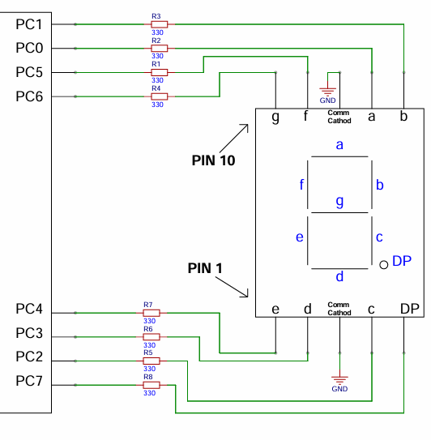
The following table shows the numbers to be set in ODR based on each segments SET/RESET:
Number to be displayed ↓ | PC7 | PC6 | PC5 | PC4 |  | PC3 | PC2 | PC1 | PC0 | ODR
 | DP | g | f | e |  | d | c | b | a
0. | 1 | 0 | 1 | 1 |  | 1 | 1 | 1 | 1 | 0xBF
1. | 1 | 0 | 0 | 0 |  | 0 | 1 | 1 | 0 | 0x86
2. | 1 | 1 | 0 | 1 |  | 1 | 0 | 1 | 1 | 0xDB
3. | 1 | 1 | 0 | 0 |  | 1 | 1 | 1 | 1 | 0xCF
4. | 1 | 1 | 1 | 0 |  | 0 | 1 | 1 | 0 | 0xE6
5. | 1 | 1 | 1 | 0 |  | 1 | 1 | 0 | 1 | 0xED
6. | 1 | 1 | 1 | 1 |  | 1 | 1 | 0 | 1 | 0xFD
7. | 1 | 0 | 0 | 0 |  | 0 | 1 | 1 | 1 | 0x87
8. | 1 | 1 | 1 | 1 |  | 1 | 1 | 1 | 1 | 0xFF
9. | 1 | 1 | 1 | 0 |  | 1 | 1 | 1 | 1 | 0xEF

