In This project we drive a two-digits seven segment which is connected to NUCLEO-L476RG board.
I used EasyEDA platfrom to design the following schematic. The PDF version has been saved in the same folder as well.
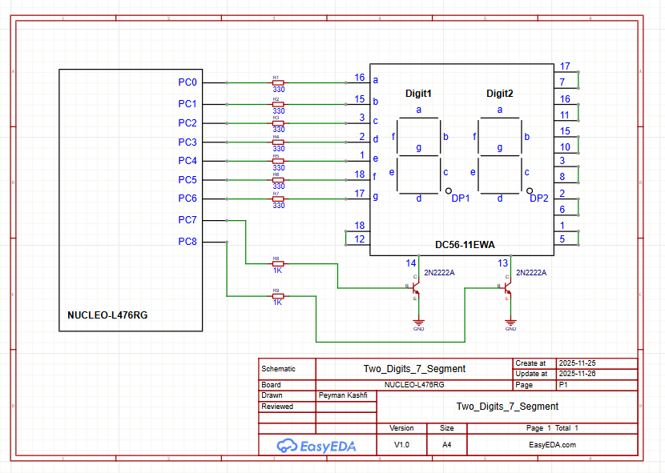
To drive this seven segment, we should configure the corresponding pins for each segment (a … f) and enable pin 14 (PC8 PC7 = 01) for digit 1 for a few milliseconds and then enable pin 13 (PC8 PC7 = 10) for digit 2 for a few milliseconds and repeat the process again.
I setup the clock to the maximum 80MHz and make PC8 … PC0 as GPIO output in the project .ioc file.

The following table shows the numbers to be set in ODR based on each segments SET/RESET:
Number to be displayed ↓ | PC6 | PC5 | PC4 |  | PC3 | PC2 | PC1 | PC0 | ODR
 | g | f | e |  | d | c | b | a
0. | 0 | 1 | 1 |  | 1 | 1 | 1 | 1 | 0x3F
1. | 0 | 0 | 0 |  | 0 | 1 | 1 | 0 | 0x06
2. | 1 | 0 | 1 |  | 1 | 0 | 1 | 1 | 0x5B
3. | 1 | 0 | 0 |  | 1 | 1 | 1 | 1 | 0x4F
4. | 1 | 1 | 0 |  | 0 | 1 | 1 | 0 | 0x66
5. | 1 | 1 | 0 |  | 1 | 1 | 0 | 1 | 0x6D
6. | 1 | 1 | 1 |  | 1 | 1 | 0 | 1 | 0x7D
7. | 0 | 0 | 0 |  | 0 | 1 | 1 | 1 | 0x07
8. | 1 | 1 | 1 |  | 1 | 1 | 1 | 1 | 0x7F
9. | 1 | 1 | 0 |  | 1 | 1 | 1 | 1 | 0x6F

