### **How to Run the Mission Control Software (Step-by-Step)**

#### **Step 1: What You Need to Get Started**

Before running the software, you will need a computer with the following:

1. **Java** installed on your computer. Java is the program that runs the software. If you don’t have it, you can download it by going to this website:  
   <https://www.oracle.com/java/technologies/javase-jdk11-downloads.html>
   * Choose the download for your computer (Windows, Mac, or Linux).
   * Follow the on-screen instructions to install it.
2. **SQLite** is used to store astronaut information. But don't worry, this software will handle it for you automatically.

#### **Step 2: Downloading the Software Files**

1. **Get the Software Files**You need to download all the files that make up the software. These are the different pieces of the program that help the software work.

Download from the GItHub Repository found at this link:

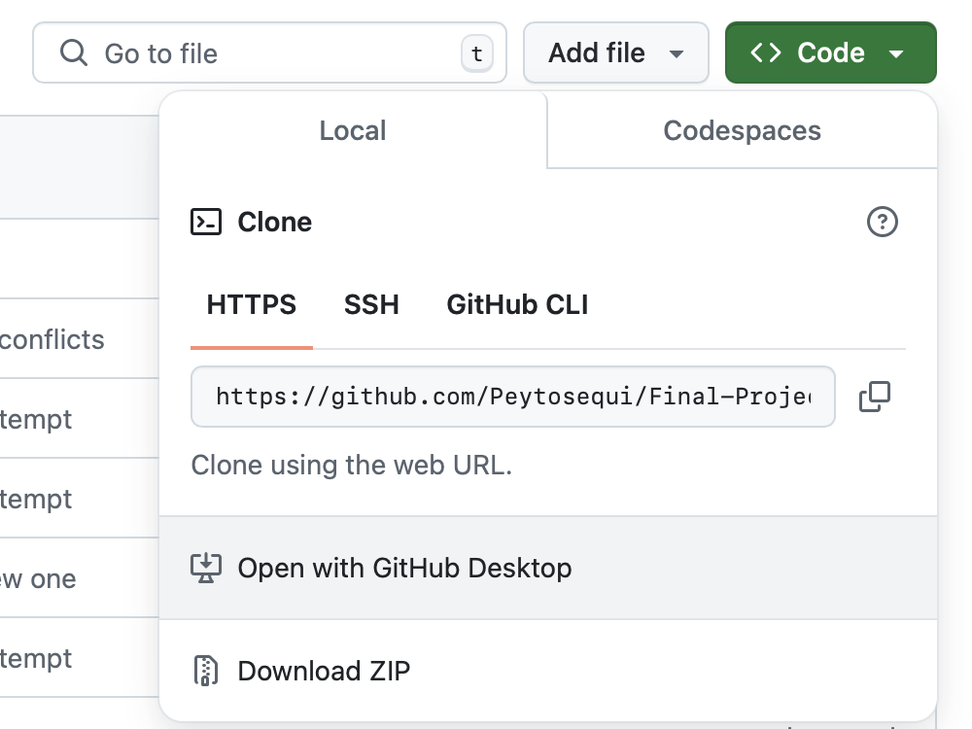 <https://github.com/Peytosequi/Final-Project-2025>

* + Click the link
  + Press the green button labeled ‘Code’



* + Look down to the option that states ‘Open with GitHub Desktop’
  + Click that
  + You'll have 8 files:
    - **.vscode**
    - **Main.java**
    - **Astronaut.java**
    - **Launchprocess.java**
    - **Spaceship.java**
    - **Protect.java**
    - **StorageData.txt**
    - **test.txt**

**Step 3: Running the Program**

Now it’s time to actually run the software!

1. **Start the Program**

In GitHub Desktop, look to the top right hand corner of the screen. You’ll see a small triangle.

Press that and the program will run.  
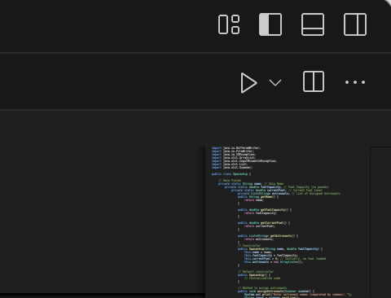  
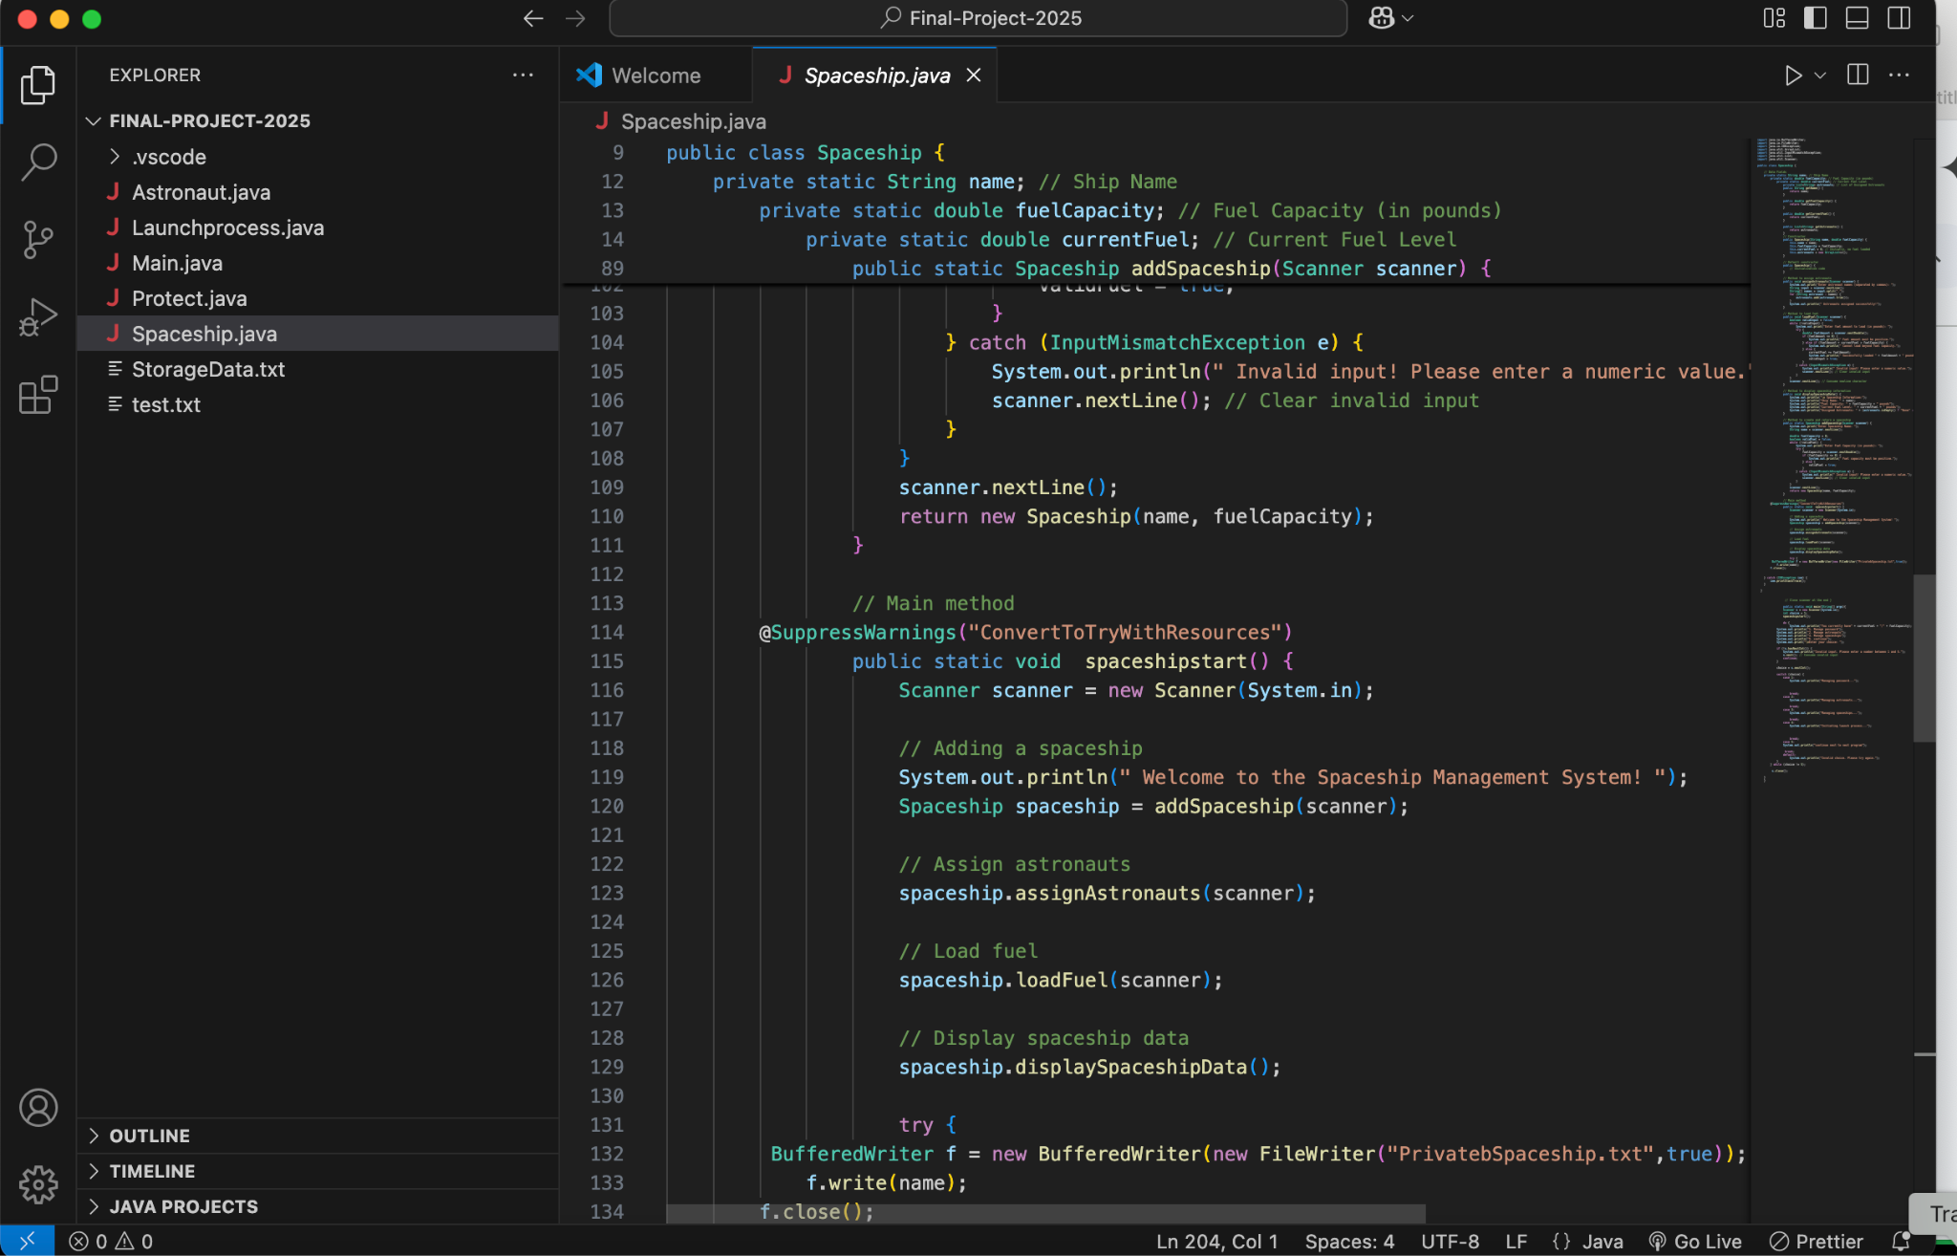

**Step 6: Using the Software**

Once the program is running, you’ll be presented with a menu that looks like this:

Available operations:

1. Manage password

2. Manage astronauts

3. Manage spaceships

4. Launch

5. Exit

Use the numbers to choose what you want to do. Here’s what each option means:

1. **Manage password**This option allows you to create a password to protect astronaut data. When you pick this option, the program will generate a password for you, and you can use it to protect sensitive astronaut information.
2. **Manage astronauts**Here, you can add or remove astronauts from the database. The program will ask for astronaut names. You can enter them, separated by commas, and they will be stored in the database.
3. **Manage spaceships**This option allows you to create new spaceships, assign astronauts to those spaceships, and load fuel into them. You’ll be asked to provide the name of the spaceship and how much fuel it should have.
4. **Launch**This option simulates launching a spaceship. If a spaceship has enough astronauts and fuel, the program will begin a countdown, simulating the launch.
5. **Exit**When you're done, you can choose to exit the program.

#### **Step 7: How to Interact with the Program**

* **Choosing an Option**:  
  When you see the menu, it will ask you to type a number (like 1, 2, etc.) into the terminal below. Use your keyboard to type the number of the option you want and then press Enter. For example, to manage astronauts, type 2 and press Enter.
* **Entering Information**:  
  If the program asks you to enter astronaut names or fuel amounts, type the information and press Enter.
  + For example, if it asks for astronaut names, you might type:  
    John, Sarah, Michael
  + When it asks for fuel, you might type something like:  
    2000 (for 2000 pounds of fuel).

#### **Step 8: What Happens After You Choose an Option**

1. **Password Management**:  
   If you choose to manage the password, the program will create a secure password for you and display it on the screen. Write this down in a safe place.
2. **Astronaut Management**:  
   When you choose to manage astronauts, the program will let you add names of astronauts to the spaceship system. You’ll type their names, and they’ll be saved in the system.
3. **Spaceship Management**:  
   If you choose to manage spaceships, you’ll be able to create a spaceship, assign astronauts to it, and load fuel. The program will ask you to input the spaceship name and the number of astronauts.
4. **Launching the Spaceship**:  
   When you choose to launch a spaceship, the program will simulate a countdown from 10 to 0 and then show the message that the spaceship has "launched" successfully.

### **Troubleshooting**

* **If You See an Error**:  
  If something goes wrong (like an error or message saying "Invalid input"), make sure that:
  + You typed the correct number when selecting an option (e.g., 1, 2, etc.).
  + If it asks for a number (like how much fuel to load), make sure you type a valid number (like 2000 instead of a word).

### **Conclusion**

That’s it! You’ve now learned how to run and use the Mission Control Software. You can manage astronauts, spaceships, and launch missions just by following the steps above.

If you ever need help, just ask someone familiar with computers, and they can assist you!