**Virtual network peering**

Virtual network peering enables you to seamlessly connect two or more Virtual Networks in Azure. The virtual networks appear as one for connectivity purposes. The traffic between virtual machines in peered virtual networks uses the Microsoft backbone infrastructure. Like traffic between virtual machines in the same network, traffic is routed through Microsoft's private network only.

Azure supports the following types of peering:

* Virtual network peering: Connect virtual networks within the same Azure region.
* Global virtual network peering: Connecting virtual networks across Azure regions.

The benefits of using virtual network peering, whether local or global, include:

* A low-latency, high-bandwidth connection between resources in different virtual networks.
* The ability for resources in one virtual network to communicate with resources in a different virtual network.
* The ability to transfer data between virtual networks across Azure subscriptions, Azure Active Directory tenants, deployment models, and Azure regions.
* The ability to peer virtual networks created through the Azure Resource Manager.
* The ability to peer a virtual network created through Resource Manager to one created through the classic deployment model. To learn more about Azure deployment models.
* No downtime to resources in either virtual network when creating the peering, or after the peering is created.

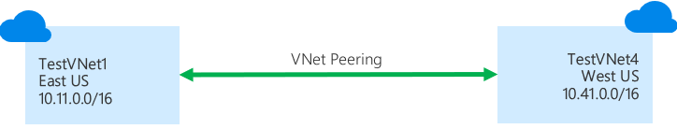

VNet peering enables you to seamlessly connect Azure virtual networks. Once peered, the VNets appear as one, for connectivity purposes. The traffic between virtual machines in the peered virtual networks is routed through the Microsoft backbone infrastructure, much like traffic is routed between virtual machines in the same VNet, through private IP addresses only. No public internet is involved. You can peer VNets across Azure regions, too – all with a single click in the Azure Portal.

1. VNet peering - connecting VNets within the same Azure region
2. Global VNet peering - connecting VNets across Azure regions

## Create virtual networks

1. On the Azure portal, select **Create a resource**.
2. Select **Networking**, and then select **Virtual network**.
3. On the **Basics** tab, enter or select the following information and accept the defaults for the remaining settings:

| **Setting** | **Value** |
| --- | --- |
| Subscription | Select your subscription. |
| Resource group | Select **Create new** and enter myResourceGroup. |
| Region | Select **East US**. |
| Name | myVirtualNetwork1 |

1. On the **IP Addresses** tab, enter 10.0.0.0/16 for the **Address Space** field. Click the **Add subnet** button below and enter Subnet1 for **Subnet Name** and 10.0.0.0/24 for **Subnet Address range**.
2. Select **Review + Create** and then select **Create**.
3. Complete steps 1-5 again, with the following changes:

| **Setting** | **Value** |
| --- | --- |
| Name | myVirtualNetwork2 |
| Address space | 10.1.0.0/16 |
| Resource group | Select **Use existing** and then select **myResourceGroup**. |
| Subnet name | Subnet2 |
| Subnet Address range | 10.1.0.0/24 |

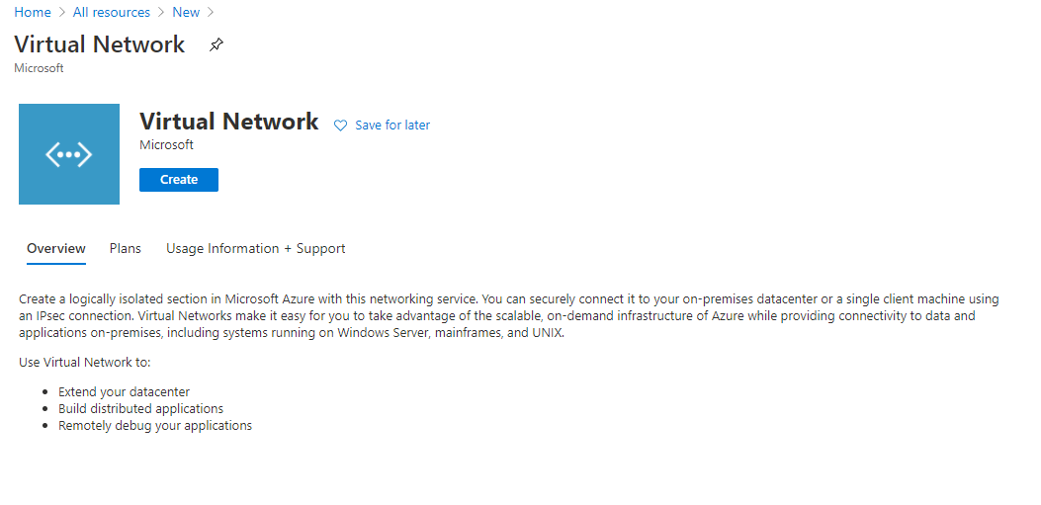

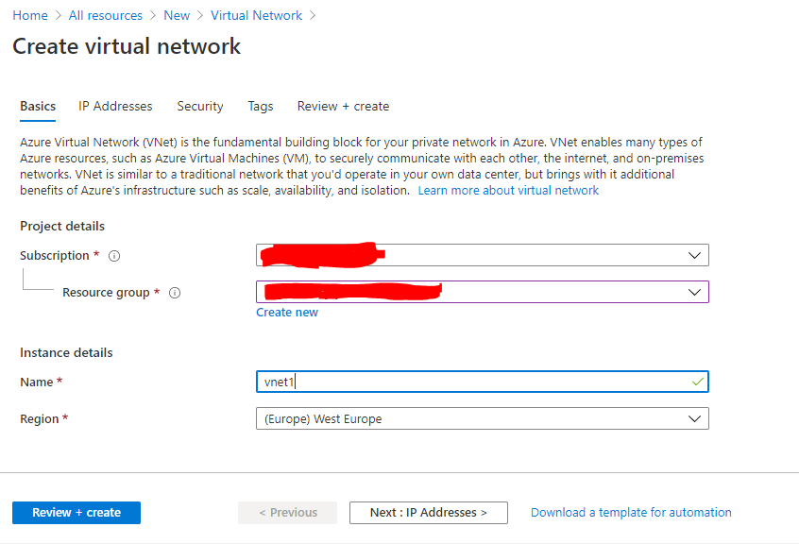

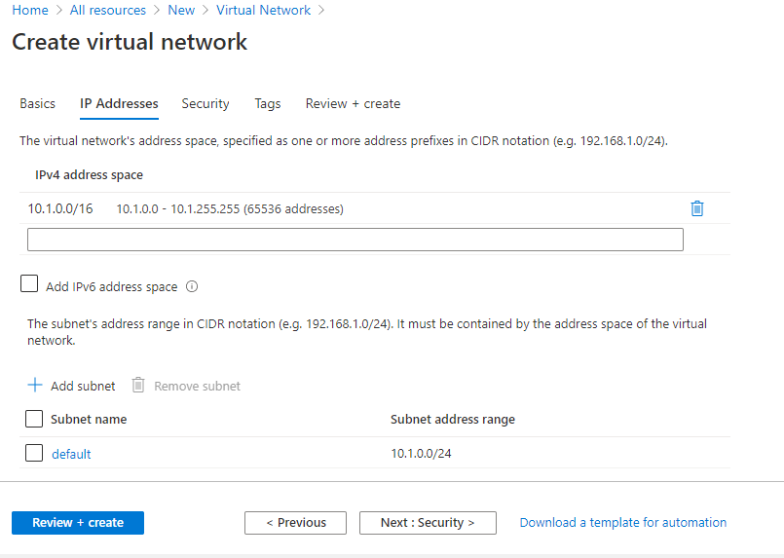

Create virtual network now

Similarly create another virtual network

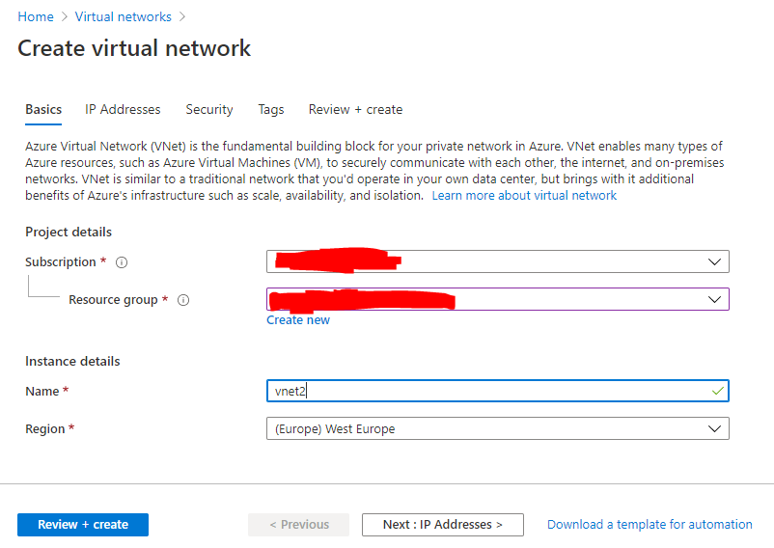

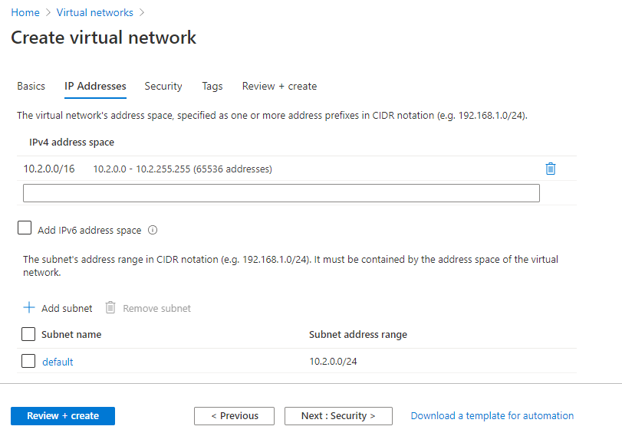

Now both virtual networks has been created

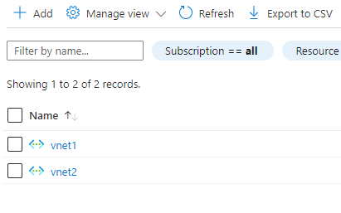

Now go to vnet1 🡪 goto peering 🡪

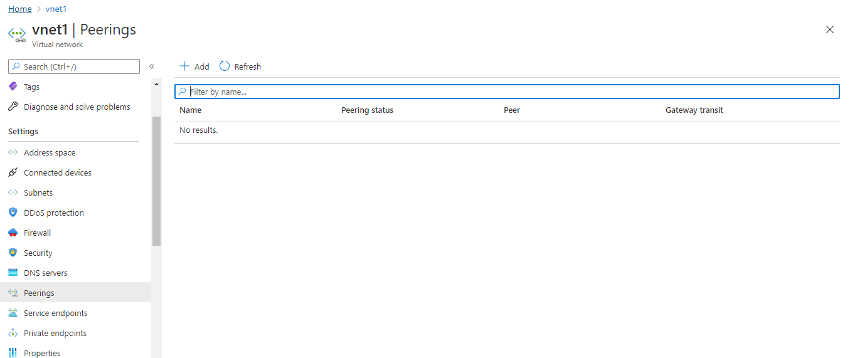

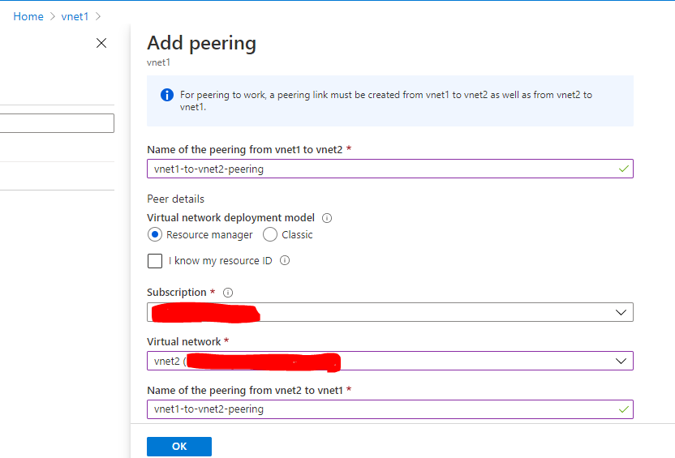

In vnet 1 you need to select vnet2 network (above screenshot)

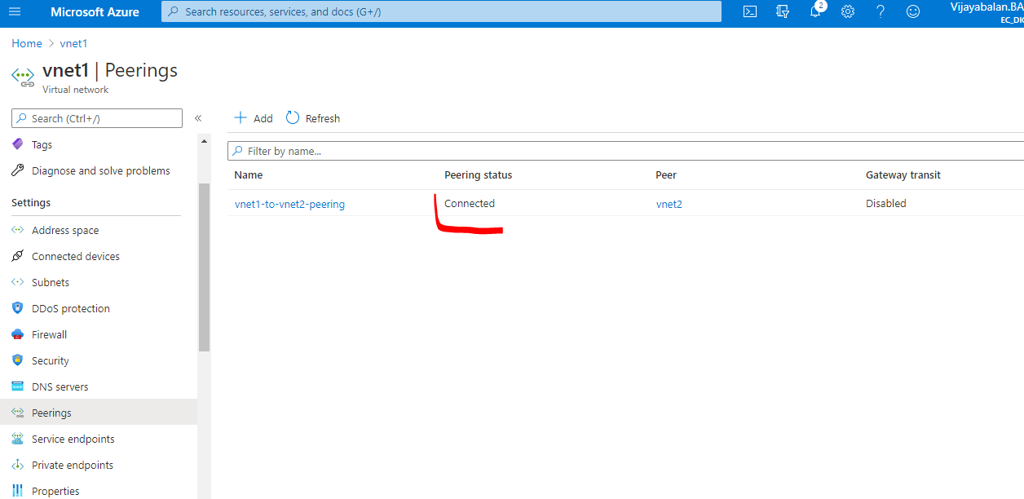

Create VM 1 in vnet1

Create vm2 in vnet2

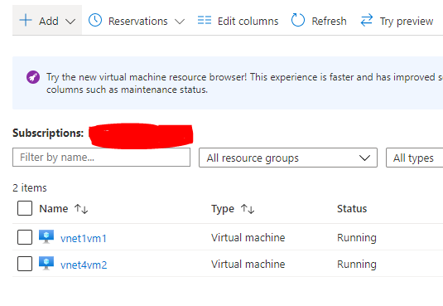

From vnet1 vm1 now am able to ping VNET2VM2 machine

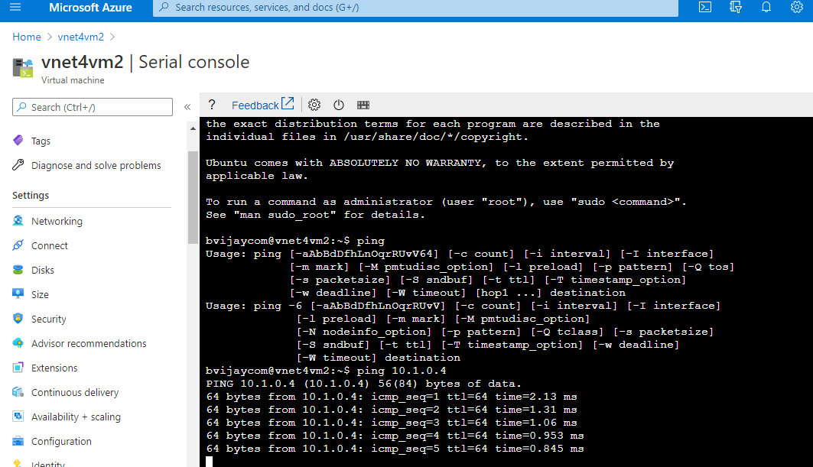

From vnet2 vm2 now am able to ping VNET1VM1 machine

