CS442 - Plant Monitor System

Cristian Guarino.

This project’s scope is to use a Raspberry Pie to collect data from an environment and transmit that data to a secure website for the users to monitor.

In this project, we use two sensors. A DHT11 sensor that collects air temperature and air humidity. And an LM393 light detection sensor that will give us a binary result based on whether it detects a light source or not.

The data from the two sensors is collected using the sensor_reader.py program and sent over to the monitor.py program to display when it runs.

We followed the instructions of hw2 and set up the Raspberry Pie as the Web Server to host our webpage using Apache2. We also generated the certificates necessary for the secure web connection allowing us to broadcast a https page. We differ from the homework since we implemented the instructions to work over a python app instead of simply with openssl.

We import the ca that we generated on the Raspberry Pie on our PC and import it to our web browser. Finally, just like in the homework, we change the hosts file to be able to recognize the page when we enter it in the web browser.

After establishing the connection, we can monitor the data and hit the update button to get newer readings.

File folder

Raspberry Pie configuration.

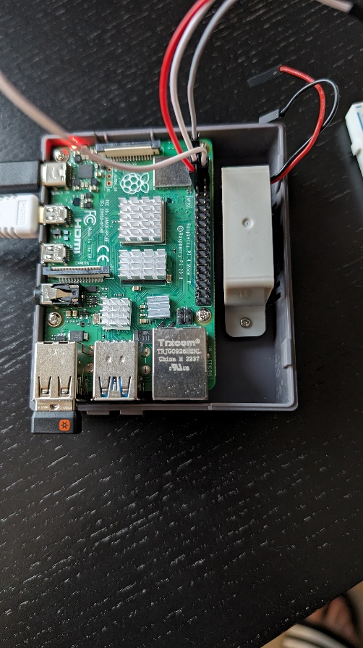

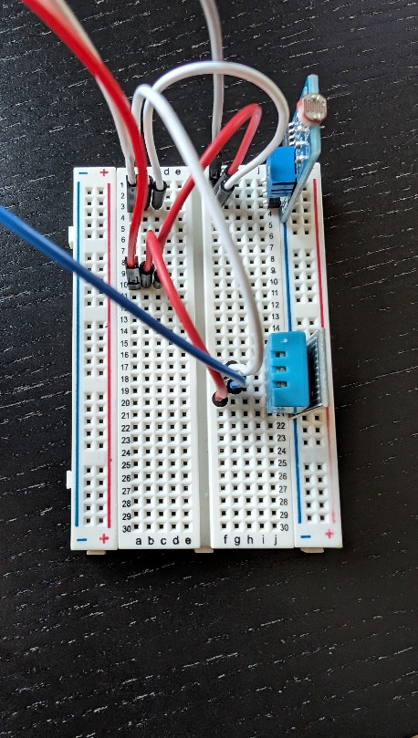

As we can see from the pictures sensors are all powered by 3V3 pin 1 (white wire). Also, they all use pin 9 for the Ground. The temperature/humidity sensor’s data is transmitted to GPIO4 at pin 7 and the light sensor’s data is transmitted to GPIO14 at pin 8.

After assigning the sensors we can collect the data and save it in a python dictionary.

The webpage is hosted on the pie using the server certificate and key that we generated with openssl.

Once the app is running we can securely access the website to monitor our readings.

