Linkedin Profile

<https://www.linkedin.com/in/pfano-muthambi-714a08235/>

Peer Evaluation

Pfano Muthambi

Harvey Marakalala

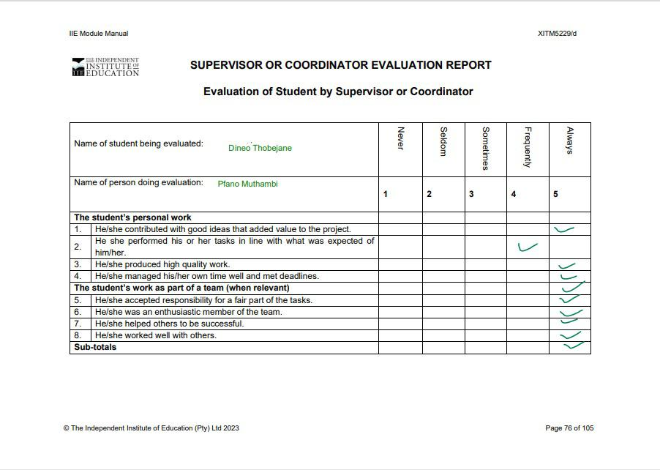

Pfano Muthambi

Dineo Thobejane

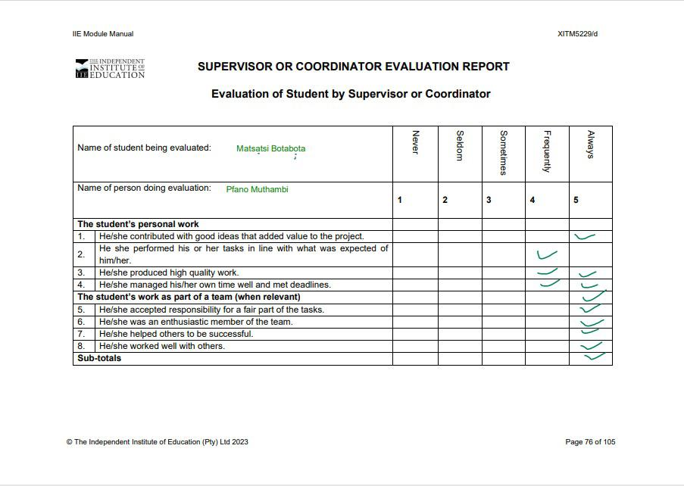

Pfano Muthambi

Matsatsi Botabota

Peer Evaluation 2

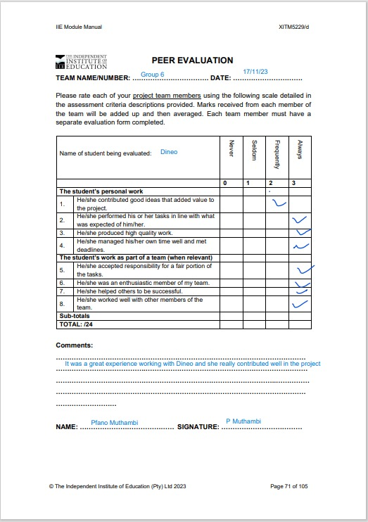

Lorax

Dineo

11/11/2024

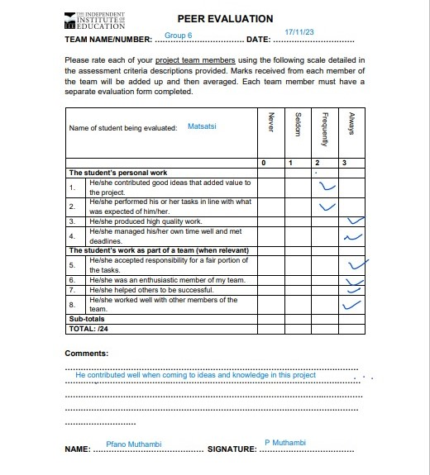

Matsatsi

Lorax

11/11/2024

Dineo

11/11/2024

Lorax

Self-Evaluation

3

4

3

11/11/2024

ST10205389

Pfano Muthambi

4

4

4

4

Declaration of Authenticity

11/11/2024

LETTER TO ORGANISATION

11/11/2024