                                                                      Graduation Project

***In order to obtain***

The license in Information Technologies.

Option: Information Systems Development

***Entitled***

“Bio Market”

|  |  |
| --- | --- |
|  |  |

**Design and production of a sales platform for organic almonds and pistachios**

|  |  |
| --- | --- |
|  |  |

***Carried out by***

**Saadli Wissem**

**Encadré par :**

**Mme/ Tlijani Hayet**

**Mme/ Hlima Mouna**

***Soutenu le  ……/06/2023 devant le jury composé de :***

|  |  |
| --- | --- |
| **M. ………………………..** | **Président (ISET GAFSA)** |
| **M. ………………………..** | **Rapporteur  (ISET GAFSA)** |
| **Mme ………………………….** | **Encadrant (ISET GAFSA)** |

***AU : 2022/2023***

**Thank You Page**

I would like to express my heartfelt gratitude to the following individuals who have played an indispensable role in my journey and have contributed immensely to my achievements:

First and foremost, I want to extend a special thank you to my beloved parents, Rebah and Brahim. Your unwavering support, encouragement, and sacrifices have been the cornerstone of my success. Your belief in me, even during the most challenging times, has given me the strength to persevere and strive for excellence. I am forever grateful for your love and guidance.

To my wonderful oldest sister, Lamia, and the rest of my family, thank you for being my pillars of strength and for providing a nurturing environment that fostered my growth. Your constant presence and belief in my abilities have been instrumental in my accomplishments. Your love and support have been invaluable to me.

I would also like to express my deepest appreciation to my dearest friends. You have been there for me throughout this journey, offering both a shoulder to lean on during difficult moments and moments of celebration. Your unwavering friendship and belief in me have been a source of inspiration and motivation. Thank you for always being by my side.

To my esteemed teachers, Mouna Hlima and Hayet Tlijani, your dedication, knowledge, and guidance have shaped me into the person I am today. Your passion for teaching and your commitment to my education have been instrumental in my academic and personal growth. I am profoundly grateful for your unwavering support and belief in my potential.

I also want to take a moment to thank myself. To the determined and resilient individual within me, thank you for believing in your abilities and for the unwavering commitment to your goals. The sleepless nights, sacrifices, and relentless pursuit of excellence have not gone unnoticed. I am proud of the person you have become and the milestones you have achieved.

Lastly, I want to express my deepest gratitude to my moon spirit, my dopamine, and my guiding light. You have been a constant source of inspiration, love, and encouragement. Your presence in my life has brought joy and positivity, and I am grateful for the support and love you have showered upon me.

To all those mentioned above and to anyone else who has played a part in my journey, thank you from the bottom of my heart. Your contributions have shaped my path, and I am humbled and grateful for the love, support, and guidance I have received.

Table of contenet

Contents

General introduction 6

State of art 7

I. Platforms of 8

1) “La ruche qui dit oui” 8

2) Agrivi: 11

II. Difference between platform and website 17

III. Solution 18

Requirement Capture 27

and 27

Specification 27

I) functional requirements: 28

1) Functionalities of the platform: 28

2) Actors : 29

I. Non-functional requirements: 30

II. Use case textual description 31

Figure 1: La Ruche qui dit oui 11

Figure 2: Agrivi 14

Figure 3:FarmMatch 16

Figure 4: Ecocert Tunisia 23

# General introduction

Local farmers in Gafsa who specialize in selling bio pistachios and almonds face significant challenges in marketing and selling their products. Similarly, buyers from different regions of Tunisia encounter difficulties in sourcing the desired quantities of these products. Furthermore, even if they manage to find the desired quantity, ensuring that the products they acquire are genuinely organic and of high quality poses a considerable obstacle. Additionally, both farmers and buyers struggle with the burden of high costs associated with production and transportation. These collective challenges contribute to a complex landscape for the local agricultural industry in Gafsa, impacting both farmers and consumers alike.

In addition to the aforementioned challenges, one major obstacle faced by buyers is the inability of a single farmer to meet the demand for large quantities of bio pistachios and almonds. The limited production capacity of individual farmers makes it exceedingly difficult for buyers to locate the required volume of products in one place. This scarcity of large quantities further exacerbates the challenges faced by buyers in their quest to source the desired amount of bio products. The fragmented availability of these goods adds another layer of complexity to the already intricate process of procuring bio pistachios and almonds, making it a formidable task for buyers across Tunisia.

Moreover, due to the relatively small sizes of their farms, farmers often find themselves providing only limited quantities of bio pistachios and almonds. This limitation can lead to a sense of shame or hesitation among farmers when it comes to marketing and selling these smaller quantities. They may perceive their small offerings as inadequate compared to the demand, which further hinders their ability to promote and sell their products confidently. This emotional aspect adds an additional layer of difficulty for farmers who already face challenges related to quantity and market access.

Chapter I:

# State of art

This chapter deals with examples of platforms similar to the one that we should perform in our project. We will set up their advantages and disadvantages. So that we keep good practice for our future work. In the following, we illustrate some of these platforms.

## Platforms of

## “La ruche qui dit oui”

Link: https://laruchequiditoui.fr/fr

"La Ruche qui dit Oui" is a French platform. It aims to connect consumers with local food producers. It allows them to purchase fresh and high-quality products directly from the producers.

The platform works by creating local online marketplaces where consumers can order food products from a range of producers in their area. The producers then bring the products to a central location, or "pickup point," where the consumers can collect their orders.

"La Ruche qui dit Oui" is used in several countries around the world, including France, Belgium, Spain, Italy, Germany, the United Kingdom, and the United States. The company has created a network of local communities, which includes both consumers and producers, who use the platform to connect with each other.

Consumers who use "La Ruche qui dit Oui" are typically people who are interested in buying fresh, local, and seasonal produce directly from farmers and small-scale producers. These consumers may be concerned about the environmental impact of industrial farming, and they may be looking for ways to support local farmers and reduce the distance that their food travels before it reaches their plates.

Producers who use "La Ruche qui dit Oui" are typically small-scale farmers, artisans, and food producers who are looking for new markets to sell their products. These producers may be located in rural areas or small towns where it can be difficult to access traditional retail markets. By using "La Ruche qui dit Oui," they are able to sell their products directly to consumers in their local communities, without having to rely on intermediaries.

* **Advantages**

There are several advantages to using "La Ruche qui dit Oui" platform:

* Locally-sourced products: "La Ruche qui dit Oui" allows consumers to purchase fresh and locally-sourced products directly from the farmers and producers in their area. This promotes sustainable and ethical food production practices while reducing the environmental impact of food transportation.
* High-quality products: The platform's focus on locally-sourced products means that consumers can access high-quality and fresh food products that have been produced using sustainable and ethical practices.
* Support for local producers: The platform helps support local farmers and producers by providing them with a direct channel to market their products to consumers. This can help to promote small-scale and sustainable agriculture and support local economies.
* **Disadvantages:**

There are some potential disadvantages to using "La Ruche qui dit Oui" platform:

* Limited product selection: As "La Ruche qui dit Oui" focuses on locally-sourced products, the product selection may be limited compared to larger supermarkets or online retailers. Consumers may not be able to find certain products or may have to wait for seasonal availability.
* Pickup point limitations: The pickup point system used by "La Ruche qui dit Oui" may not be convenient for all consumers, especially those who live far from the designated pickup locations or who have limited transportation options.
* Higher prices: As locally-sourced and sustainably-produced products can be more expensive to produce, the prices on "La Ruche qui dit Oui" may be higher compared to mass-produced products in larger supermarkets or online retailers.
* **Rating:**

It is difficult to provide a rating for "La Ruche qui dit Oui" as it can be subjective and depend on individual experiences. However, the platform has generally received positive reviews and has been well-received by consumers who appreciate the opportunity to purchase fresh and locally-sourced food products. Additionally, the platform has received recognition for its efforts to promote sustainable and ethical food production practices.

* **Value:**

according to their website, as of 2021, there are more than 1,300 local communities or "Ruches" in France, with over 1,800 farmers and producers selling their products on the platform. The website also states that millions of products have been sold through the platform since its inception in 2010.

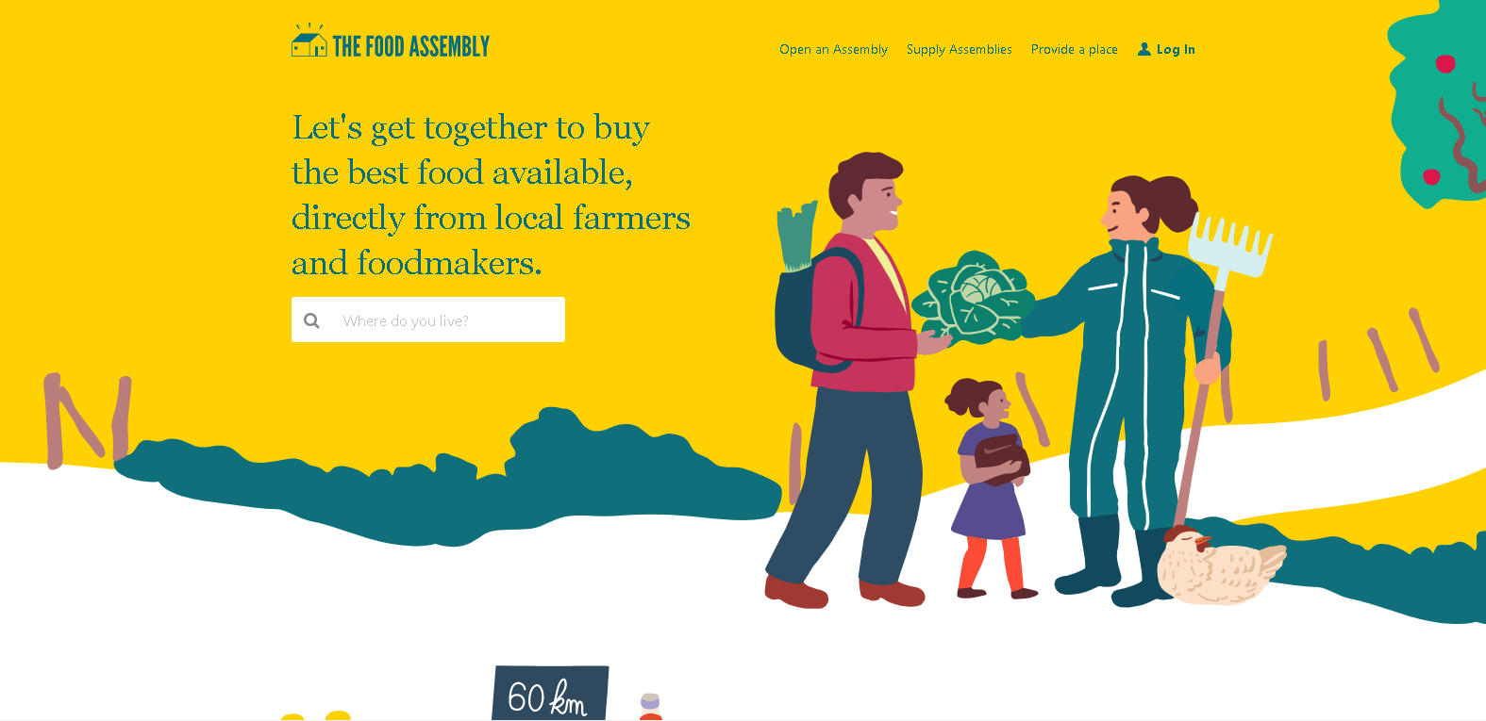

Figure : La Ruche qui dit oui

1. Agrivi:

Agrivi is a cloud-based farm management platform that helps farmers manage their agricultural operations more efficiently and effectively. The platform provides a range of tools and features that enable farmers to track and manage their crops, livestock, and farm inputs such as fertilizers and pesticides.

Agrivi allows farmers to plan and schedule their farm activities, monitor crop growth and yield, and identify potential issues that may affect their crops. The platform also provides data analytics and insights to help farmers make better decisions about their farming practices.

Agrivi can be accessed through a web browser or mobile app, making it easy for farmers to use the platform on the go. The platform supports a wide range of crops and livestock, including fruits, vegetables, cereals, and dairy and beef cattle.

Overall, Agrivi is designed to help farmers improve their yields, reduce costs, and optimize their farming practices to achieve better results.

* **Advantages**

There are several advantages of using the Agrivi platform for farm management:

* Comprehensive farm management features: Agrivi provides a wide range of features and tools that can help farmers manage their crops, livestock, and farm inputs more effectively. This includes crop planning and tracking, inventory management, production analytics, and financial tracking.
* User-friendly interface: Agrivi's interface is designed to be user-friendly and intuitive, making it easy for farmers to use and navigate the platform. This can help reduce the learning curve for new users and enable them to start using the platform more quickly.
* Cloud-based platform: Agrivi is a cloud-based platform, which means that farmers can access their data from anywhere with an internet connection. This can be particularly useful for farmers who need to monitor their farms remotely or who travel frequently.

Overall, the Agrivi platform can help farmers improve their efficiency, productivity, and sustainability, leading to better outcomes for their farm businesses.

* **Disadvantages**

While there are several advantages to using the Agrivi platform for farm management, there are also some potential disadvantages to consider:

* Cost: The Agrivi platform is a subscription-based service, which means that farmers will need to pay a recurring fee to use the platform. This cost may be prohibitive for some farmers, particularly those with smaller operations or limited budgets.
* Limited customization: While the Agrivi platform provides a range of features and tools, some farmers may find that the platform does not fully meet their specific needs or requirements. The platform may not be customizable enough to accommodate unique farming practices or workflows.

Overall, it is important for farmers to carefully consider their specific needs and circumstances before deciding whether the Agrivi platform is the right fit for their farm business.

* **“COOPÉRATIVES” section:**

The "COOPÉRATIVES" section in Agrivi is most likely a feature that allows farmers who belong to agricultural cooperatives to collaborate and share information on the platform. Agricultural cooperatives are organizations that are owned and operated by a group of farmers who work together to achieve common goals, such as improving their bargaining power with suppliers or increasing their access to markets.

The Agrivi platform may allow these cooperatives to create a shared account where members can access and update information on their farming activities, such as crop plans, production data, and input usage. This can help cooperative members to better coordinate their activities, optimize their production processes, and share best practices with one another.

The "COOPÉRATIVES" section may also provide additional features specifically designed for cooperatives, such as tools for managing membership and governance, as well as features for organizing joint marketing and sales activities. Ultimately, the goal of this feature is to help agricultural cooperatives operate more efficiently and effectively, leading to better outcomes for their members.

* **Rating:**

Agrivi has generally received positive reviews from users and industry experts for its comprehensive farm management features, user-friendly interface, and helpful customer support.

The platform has been recognized by various organizations, such as the European Commission and the United Nations, for its innovative approach to improving agricultural practices and sustainability. Agrivi has also won multiple awards for its technology and impact in the agriculture industry.

Ultimately, the usefulness and effectiveness of the Agrivi platform will depend on the specific needs and requirements of individual farmers or agricultural organizations. It may be helpful to evaluate the platform's features and capabilities in the context of one's specific farming operation, and to consider feedback from other users or industry experts before making a decision about using the platform.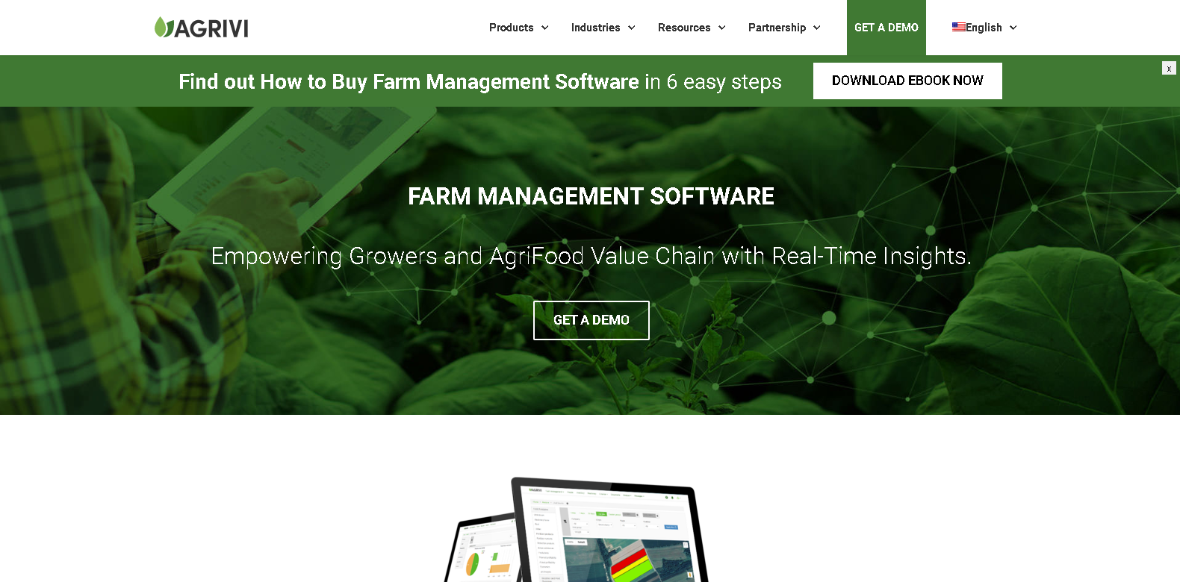

Figure : Agrivi

1. **FarmMatch:**

FarmMatch is an online platform that connects farmers, food producers, and consumers in their local community. It was created to provide a simple and efficient way for consumers to find and purchase fresh, healthy, and sustainable food from local farmers and food producers.

FarmMatch allows farmers and food producers to create a free profile where they can list their products, pricing, and location. Consumers can then search for products by location, product type, and other criteria, and place orders directly with the farmer or food producer.

One of the unique features of FarmMatch is the ability to create "farm-to-table groups". These are groups of consumers who come together to collectively purchase food from a specific farmer or food producer. This allows farmers to sell larger quantities of products at once and provides consumers with access to fresh, local food at a lower cost.

FarmMatch also provides tools for farmers and food producers to manage their orders, track inventory, and communicate with customers. This makes it easier for small-scale farmers and food producers to sell their products directly to consumers, without the need for expensive marketing and distribution channels.

Overall, FarmMatch helps to support local agriculture, promote sustainable food production practices, and provide consumers with access to fresh, healthy, and locally sourced food.

* **Advantages :**

There are several advantages to using FarmMatch as a farmer, food producer, or consumer:

* Direct access to local food: FarmMatch connects consumers directly with local farmers and food producers, allowing them to purchase fresh, healthy, and sustainable food without the need for intermediaries.
* Increased visibility for farmers and food producers: By creating a profile on FarmMatch, farmers and food producers can increase their visibility and reach a wider audience of potential customers.
* Cost-effective marketing: FarmMatch provides farmers and food producers with a free platform to market their products, reducing the need for expensive advertising and distribution channels.

Overall, FarmMatch provides a range of benefits for farmers, food producers, and consumers, promoting sustainable agriculture practices and building stronger local food systems.

* **Disadvantages** :

While FarmMatch has many advantages, there are also some potential disadvantages to consider:

* Inconsistent product quality: The quality and availability of products may vary depending on factors such as weather, seasonality, and other conditions beyond the control of farmers and food producers.
* Limited geographic coverage: FarmMatch may not be available in all geographic areas, which could limit its usefulness for consumers or farmers and food producers in certain regions.
* Cost: While creating a profile on FarmMatch is free for farmers and food producers, there may be costs associated with managing orders, shipping, and other aspects of the sales process.

Overall, while FarmMatch offers many benefits, it is important to consider these potential disadvantages when deciding whether to use the platform.

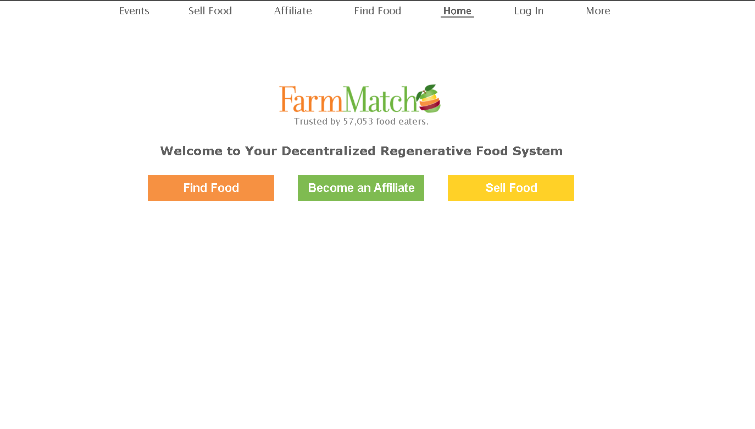

Figure :FarmMatch

1. Conclution:

We have to resume the different platforms in one table and then conclude to go forward the solution that we suggest.

|  |  |  |  |
| --- | --- | --- | --- |
| Platform | Advantages | Disadvantages | Note |
| “La ruche qui dit oui” | - Locally-sourced products.  - High-quality products.  - Support for local producers. | - Limited product selection.  - Pickup point limitations.  - Higher prices. | We need to consider the values this platform is giving.  About disadvantages, we cannot avoid that we will start just with pistachio and almond as a start but we will provide more products in the future. |
| “Agrivi” | - Comprehensive farm management features.  - User-friendly interface.  - Cloud-based platform. | - Cost.  - Limited customization. | - we will think in adding farm management features.  - and of course, our prices are going to be lower than prices in the market. |
| FarmMatch | - Increased visibility for farmers.  - Cost-effective marketing | - Inconsistent product quality.  - Limited geographic coverage.  - Cost | - we have to make sure that products have a very good quality.  - our dilevery services will cover all Tunisia. |

## Difference between platform and website

A website and a platform are distinct digital entities with different purposes and characteristics. While both exist in the digital realm, they serve unique functions.

A website refers to a collection of web pages that are hosted on a server and can be accessed through the Internet. These pages typically provide information, present content, or enable communication. Websites are commonly utilized for promotional or informational purposes, displaying various types of content like text, images, videos, and links. Users interact with website content using a web browser.

On the other hand, a platform is a more comprehensive concept that encompasses a variety of services, tools, and technologies. It acts as an intermediary, facilitating interactions and transactions between different parties. Platforms often comprise multiple components such as websites, applications, APIs (Application Programming Interfaces), and databases.

Platforms offer diverse functionalities, including but not limited to:

**a) E-commerce platforms**, which facilitate online buying and selling by providing features like product listings, shopping carts, and payment gateways.

**b) Social media platforms**, which allow users to create profiles, share content, connect with others, and engage in communication and networking activities.

**c) Service platforms**, which connect service providers with customers, enabling users to request services, find professionals, and conduct transactions.

**d) Development platforms**, which offer developers tools, frameworks, and resources to create applications, websites, or software solutions.

To summarize, while a website is a specific type of online presence primarily focused on delivering content or information, a platform is a broader concept that encompasses a range of services. Platforms go beyond content delivery and provide various functionalities through a combination of websites, applications, and other tools.

So in order to achieve all these services our solution is going to be a platform.

## Solution

Our solution combines the advantages of previous samples and solve the disadvantages.

Here we will set the advantages that we took in consideration and how we are going to deal with the troubles that we may face.

1. High-quality products:

As a first step, we need to verify that all products that a farmer will provide are 100% bio. So we will add a verification that a farmer cannot use all platform services without providing the platform with a bio certification from a national or international company or organization.

There are several international quality standards that may apply to bio (organic) pistachios and almonds. Some of the most widely recognized standards include:

1. USDA Organic: This certification ensures that the pistachios and almonds are grown without the use of synthetic fertilizers, pesticides, or genetically modified organisms (GMOs). It also requires that the crops are rotated to maintain soil health and that no irradiation or sewage sludge is used.
2. European Union Organic: Similar to the USDA Organic standard, this certification requires that the crops are grown without synthetic fertilizers, pesticides, or GMOs. It also mandates that animal welfare and environmental sustainability are taken into account.
3. Global Organic Textile Standard (GOTS): This certification is specific to textile products made from organic crops, including fabrics made from pistachio and almond fibers. It ensures that the products are made using environmentally friendly processes and that workers are treated fairly.
4. Fairtrade: This certification is focused on ensuring fair prices for farmers and workers, as well as promoting sustainable farming practices. It also requires that no forced or child labor is used.
5. Non-GMO Project Verified: This certification ensures that the pistachios and almonds have not been genetically modified and that the crops are free from genetically modified organisms.
6. Kosher: This certification ensures that the pistachios and almonds meet specific dietary restrictions for Jewish dietary laws.

The specific standards that apply to bio pistachios and almonds will depend on the country of origin and the intended market. It's important for producers to research and comply with the relevant standards to ensure that their products meet the highest international quality requirements.

**Body certifications available in Tunisia**

In Tunisia, the organic pistachios and almonds may be certified according to the EU Organic standards or the USDA Organic standards, as these are two of the most widely recognized organic certifications in the world.

It's best to consult with Tunisian organic certification bodies, such as Ecocert Tunisia or Bureau Veritas Tunisia, to determine the specific certification options available for organic pistachios and almonds in Tunisia.

**Ecocert Tunisia and Bureau Veritas Tunisia**

Ecocert Tunisia and Bureau Veritas Tunisia are two of the main certification bodies in Tunisia that provide certification services for organic products, including pistachios and almonds.

Ecocert Tunisia is a subsidiary of Ecocert, an international certification body that specializes in the certification of organic and fair trade products. Ecocert Tunisia provides certification services for organic products according to the EU Organic standards, as well as other international standards such as Natrue, Cosmos, and Fair for Life. The certification process involves a detailed audit of the production process to ensure that it meets the standards for organic certification, including the use of organic farming methods and compliance with social and environmental criteria.

Bureau Veritas Tunisia is part of the Bureau Veritas Group, a global certification body that provides services related to quality, health, safety, and the environment. Bureau Veritas Tunisia provides certification services for organic products according to the USDA Organic standards, as well as other international standards such as Fairtrade and Rainforest Alliance. The certification process involves a comprehensive audit of the production process, including the inspection of farms and facilities, testing of products, and documentation review to ensure compliance with the relevant standards.

Both Ecocert Tunisia and Bureau Veritas Tunisia are accredited by the relevant accreditation bodies and are recognized internationally for their certification services. They play an important role in ensuring the quality and authenticity of organic products in Tunisia and promoting sustainable production practices.

**Guide to having a bio certification :**

If you're a Tunisian farmer who wants to prove that your pistachios or almonds are organic (bio), here are the general steps you should follow:

1. Choose a certification body: The first step is to choose a certification body that is accredited to certify organic products in Tunisia. As I mentioned earlier, Ecocert Tunisia and Bureau Veritas Tunisia are two of the main certification bodies in Tunisia that provide certification services for organic products.
2. Contact the certification body: Once you have chosen a certification body, you should contact them to learn about the certification process and the specific requirements for organic certification. They will provide you with information on the application process, fees, and what you need to do to prepare for the certification audit.
3. Prepare your farm for the audit: The next step is to prepare your farm for the certification audit. This may involve implementing organic farming practices, such as using natural fertilizers and avoiding synthetic pesticides and herbicides. You may also need to keep detailed records of your farming practices and provide documentation to support your compliance with the organic standards.
4. Schedule the certification audit: Once you have prepared your farm for the audit, you can schedule the certification audit with the certification body. The audit will typically involve an on-site inspection of your farm and facilities to verify your compliance with the organic standards.
5. Receive your certification: If your farm passes the audit and meets the requirements for organic certification, you will receive your organic certification. You can then use this certification to prove that your pistachios or almonds are organic.

It's important to note that organic certification requires a significant commitment to sustainable farming practices and compliance with the relevant organic standards. However, the certification can provide you with a competitive advantage in the market and help you access premium prices for your organic pistachios and almonds.

**how much this certification can cost**

The cost of organic certification from Ecocert Tunisia can vary depending on several factors, such as the size and complexity of your farm, the number of products being certified, and the specific services required.

However, as a general estimate, the cost of organic certification for a farm with 500 pistachio trees in Tunisia could range from approximately 1,000 to 2,500 Tunisian dinars (TND) per year. This estimate includes the application fee, annual certification fee, and inspection fees.

It's important to note that this is just a rough estimate and the actual cost may be higher or lower depending on your specific situation. Additionally, you may also need to factor in the cost of implementing organic farming practices and other requirements for organic certification, such as record-keeping and documentation.

I would recommend contacting Ecocert Tunisia directly to get a more accurate estimate of the costs involved. They can provide you with information on the certification process, fees, and requirements, and help you determine if organic certification is the right choice for your farm.

In order to make this process of having a bio certification easier and faster we contacted “Ecocert Tunisia” to look after having APIs that we can access to verify the state of our farmers’ certifications but unfortunately, they did not provide us with it so we will work in developing these APIs in the future.

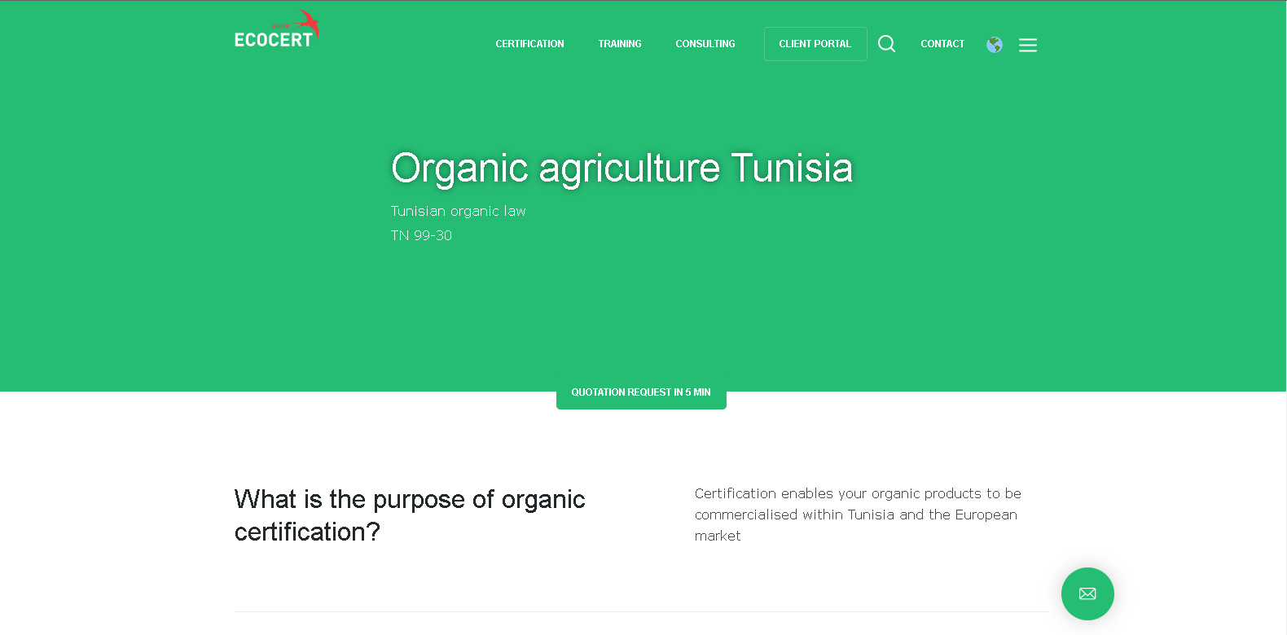

Figure : Ecocert Tunisia

Link : https://www.ecocert.com

1. Support for local producers:

The implementation of bio market platform holds the potential to address the challenges faced by local pistachio and almond producers in Gafsa. By leveraging the power of collaboration and collective efforts, small farmers with limited land can actively participate in fulfilling larger orders. The platform can facilitate connections and partnerships among these farmers, enabling them to pool their resources, combine their produce, and collectively meet the necessary quantity requirements. This collaborative approach not only ensures that buyers can access the desired volumes of bio products but also opens up new opportunities for small farmers to be part of larger transactions. By supporting these local producers and providing them with a platform to showcase their goods, the bio market platform empowers and uplifts small farmers, enabling them to compete on a larger scale and establish a stronger presence in the market. This symbiotic relationship between the platform and local producers creates a mutually beneficial ecosystem that fosters growth, sustainability, and success for all involved stakeholders in the Gafsa region.

In the innovative bio market platform, when a buyer requests a specific quantity of pistachios or almonds, a collaborative opportunity arises for farmers. Within the platform, a collaboration option is displayed, inviting farmers to join by indicating the available quantity they can contribute. The platform ensures that farmers cannot offer a quantity exceeding the buyer's requirements, maintaining transparency and efficiency in the collaboration process. Once a farmer adds their available quantity, it becomes a committed contribution that cannot be undone. However, farmers have the flexibility to provide additional quantities beyond their initial commitment if they choose to do so. This collaborative feature not only streamlines the process of meeting buyer demands but also fosters a sense of cooperation among farmers, promoting collective growth and a more cohesive agricultural community. By leveraging the power of collaboration, the bio market platform creates a dynamic ecosystem that empowers farmers and enables them to efficiently participate in fulfilling orders while meeting the specific needs of buyers.

1. Pickup point limitations:

The bio market platform also incorporates a robust delivery service to further enhance the overall experience for both buyers and farmers. Recognizing the importance of timely and efficient product delivery, the platform integrates a dedicated logistics system that ensures smooth and reliable transportation of bio pistachios and almonds.

Through the platform's delivery service, buyers can conveniently specify their desired delivery location and schedule, allowing them to receive their orders promptly. The platform collaborates with trusted delivery partners who specialize in handling perishable goods and maintaining their quality during transit. This ensures that the bio products reach the buyers in optimal condition, preserving their freshness and nutritional value.

For farmers, the delivery service offers a streamlined approach to shipping their products to buyers. By leveraging the platform's logistics network, farmers can access cost-effective shipping options, eliminating the need to handle the intricacies of transportation themselves. This convenience saves farmers valuable time and resources, allowing them to focus on their core expertise of producing high-quality bio pistachios and almonds.

The delivery service provided by the platform acts as a bridge, connecting farmers and buyers efficiently and securely. It contributes to a seamless and reliable transaction process, promoting trust and confidence between all parties involved. This aspect of the platform eliminates logistical barriers and expands market reach, ensuring that bio pistachios and almonds from Gafsa can reach buyers across Tunisia and beyond.

Overall, the incorporation of a dedicated delivery service within the bio market platform underscores its commitment to facilitating a comprehensive and end-to-end solution. By offering a reliable and efficient logistics network, the platform enables farmers to focus on their agricultural expertise while ensuring that buyers receive their orders in a timely and satisfactory manner.

1. Inconsistent product quality:

In addition to the delivery service, the bio market platform introduces a unique packaging system that enhances traceability and accountability. Each shipment of bio pistachios and almonds is carefully organized into separate boxes, while all the boxes are consolidated within a larger container for convenience.

What sets this packaging system apart is that each individual box represents a farmer's commitment. To ensure transparency and facilitate effective communication, each box is labeled with a QR code that contains the specific farmer's data. In the event that a buyer encounters an issue or wishes to provide feedback about a particular box, they can easily scan the QR code, pinpointing the exact farmer responsible for that specific portion of the order.

By utilizing the QR code system, the buyer can generate a detailed report and submit it directly to the platform's administration. This report will include relevant information about the specific box, allowing the administration to efficiently address the matter with the respective farmer. This approach ensures that any concerns or complaints can be promptly dealt with at the source, enabling appropriate actions to be taken to resolve the issue.

The implementation of this packaging system with individualized QR codes reinforces the platform's commitment to accountability, quality control, and customer satisfaction. It empowers buyers to provide feedback while establishing a direct channel for communication between buyers, farmers, and the platform's administration. This level of traceability fosters trust among all stakeholders and promotes a sense of responsibility and accountability within the bio market ecosystem.

1. User-friendly interface:

The bio market platform will be designed with a user-friendly interface that caters to the needs and preferences of both farmers and buyers. With a focus on simplicity, intuitiveness, and accessibility, the platform ensures a seamless and enjoyable experience for all users.

For farmers, the platform offers an easy-to-navigate interface that allows them to showcase their bio pistachios and almonds effectively. They can create detailed product listings, including information about farming practices, certifications, and quality standards. The platform provides intuitive tools for inventory management, enabling farmers to update product availability, quantities, and pricing effortlessly. Additionally, farmers have access to real-time analytics and sales data, empowering them to make informed decisions regarding their products and pricing strategies.

Buyers, on the other hand, benefit from a user-friendly interface that facilitates smooth and efficient purchasing experiences. The platform offers intuitive search and filtering options, enabling buyers to explore and discover bio pistachios and almonds that meet their specific requirements. Detailed product descriptions, accompanied by high-quality images, provide buyers with a comprehensive understanding of the products they are considering. The platform also integrates secure payment gateways, ensuring a seamless and secure transaction process.

Furthermore, the platform incorporates personalized features to enhance user experiences for both farmers and buyers. Farmers can customize their profiles, farming practices, and values, thereby establishing a stronger connection with potential buyers. Buyers can create personalized accounts, save their preferences, and receive tailored recommendations based on their interests and past purchases.

The user-friendly interface of the bio market platform is designed to minimize complexities, reduce learning curves, and ensure that both farmers and buyers can navigate the platform effortlessly. By prioritizing usability and accessibility, the platform fosters a positive and engaging environment, promoting stronger connections, trust, and long-term relationships between farmers and buyers.

1. Resume:

The bio market platform plays a pivotal role in revolutionizing the bio-agriculture industry by connecting farmers and buyers, providing innovative solutions to their challenges. It enables small farmers in Gafsa to overcome limitations by facilitating collaborations and participating in larger orders, ensuring that buyers can access the required quantities of bio pistachios and almonds. The platform offers a dedicated delivery service, incorporating a unique packaging system with individualized QR codes for enhanced traceability and accountability. With its user-friendly interface, the platform provides an intuitive experience for both farmers and buyers, fostering stronger connections and trust. Overall, the platform's principal role is to empower farmers, expand market reach, and ensure the availability of high-quality bio products while delivering a seamless and enjoyable experience for all users.

Chapter II:

# Requirement Capture

# and

# Specification

In this chapter we will capture functional and non-functional requirements of our platform. Oups that’s all ??? !!!!

1. functional requirements:

Functional requirements refer to the specific features and functions that developers need to incorporate into a product to help users achieve their goals. Clear communication of these requirements is essential for the development team and. Typically, functional requirements describe how a system will behave in specific circumstances.

In the following we will exhibit the functionalities to produce using the platform

### 1) Functionalities of the platform:

- log-in and registration of user (farmer, …)

- Farmers collaborate to achieve customers commands.

- Farmer participate in a collaboration with a specific quantity of a specific product.

- Follow a collaboration status and details. (buyer & farmer)

- Subscribes to newsletter.

- Farmer receives notifications about new collaborations.

- Farmer verifies his bio certification so he can have access to all our features.

- Manage his account (changing cover, profile pictures and personal information...)[Farmer& buyer]

- See his history (buyer, farmer & Admin).

- Chat: buyers can communicate with farmers that committed to their collaboration.

- Buyer Creates a Collaboration by providing the requested quantity of a requested product (pistachio or almond)

- Once collaboration is ready Buyer can track his order’s state.

- Manage feedback messages (Admin).

- Manage Users (Admin)

- Manage dashboard analytics (Admin).

### 2) Actors :

Here are the actors that intervene with the system:

* Farmer
* Buyer
* Admin
* Payment system
* Tracking system

Use cases identification:

* Farmer:
* Authenticate.
* Manage account.
* Chat with buyers.
* Manage history.
* Manage collaborations
* Join collaboration.
* subscribe to newsletter
* Buyer:
* Authenticate.
* Feedback.
* Track the order’s state.
* Get tracking information.
* Chat with farmers.
* subscribe to newsletter.
* Create a collaboration.
* Admin:
* Manage Collaborations.
* Get feedback messages.
* Manage users.
* Tracking system:
* Provide traceability.
* Payment system:

Offer money transactions.

1. Non-functional requirements:

Nonfunctional requirements are a set of criteria that describe how a system should perform, as opposed to what it should do. These requirements may be related to the system's performance, security, usability, or other aspects. For example, a nonfunctional requirement could specify that website pages should load within three seconds, even when there are up to 5,000 simultaneous users. Another nonfunctional requirement could specify that the system should be capable of handling up to 20 million users without any performance degradation. These requirements play a critical role in ensuring that a system meets the needs and expectations of its users.

Here are non-functional requirements of our platform:

* Consumers purchase fresh and bio products directly from the farmers and producers.
* High-quality products: The platform's focus on locally-sourced products means that consumers can access high-quality and fresh products that have been produced using sustainable and ethical practices so it makes sure that products listed on it are have a high-quality.
* Convenience for consumers: The online marketplace allows consumers to easily browse and purchase products from multiple producers in one place, saving them time and effort.
* Support for local producers: The platform helps support local farmers and producers by providing them with a direct channel to market their products to consumers. This can help to promote small-scale and sustainable agriculture and support local economies.
* Community-building: local communities where consumers and producers can connect and build relationships. This can promote a sense of community and social interaction, which can be valuable in promoting healthy and sustainable products practices.
* unlimited product selection: it’s true that our platform will just start with bio pistachio & almond because those are the best bio products that Gafsa can offers but it will provide a larger selection of products in the future.
* Low prices: the fee of using the platform as a farmer will be related to your sells and it will not be large so it will be acceptable.
* independence on local producers: as a start the platform will depend on Gafsa’s pistachio and almond producers but step by step it will be provided by producers from all over the country such as different and variant products.
* unlimited geographical coverage: everyone will be able to use the platform and order products directly from farmers and the strong third-party partner will provide a good delivery service.
* User-friendly interface: the interface will be designed to be user-friendly and intuitive, making it easy for farmers to use and navigate the platform. This can help reduce the learning curve for new users and enable them to start using the platform more quickly.
* Cloud-based platform: it is a cloud-based platform, which means that farmers can access their data from anywhere with an internet connection. This can be particularly useful for farmers who need to monitor their farms remotely or who travel frequently.
* Language support: it will support multiple languages. This could make it easier for farmers in certain areas to use the platform effectively.
* Direct access to local food: it connects consumers directly with local farmers and food producers, allowing them to purchase fresh, healthy, and sustainable products without the need for intermediaries.
* Increased visibility for farmers: By creating a profile, farmers and food producers can increase their visibility and reach a wider audience of potential customers.
* Cost-effective marketing: it provides farmers with a free platform to market their products, reducing the need for expensive advertising and distribution channels.
* Improved profitability: By eliminating intermediaries, farmers can sell their products at a higher price, improving their profitability and enabling them to invest in their businesses.
* Information are securely stocked in the database with a hashed password.
* verification of valid inputs and set user token to local storage

## Use case textual description

**This following template show you how to describe functionalities**

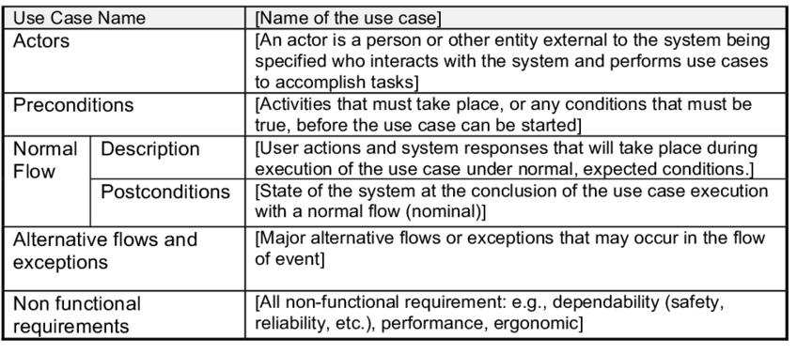

Table : Register Textual Description

|  |  |  |
| --- | --- | --- |
| **Use case name** | | Register |
| **Actors** | | Farmer, Buyer |
| **Pre-conditions** | | Register page is running and user doesn’t exist in the database. |
| **Normal Flow** | **Description** | 1. The user accesses the registration page.  2. The user enters the required information, such as name, email, password, and additional details.  3. The system validates the entered information.  4. If the information is valid, the system creates a new account for the user.  5. The user is logged in automatically.  6. The user is redirected to the main page of the platform. |
| **Post-conditions** | User have an account and logged in. |
| **Alternative Flows and Exceptions** | | 1. Wrong or invalid inputs:  a. If the user enters incorrect or invalid information, an error message is displayed.  b. The "Sign-up" button is disabled until the user corrects the information.  2. User already has an account:  a. If the user's email is already registered, an error message is displayed.  b. The user is redirected to the login page.  2. redirect to login page. |
| **Non functional requirements** | | The entered information is securely stored in the database, and the password is hashed to ensure data security. |

|  |  |  |
| --- | --- | --- |
| **Use case name** | | Login |
| **Actors** | | Buyer, Farmer |
| **Pre-conditions** | | User have an account and not logged in. |
| **Normal Flow** | **Description** | 1. The user accesses the login page.  2. The user enters their email and password.  3. The system validates the entered credentials.  4. If the credentials are valid, the user is logged into their account.  5. The user is redirected to their personalized dashboard or the main page of the platform, depending on their role (farmer or buyer). |
| **Post-conditions** | The user successfully logs into their account and gains access to the platform. |
| **Alternative Flows and Exceptions** | | 1. Incorrect credentials:  a. If the user enters incorrect or invalid credentials, an error message is displayed.  b. The user is prompted to re-enter the correct credentials.  2. Forgotten password:  a. If the user forgets their password, they can click on the "Forgot password" link.  b. The user is redirected to a password recovery page where they can reset their password using their registered email. |
| **Non functional requirements** | | User credentials and sensitive information are securely stored and transmitted using encryption protocols to ensure data privacy and protection. |

|  |  |  |
| --- | --- | --- |
| **Use case name** | | Manage Account |
| **Actors** | | Farmer, Buyer |
| **Pre-conditions** | | The user is logged into their account. |
| **Normal Flow** | **Description** | 1. The user navigates to the account management section within the platform.  2. The user can view and edit their personal information, such as name, email, contact details, and profile picture.  3. The user can update their password or change other account settings.  4. The user can manage their communication preferences, such as opting in or out of notifications or newsletters.  5. The user can view their order history, transaction details, and any relevant activity related to their account.  6. The user can update their profile information, such as adding a bio, specifying farming practices, or showcasing certifications.  7. The user can save and apply changes to their account. |
| **Post-conditions** | The user's account information and preferences are updated and saved successfully. |
| **Alternative Flows and Exceptions** | | 1. Invalid inputs:  a. If the user enters invalid or incorrect information, appropriate error messages are displayed.  b. The user is prompted to correct the information.  2. Profile picture update:  a. The user can upload a new profile picture by selecting an image from their device or providing a URL.  b. The system verifies the image format and size to ensure compatibility.  3. Security measures:  a. The user may be required to re-enter their password or provide additional verification for certain sensitive actions, such as changing the password. |
| **Non functional requirements** | | The platform ensures data privacy and security by storing and transmitting user information using encryption techniques. Changes made to the account settings are reflected in real-time and stored securely in the database. |

|  |  |  |
| --- | --- | --- |
| **Use case name** | | Chat |
| **Actors** | | Buyer, Farmer |
| **Pre-conditions** | | The user is logged into their account and has an active collaboration with farmers. |
| **Normal Flow** | **Description** | 1. The buyer navigates to the chat section within the platform.  2. The buyer can view a list of collaboration farmers they are associated with.  3. The buyer selects a specific farmer from the list to initiate a conversation.  4. The platform opens a chat interface where the buyer can send messages to the selected farmer.  5. The buyer can type and send text messages, ask questions, provide instructions, or discuss specific details related to the collaboration.  6. The farmer receives the messages and can read, respond, and engage in a conversation with the buyer.  7. Both parties can exchange messages, updates, and clarify any concerns or requirements. |
| **Post-conditions** | The buyer and collaboration farmers can communicate effectively through the chat feature. |
| **Alternative Flows and Exceptions** | | 1. Unavailable farmers:  a. If a collaboration farmer is currently unavailable or offline, the buyer may see their status as "offline" or "unreachable."  b. The buyer can leave a message for the farmer, and the farmer can respond when they are available.  2. Message notifications:  a. The platform may provide notifications to inform the buyer about new messages from collaboration farmers.  b. The buyer can opt to receive email or in-platform notifications for message updates.  3. Multimedia messages:  a. The chat interface may support the exchange of multimedia content, such as images or files, allowing the buyer and farmer to share relevant information easily. |
| **Non functional requirements** | | The chat feature ensures real-time communication between the buyer and collaboration farmers. Messages are transmitted securely using encryption protocols to protect sensitive information. The platform provides a user-friendly interface for convenient and efficient messaging, promoting effective collaboration and communication. |

|  |  |  |
| --- | --- | --- |
| **Use case name** | | Subscribe to Newsletter |
| **Actors** | | Buyer, farmer |
| **Pre-conditions** | | The user is logged into their account or has access to the platform's website. |
| **Normal Flow** | **Description** | 1. The user navigates to the newsletter subscription section within the platform or website.  2. The user provides their email address in the designated field.  3. The user confirms their subscription by clicking on the "Subscribe" button.  4. The system validates the email address and adds it to the newsletter subscription list.  5. The user receives a confirmation message or email acknowledging their successful subscription. |
| **Post-conditions** | The user's email address is successfully added to the newsletter subscription list. |
| **Alternative Flows and Exceptions** | | 1. Invalid email address:  a. If the user enters an invalid or incorrectly formatted email address, an error message is displayed.  b. The user is prompted to enter a valid email address.  2. Existing subscription:  a. If the user's email address is already subscribed to the newsletter, a message informs them that they are already subscribed.  b. No duplicate entry is made in the subscription list.  3. Unsubscribe option:  a. The newsletter emails may include an option for the user to unsubscribe from the newsletter.  b. If the user decides to unsubscribe, they can click on the provided link or follow the instructions to opt-out. |
| **Non functional requirements** | | The platform ensures the privacy and security of user information, including email addresses. The newsletter subscription process is designed to be user-friendly and straightforward, minimizing the steps required to subscribe. Users have the option to unsubscribe at any time, and the system promptly processes their request to stop receiving newsletters. |

|  |  |  |
| --- | --- | --- |
| **Use case name** | | Manage Collaboration |
| **Actors** | | Farmer |
| **Pre-conditions** | | The farmer is logged into their account and has access to collaboration details. |
| **Normal Flow** | **Description** | This use case allows farmers to participate in a collaboration by contributing a specific quantity of a product, even if it is less than the required quantity. Collaboration involves farmers working together to achieve the necessary quantity collectively.  1.The farmer navigates to the collaboration management section within the platform.  2.The farmer selects the specific collaboration they want to participate in.  3.The platform displays the collaboration details, including the required product, total quantity, and remaining quantity to be fulfilled.  4.The farmer enters the quantity they can contribute, ensuring it is more than 0 and less than or equal to the remaining quantity.  5.The farmer submits their participation with the specified quantity.  6.The system validates the quantity provided by the farmer, ensuring it meets the necessary criteria.  7.The farmer's contribution is added to the collaboration, and the remaining quantity is updated accordingly.  8.The farmer receives a confirmation message indicating their successful participation in the collaboration. |
| **Post-conditions** | The farmer successfully participates in the collaboration by contributing a specific quantity of the product, contributing to the collective goal of achieving the required quantity. |
| **Alternative Flows and Exceptions** | | 1.Quantity provided is less than required:  a. If the quantity provided by the farmer is less than the required quantity, the system allows the submission as long as it meets the minimum criteria (more than 0 and less than or equal to the remaining quantity).  b. The collaboration continues with the contributed quantity, and the remaining quantity is adjusted accordingly.  2.Farmer wishes to increase their contribution:  a. If the farmer wishes to increase their contribution after the initial submission, they can access the collaboration management section, select the collaboration, and update their contributed quantity.  b. The system validates the new quantity and adjusts the collaboration details accordingly. |
| **Non functional requirements** | | The collaboration management feature enables farmers to collaborate and contribute to achieving the required quantity collectively. The platform ensures a user-friendly interface for easy participation, allowing farmers to provide any quantity above 0 and within the remaining quantity. The system accurately tracks and updates the collaboration details, maintaining transparency and progress monitoring for all participating farmers. |

|  |  |  |
| --- | --- | --- |
| **Use case name** | | Create Collaboration |
| **Actors** | | buyer |
| **Pre-conditions** | | The buyer is logged into their account and has access to the collaboration creation feature. |
| **Normal Flow** | **Description** | 1. The buyer navigates to the collaboration creation section within the platform.  2. The buyer initiates the creation of a new collaboration by clicking on the "Create Collaboration" button.  3. The platform presents a form or interface where the buyer can enter the details of the collaboration.  4. The buyer specifies the product for the collaboration, such as pistachios or almonds, and the desired quantity.  5. The buyer may provide additional information or instructions related to the collaboration, such as quality requirements, delivery preferences, or specific product specifications.  6. The buyer submits the collaboration details for creation.  7. The system validates the entered information and creates a new collaboration with the specified details.  8. The collaboration is added to the list of available collaborations, making it visible to farmers who can participate and fulfill the order. |
| **Post-conditions** |  |
| **Alternative Flows and Exceptions** | |  |
| **Non functional requirements** | |  |

|  |  |  |
| --- | --- | --- |
| **Use case name** | |  |
| **Actors** | |  |
| **Pre-conditions** | |  |
| **Normal Flow** | **Description** |  |
| **Post-conditions** |  |
| **Alternative Flows and Exceptions** | |  |
| **Non functional requirements** | |  |

|  |  |  |
| --- | --- | --- |
| **Use case name** | |  |
| **Actors** | |  |
| **Pre-conditions** | |  |
| **Normal Flow** | **Description** |  |
| **Post-conditions** |  |
| **Alternative Flows and Exceptions** | |  |
| **Non functional requirements** | |  |

|  |  |  |
| --- | --- | --- |
| **Use case name** | |  |
| **Actors** | |  |
| **Pre-conditions** | |  |
| **Normal Flow** | **Description** |  |
| **Post-conditions** |  |
| **Alternative Flows and Exceptions** | |  |
| **Non functional requirements** | |  |

|  |  |  |
| --- | --- | --- |
| **Use case name** | |  |
| **Actors** | |  |
| **Pre-conditions** | |  |
| **Normal Flow** | **Description** |  |
| **Post-conditions** |  |
| **Alternative Flows and Exceptions** | |  |
| **Non functional requirements** | |  |

|  |  |
| --- | --- |
| Title | Manage account |
| Pre-condition | User is logged in, user opening his profile page. |
| Resume | This use case allows user to control his personal information and the content of his profile. |
| Post-condition | User information are up to date. |
| Actors | Farmer, Buyer |

|  |  |
| --- | --- |
| Title | Manage history |
| Pre-condition | User is logged |
| Resume | This use case allows user to go back to his history and get the details about his activities and download them if he wants to. |
| Post-condition | User’s history is downloaded to his device. |
| Actors | Buyer, farmer and admin. |

|  |  |
| --- | --- |
| Title | Chat |
| Pre-condition | User is logged in and buyer joining a farmer’s collaboration. |
| Resume | This use case allows message communication between a buyer and his collaboration farmers. |
| Post-condition | Buyer and farmer having a conversation. |
| Actors | Buyer, Farmer. |

|  |  |
| --- | --- |
| Title | subscribe to newsletter |
| Pre-condition | User is in the index page |
| Resume | This use case allows user to subscribe to the newsletter so he gets all news by email. |
| Post-condition | User is subscribed to newsletter. |
| Actors | Farmer, Buyer. |

|  |  |
| --- | --- |
| Title | manage collaboration |
| Pre-condition | Farmer is logged in and his account is verified. |
| Resume | This use case allows farmer to read a collaboration detail and join it with a specific quantity of a specific product. |
| Post-condition | Farmer joined the collaboration, his profile is added to the list of farmers collaboration and he can now chat with the Buyer. |
| Actors | Farmer |

|  |  |
| --- | --- |
| Title | Make a tender |
| Pre-condition | Buyer is logged in and his account is verified. |
| Resume | This use case allows making a tender that contains details about the order such as how much quantity and witch product. |
| Post-condition | Tender is created and displayed in the farmer’s tenders page. |
| Actors | Buyer |

|  |  |
| --- | --- |
| Title | Track the tender’s state |
| Pre-condition | Tender is created |
| Resume | This use case allows the Buyer to stay up to date with his command so he can follow how many farmers are joining it and how are remaining. |
| Post-condition | The Buyer has the tender’s information and state. |
| Actors | Buyer |

|  |  |
| --- | --- |
| Title | Feedback |
| Pre-condition | User logged in and got an order from a farmers collaboration. |
| Resume | This use case allows the Buyer to send a review message about farmers and their products. |
| Post-condition | Admin gets a the feedback message. |
| Actors | Buyer. |

|  |  |
| --- | --- |
| Title | Get feedback messages |
| Pre-condition | The buyer feeds back a command. |
| Resume | This use case allows admin to manage the Buyers feedbacks about farmers products. |
| Post-condition | Admin decides what to do based on the feedback content. |
| Actors | Admin. |

|  |  |
| --- | --- |
| Title | Block a user |
| Pre-condition | Admin is looged in, select the user to block and clicks block button. |
| Resume | Once admin gets a bad behavior from a farmer or a buyer such as fake orders or fake information, this use case allows him to block him so he can’t anymore use the platform. |
| Post-condition | The blocked user can’ use the platform anymore |
| Actors | admin |

|  |  |
| --- | --- |
| Title | Manage tenders |
| Pre-condition | Admin is logged in and a buyer creates a tender. |
| Resume | Once a buyer creates a tender it’s details are transformed to the admin and he decides to confirm it or not. |
| Post-condition | Admin confirm or cancel the tender. |
| Actors | Admin. |

1. **Architecture (MVVM):**

MVVM (Model-View-View-Model) is an architectural pattern used in software development to separate the user interface (View) from the business logic (Model) and the application logic (View-model). The Model represents the data and the business rules, the View represents the UI components, and the View-model acts as a mediator between the View and the Model, providing data and commands to the View and updating the Model based on user interactions.

One of the main advantages of MVVM is that it allows for a clear separation of concerns, making the code easier to maintain and test. The ViewModel is responsible for implementing the business logic and exposing it to the View, while the View is responsible for displaying the data and handling user input. The Model represents the data and the business rules, which can be tested independently of the View and the ViewModel.

Another advantage of MVVM is that it facilitates the development of large and complex applications, as it provides a clear structure and organization to the code. It also allows for better collaboration among developers, as each component can be developed independently and tested separately.

However, there are also some disadvantages to using MVVM. One of the main drawbacks is that it can increase the complexity of the code, as there are more layers and components to manage. Additionally, it can be more difficult to debug, as there are more moving parts and dependencies between components.

Overall, the MVVM architecture is a popular choice for building modern applications, particularly those that require a high degree of separation between the UI and the business logic. It provides a clear structure and organization to the code, making it easier to maintain and test, and is well-suited for large and complex applications. However, it may not be the best choice for all projects, but it’s going to be a perfect choice in our case.

So, we are going to have a project divided into three big parts:

* View:

The components will represent the user-friendly interface and the more this view is divided into components the more code is better, maintainable, reusable, and testable.

* Model :

The model will contain the business logic, the functions or scripts that runs the different functionalities of the application which have to be also separated as maximum as possible in order to have a clean code with a good quality.

* View-model :

This part is about the application’s functionalities or logic that will control navigation and handling view events.

Chapter III:

Analysis

And

Software Design