GIS and remote sensing for conservation and evolutionary biology
Session 4: computer lab exercise

Aim: To run Maxent niche-based distribution models, and statistically evaluate model output.

The basis for this session’s lab is a tutorial written by Steven Phillips (AT&T Research). The tutorial and Maxent software can be downloaded from:

https://biodiversityinformatics.amnh.org/open_source/maxent/

There’s no need for our purposes to download the example datasets available on the web page.

Steven’s tutorial provides an introduction to the many features of Maxent and you are encouraged to work through as much of the tutorial as possible. However, in this document I pick out the sections you should complete as a minimum requirement for this course. I also briefly outline some additional processes that you will find useful, including how to import your results in to QGIS and explore various thresholds.

The data you have prepared in previous weeks is formatted (almost!) for use with Maxent, so you should use your own case study species instead of the Bradypus example used in Steven’s tutorial.

Part 1: Make a Maxent model

Follow the first pages of the Maxent tutorial, until the section Statistical Analysis, which will guide you through inputting your data and running a model. Note that your tab delimited species file from previous weeks will need to be converted to comma delimited; this can be done in Excel by saving in .csv (‘comma separated values’) format. If you are using a Mac, remember to do this file manipulation within Windows, or use a text editor that allows you to save a .csv file with Windows line endings.
For your environmental layers, use the bioclim layers that you clipped to the appropriate region and convert them to ascii grids (Ascii files are essentially just text files, and can be opened in text editors. Ascii grids are much larger than GTiff files). Drag the layers into QGIS. Then go to Raster > Conversion > Translate (convert format) > Run as Batch process. Add the input and output directories for your rasters. When selecting the output directory change the output format to Arc/Info ASCII GRID(*.asc *.ASC).

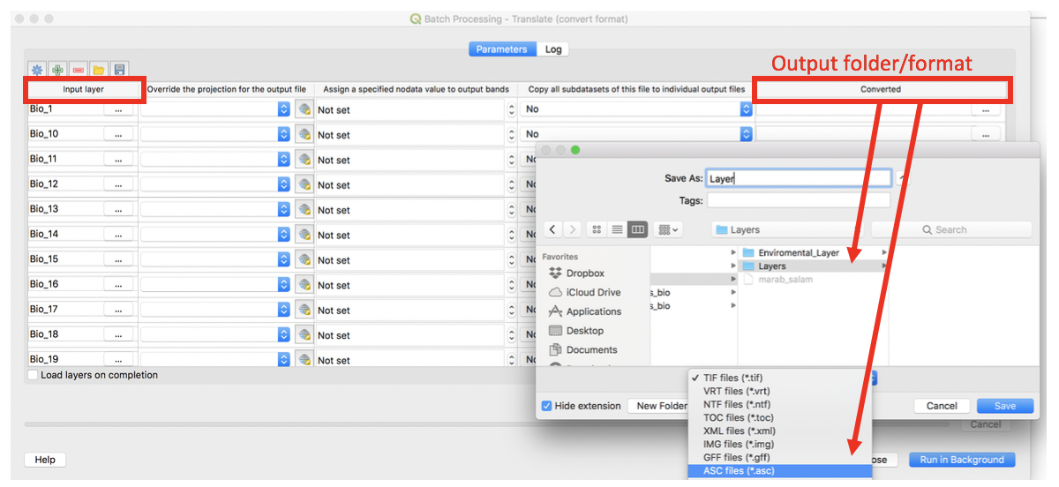

Follow the Maxent tutorial carefully and make sure the headers to your ascii grids are all exactly the same. You can also include categorical variables, such as a land cover classification, but they should also be in ascii grid format with exactly the same header as your other grids.

For our purposes, we will use the logistic output format in Maxent.

Here is the Maxent model using all 19 bioclimate variables from WorldClim for the marbled salamander, which we have used in previous sessions:

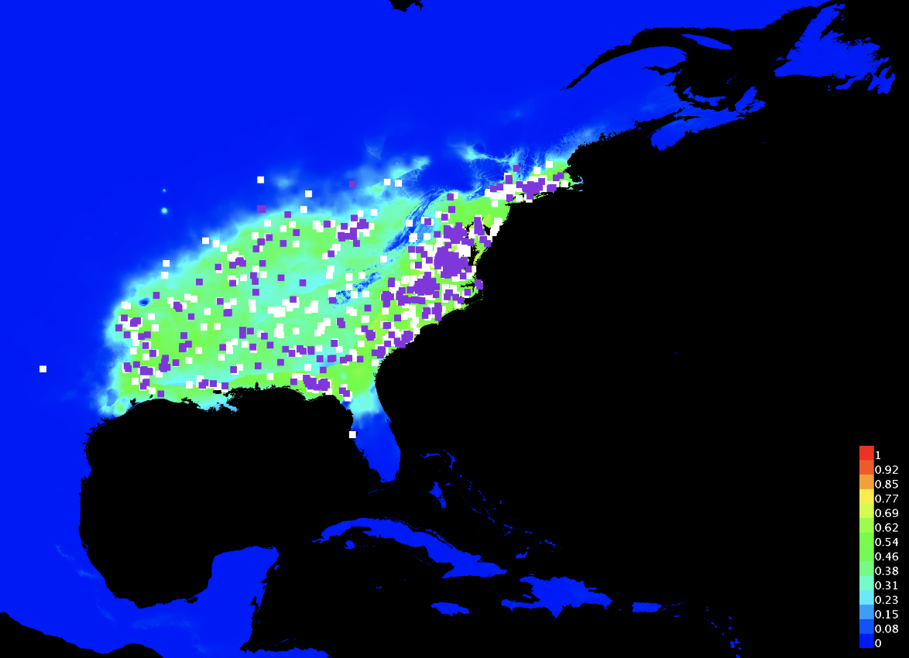
Notice that the software has also created an ASCII grid file in your output directory. This file contains the model results, as plotted in the html file (and as shown above). This ASCII grid file can be imported into GIS for mapping and/or further analysis. In QGIS, you can save these rasters as GTiff or among other formats.

Having made the model, you should next explore the following sections of the tutorial:

Part 2: Statistical analysis of model performance
Note that the lecture in session 5 will detail the statistical tests. Part 2 of this exercise can be completed during session 5.

Follow the next section of the Maxent tutorial: Statistical Analysis (until Which variables matter most?). We are especially interested in the table presenting alternative thresholds and tests of statistical significance, for example:
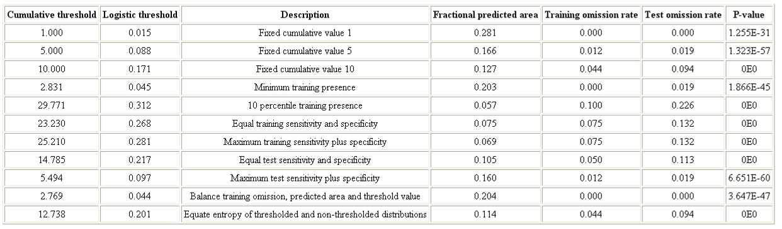

Let’s take the ‘minimum training presence’ threshold (alternatively called ‘lowest presence threshold’) as an example. In the case presented above (for marbled salamander):

- the logistic threshold is 0.045 (this is the lowest predicted value for any of the occurrence records used to ‘train’ the model);
- the proportion of the study area predicted as suitable is 0.203 (i.e. 20.3%);
- the training omission rate is 0 (i.e., none of the training points have a predicted value below the threshold – this will always be the case, since we set the threshold to ensure this!);
- the test omission rate is 0.019 (i.e., 1.9% of the test occurrences were omitted from the prediction).
- The p-value associated with this threshold is statistically significant (p<0.05). This p-value tells us that the chance of randomly omitting only 1.9% of the test points when predicting 20.3% of the study area as suitable is extremely low.

Another threshold to take a look at is the ‘10 percentile training presence,’ which sets the threshold so that 10% of the training localities are omitted. In this case, the model is also significant.

In order to visualize the model results when a threshold is set, we can use the raster calculator. We want to only get the raster pixels above 0.045 (the Logistic threshold of the Minimum training presence). This can be saved as a different raster:

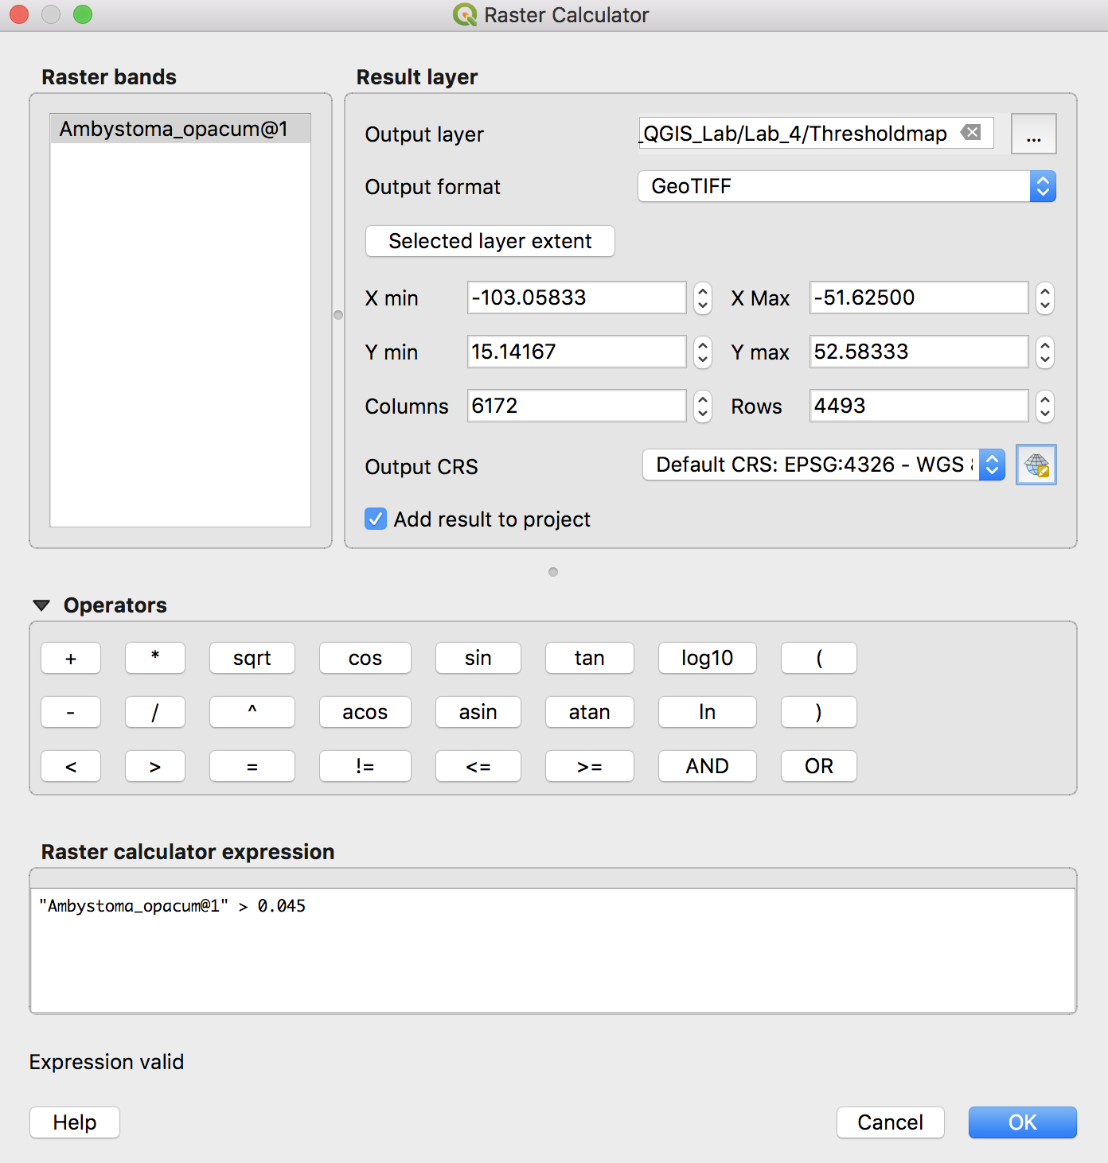

Here I have used the minimum training presence, 0.045. Give your output raster file a name and hit OK (this creates a new raster grid file that is permanent this time – there’s no need to export it):

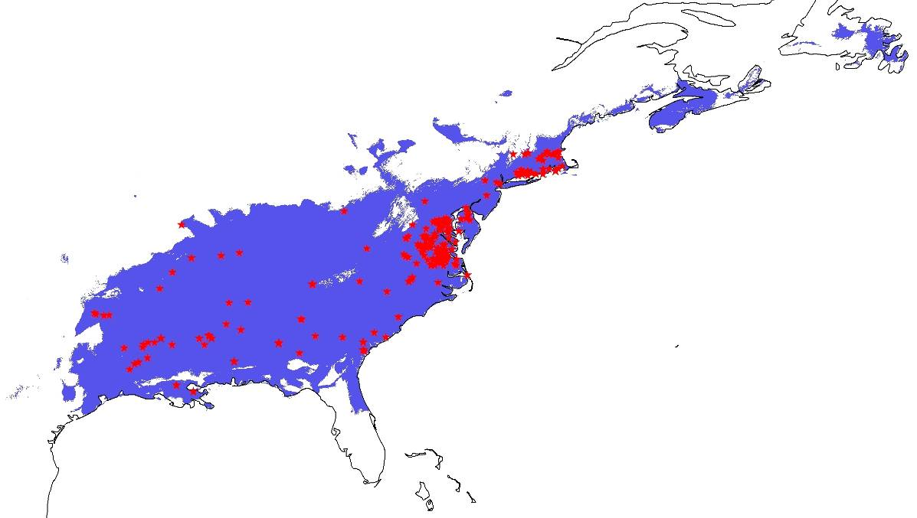

You can experiment creating files with different thresholds and study how the prediction changes. Try to finish with a nice map, as usual!

Some questions you might consider include:
- What threshold makes sense for your study? Do you want a high threshold (smaller predicted area), or a low threshold (larger predicted area)?
- How is the model performance affected by selecting different percentages of test data?

Part 3: Which variables matter most?

This section explains how it is possible to assess which environmental variables are contributing most to the model prediction.

If you check the box for Create response curves, you will get fitted curves of the suitability of your species to each variable. To see which variables were important to creating the model, look at the variable importance tables. For example:

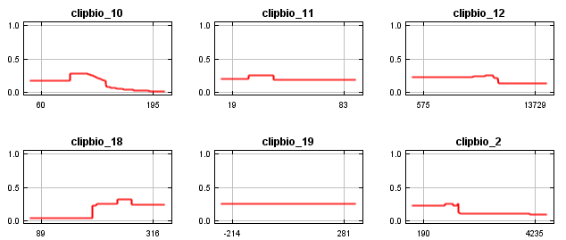
HOWEVER, if you want to see which variables were actually included in your model, you need to look at the lambdas file. This can be opened in a text editor. Interpretation of this file can be found here: https://docs.google.com/viewer?a=v&pid=forums&srcid=MDk5ODk4MTMxNjU4MDYzMDM0NzcBMTcyNTk1MTUxODc1NDE4MDU3ODYBOVlQQlJMNEgyellKATAuMQEBdjI&authuser=0

Part 4: Projecting

Here you can learn how to use Maxent to ‘project’ the model onto another set of environmental layers; for instance, you might want to map niche space in a region that the species is invading, or under a future climate scenario.

