GIS and remote sensing for conservation and evolutionary biology

Aims:

To select small patches of remnant rainforest on freehold or leasehold land in the Daintree River catchment in the Wet Tropics region of Far North Queensland, Australia.

To use simple landscape metrics to determine which patches have the best combination of core area and shape to conserve habitat values.

To use these data to analyse the distribution of rainforest patches in relation to land tenure and make recommendations regarding purchase for nature reserves or development of conservation agreements.

Tasks:

Use select by attribute to select small rainforest patches between 50 and 100 ha from rainforest coverage.
Compile landscape metrics about small patches of rainforest and save these as a spreadsheet.
Produce summary graphs and a map.

Data layers:
coast.shp – Section of coastline including Douglas Shire
daintree_catch.shp – Daintree river catchment
daintree_catchment_landsat.tif – Landsat image for Daintree area from May 22, 2001.
dcdb_clip.shp – cadastral database clipped to catchment boundary
rainforest_clip.shp – rainforest areas clipped from Tracey & Webb vegetation
rivers.shp – Drainage within Douglas Shire
roads.shp – Main roads (only) in Douglas Shire
town.shp – Urban centers within Douglas Shire

Procedure:

- Display all data layers in QGIS (either using the “add data” buttons, or by dragging in the layers- i.e. files with .shp extension). Adjust the Symbology for the individual layer displays to show the categories of vegetation structure “STRUCTURE” for rainforest_clip.shp and land tenure “TENURE” for dcdb_clip.shp (double-click on the layer and go to Style> Change top drop-down box to Categorized > Set Column to STRUCTURE > Click Classify > Click Apply).

- Open the Attribute table for rainforest_clip (right click the layer > Open Attribute Table. Select all rainforest patches between 50 and 100 hectares in area. To do this, Click Select features using an expression . HINT: Use the Boolean “AND” operator – and note that the AREA column in the attribute table is in square meters, not hectares. There is a “Hectares” column. Selected features are highlighted in blue. Save these as a new shapefile called rainforest_clip_Selection. This is done by right clicking the layer that contains the selected features in the Table of Contents (rainforest_clip; on the left) then selecting Save as > Fill out the file path and name; save as rainforest_clip_Selection. Check the box for Save only selected features.

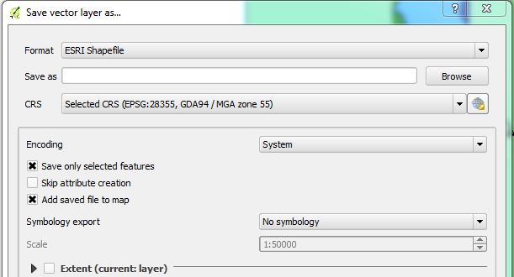

- Use Select features using an expression on the attribute table for dcdb_clip.shp to identify all freehold and leasehold land in the Daintree catchment (tenure categories FH, LL). HINT: use the “OR” Boolean operator. Save this as a new shapefile called freehold_leasehold.shp.
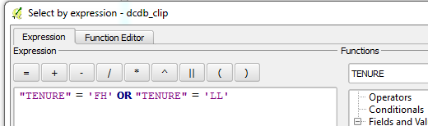

- We want to select forest patches whose centroids (“center of mass”) are located in a freehold or leasehold. This will be a multistep process:

  - To do this, we first need to create a shapefile of the centroid points of all small rainforest patches. Go to Vector > Geometry tools > Polygon centroids. Input the small forest patches layer (rainforest_clip_Selection), and save as RFPatchCentroids.shp.
  - Next use “Select by Location” (Vector > Research tools > Select by location) to select all small rainforest patches that have their center (centroid) in freehold or leasehold land (Select features in RFPatchCentroids that intersect features in freehold_leasehold. Check the box for “intersects”). Save the selection as a new shapefile called rainforest_freeleasePoints.shp. 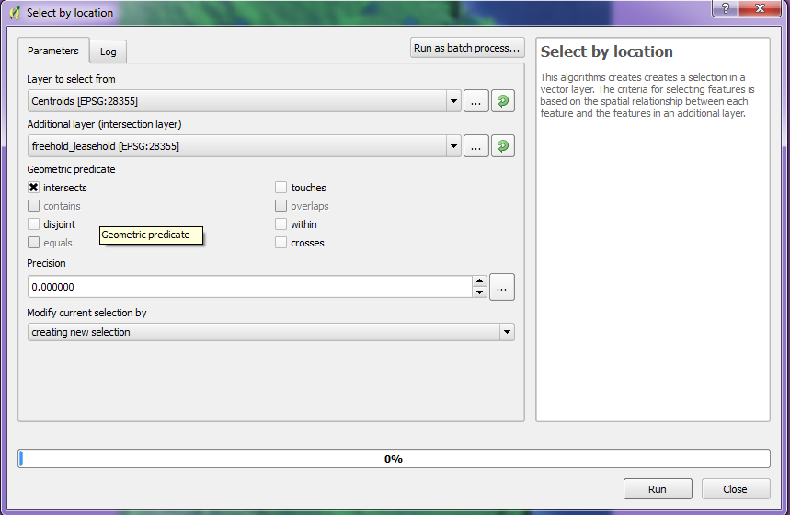
  - In the table of contents, click on rainforest_clip_Selection, then click the button for Select Features by area or single click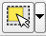. This will allow you to highlight the Rainforest areas whose corresponding centroids are within leaseholds. Holding crtl (command on Mac) on the keyboard, click all of the polygons that correspond with rainforest_freeleasePoints, and create a new shapefile from this selection called “rainforest_freelease”. Hint: You can draw a box encompassing all points and un-highlight the few polygons without centroids in the leaseholds.
  - How many patches of rainforest are there? Using the attribute table, produce a bar chart that shows the area within each structural type in the rainforest. This is most easily done by copying the attribute table and pasting into excel.

- Open the attribute table for rainforest_freelease.shp and go to Toggle editing mode > then New field. Call this column RFP_ID and make the type a text (string) field with a length of four. Create a unique ID for each of these. You will need to turn on the Editor to enter the IDs in the field.

Click each cell under RFP_ID and create a unique ID for each patch (RFP1, RFP2, RFP3…). Since there is only a small selection this manual labelling is easy to do. For longer lists, the shapefile .dbf file can be edited in a spreadsheet program for automated incrementing of unique ID’s. Only fields created within QGIS can be populated in Excel (i.e. you cannot create a new column in Excel and expect that to become a new field when viewed within QGIS). When you are done creating a unique ID for each patch, select “Save Edits”, then stop editing (click the pencil).

- Following the instructions above, add a new field called Shape Index (SI), as Decimal numbers (real) with a length of 10 for simplicity (length = number of total digits and precision = number of decimals). Calculate the shape index using SI = “PERIMETER” / (2 * sqrt (“AREA” )). This will give an index of circularity, with low values indicating near circularity and high values elongated polygons. Save and stop editing.
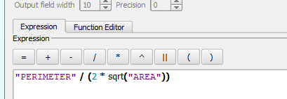

- Now, we want to find the core areas by buffering the inside of these rainforest polygons. This is very easy to do in QGIS. In the table of contents, click on rainforest_freelease, then go to Vector > Geoprocessing tools > Fixed distance buffer. Using rainforest_freelease, add a buffer distance of -50m (negative numbers buffer the inside, positive numbers buffer the outside). NOTE: here, our units are in meters because we are using UTM projections. If the coordinates are in decimal degrees, the buffer must correspond. Save this new file as rainforest_cores.shp.
- We want to calculate an index of the relationship between perimeter and area. Look at the attribute tables for “rainforest_cores” and “rainforest_freelease”. You’ll notice that the values are the same. You will need to create a new column of the updated core area in “rainforest_cores”. This can also be done using the Field calculator. To do so, open the attribute table, click Field Calculator . Click Create a new field, name it Core_area and change the dropdown box to Decimal number (real; default length is fine). In the expression box, enter $area. This will calculate the area (in the map’s measurement units- in this case meters) for each row. Do the same for Core_perimeter using $perimeter (again, this measures in meters). In the next step, we will calculate a ratio of these two measures, therefore the units are inconsequential. Create another attribute field called PA_Index and make it Decimal number (real) with a length of 5. Now calculate the Perimeter/area ratio = Core_perimeter(m)/Core_area(ha), using Field Calculator. Check the box for Update existing field, use the drop-down window to find PA_Index. Then enter the equation and click OK.

- Now add another Field and call it CA_ratio and make it use Decimal numbers. Calculate the ratio of core area to total patch area (CA ratio).
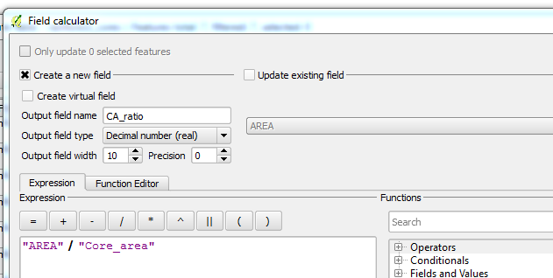

- Using the three shape metrics we have calculated here, identify those patches that have optimal values of CA, SI and PA indices. You may wish to open the attribute tables as .csv files in Excel, and use its plotting capabilities to visualise these data. To do this, right click on the layer, and select Save As…. Change the Format (first dropdown box) to Comma Separated Value [CSV], and save using the layer name. For example “rainforest_cores_attributeTable.csv” to clearly mark this file as the attribute table of that specific shapefile.

Submit the following by next class:

Map of rainforest patches between 50 and 100 ha on leasehold or freehold land in the Daintree catchment, showing structural vegetation types, land tenure and roads.

Bar charts and/or summary table of the area in hectares of each structural type of rainforest in the set identified above.

Graph(s) which display the shape metrics and indicate the best rainforest patches for habitat value.

Recommend two rainforest patches for purchase based on the shape metrics you produced. Why did you select them?

