**Aim:** To locate and view Landsat images and to produce an NDVI image.

**Part 1: Locate a Landsat Scene in Earth Explorer**

All archived Landsat scenes are now available for free download from the USGS. There are USGS tools commonly used for finding and downloading Landsat, commonly Earth Explorer. First, go to Earth Explorer and register to create a free account. <http://earthexplorer.usgs.gov/>

Go to the Earth Explorer website and zoom to an area of interest within the climate extent created last session. Under **Coordinates (Search Criteria)**, click Use Map. This will tell the website that you only want the imagery from this map area. Under **Data Sets**, go to *Landsat > Landsat Collection 1 Level-1* to see available data. L7 SLC-off (2003->) are Landsat 7 scenes collected after a sensor failure in 2003. These scenes are missing data stripes (scan lines), which can be difficult to deal with. I recommend that you select a Landsat 8 product; anything that uses TIRS (Thermal Infrared Sensor).

**Example of SLC-off**

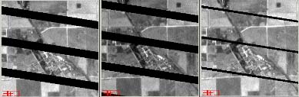

Under **Additional Criteria**, specify that you want images with less than 10% cloud cover (depending on the data available, you may need to relax this number).

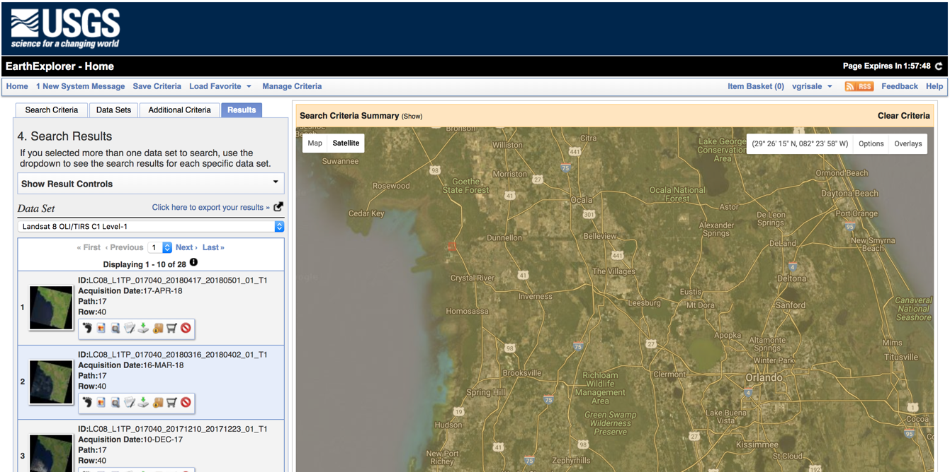

Click **Results**, and you will see many tiles with options. To see each tile, click on “Show Browse Overlay”. When you find a tile with few clouds and good coverage, click **download options** then Download **Level 1 GeoTIFF Data Product**.

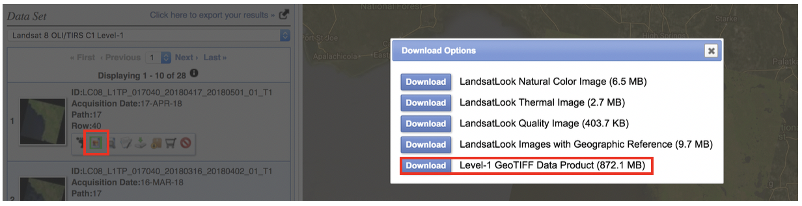

**Part 2: Creating a multi-band GeoTIFF from individual files using QGIS**

While your data is downloading, familiarize yourself with Landsat bands using the Band combination interactive on the Biodiversity Informatics Facility website. <http://biodiversityinformatics.amnh.org/interactives/bandcombination.php>.

1. Select LANDSAT image from the image mode choices. Experiment with band combinations discussed during the lecture. Try Red = 3, Green = 2 and Blue = 1 for a natural color view. Then try 4,3,2 for false color and the 4,5,3 and 7,4,2 color combinations.

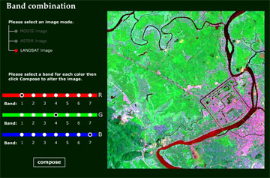

1. When the data has completed downloading, place the file in your project directory on your computer.
2. You will need to unpack the tar.gz file. In windows you can use 7-zip, or this is very easily done in R using the function untar(). This will give a list of rasters and a text file. The rasters represent the various bands available. The bands are named according to this table.

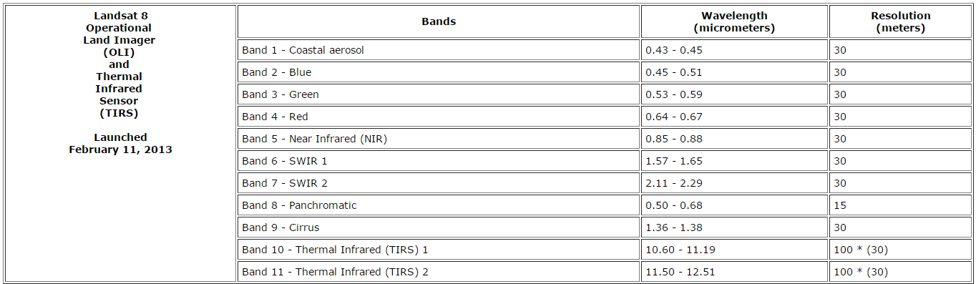

1. Now we need to merge all of these layers into one composite raster with 11 bands. Go to **Raster > Miscellaneous > Merge** and select all bands as input files (i.e. 1-11). Next to **Input files**>**select**>choose the first file, hold shift, choose the last file, and click **Open.** Then name an output file. Click the box for **Place each input file into a separate band**.

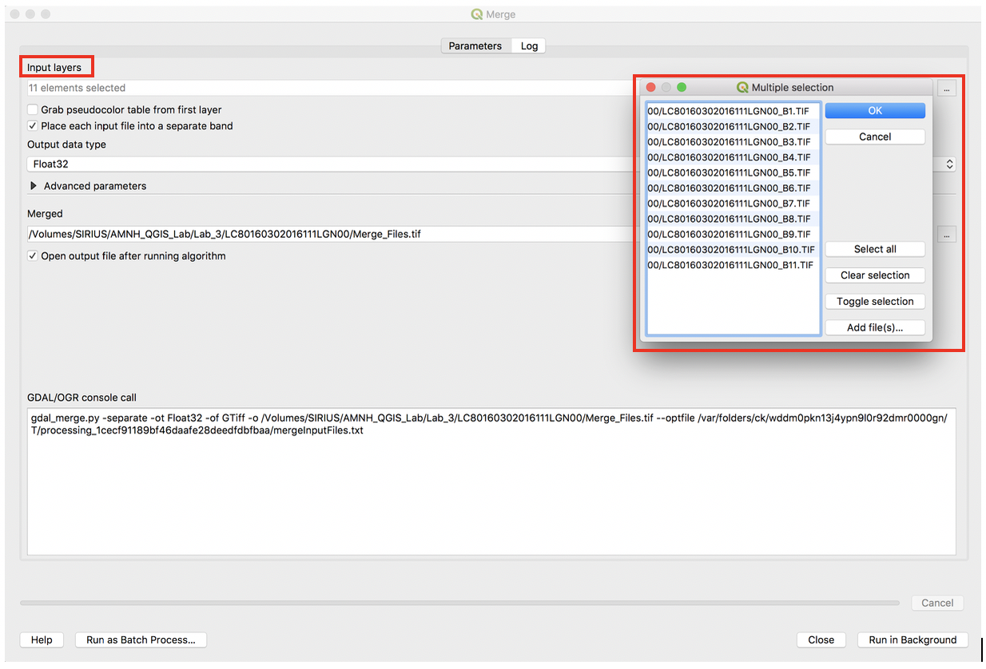

1. The file that has been created can be opened and viewed as a multi-band image in QGIS or other data viewers like R.
2. Practice viewing different RGB combinations of the Landsat bands. In the Table of Contents, right click the composite image and select **properties** or double click the image to pull up the **Layer Properties** dialog. Under Symbology you can assign different bands to display as Red, Green and Blue (Keep Render type as Multiband color). Experiment with different stretches. Also experiment with the Statistics drop-down menu (Min / max values settings).

**Part 3: Create an NDVI image**

As discussed in the lecture, NDVI is a powerful tool for evaluating vegetation.

Add bands 4 and 5 as layers into your map (say no to creating pyramids). These bands will have _B4 (band 4) and _B5 (band 5) at the end of the file name. The individual bands will be displayed as grey scales.

Rename these bands “red” (band 4) and “NIR” (band5) within the map (this will not change the filename on your computer) by right clicking and Rename the band name as displayed under Layers.

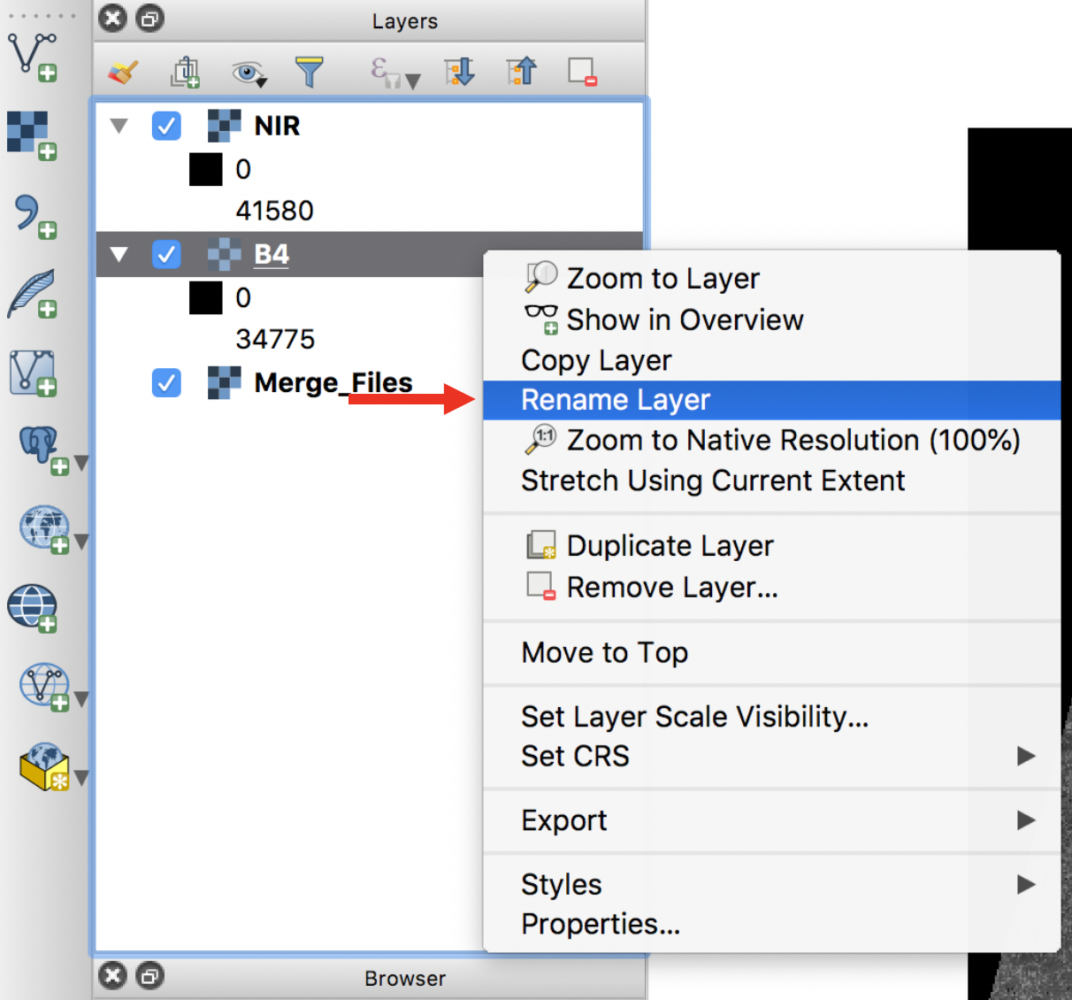

Click on **Raster > Raster calculator**. Notice that this shows you all of the bands in the composite layer, as well as the single bands in Red and NIR. Recall that NDVI is **(NIR – Red)/(NIR + Red)**. Enter this expression into the Raster Calculator ( "NIR@1" - "red@1" ) / ( "NIR@1" + "red@1" ). Save the Output layer as “NDVI.tif”.

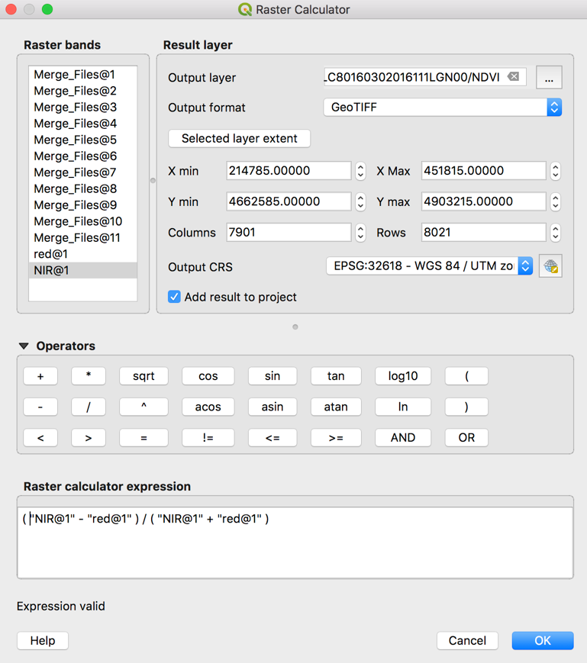

Explore the NDVI file, try displaying it with different colors (such as a rainbow gradient) in order to highlight the vegetation response.

**Note: The Landsat scenes, as received from USGS, require additional radiometric and geometric corrections for data specific analysis purposes. This is beyond the scope of this lab and is not easily done using GIS software. However the products created today are suitable for visual interpretation of ground features.**

