Brushstrokes of Beauty: Masterpieces from the Alte Nationalgalerie, Berlin

Lisa Sommer

2023-07-06

Table of contents

# 1. Part of the series: Baroque TOC

[Programme instructions](https://nfdi4culture.github.io/class-ADA-CP-pipeline/)

2023-07-07 v1.0

The Monk by the Sea (German: Der Mönch am Meer), painted between 1808 and 1810 by Caspar David Friedrich. https://commons.wikimedia.org/wiki/File:Caspar_David_Friedrich_-*Der_M%C3%B6nch_am_Meer*-_Google_Art_Project.jpg This work is in the public domain.

Example publications:

* [Exhibition catalogue demo: toc Baroque /toc](https://nfdi4culture.github.io/experimental-books-workshop/) from Experimental Books – Re-imagining Scholarly Publishing, COPIM. Workshop URL: https://experimentalbooks.pubpub.org/programme-overview
* [Publishers catalogue demo: ScholarLed](https://simonxix.github.io/scholarled_catalogue/) A catalogue of ScholarLed presses built on a Quarto / Jupyter Notebook model for computational publishing. The publication is automatically updated daily to reflect any new books added by the publishers.
* [Proof of concept #1](https://nfdi4culture.github.io/cp4c/) - Computational Publication: Computational Publishing for Collections - ADA CP Prototype #1 - Nov 22
* [Proof of concept #2](https://nfdi4culture.github.io/art_catalogue_test/) - To be confirmed, completion for end of April 2023. This contains all parts fully rendered: Cover, colophon, essay, collection, graph, TIB AV Portal, Semantic Kompakkt
* semanticClimate: To be confirmed - customised research papers readers made for regional climate change action plans based on IPCC reports and sourcing content from open research repositories.
* FSCI Summer School - publishing from collections class: To be confirmed, July 2023

This work is licensed under a Creative Commons Attribution-ShareAlike 4.0 International License.

# 2. Colophon

Fork title: Brushstrokes of Beauty: Masterpieces from the Alte Nationalgalerie, Berlin

Author: Lisa Sommer

ORCID: https://orcid.org/0000-0003-3185-2241

Date: 2023-07-07

DOI: 10.5281/zenodo.8125019

Repository URL: https://github.com/Pgxe9zu1/catalogue-003

# 3. Catalogue Experiment: Baroque AI

Nextcloud Markdown document link: https://tib.eu/cloud/s/qBx8SbqiPBBedye

## 3.1 Part of the series: Baroque TOC

* Class instructions and all links: <https://nfdi4culture.github.io/class-ADA-CP-pipeline/>
* Demo publication: <https://nfdi4culture.github.io/catalogue-003/>
* Repo link: <https://github.com/NFDI4Culture/catalogue-003>

## 3.2 Add your name:

* Lisa Sommer

## 3.3 Text editing

The Alte Nationalgalerie, located in Berlin, Germany, is a renowned art museum that houses an impressive collection of 19th-century artwork. It is situated on Museum Island, a UNESCO World Heritage site, and is one of the five museums that form the Berlin State Museums. The museum’s architecture is a striking combination of neoclassical and Italian Renaissance styles. It was designed by the prominent Prussian architect Friedrich August Stüler and opened its doors to the public in 1876. The building itself is a work of art, with its grand colonnaded entrance and ornate interior spaces.

Inside the Alte Nationalgalerie, visitors can explore a vast array of paintings and sculptures from the 19th century. The collection primarily focuses on German art from the Romantic, Biedermeier, and Impressionist periods, but it also includes notable works from other European artists. One of the highlights of the museum is its extensive collection of paintings by Caspar David Friedrich, a leading figure in German Romanticism. Friedrich’s landscapes, characterized by their sublime and mystical qualities, evoke a sense of awe and introspection. Other prominent artists featured in the Alte Nationalgalerie include Karl Friedrich Schinkel, Adolph Menzel, and Max Liebermann. The museum’s sculpture collection showcases works by renowned artists such as Johann Gottfried Schadow and Reinhold Begas. These sculptures, often depicting mythological figures or historical personalities, demonstrate the technical mastery and artistic sensibilities of the 19th century.

Overall, the Alte Nationalgalerie provides visitors with a unique opportunity to explore the artistic developments and cultural context of 19th-century Germany and Europe. It offers a captivating journey through a transformative era in art history, allowing visitors to appreciate the beauty and significance of the works on display.

-OpenAI. (2023). ChatGPT (May 24 version) [Large language model]. https://chat.openai.com/chat

# 4. Brushstrokes of Beauty: Masterpieces from the Alte Nationalgalerie, Berlin

Title: Dachauerin mit Kind

Wikidata link: <http://www.wikidata.org/entity/Q18689477>

Creator: Wilhelm Leibl

Year: 1873

Material: Paneel

Inventory number: A I 824

Copyright: Gemeinfreiheit

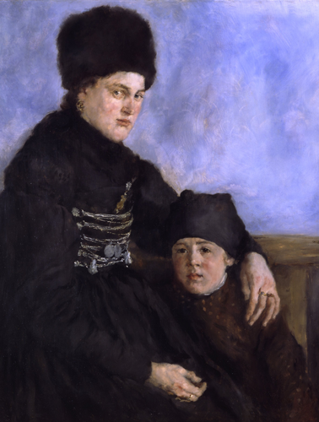

Title: Der Sänger Francisco d’Andrade als Don Giovanni in Mozarts Oper

Wikidata link: <http://www.wikidata.org/entity/Q18688179>

Creator: Max Slevogt

Year: 1912

Material: Leinwand

Inventory number: A II 36

Copyright: Gemeinfreiheit

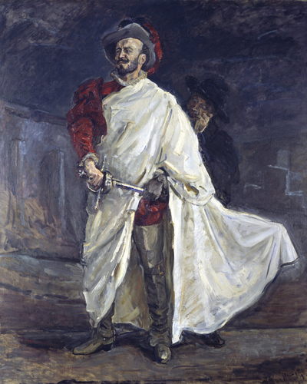

Title: Flachsscheuer in Laren

Wikidata link: <http://www.wikidata.org/entity/Q18688178>

Creator: Max Liebermann

Year: 1887

Material: Leinwand

Inventory number: A I 431

Copyright: Gemeinfreiheit

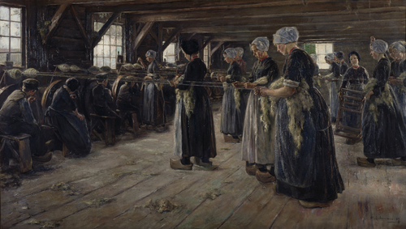

Title: Frau und Söhnchen des Künstlers

Wikidata link: <http://www.wikidata.org/entity/Q18688360>

Creator: Philipp Otto Runge

Year: 1807

Material: Leinwand

Inventory number: A II 755

Copyright: Gemeinfreiheit

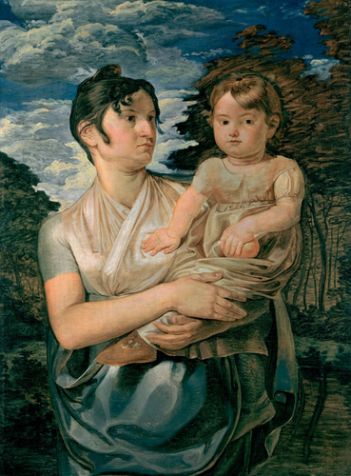

Title: Auf dem Kanapee

Wikidata link: <http://www.wikidata.org/entity/Q18689478>

Creator: Wilhelm Trübner

Year: 1872

Material: Leinwand

Inventory number: A I 645

Copyright: Gemeinfreiheit

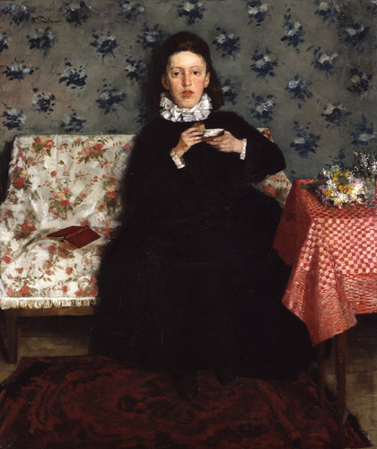

Title: Le Moulin sur la Couleuvre à Pontoise

Wikidata link: <http://www.wikidata.org/entity/Q18688308>

Creator: Paul Cézanne

Year: 1881

Material: Leinwand

Inventory number: A I 606

Copyright: Gemeinfreiheit

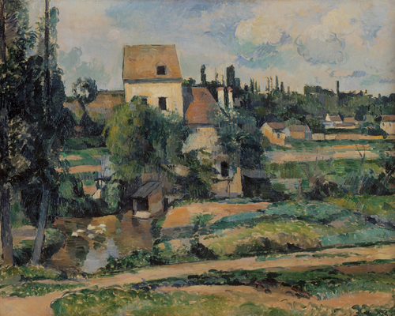

Title: Fleurs dans un pot de gingembre et fruits

Wikidata link: <http://www.wikidata.org/entity/Q18688310>

Creator: Paul Cézanne

Year: 1888

Material: Leinwand

Inventory number: A I 965

Copyright: Gemeinfreiheit

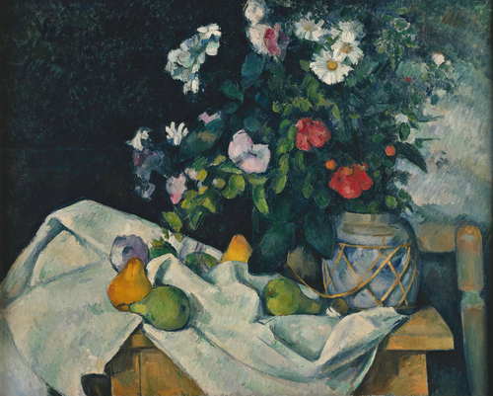

Title: Rosa Straße mit Auto

Wikidata link: <http://www.wikidata.org/entity/Q19883652>

Creator: Ernst Ludwig Kirchner

Year: 1913

Material: Leinwand

Inventory number: A II 318

Copyright: Gemeinfreiheit

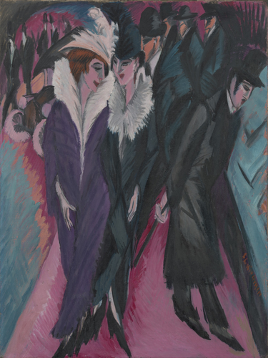

Title: Kreuzgang am Dom zu Halberstadt

Wikidata link: <http://www.wikidata.org/entity/Q19915165>

Creator: Carl Hasenpflug

Year: 1836

Material: Leinwand

Inventory number: W.S. 75

Copyright: Gemeinfreiheit

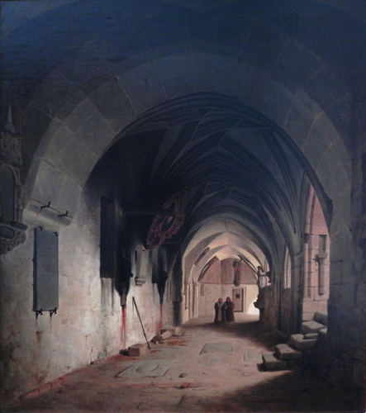

# 5. query link - https://w.wiki/6yhw

import sys  
from SPARQLWrapper import SPARQLWrapper, JSON  
  
  
endpoint_url = "https://query.wikidata.org/sparql"  
  
query = """#defaultView:ImageGrid  
SELECT DISTINCT ?painting ?title ?creator ?creatorLabel ?inceptionyear ?material ?materialLabel ?image ?inventory_number ?inventory_numberLabel ?copyright_status ?copyright_statusLabel WHERE {  
 SERVICE wikibase:label { bd:serviceParam wikibase:language "[AUTO_LANGUAGE],de". }  
 ?painting wdt:P195 wd:Q162111;  
 ((wdt:P31?)/(wdt:P279*)) wd:Q3305213;  
 p:P186 _:b34.  
 _:b34 ps:P186 ?material;  
 pq:P518 wd:Q861259.  
 ?painting wdt:P18 ?image;  
 wdt:P1476 ?title;  
 wdt:P170 ?creator;  
 wdt:P571 ?inception.  
 BIND(YEAR(?inception) AS ?inceptionyear)  
 ?painting wdt:P6216 ?copyright_status;  
 p:P217 _:b35.  
 _:b35 ps:P217 ?inventory_number;  
 pq:P195 wd:Q162111.  
}  
LIMIT 9"""  
  
  
def get_results(endpoint_url, query):  
 user_agent = "WDQS-example Python/%s.%s" % (sys.version_info[0], sys.version_info[1])  
 # TODO adjust user agent; see https://w.wiki/CX6  
 sparql = SPARQLWrapper(endpoint_url, agent=user_agent)  
 sparql.setQuery(query)  
 sparql.setReturnFormat(JSON)  
 return sparql.query().convert()  
  
  
results = get_results(endpoint_url, query)  
  
for result in results["results"]["bindings"]:  
 print(result)

{'painting': {'type': 'uri', 'value': 'http://www.wikidata.org/entity/Q19883652'}, 'creator': {'type': 'uri', 'value': 'http://www.wikidata.org/entity/Q229272'}, 'inventory_number': {'type': 'literal', 'value': 'A II 318'}, 'material': {'type': 'uri', 'value': 'http://www.wikidata.org/entity/Q12321255'}, 'copyright_status': {'type': 'uri', 'value': 'http://www.wikidata.org/entity/Q19652'}, 'creatorLabel': {'xml:lang': 'de', 'type': 'literal', 'value': 'Ernst Ludwig Kirchner'}, 'materialLabel': {'xml:lang': 'de', 'type': 'literal', 'value': 'Leinwand'}, 'inventory_numberLabel': {'type': 'literal', 'value': 'A II 318'}, 'copyright_statusLabel': {'xml:lang': 'de', 'type': 'literal', 'value': 'Gemeinfreiheit'}, 'image': {'type': 'uri', 'value': 'http://commons.wikimedia.org/wiki/Special:FilePath/Ernst%20Ludwig%20Kirchner%2C%201913%2C%20Street%2C%20Berlin%2C%20oil%20on%20canvas%2C%20120.6%20x%2091.1%20cm%2C%20MoMA.jpg'}, 'title': {'xml:lang': 'de', 'type': 'literal', 'value': 'Rosa Straße mit Auto'}, 'inceptionyear': {'datatype': 'http://www.w3.org/2001/XMLSchema#integer', 'type': 'literal', 'value': '1913'}}  
{'painting': {'type': 'uri', 'value': 'http://www.wikidata.org/entity/Q19915165'}, 'creator': {'type': 'uri', 'value': 'http://www.wikidata.org/entity/Q1038608'}, 'inventory_number': {'type': 'literal', 'value': 'W.S. 75'}, 'material': {'type': 'uri', 'value': 'http://www.wikidata.org/entity/Q12321255'}, 'copyright_status': {'type': 'uri', 'value': 'http://www.wikidata.org/entity/Q19652'}, 'creatorLabel': {'xml:lang': 'de', 'type': 'literal', 'value': 'Carl Hasenpflug'}, 'materialLabel': {'xml:lang': 'de', 'type': 'literal', 'value': 'Leinwand'}, 'inventory_numberLabel': {'type': 'literal', 'value': 'W.S. 75'}, 'copyright_statusLabel': {'xml:lang': 'de', 'type': 'literal', 'value': 'Gemeinfreiheit'}, 'image': {'type': 'uri', 'value': 'http://commons.wikimedia.org/wiki/Special:FilePath/Carl%20Georg%20A.%20Hasenpflug%20%281%29Halberstadt.JPG'}, 'title': {'xml:lang': 'de', 'type': 'literal', 'value': 'Kreuzgang am Dom zu Halberstadt'}, 'inceptionyear': {'datatype': 'http://www.w3.org/2001/XMLSchema#integer', 'type': 'literal', 'value': '1836'}}  
{'painting': {'type': 'uri', 'value': 'http://www.wikidata.org/entity/Q18891287'}, 'creator': {'type': 'uri', 'value': 'http://www.wikidata.org/entity/Q41406'}, 'inventory_number': {'type': 'literal', 'value': 'A II 727'}, 'material': {'type': 'uri', 'value': 'http://www.wikidata.org/entity/Q12321255'}, 'copyright_status': {'type': 'uri', 'value': 'http://www.wikidata.org/entity/Q19652'}, 'creatorLabel': {'xml:lang': 'de', 'type': 'literal', 'value': 'Edvard Munch'}, 'materialLabel': {'xml:lang': 'de', 'type': 'literal', 'value': 'Leinwand'}, 'inventory_numberLabel': {'type': 'literal', 'value': 'A II 727'}, 'copyright_statusLabel': {'xml:lang': 'de', 'type': 'literal', 'value': 'Gemeinfreiheit'}, 'image': {'type': 'uri', 'value': 'http://commons.wikimedia.org/wiki/Special:FilePath/Munch%20-%20To%20mennesker.%20De%20ensomme%20%28Reinhardt-frisen%29%2C%201906-07%2C%20G%20358.jpg'}, 'title': {'xml:lang': 'de', 'type': 'literal', 'value': 'Zwei Menschen. Die Einsamen (Reinhardt-Fries)'}, 'inceptionyear': {'datatype': 'http://www.w3.org/2001/XMLSchema#integer', 'type': 'literal', 'value': '1906'}}  
{'painting': {'type': 'uri', 'value': 'http://www.wikidata.org/entity/Q21344996'}, 'creator': {'type': 'uri', 'value': 'http://www.wikidata.org/entity/Q134741'}, 'inventory_number': {'type': 'literal', 'value': 'NG 23/61'}, 'material': {'type': 'uri', 'value': 'http://www.wikidata.org/entity/Q12321255'}, 'copyright_status': {'type': 'uri', 'value': 'http://www.wikidata.org/entity/Q19652'}, 'creatorLabel': {'xml:lang': 'de', 'type': 'literal', 'value': 'Camille Pissarro'}, 'materialLabel': {'xml:lang': 'de', 'type': 'literal', 'value': 'Leinwand'}, 'inventory_numberLabel': {'type': 'literal', 'value': 'NG 23/61'}, 'copyright_statusLabel': {'xml:lang': 'de', 'type': 'literal', 'value': 'Gemeinfreiheit'}, 'image': {'type': 'uri', 'value': 'http://commons.wikimedia.org/wiki/Special:FilePath/1870%20Pissarro%20Louveciennes%20mit%20Mont%20Valerien%20anagoria.JPG'}, 'title': {'xml:lang': 'de', 'type': 'literal', 'value': 'Louveciennes mit dem Mont Valérien im Hintergrund'}, 'inceptionyear': {'datatype': 'http://www.w3.org/2001/XMLSchema#integer', 'type': 'literal', 'value': '1870'}}  
{'painting': {'type': 'uri', 'value': 'http://www.wikidata.org/entity/Q23009065'}, 'creator': {'type': 'uri', 'value': 'http://www.wikidata.org/entity/Q113144'}, 'inventory_number': {'type': 'literal', 'value': 'A I 580'}, 'material': {'type': 'uri', 'value': 'http://www.wikidata.org/entity/Q12321255'}, 'copyright_status': {'type': 'uri', 'value': 'http://www.wikidata.org/entity/Q19652'}, 'creatorLabel': {'xml:lang': 'de', 'type': 'literal', 'value': 'Dora Hitz'}, 'materialLabel': {'xml:lang': 'de', 'type': 'literal', 'value': 'Leinwand'}, 'inventory_numberLabel': {'type': 'literal', 'value': 'A I 580'}, 'copyright_statusLabel': {'xml:lang': 'de', 'type': 'literal', 'value': 'Gemeinfreiheit'}, 'image': {'type': 'uri', 'value': 'http://commons.wikimedia.org/wiki/Special:FilePath/Dora%20Hitz-%20Portrait%20of%20a%20girl%20-%20Gem%C3%A4ldegalerie.jpg'}, 'title': {'xml:lang': 'de', 'type': 'literal', 'value': 'Bildnis eines kleinen Mädchens'}, 'inceptionyear': {'datatype': 'http://www.w3.org/2001/XMLSchema#integer', 'type': 'literal', 'value': '1880'}}  
{'painting': {'type': 'uri', 'value': 'http://www.wikidata.org/entity/Q30005101'}, 'creator': {'type': 'uri', 'value': 'http://www.wikidata.org/entity/Q821537'}, 'inventory_number': {'type': 'literal', 'value': 'A II 829'}, 'material': {'type': 'uri', 'value': 'http://www.wikidata.org/entity/Q12321255'}, 'copyright_status': {'type': 'uri', 'value': 'http://www.wikidata.org/entity/Q19652'}, 'creatorLabel': {'xml:lang': 'de', 'type': 'literal', 'value': 'Carl Friedrich Lessing'}, 'materialLabel': {'xml:lang': 'de', 'type': 'literal', 'value': 'Leinwand'}, 'inventory_numberLabel': {'type': 'literal', 'value': 'A II 829'}, 'copyright_statusLabel': {'xml:lang': 'de', 'type': 'literal', 'value': 'Gemeinfreiheit'}, 'image': {'type': 'uri', 'value': 'http://commons.wikimedia.org/wiki/Special:FilePath/Hussitenpredigt.jpg'}, 'title': {'xml:lang': 'de', 'type': 'literal', 'value': 'Hussitenpredigt'}, 'inceptionyear': {'datatype': 'http://www.w3.org/2001/XMLSchema#integer', 'type': 'literal', 'value': '1836'}}  
{'painting': {'type': 'uri', 'value': 'http://www.wikidata.org/entity/Q41975024'}, 'creator': {'type': 'uri', 'value': 'http://www.wikidata.org/entity/Q1167278'}, 'inventory_number': {'type': 'literal', 'value': 'W.S. 153'}, 'material': {'type': 'uri', 'value': 'http://www.wikidata.org/entity/Q12321255'}, 'copyright_status': {'type': 'uri', 'value': 'http://www.wikidata.org/entity/Q19652'}, 'creatorLabel': {'xml:lang': 'de', 'type': 'literal', 'value': 'Dietrich Monten'}, 'materialLabel': {'xml:lang': 'de', 'type': 'literal', 'value': 'Leinwand'}, 'inventory_numberLabel': {'type': 'literal', 'value': 'W.S. 153'}, 'copyright_statusLabel': {'xml:lang': 'de', 'type': 'literal', 'value': 'Gemeinfreiheit'}, 'image': {'type': 'uri', 'value': 'http://commons.wikimedia.org/wiki/Special:FilePath/Dietrich%20Monten%20Finis%20Poloniae.%20Abschied%20der%20Polen%20von%20ihrem%20Vaterlande%201831.jpg'}, 'title': {'xml:lang': 'de', 'type': 'literal', 'value': 'Finis Poloniae. Abschied der Polen von ihrem Vaterlande 1831'}, 'inceptionyear': {'datatype': 'http://www.w3.org/2001/XMLSchema#integer', 'type': 'literal', 'value': '1832'}}  
{'painting': {'type': 'uri', 'value': 'http://www.wikidata.org/entity/Q48757613'}, 'creator': {'type': 'uri', 'value': 'http://www.wikidata.org/entity/Q668099'}, 'inventory_number': {'type': 'literal', 'value': 'A II 391'}, 'material': {'type': 'uri', 'value': 'http://www.wikidata.org/entity/Q12321255'}, 'copyright_status': {'type': 'uri', 'value': 'http://www.wikidata.org/entity/Q19652'}, 'creatorLabel': {'xml:lang': 'de', 'type': 'literal', 'value': 'Julius Hübner'}, 'materialLabel': {'xml:lang': 'de', 'type': 'literal', 'value': 'Leinwand'}, 'inventory_numberLabel': {'type': 'literal', 'value': 'A II 391'}, 'copyright_statusLabel': {'xml:lang': 'de', 'type': 'literal', 'value': 'Gemeinfreiheit'}, 'image': {'type': 'uri', 'value': 'http://commons.wikimedia.org/wiki/Special:FilePath/Pauline%20H%C3%BCbner%2C%20by%20Julius%20H%C3%BCbner.jpg'}, 'title': {'xml:lang': 'de', 'type': 'literal', 'value': 'Pauline Hübner, geb. Bendemann'}, 'inceptionyear': {'datatype': 'http://www.w3.org/2001/XMLSchema#integer', 'type': 'literal', 'value': '1829'}}  
{'painting': {'type': 'uri', 'value': 'http://www.wikidata.org/entity/Q31188374'}, 'creator': {'type': 'uri', 'value': 'http://www.wikidata.org/entity/Q1190012'}, 'inventory_number': {'type': 'literal', 'value': 'A I 420'}, 'material': {'type': 'uri', 'value': 'http://www.wikidata.org/entity/Q12321255'}, 'copyright_status': {'type': 'uri', 'value': 'http://www.wikidata.org/entity/Q19652'}, 'creatorLabel': {'xml:lang': 'de', 'type': 'literal', 'value': 'Osman Hamdi Bey'}, 'materialLabel': {'xml:lang': 'de', 'type': 'literal', 'value': 'Leinwand'}, 'inventory_numberLabel': {'type': 'literal', 'value': 'A I 420'}, 'copyright_statusLabel': {'xml:lang': 'de', 'type': 'literal', 'value': 'Gemeinfreiheit'}, 'image': {'type': 'uri', 'value': 'http://commons.wikimedia.org/wiki/Special:FilePath/1888%20Bey%20Persischer%20Teppichh%C3%A4ndler%20auf%20der%20Stra%C3%9Fe%20anagoria.JPG'}, 'title': {'xml:lang': 'de', 'type': 'literal', 'value': 'Türkische Straßenszene'}, 'inceptionyear': {'datatype': 'http://www.w3.org/2001/XMLSchema#integer', 'type': 'literal', 'value': '1888'}}

Custom Collection by Lisa Sommer (July 23): Paintings part of the collection of the Alte Nationalgalerie, Berlin https://www.wikidata.org/wiki/Q162111.  
  
The collection Notebook only contains the SPARQL query and needs additional Python adding to parse the metadata output.