**Case Study: Intense rainfall and flash floods in Ecuador on 8th March 2021**

In Ecuador, March was one of the wettest months in 2021. As a result of numerous heavy rainfall events across the whole country rivers such as Guayas, Los Ríos, Esmeraldas, and Manabí burst their banks, and several landslides were observed[1]. March 8th was one of the wettest days, with major impacts resulting in the highly populated city of Guayaquil. Fig. 7 shows flash flood reports (black diamonds) and 24h-hourly rainfall observations for the whole of Ecuador. Rainfall observations are provided as synop rainfall observations (dots) valid for the 24-hourly period ending 9th March at 6 am (local time, available in ECMWF observational database), and as INAMHI rainfall reports for Guayaquil (triangles) that were found reported in local news[2]. In Guayaquil, the heaviest rainfall was mainly concentrated on the afternoon of March, 8th, between 5 pm and 7 pm (local time)[3], with peaks that exceeded 100 mm/24h in the city centre (see zoomed in area in Fig.7, bottom left panel)[4].

Around 8th March the Madden-Julian oscillation was reported by various centres to be in phase 8 (Wheeler and Hendon reference), which tends to be conducive to, or at least correlated with, onshore lower tropospheric westerly wind anomalies near the equatorial west-facing coasts of South America. In conjunction analysts from NOAA had highlighted the likelihood of enhanced convective activity in the region in routine bulletins (web link I sent). Indeed outgoing longwave radiation anomalies documented by the Australian Bureau of Meteorology exhibited a 6-month minimum, for the Jan-Jun period, around that time. On the day, numerical model soundings from around dawn (lower right of Fig. 7) looked particularly conducive to flash flood activity, denoting the very high CAPE (Convective Available Potential Energy) potential once insolation got to work, a sufficiently high dewpoint depression to suggest insolation-based triggering would not be impeded by thick cloud, the potential for very high altitude convective cloud tops, wind shear to favour prolonged convective cell life-cycles (as downdraughts don’t interfere with updraughts), and relatively light steering winds favouring slow movement of those long lived convective cells.

The top panel in Fig. 7 shows the day 1 (first row), day 3 (second row), and day 7 (third row) forecasts for ENS and ecPoint. Besides the wavy behaviour that can be observed in both forecasting systems caused by the difficulty of representing steep slopes in spectral form, ecPoint provides a smoother view of the rainfall totals. This is expected in ecPoint as it is supposed to smooth out the rainfall totals on ENS.

Westerly winds, constant supply of moisture.

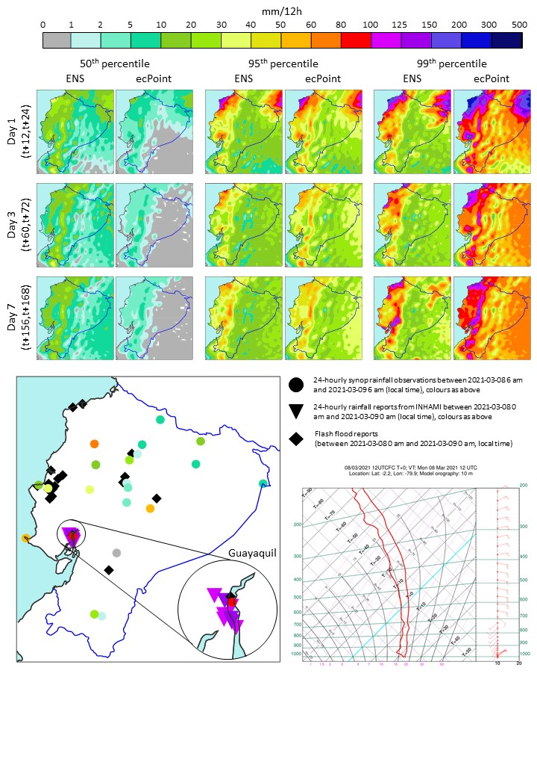

Fig 7 - Flash floods in Ecuador on March 8th 2021. The top section shows the 50th, 95th, and 99th percentiles of the ENS and ecPoint-Rainfall forecasts for day 1, day 3, and day 7 from 00 UTC runs, valid for the period between March 8th 2021 at midday and March 9th 2021 at midnight (when the rainfall was at its peak). The bottom left panel shows the 24-hourly synop rainfall observations (dots), the 24-hourly rainfall reports from INAMHI for Guayaquil (triangles)[5], and the flash flood reports for different locations in the country (diamonds). The bottom right panel shows the sounding for Guayaquil valid for March 8th 2021 at 6 am. All times refer to local time.

1. https://www.pichinchacomunicaciones.com.ec/lluvias-causan-desborde-de-rios-e-inundaciones-en-varias-provincias/
2. https://www.eluniverso.com/guayaquil/comunidad/la-mayor-lluvia-del-2021-en-guayaquil-provoco-afectaciones-en-64-zonas-entre-inundaciones-arboles-caidos-canales-rebosados-y-otros-nota/
3. https://www.wunderground.com/history/daily/ec/guayaquil/SEGU/date/2021-3-8
4. https://www.eluniverso.com/guayaquil/comunidad/la-mayor-lluvia-del-2021-en-guayaquil-provoco-afectaciones-en-64-zonas-entre-inundaciones-arboles-caidos-canales-rebosados-y-otros-nota/
5. https://www.eluniverso.com/guayaquil/comunidad/la-mayor-lluvia-del-2021-en-guayaquil-provoco-afectaciones-en-64-zonas-entre-inundaciones-arboles-caidos-canales-rebosados-y-otros-nota/