Sample Weighting in SPSS

Weighting cases
Within statistics, weighting is used to correct disproportional sample sizes and adjust the collected data to represent the population from which the sample was drawn. For example, we state that the proportion of officials in our sample amounts to 10,5%, while the proportion of officials in the total population only amounts to 8%. With it our sample is not representative, i.e. the frequency distribution of our sample does not match that of the population and estimates for that group may be biased.

Calculating weighting factors
To adjust such distortion within a sample, every case (every asked person) will be assigned a weighting factor, by which the corresponding data is multiplied. This factor is determined by the proportion of the respective group or stratum in the population divided by the proportion of that group or stratum in the sample (the inverse of the sample fraction in each group).weighting factor = % in population / % in sample. In our example with assumed 8% of officials in the population and 10,5% of officials in the sample the weighting factor is calculated 8/10,5 = 0,76 for this group. For the group of "non-offcials" we have a weighting factor of rounded 1,03 (0,92/0,895).
Now we have to create a new frequency variable in SPSS that assigns the calculated values to the corresponding group. This can be easily done with the SPSS Syntax. We open a new syntax window and enter something similar to the following:
IF official=1 weight=0.76 .
IF official=0 weight=1.03 .
EXECUTE .
The existing variable named "official" that indicates the affiliation with this group is used to compute a new variable named "weight" with the calculated weighting factors as values.
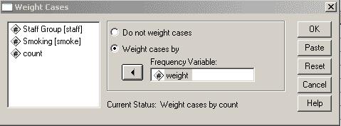

Weighting Cases in SPSS
We now select "Weight Cases" from the "Data" menu und chose the option "Weight cases by", using our new variable "weight" as frequency variable. The adjusted weighting remains valid for all statistic operations, until the option “Do not weight cases” is selected again.

