A Two-Stage Deep Learning Cascade Framework for Robust Papaya Leaf Disease Detection and Classification

Dang Quang Pham
Department of Artificial Intelligence
University of Technology and Education
Ho Chi Minh City, Vietnam
quang.wthz@gmail.com
Quang Sang Le
Department of Artificial Intelligence
University of Technology and Education
Ho Chi Minh City, Vietnam
sangsang.qn.qn.vn@gmail.com
Minh Hieu Vu
Department of Software Engineering
University of Technology and Education
Ho Chi Minh City, Vietnam
23110218@student.hcmute.edu.vn

Abstract— Papaya (Carica papaya) is an economically important tropical crop but is highly susceptible to leaf diseases such as Ring Spot, Leaf Curl, Bacterial Spot, and Anthracnose, which significantly reduce yield. Early detection is essential, yet manual inspection is often inaccurate and time-consuming. This study proposes a two-stage deep learning cascade system for automated papaya leaf disease detection. In Stage 1, YOLOv11 detects and localizes diseased regions from complex backgrounds to extract Regions of Interest (ROIs). In Stage 2, a CNN model performs feature extraction and classifies images into five categories: Healthy, Ring Spot, Curl, Bacterial Spot, and Anthracnose. The system is evaluated on the BDPapayaLeaf dataset, demonstrating improved accuracy by reducing background noise compared to single-stage approaches.
Keywords: Deep Learning, Papaya Leaf Disease Detection, Smart Agriculture

Introduction
Papaya is a nutritious fruit that contains many important nutrients such as fiber, antioxidants, and vitamin C. It is beneficial for human health and is widely grown in many agricultural regions [1]. However, papaya plants are vulnerable to many diseases that can reduce both yield and fruit quality [2]. Common diseases such as anthracnose, bacterial spot, leaf curl, and ring spot can damage the leaves and later affect the fruits. This causes economic losses for farmers and reduces the market value of the crop.
One major problem is that the early symptoms of papaya leaf diseases often look similar to nutrient deficiency symptoms. Because of this, farmers may find it difficult to identify the disease correctly by visual observation alone. In many cases, they still rely on manual inspection and spray pesticides [3]. This process is slow, subjective, and sometimes inaccurate. Excessive or incorrect use of pesticides can also harm the crops, pollute soil and water, and negatively affect human health and the environment.
To address these issues, early and accurate disease detection is very important. In recent years, computer vision and deep learning have become useful tools for automatic plant disease detection [4] [5]. In this study, we propose a papaya leaf disease detection system based on YOLO and CNN. First, YOLO is used to detect diseased regions on papaya leaves. Then, a CNN model is used to classify the detected disease into specific categories. This approach can help improve detection efficiency and support a faster, more practical solution for disease diagnosis in papaya farming.

Theoretical Background And Related Works

Convolutional Neural Networks
CNNs are widely used in computer vision because they can learn visual features directly from raw image pixels instead of relying on manually designed features. This makes them suitable for agricultural image analysis, especially plant leaf disease classification [6].
A typical CNN includes convolutional layers, pooling layers, and classification layers. Convolutional layers extract local patterns such as edges, textures, shapes, and color variations [6]. Pooling layers reduce feature map size and computational cost while retaining important information. The final layers use these learned features to classify the image into target categories. With local connectivity, shared weights, downsampling, and nonlinear activation functions such as ReLU, CNNs can learn complex visual differences and serve as a strong baseline for detecting subtle disease symptoms on plant leaves.

EfficientNet
EfficientNet was developed to improve model accuracy while keeping computational cost efficient. It includes a family of CNN models from B0 to B7, where larger versions generally provide higher accuracy with a moderate increase in parameters [7]. Unlike many traditional CNNs that use ReLU, EfficientNet applies the Swish activation function to support smoother training and improve feature learning.
The main idea of EfficientNet is compound scaling, which scales network depth, width, and input resolution in a balanced way [7]. Instead of increasing only one dimension, EfficientNet uses a compound coefficient to control all three factors together. This design allows the model to achieve strong performance while remaining efficient, making it suitable for plant leaf disease classification tasks:
$$depth: d= α^{φ}$$
$$width: w= β^{φ}$$
$$resolution: r= γ^{φ}$$
where α, β, and γ are constants determined by grid search, and φ is a user-defined coefficient. Here, α controls the scaling of network depth, β controls the scaling of network width, and γ controls the scaling of input image resolution. These coefficients are usually constrained by α ≥ 1, β ≥ 1, and γ ≥ 1.
Another important component of EfficientNet is the use of Mobile Inverted Bottleneck Convolution (MBConv) blocks, which were originally introduced in MobileNetV2. These blocks first expand the number of channels and then project them back to a lower-dimensional space, enabling efficient feature extraction. Additionally, MBConv uses depthwise separable convolution, which reduces computational cost by approximately k² times compared to standard convolution, where k is the kernel size.

YOLO
YOLO, which stands for You Only Look Once, is a deep learning-based object detection framework designed to identify and localize objects in an image using a single forward pass [8] [9]. The main idea of YOLO is to formulate object detection as a regression problem [8] [10]. Instead of scanning an image multiple times or analyzing several proposed regions separately, YOLO directly predicts bounding box coordinates, objectness scores, and class probabilities from the entire input image. The image is divided into a grid, and each grid cell is responsible for detecting objects whose centers fall inside that cell [9]. This design enables YOLO to use global image information, which helps the model understand the overall context of the scene.
In a typical YOLO architecture, the network consists of three main components: the backbone, the neck, and the head [8]. The backbone is responsible for extracting visual features from the input image through a series of convolutional and pooling layers. As shown in the architecture diagram, the input image is gradually downsampled while the number of feature channels increases. This allows the network to learn both low-level features, such as edges and textures, and higher-level semantic features related to object regions.

Related Works
In Vietnam, several studies have demonstrated the potential of image processing, computer vision, and deep learning in agricultural recognition and classification tasks. Recent domestic studies have increasingly adopted deep learning models for agricultural applications. Nguyen Duc Tan and Thai Thuan Thuong investigated the recognition of 41 medicinal plants and herbs in Vietnam using CNN-based models on mobile devices, where EfficientNet-B0 with transfer learning and data augmentation achieved approximately 94% accuracy [11]. Dao Van Thien et al. proposed an automatic fruit-sorting system using YOLOv3 to classify tomato quality on a conveyor belt, achieving about 94% accuracy [12]. Similarly, Nguyen Van Manh et al. applied an improved YOLOv7 model for tomato quality classification, obtaining 93.3% accuracy for normal tomatoes and 89.1% for damaged ones [13]. These studies indicate that CNN- and YOLO-based models are suitable for agricultural classification, quality assessment, and mobile deployment in Vietnam.
Internationally, deep learning has also been widely applied to papaya disease detection and plant health diagnosis. Gani introduced PapayaNet, a CNN-based transfer learning approach for papaya leaf disease recognition [14]. Mustofa et al. developed the BDPapayaLeaf dataset for papaya leaf disease detection and classification in Bangladesh, supporting the evaluation of modern models such as YOLOv8 and Vision Transformer [15]. Sharma et al. compared several transfer learning architectures, including VGG-16, ResNet-50, DenseNet-121, and Inception V4, and showed that pretrained CNNs combined with data augmentation can improve classification performance and reduce overfitting [16]. Hussain et al. proposed a deep CNN model for fruit and vegetable recognition under complex real-world conditions, achieving 96% accuracy across 20 categories [17]. In addition, Moraes et al. proposed a YOLOv7-based papaya disease detector for large-scale disease detection, with potential applications in post-harvest quality control, embedded systems, and smart agriculture [18].
Overall, previous studies confirm that CNN and YOLO based approaches are effective for agricultural image recognition and plant disease detection. However, many existing works mainly focus on either whole-image classification or single-stage object detection. These approaches may still be affected by complex backgrounds, lighting variations, and visually similar disease symptoms. Therefore, this study proposes a two-stage cascade framework that combines YOLOv11m for disease region localization and EfficientNet-B2 for region-based classification, aiming to improve the accuracy of papaya leaf disease classification.

Methodology

System Architecture
This study proposes a two-stage deep learning cascade framework for papaya leaf disease detection and classification. The proposed system combines YOLOv11 and EfficientNet-B2 to improve the accuracy of disease recognition from leaf images. YOLOv11 is used in the first stage to detect and localize suspicious disease regions, while EfficientNet-B2 is used in the second stage to classify the detected regions into specific disease categories.
The main purpose of using a two-stage framework is to reduce the influence of complex backgrounds. In real-world leaf images, the background may include soil, branches, other leaves, or lighting variations. If the whole image is directly passed into a classifier, these irrelevant regions may reduce classification performance. Therefore, YOLOv11 first extracts the important Regions of Interest (ROIs), and EfficientNet-B2 then focuses only on these regions for classification. The proposed system classifies papaya leaf images into five categories: Healthy, Ring Spot, Curl, Bacterial Spot, and Anthracnose. The overall pipeline of the proposed method is shown in Fig. 1.
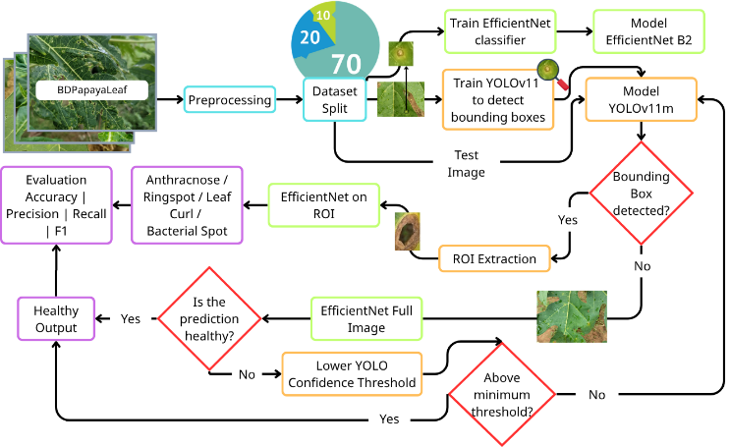
Fig. 1. The overall pipeline of the proposed two-stage framework.

Dataset description, preprocessing, and augmentation
In the first phase, the BDPapayaLeaf dataset was prepared for training and evaluation. The dataset contains papaya leaf images belonging to four disease classes and one healthy class. The disease classes include Ring Spot, Curl, Bacterial Spot, and Anthracnose, while the healthy class contains images of normal papaya leaves.
The dataset was divided into three subsets: training, validation, and testing. The training set was used to train the models, the validation set was used to monitor model performance during training, and the test set was used for final evaluation.
In this study, the dataset was split using a 70:20:10 ratio, where 70% of the data was used for training, 20% for validation, and 10% for testing. This split was applied to both the YOLOv11 detection dataset and the EfficientNet-B2 classification dataset to ensure a consistent evaluation process.
For the YOLOv11 detection stage, the disease images were prepared in YOLO format, including image files and corresponding bounding box annotation files. Each annotation file contains the class label and the normalized coordinates of the diseased region. The healthy images were not assigned bounding boxes because they do not contain visible disease regions.
- Distribution of the YOLOv11 detection dataset.
Class | Total Images | Train | Validation | Test
Anthracnose | 355 | 248 | 53 | 54
Bacterial Spot | 458 | 320 | 69 | 69
Curl | 361 | 253 | 54 | 54
Ring Spot | 533 | 373 | 80 | 80
Total | 1707 | 1194 | 256 | 257

For the EfficientNet-B2 classification stage, the images were prepared as class-based folders. The diseased regions detected by YOLOv11 were cropped and used as input images for the CNN classifier. Healthy images were used as full images because they do not contain bounding box annotations.
- Distribution of the EfficientNet-B2 classification dataset.
Class | Total Images | Train | Validation | Test
Anthracnose | 6502 | 4416 | 1046 | 1040
Bacterial Spot | 458 | 320 | 69 | 69
Curl | 362 | 254 | 54 | 54
Healthy | 228 | 160 | 34 | 34
Ring Spot | 3561 | 2412 | 510 | 639
Total | 11111 | 7562 | 1713 | 1836

After the construction of the EfficientNet-B2 classification dataset, class imbalance was considered during model training. As shown in Table II, the number of samples varies significantly among classes, especially between majority classes such as Anthracnose and Ring Spot and minority classes such as Healthy and Bacterial Spot. To reduce the influence of this imbalance, class-balancing strategies were applied during the CNN training stage. In particular, class-weighted loss was used to assign higher penalty values to minority classes, while oversampling and data augmentation were applied to underrepresented classes to increase their effective training samples. These strategies helped the classifier avoid being biased toward majority classes and improved its ability to learn discriminative features from minority disease categories.
The final evaluation was conducted by using a combined test set for the complete YOLOv11–EfficientNet-B2 cascade framework. Specifically, 257 test images from the YOLO dataset were used for the four disease classes, while 34 additional Healthy images were included for CNN-based classification because healthy leaves do not contain bounding-box annotations. Therefore, the final test set consisted of 291 images and represented the five-class classification task rather than the YOLO detection dataset alone.

Detection phase
In this study, YOLOv11 is selected as the object detection model due to its superior balance between accuracy, efficiency, and real-time performance compared to earlier object detection approaches [9]. Among the YOLO family, YOLOv11 represents the latest advancement, incorporating several architectural improvements over previous versions. One key reason for choosing YOLOv11 is its enhanced feature extraction capability, achieved through newly introduced modules such as the C3k2 block and C2PSA attention mechanism. These components allow the model to capture more discriminative spatial features and focus on important regions in the image, which is particularly beneficial for detecting small or subtle objects such as disease spots on leaves.
In addition, YOLOv11 demonstrates better multi-scale detection performance, which is critical in agricultural datasets where objects (e.g., disease regions) vary in size and shape [19]. Its architecture effectively combines features at different resolutions, improving detection robustness across varying conditions.

ROI Extraction
After YOLOv11 predicts the bounding boxes, the corresponding disease regions are cropped from the original image. Each cropped region is considered a Region of Interest (ROI). This step is important because it removes unnecessary background information and allows the classification model to focus on the disease symptoms.
The extracted ROIs are resized to match the input size required by EfficientNet-B2. If multiple bounding boxes are detected in one image, each region can be classified separately. The final prediction can then be selected based on the highest confidence score or the most relevant detected region.

Classification phase
EfficientNet-B2 was selected as the classification model in this study because it provides an optimal balance between high accuracy, model complexity, and computational efficiency [20]. In the proposed YOLO–CNN pipeline, YOLOv11 is used to detect suspicious disease regions on papaya leaves, and EfficientNet-B2 is then used to classify these cropped regions. Therefore, the classifier needs to possess robust feature extraction capabilities to distinguish subtle and complex disease patterns, while still remaining lightweight enough to train and run efficiently.
The suitability of EfficientNet-B2 for meeting these lightweight operational requirements is clearly demonstrated by its baseline performance metrics. According to the original EfficientNet study by Tan and Le (2019), EfficientNet-B2 achieves a Top-1 accuracy of 80.1% on the ImageNet dataset while requiring only 9.2 million parameters and 1.0 billion FLOPs (Floating Point Operations). When compared to traditional Convolutional Neural Networks with similar accuracy levels, the efficiency of EfficientNet-B2 becomes highly evident. For instance, models like Inception-v4 (80.0% accuracy) and Inception-resnet-v2 (80.1% accuracy) require between 48 and 56 million parameters and 13 billion FLOPs. This means EfficientNet-B2 achieves the same predictive performance while reducing the parameter size by a factor of 5 to 6, and decreasing the computational cost (FLOPs) by 13 times.
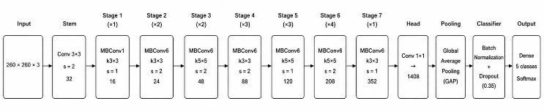
This significant reduction in computational cost without sacrificing accuracy is achieved through the model's unique structural design (see Fig. 2). The architecture of EfficientNet-B2 relies on Mobile Inverted Residual Bottleneck (MBConv) blocks, which are highly efficient convolutional structures inspired by MobileNetV2 [21]. These blocks facilitate the learning of complex visual features while minimizing computational demands.
Fig. 2. EfficientNet B2 Architecture

Evaluation Metrics
The confusion matrix shown in Fig. 3 is used to evaluate the performance of the classification model by comparing the predicted labels with the actual labels.
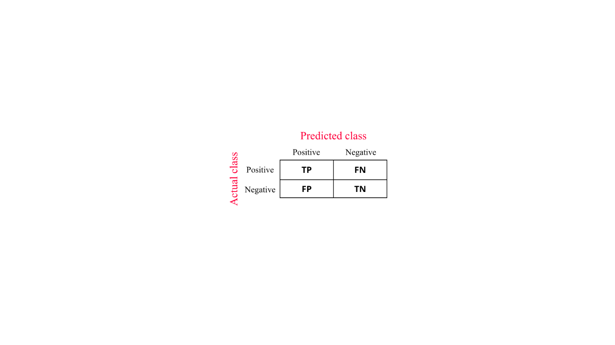
Fig. 3. Confusion Matrix
In the confusion matrix, True Negative (TN) refers to negative samples that are correctly classified as negative. True Positive (TP) represents positive samples that are correctly classified as positive. False Positive (FP) indicates negative samples that are incorrectly predicted as positive, while False Negative (FN) refers to positive samples that are incorrectly classified as negative.
Accuracy measures the overall proportion of correct predictions among all samples. A higher accuracy usually indicates better model performance. However, in imbalanced datasets, accuracy alone may not fully reflect the model’s effectiveness.
$$\text{Accuracy}\text{ = }\frac{TN+ TP}{TP+ TN+ FP+ FN}$$
Precision measures the proportion of correctly predicted positive samples among all samples predicted as positive. A high precision value means that the model produces fewer false positive predictions.
$$Precision= \frac{TP}{TP+ FP}$$
Recall measures the proportion of correctly predicted positive samples among all actual positive samples. A high recall value indicates that the model is effective at detecting positive cases.
$$Recall= \frac{TP}{TP+ FN}$$
F1-score combines precision and recall into a single metric. It provides a balanced evaluation of model performance, especially when there is a trade-off between precision and recall.
$$F1 Score=2 * \frac{Precision*Recall}{Precision+ Recall }$$

Experiments and Results
Before evaluating the complete cascade framework, the YOLOv11m detector was first tested to assess its ability to localize disease regions on papaya leaves. Since the Healthy class does not contain disease regions, it was not included in the detection evaluation. Therefore, the YOLOv11m test set consisted of four disease classes only.
As shown in Table III, YOLOv11m achieved good overall detection performance on the test set. The model performed particularly well on Bacterial Spot and Curl, while lower results were observed for Anthracnose and Ring Spot. This difference may be due to variations in lesion size, irregular disease distribution, and visual similarity between disease symptoms. Overall, the detection results indicate that YOLOv11m can provide useful localized regions for the second-stage EfficientNet-B2 classifier.
- DETECTION PERFORMANCE OF YOLOv11m ON THE TEST SET
Class | Precision | Recall | mAP@0.5 | mAP@0.5:0.95
Anthracnose | 0.578 | 0.621 | 0.515 | 0.319
Bacterial Spot | 0.958 | 1.000 | 0.993 | 0.915
Curl | 0.982 | 1.000 | 0.995 | 0.948
Ring Spot | 0.692 | 0.643 | 0.604 | 0.426
All classes | 0.802 | 0.816 | 0.777 | 0.652

The proposed YOLOv11–EfficientNet-B2 cascade model was evaluated on a test set of 291 images, achieving 276 correct predictions and 15 misclassifications, corresponding to an overall accuracy of approximately 94.85%. This result demonstrates the effectiveness of the proposed two-stage framework in improving classification performance by combining object detection and region-based classification.
In terms of class-wise performance, the model achieved high accuracy across all categories, including Anthracnose (94.44%), Bacterial Spot (94.20%), Curl (98.15%), Healthy (94.12%), and Ring Spot (93.75%). Among these, the Curl class achieved the highest accuracy, indicating that its visual features are more distinctive.
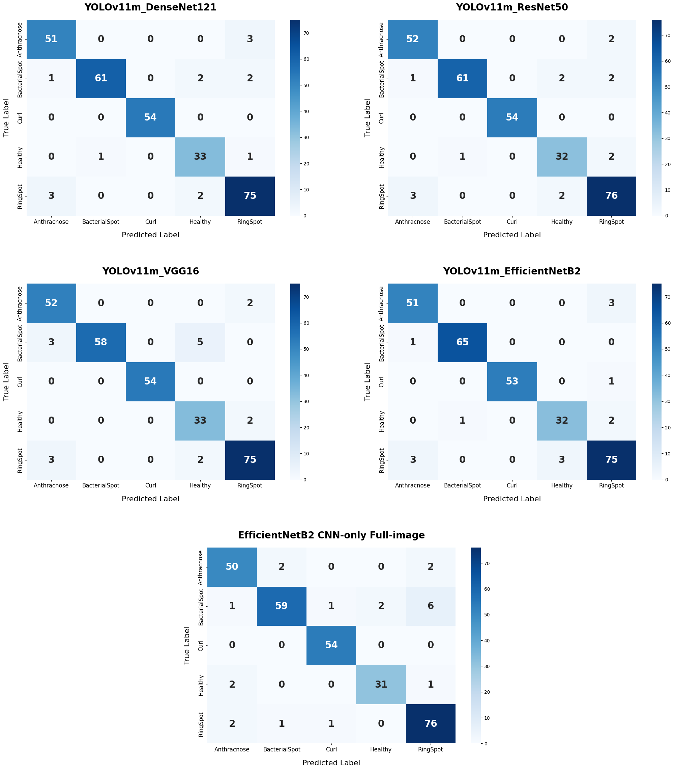
The confusion matrix of the proposed YOLOv11m–EfficientNet-B2 model, presented in Fig. 4, shows that most samples were correctly classified along the diagonal, with only a few misclassifications among visually similar classes. This concentrated diagonal distribution indicates strong classification stability on the tested samples.

Fig. 4. Confusion matrix of the proposed YOLOv11m–EfficientNet-B2 model.
Table IV presents a quantitative performance comparison between the single-stage EfficientNet-B2 model and several YOLOv11m-based cascade models. The single-stage approach achieved a baseline accuracy of 0.9278, macro precision of 0.9317, macro recall of 0.9285, and macro F1-score of 0.9293. While these results are relatively strong, whole-image classification is frequently hindered by complex agricultural backgrounds, such as soil, overlapping branches, and lighting variations. By introducing YOLOv11m as a first-stage disease detector to isolate Regions of Interest (ROIs), all cascade configurations showed noticeable improvements. This confirms that filtering out irrelevant environmental noise helps the classifier function more effectively.
Among the evaluated cascade models, the choice of the CNN backbone significantly influenced the final results. YOLOv11m combined with VGG16 achieved a modest accuracy of 0.9347. More advanced and deeper architectures like DenseNet121 and ResNet50 yielded stronger results, obtaining accuracies of 0.9416 and 0.9450, respectively. However, despite their depth, they were outperformed by the proposed YOLOv11m–EfficientNet-B2 model. This indicates that EfficientNet's compound scaling provides the most optimal feature extraction for analyzing localized disease spots, avoiding the potential overfitting that might occur with heavier networks on small ROIs.
Ultimately, the YOLOv11m–EfficientNet-B2 cascade model achieved the highest overall performance: an accuracy of 0.9485, macro precision of 0.9492, macro recall of 0.9493, and a macro F1-score of 0.9492. The near-identical precision and recall scores demonstrate an exceptional model balance, which is crucial in real-world agriculture to minimize false positive misdiagnoses while ensuring no diseased leaves are missed. Compared to the single-stage baseline, this two-stage framework improved overall accuracy by over 2.0%. By precisely cropping disease lesions first, the classifier can dedicate its computational resources entirely to learning subtle pathological differences, resulting in highly stable, accurate, and reliable diagnostics under experimental conditions.

- Metrics illustrations of proposed models
Algorithm | Accuracy | Macro Precision | Macro Recall | Macro F1-Score
EfficientNet B2 | 0.9278 | 0.9317 | 0.9285 | 0.9293
YOLOv11m + DenseNet121 | 0.9416 | 0.9372 | 0.9473 | 0.9409
YOLOv11m + ResNet50 | 0.9450 | 0.9393 | 0.9476 | 0.9426
YOLOv11m + VGG16 | 0.9347 | 0.9288 | 0.9423 | 0.9328
YOLOv11m + EfficientNet B2 | 0.9485 | 0.9492 | 0.9493 | 0.9492

To further contextualize the obtained results, the proposed model was compared with several existing studies reported in the literature [21]. It should be noted that these studies may differ in terms of dataset size, disease categories, image acquisition conditions, and evaluation protocols; therefore, the comparison should be interpreted as a reference rather than a strictly identical experimental comparison. In a transfer learning study that evaluated models such as VGG16, DenseNet121, and EfficientNet-B0, the highest reported accuracy was about 87.95%. The proposed model achieved higher reported accuracy, which suggests that combining YOLO-based region detection with CNN classification can be beneficial compared with whole-image CNN classification. The proposed method also achieved slightly higher reported accuracy, precision, recall, and F1-score compared with the HASPNet approach, which reported a validation accuracy of 93.87% [22]. Compared with the Darknet-based study, where the F1-scores varied among classes, such as 0.721 for Bacterial Spot and 0.765 for Curl, the proposed model showed more balanced performance across disease categories in the present experiment [23]. Table V presents a comparison between the proposed model and existing models reported in previous studies, indicating that the proposed framework achieves competitive performance and shows potential for robust papaya leaf disease classification.
- Comparison with existing studies
Model | Accuracy (%) | Precision (%) | Recall (%) | F1-score (%)
Darknet53 (Optimized) [23] | 84.78 | 85.86 | 86.90 | 86.00
Proposed ResNet50 [21] | 87.95 | 90.16 | 90.70 | 90.17
HASPNet [22] | 93.87 | 94.00 | 94.00 | 94.00
YOLOv11m + EfficientNet B2 | 94.85 | 94.92 | 94.93 | 94.92
Overall, these results suggest that the proposed cascade framework is a promising and effective approach for papaya leaf disease classification, particularly when disease localization is used to support region-based classification.

Conclusion
This study proposed a two-stage cascade deep learning framework for papaya leaf disease detection and classification by combining YOLOv11 and EfficientNet-B2. The main objective was to improve classification accuracy by first localizing disease regions and then performing region-based classification.
Experimental results demonstrated that the proposed method achieved high performance, with an overall accuracy of approximately 94.85% on the test set. The model showed consistent results across all disease classes and effectively reduced background noise by focusing on Regions of Interest (ROIs). Compared to existing methods, the proposed approach outperformed single-stage CNN models and provided more stable classification results.
However, some challenges still remain. Certain disease classes have similar visual symptoms, such as color changes, spots, or irregular leaf patterns, which may lead to misclassification. In addition, image quality, lighting conditions, complex backgrounds, and different leaf orientations can affect the model’s performance.
In future work, the proposed system can be improved by using a larger and more diverse dataset collected from different environments. Advanced attention mechanisms may also be integrated to help the model focus more effectively on important disease features. Moreover, more robust architectures or ensemble learning methods can be explored to further improve classification accuracy and generalization performance.

Acknowledgment
The authors would like to thank PhD. Bui Manh Quan for the guidance and support throughout this research. We also acknowledge the use of the BDPapayaLeaf dataset and computational resources provided by Google Colab.

References

- B. Koul et al., “Carica papaya L.: A tropical fruit with benefits beyond the tropics,” Diversity, vol. 14, no. 8, p. 683, 2022, doi: 10.3390/d14080683.
- S. Savary, L. Willocquet, S. J. Pethybridge, P. Esker, N. McRoberts, and A. Nelson, “The global burden of pathogens and pests on major food crops,” Nature Ecology & Evolution, vol. 3, no. 3, pp. 430–439, 2019.
- B. Richard, A. Qi, and B. D. Fitt, “Control of crop diseases through integrated crop management to deliver climate-smart farming systems for low- and high-input crop production,” Plant Pathology, vol. 71, no. 1, pp. 187–206, 2022.
- A. Upadhyay, N. S. Chandel, K. P. Singh, S. K. Chakraborty, B. M. Nandede, M. Kumar, et al., “Deep learning and computer vision in plant disease detection: A comprehensive review of techniques, models, and trends in precision agriculture,” Artificial Intelligence Review, vol. 58, no. 3, p. 92, 2025.
- C. G. Simhadri and H. K. Kondaveeti, “Automatic recognition of rice leaf diseases using transfer learning,” Agronomy, vol. 13, no. 4, p. 961, 2023.
- Z. Li, F. Liu, W. Yang, S. Peng, and J. Zhou, “A survey of convolutional neural networks: Analysis, applications, and prospects,” IEEE Transactions on Neural Networks and Learning Systems, vol. 33, no. 12, pp. 6999–7019, 2021.
- Ü. Atila, M. Uçar, K. Akyol, and E. Uçar, “Plant leaf disease classification using EfficientNet deep learning model,” Ecological Informatics, vol. 61, p. 101182, 2021.
- A. Vijayakumar and S. Vairavasundaram, “YOLO-based object detection models: A review and its applications,” Multimedia Tools and Applications, vol. 83, no. 35, pp. 83535–83574, 2024.
- T. Diwan, G. Anirudh, and J. V. Tembhurne, “Object detection using YOLO: Challenges, architectural successors, datasets and applications,” Multimedia Tools and Applications, vol. 82, no. 6, pp. 9243–9275, 2023.
- M. L. Ali and Z. Zhang, “The YOLO framework: A comprehensive review of evolution, applications, and benchmarks in object detection,” Computers, vol. 13, no. 12, p. 336, 2024.
- Đ. T. Nguyễn and T. T. Thái, “Nhận dạng một số loại cây thuốc bằng mô hình Convolutional Neural Network CNN trên ứng dụng di động,” Tạp chí Khoa học Đại học Cần Thơ, vol. 61, no. 2A, pp. 80–89, 2025.
- Đ. V. Thiên et al., “Ứng dụng xử lý ảnh và công nghệ trí tuệ nhân tạo AI trong hệ thống phân loại hoa quả,” Tập san Sinh viên Nghiên cứu Khoa học, Trường Đại học Công nghiệp Hà Nội, vol. 12, pp. 13–18, 2022.
- M. N. Văn, A. Lê Văn, L. T. Đức, T. N. Tuấn, H. N. T. Thanh, T. N. T. Bích, and C. N. Thái, “Nghiên cứu và ứng dụng thuật toán YOLOv7 để phân loại cà chua,” Tạp chí Khoa học Tài nguyên và Môi trường, vol. 50, pp. 102–112, 2024.
- R. Gani et al., “Attention guided convolutional neural network with explainable AI for papaya leaf disease detection in edge and drone agricultural systems,” Scientific Reports, vol. 15, p. 41489, pp. 1–22, 2025.
- S. Mustofa, M. T. Ahad, Y. R. Emon, and A. Sarker, “BDPapayaLeaf: A dataset of papaya leaf for disease detection, classification, and analysis,” Data in Brief, vol. 57, p. 110910, 2024.
- N. Sharma, V. Jain, and A. Mishra, “An analysis of deep learning techniques used for tree leaf disease identification,” Procedia Computer Science, vol. 171, pp. 1507–1516, 2020.
- D. Hussain, I. Hussain, M. Ismail, A. Alabrah, S. S. Ullah, and H. M. Alaghbari, “A simple and efficient deep learning-based framework for automatic fruit recognition,” Computational Intelligence and Neuroscience, vol. 2022, p. 6538117, 2022.
- J. L. De Moraes, J. de Oliveira Neto, C. Badue, T. Oliveira-Santos, and A. F. de Souza, “Yolo-Papaya: A papaya fruit disease detector and classifier using CNNs and convolutional block attention modules,” Electronics, vol. 12, no. 10, p. 2202, 2023.
- R. Khanam and M. Hussain, “YOLOv11: An overview of the key architectural enhancements,” arXiv preprint arXiv:2410.17725, 2024.
- B. Koonce, “EfficientNet,” in Convolutional Neural Networks with Swift for TensorFlow: Image Recognition and Dataset Categorization. Berkeley, CA, USA: Apress, 2021, pp. 109–123.
- A. S. Chaithanya and M. Rachana, “Identification of diseased papaya leaf through transfer learning,” Indian Journal of Science and Technology, vol. 16, no. 48, pp. 4676–4687, 2023.
- M. Sundara Srivathsan, S. Manikandan, S. Preethi, P. R. Lighittha, S. Prithivraj, and S. Mariam, “HASPNet: a hierarchically attentive signal-preserving network for papaya leaf disease classification with explainable deep learning,” Frontiers in Artificial Intelligence, vol. 9, Art. no. 1734865, 2026, doi: 10.3389/frai.2026.1734865.
[23] R. Kılıç and H. K. Sağlam, “A comparative analysis of multi-class and binary papaya leaf classification using optimized Darknet architectures,” International Journal of Innovative Research and Reviews, vol. 9, no. 2, pp. 45–50, 2025.

