|  |
| --- |
|  |
|  |
| **ADMIN User Manual**  **---------------**  Automated Test with the Robot |

|  |
| --- |
| **Admin User Manual** |

Contents

Foreword 3

Working with Proxy 4

Login 6

User Interface 6

User interface for the editing 7

User Interface 7

Control Panel 8

User Interface 8

Workspaces 9

User Interface 9

Workspace Edit 10

Users 11

User Interface 11

User Edit 12

Projects 13

User Interface 13

Project Edit 14

Project/Subproject Interface 15

Project/Subproject Edit 16

Project/User Interface 17

Project/User Edit 18

Project/Parameter Interface 19

Project/ Parameter Edit 20

Upload 21

User Interface 21

AI Robot 22

User Interface 22

Performance 23

User Interface 23

# **Foreword**

This user manual will give you information on how to use the robot as an Administrator.

**Administrator**:

The Administrator manages:

* The workspace (of the customer)
* The users
* The projects/subproject and the assignment of a user into a project
* The documents available for the upload function
* The AI Robot used to train the Robot to recognize element on a screen

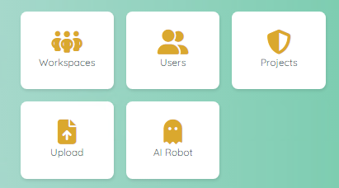

# **Working with Proxy**

If you need to test a project that requires a proxy, please use the following method.

**Job to be performed by the Administrator:**

In the parameters of the project, create a new entry for the parameter Proxy

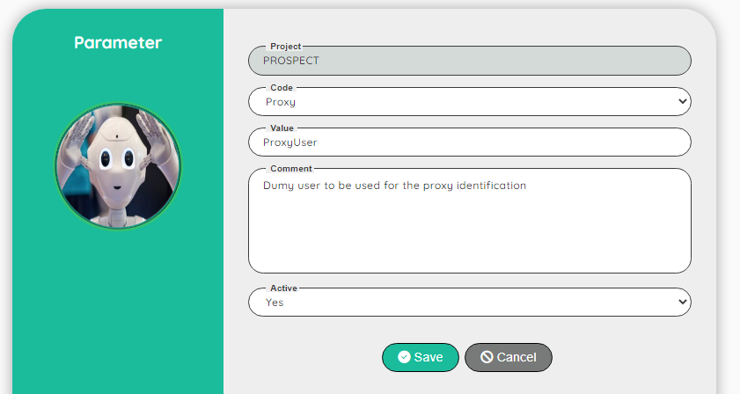

The value must be a valid dummy user

**Job to be performed by the Tester (or Designer, Administrator):**

Go to the dummy users and add a new entry for the value defined in the parameter (here: ProxyUser)

In the field Extra information, fill the proxy link including the port number

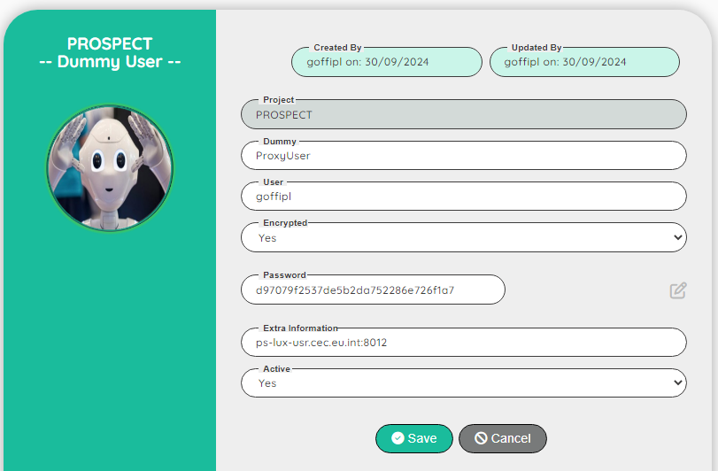

Note: You can encrypt the password

If you don’t need a proxy login, you don’t need to define a specific parameter and dummy user.

If you try to connect to a proxy website without defining the parameter and the dummy user, the application will display a window to ask you to enter a proxy login/password.  
This popup window cannot be manipulated by normal functions!

If you define a proxy, the Robot will be able to login to a normal website or a website with proxy.  
For information: the time to launch the script will be shorter with a proxy defined!

# **Login**

|  |
| --- |
| User Interface |

To access to the Robot, you need to have a login.  
After you successfully register to the application as a new user (Guess), you have to wait that the Administrator will assign you a Role to a project (or multiple projects).

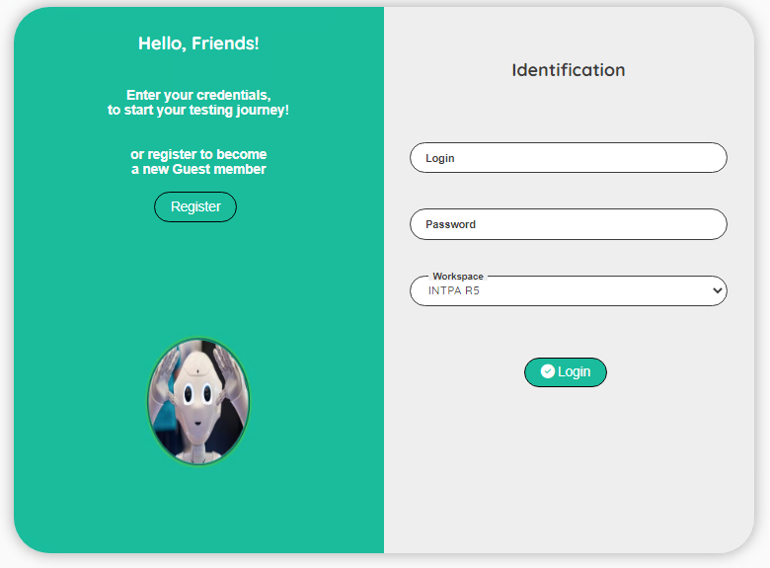

| **Topic** | **Icon** | **Comment** |
| --- | --- | --- |
| Register |  | Click to Register as a new user |
| Login |  | Enter your login |
| Password |  | Enter your password |
| Workspace |  | Enter your workspace |
| Login |  | Click to login to the Robot |

# **User interface for the editing**

|  |
| --- |
| User Interface |

We use the same user interface when editing a record.  
To avoid repeating the same explanation all the time, you will find here a generic explanation on how to use the edit interface.  
When you have the permission to edit a record, you will see the following icons:  


| **Topic** | **Icon** | **Comment** |
| --- | --- | --- |
| Delete | or | Delete a record (a confirmation is required!) To delete multiple records, select the records first. |
| Edit |  | Go to a screen to update the record. |
| Copy |  | First select the record to copy and then click on the copy icon. Record(s) will be set after the copy icon. |
| Move |  | First select the record to move and then click on the move icon. Record(s) will be set after the move icon. |
| Select / Unselect | / | Select or unselect a record |

Depending of the context, some extra icon(s) can be available.  
The extra icon(s) will be explain in the section dedicated to the context.

# **Control Panel**

|  |
| --- |
| User Interface |

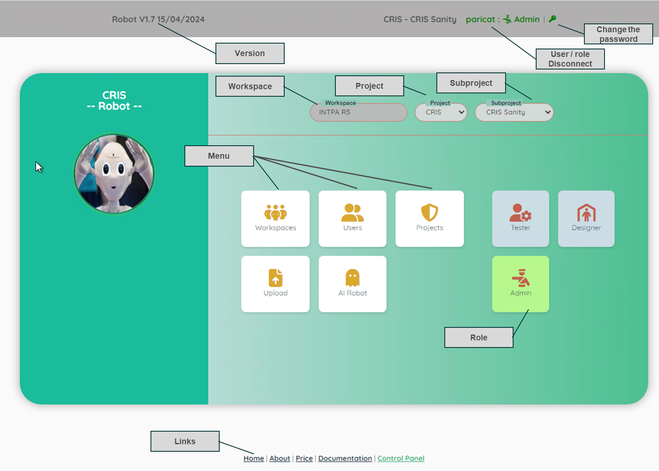

| **Topic** | **Comment** |
| --- | --- |
| Version | Version of the Robot. |
| Workspace | For info: the name of the workspace of the customer. |
| Project | List of the project(s) that you have access (assignment to a project is done by an Administrator). |
| Subproject | Access to all the subproject(s) of the selected project. |
|  | When executing a story, you can stop the execution. |
| User/Role Disconnect | For info: your login and your role. If you click on the ‘User/Role’, you will be disconnected from the application. |
| Change the password | Click on the icon to change your current password |
| Menu | Click on the items to open a new section of the application |
| Role | Click on an icon to change the Role: from ADMIN, DESIGNER or TESTER |
| Links | Useful links |

# **Workspaces**

|  |
| --- |
| User Interface |

The workspace represents the environment of the Customer.

**Warning:** Do not delete your workspace, otherwise all your data will be lost!  
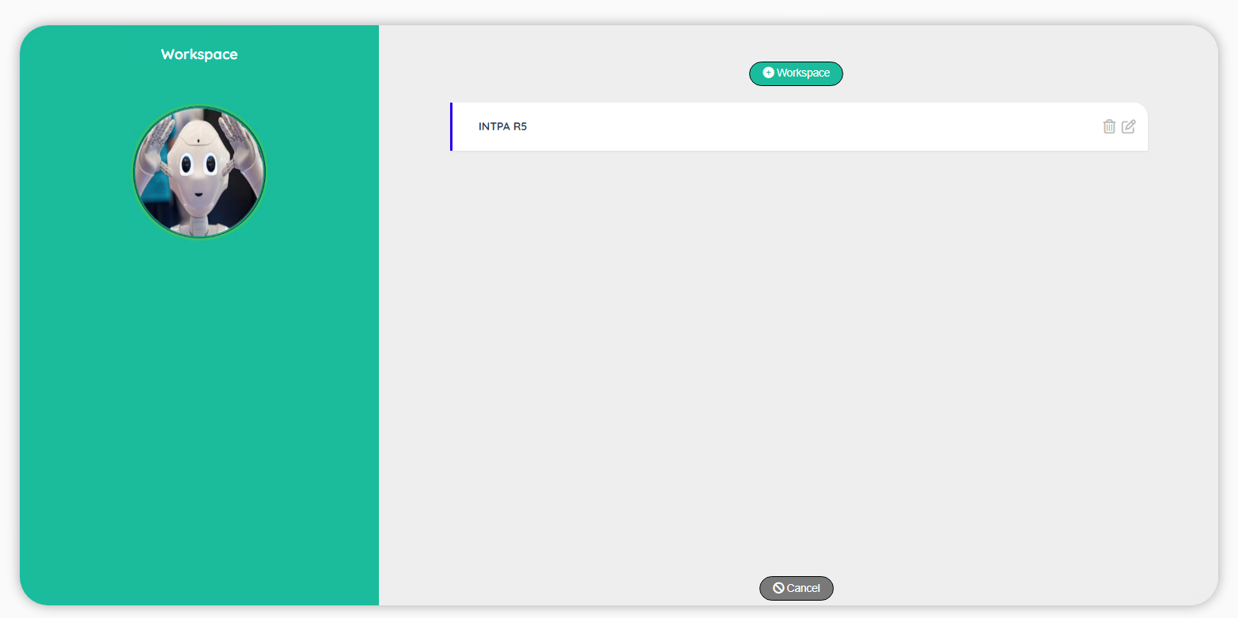

|  |
| --- |
| Workspace Edit |

If you are authorized to edit a workspace, you can access to a screen to edit.

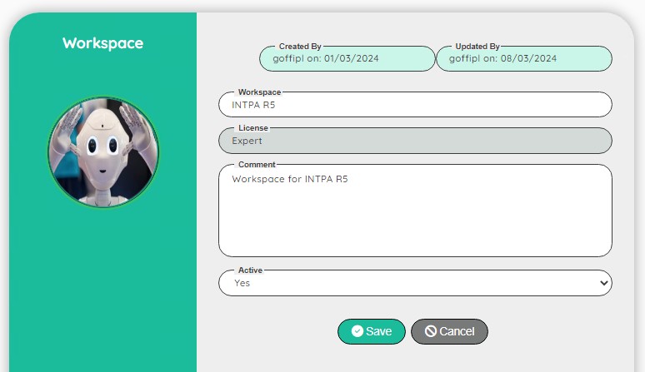

| **Topic** | **Icon** | **Comment** |
| --- | --- | --- |
| Workspace |  | Name of the Workspace |
| License |  | For info: Type of License (from Free to Expert) |
| Comment |  | For info: Comment |
| Active |  | For info: Status of the reference (do not change it) |
| Save |  | Save the edit |
| Cancel |  | Discard the edit |

# **Users**

|  |
| --- |
| User Interface |

The Users screen displays all the registered users.  
You can delete, update or change the password of a user

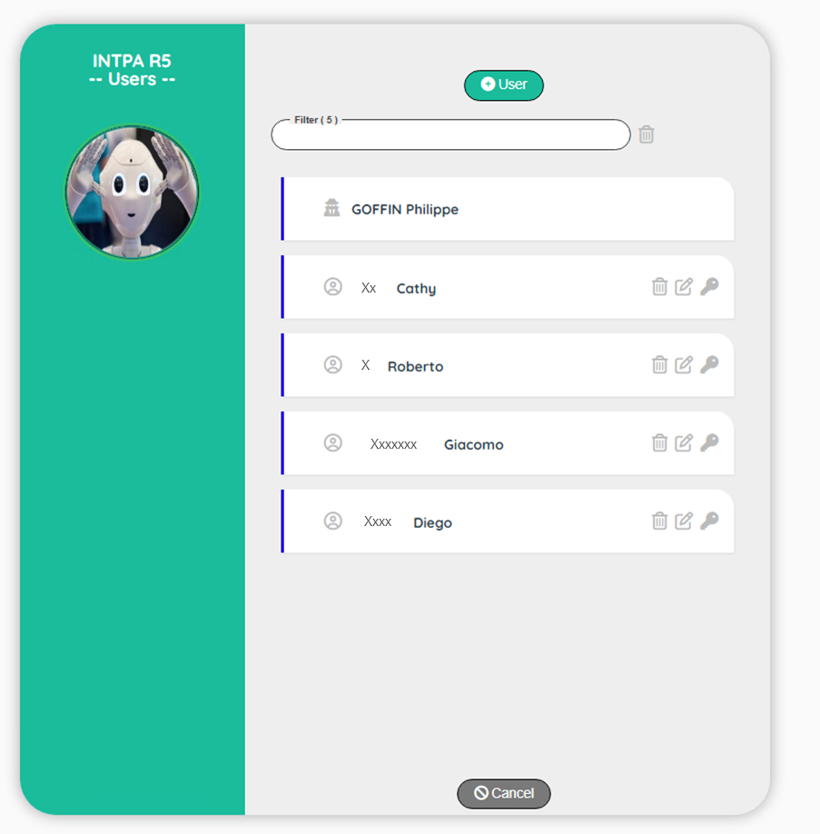

|  |
| --- |
| User Edit |

If you are authorized to edit a user, you can access to a screen to edit.

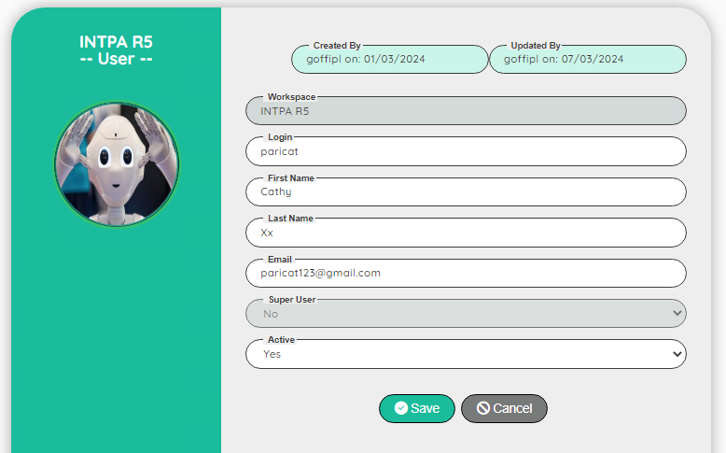

| **Topic** | **Icon** | **Comment** |
| --- | --- | --- |
| Workspace |  | For Info: Name of the Workspace |
| Login |  | Login of the user |
| First name |  | First name of the user |
| Last name |  | Last name of the user |
| Email |  | Email of the user |
| Super User |  | For Info: Default is No |
| Active |  | For info: Status of the reference (do not change it) |
| Save |  | Save the edit |
| Cancel |  | Discard the edit |

# **Projects**

|  |
| --- |
| User Interface |

The Projects interface shows all the projects in your workspace.  
To edit a project, you must be assign as ADMIN of this project.  
In the following figure, the user is ADMIN for CRIS but not for OPSYS.

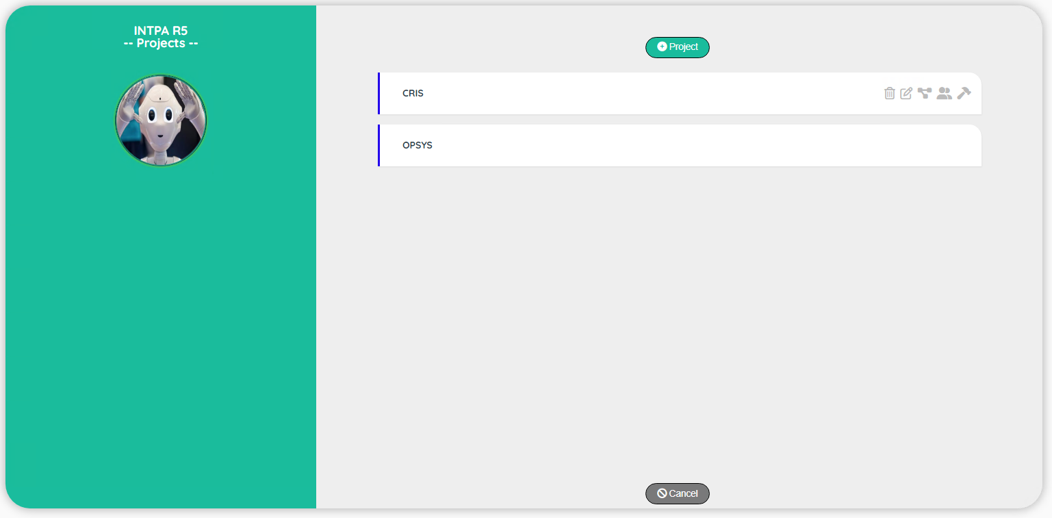

| **Topic** | **Icon** | **Comment** |
| --- | --- | --- |
| Delete |  | Delete a record (a confirmation is required!). |
| Edit |  | Go to a screen to update the record. |
| Subprojects |  | Go to the screen subprojects |
| Users |  | Go to the screen users |
| Parameters |  | Go to the screen Parameters |

|  |
| --- |
| Project Edit |

If you are authorized to edit a project, you can access to a screen to edit.

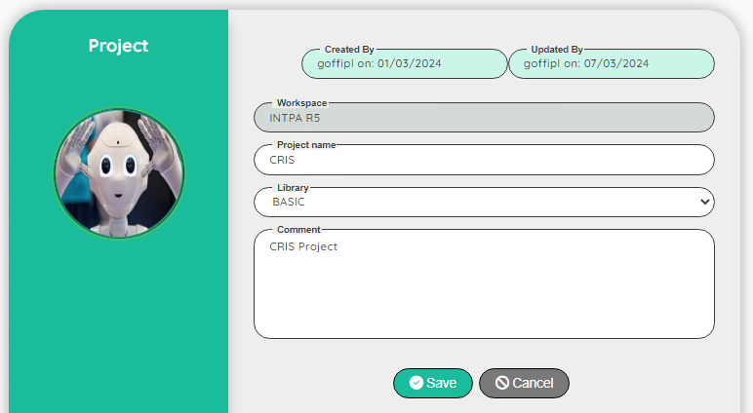

| **Topic** | **Icon** | **Comment** |
| --- | --- | --- |
| Workspace |  | For Info: Name of the Workspace |
| Project name |  | Name of the project |
| Library |  | Obsolete – will be removed soon |
| Comment |  | Comment on the project |
| Save |  | Save the edit |
| Cancel |  | Discard the edit |

|  |
| --- |
| Project/Subproject Interface |

The subproject interface will allow you to manage subprojects.  
A subproject is linked to a project. The idea behind the subproject is to structure the tests in a clear way.

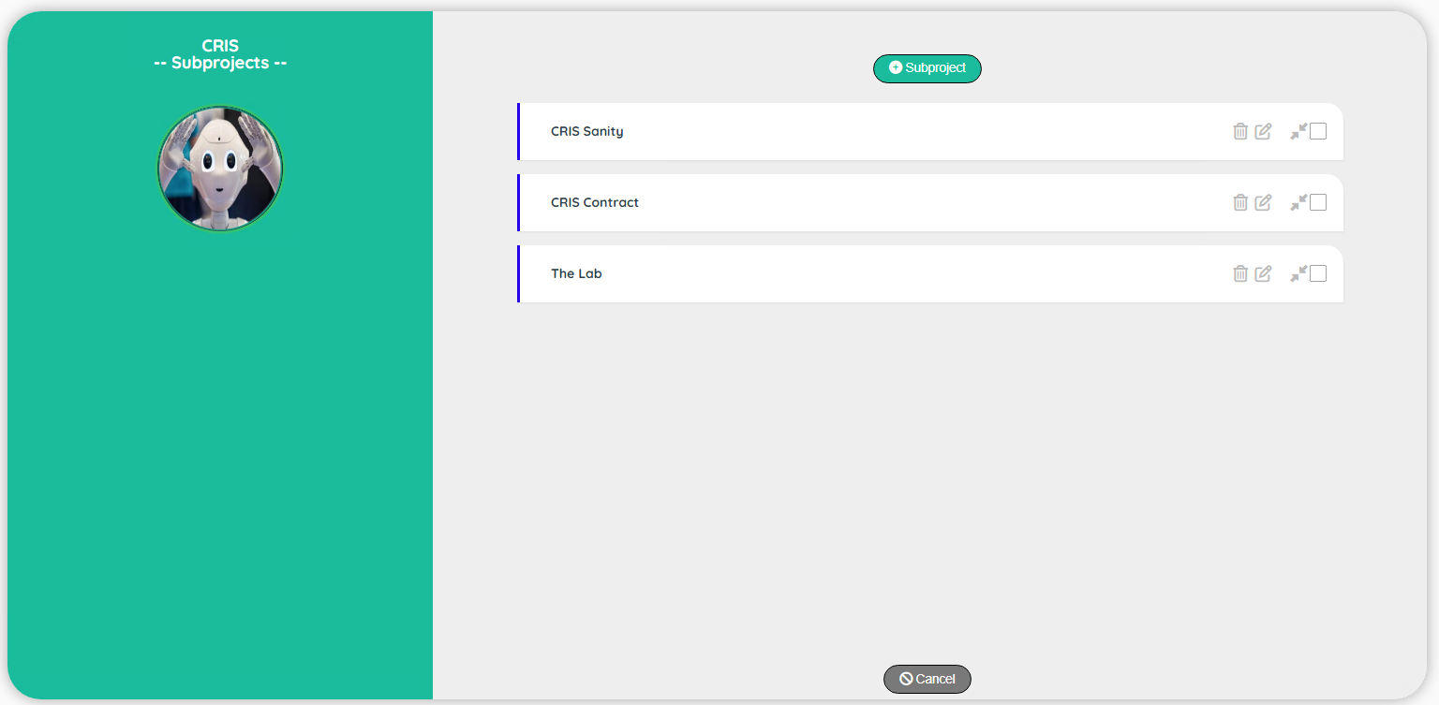

|  |
| --- |
| Project/Subproject Edit |

If you are authorized to edit a subproject, you can access to a screen to edit.

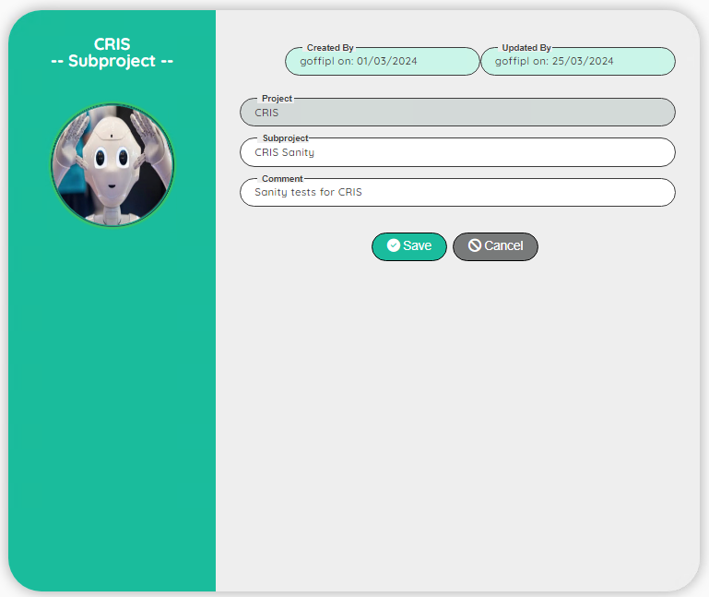

| **Topic** | **Icon** | **Comment** |
| --- | --- | --- |
| Project |  | For Info: Name of the Project |
| Subproject |  | Name of the subproject |
| Comment |  | Comment on the project |
| Save |  | Save the edit |
| Cancel |  | Discard the edit |

|  |
| --- |
| Project/User Interface |

The user interface will allow you to link a user to a project with a specific role (TESTER, DESIGNER or ADMIN). When a user has access to a project with a role, he has automatically access to all the subprojects of the project with the same role.

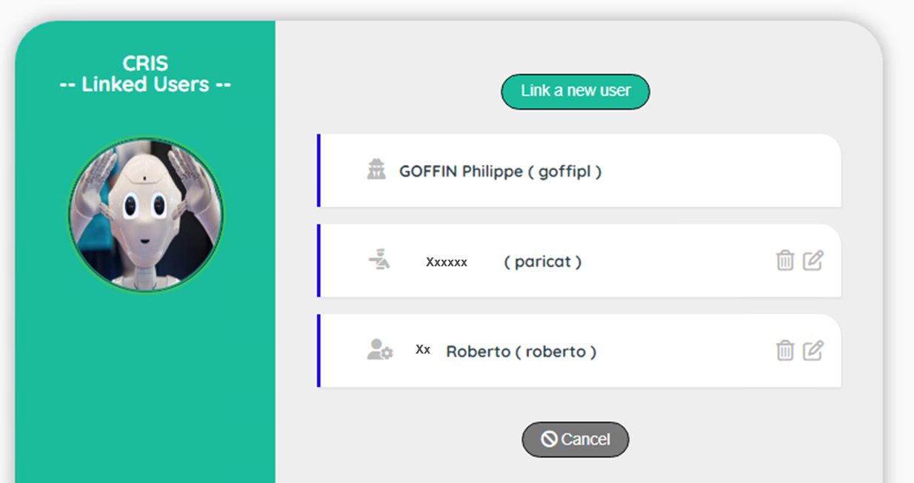

If you delete a user at this level, you just delete the link between the user and the project, not the user himself!

|  |
| --- |
| Project/User Edit |

If you are authorized to edit a user, you can access to a screen to edit.

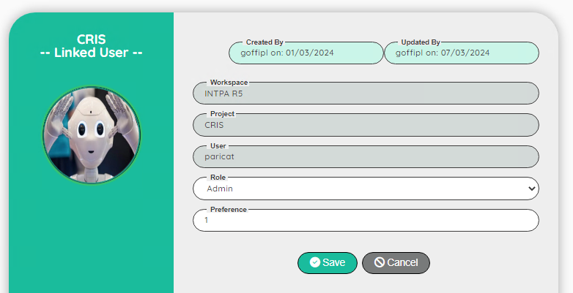

| **Topic** | **Icon** | **Comment** |
| --- | --- | --- |
| Workspace |  | For Info: Name of the Project |
| Project |  | For Info: Login of the User |
| Role |  | Role on the project: TESTER, DESIGNER, ADMIN |
| Comment |  | Comment on the user/project |
| Save |  | Save the edit |
| Cancel |  | Discard the edit |

|  |
| --- |
| Project/Parameter Interface |

The parameter interface allows you to manage parameters global to a project.  
Two parameters are important if you want to use the function mail

|  |  |
| --- | --- |
| **Parameter name** | **Example** |
| Email host | smtpmail.cec.eu.int:25 |
| Email from | automated-notifications@nomail.ec.europa.eu (AutoTest) |

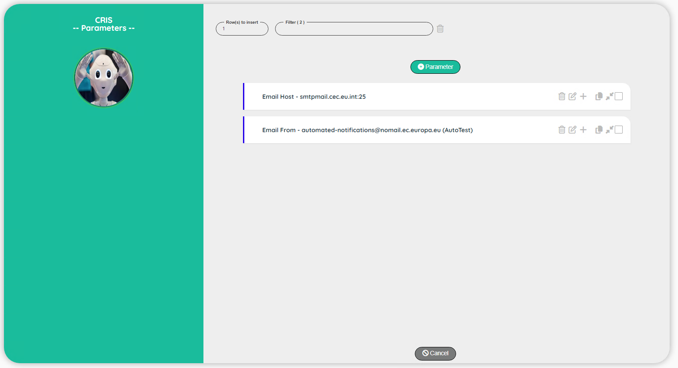

|  |
| --- |
| Project/ Parameter Edit |

If you are authorized to edit a parameter, you can access to a screen to edit.

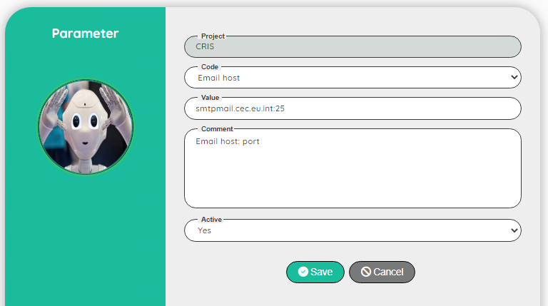

| **Topic** | **Icon** | **Comment** |
| --- | --- | --- |
| Project |  | For Info: Login of the User |
| Code |  | Code of the parameter |
| Value |  | Value of the parameter |
| Comment |  | Comment on the parameter |
| Save |  | Save the edit |
| Cancel |  | Discard the edit |

# **Upload**

|  |
| --- |
| User Interface |

The upload interface will allow you to manage the documents available in the function uploadFile

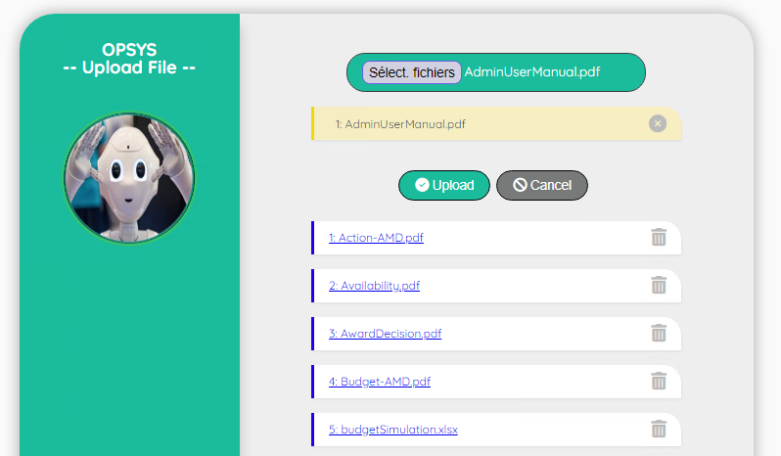

| **Topic** | **Icon** | **Comment** |
| --- | --- | --- |
| Select files |  | Click on the button to open a browser to select file(s) |
| File selected |  | Selected file(s) are displayed in yellow |
| Remove selected |  | You can remove a selected file |
| Upload |  | Upload the selected file(s) |
| Cancel |  | Discard the upload |
| File(s) uploaded |  | List of the uploaded files |
| Delete a file |  | Delete an uploaded file |

# **AI Robot**

|  |
| --- |
| User Interface |

The AI Robot will allow you to train the robot to generate generic patterns.  
The use of the AI Robot is defined in a dedicated **AI User Manual**

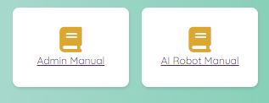

# **Performance**

|  |
| --- |
| User Interface |

Performance screen will allow you to export the data into a json file.  
With this file, it’s possible to format nice graph of the performance in an Excel sheet.  
The use of the performances is defined in a dedicated **Designer Manual**

