|  |
| --- |
|  |
|  |
| **Natural Language Manual**  **---------------**  Automated Test with the Robot |

|  |
| --- |
| **Natural Language Manual** |

Contents

Foreword 3

Working with the natural language 4

What you need to know before you start 5

How it works? 6

Example of sentences 8

# **Foreword**

This manual will give you information on how to design a test case with a natural language.

The concept of the natural language is the possibility for the designer to key a sentence to explain to the robot what to do.  
The sentence is processed by the robot with different parsers to extract the context of the actions to be done.

The robot will extract the function as well as all the parameters to be used.

Natural language has three objectives:

* Force the designer to provide a clear documentation on the step of the test.  
  The comment should be used to document the test from a business perspective, while the field transpose (optional) should be use for a technical documentation.
* Assist the designer by fully or partially translate the comment into a technical instruction.
* Reduce the learning curve of the tool

**Disclaimer**: The natural language is implemented as a prototype. There are currently several limits to the recognition of sentences!

# **Working with the natural language**

Prior to start to work with the natural language, you need to be familiar with the different functions available (see the functions user manual)

The natural language is available on the test editor screen.

Next to the transpose field, you have an icon to transpose your sentence into a technical instruction.

| **Topic** | **Icon** | **Comment** |
| --- | --- | --- |
| Transpose |  | Transpose the text into a technical information |

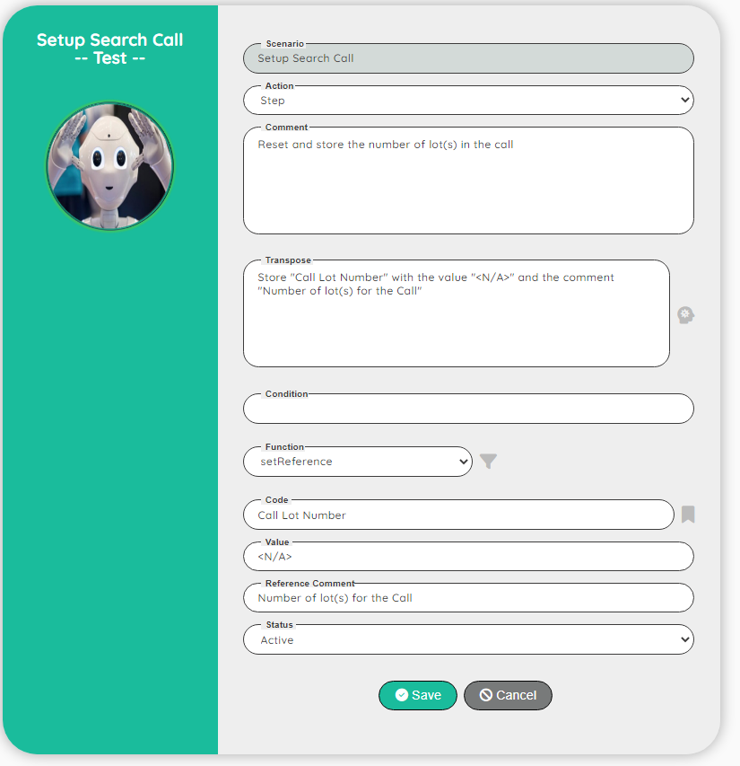

# **What you need to know before you start**

We have 5 specific keywords:

* The word “If” means a start of a condition.  
  A condition is closed by the word “then”  
  Example: **if** the variable "exist" equal 1 **then** detect the field "EU amount"
* The word “when” means a start of an expression.  
  An expression is closed by the word “then”  
  Example: skip the tests **when** the variable "exist" is not equal 0 **then** display the message "skip: data not exist"
* The word “then” to close a condition or an expression
* The word “variable” associated with a text between quotes will transform a text into a variable name.  
  Example: **variable** “first name” will become $first_name
* The word “field” is associated with a type of web element (a checkbox, a listbox, an input field…).  
  Field is used (only) by the function detect GUI.  
  You can use the word “element” to avoid conflict with the word “field”, “element” is neutral, with no specific meaning for the robot.

When you need to express the name of a variable, a comment, a value….  
You need to enclose the text with quotes (“)

Exemple: say "hello to the word"  
 get the link into the variable "myLink"  
 wait for the "amount" waiting 5 sec otherwise "Skip the IT"

|  |
| --- |
| Tips:   * Key your comment with lower case, except for the word(s) between quote * Start your sentence by a verb that specify the requested action |

# **How it works?**

The robot use a “parser” to transpose your sentence into a technical information.  
parsers are very present in most computer languages ​​where the code must be transformed into something easier for a computer to understand

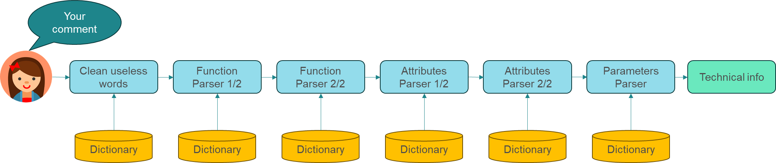

We use the function parser and the attribute parser twice in order to be able to combine words.

Example: click on the cell

* Clean useless words: click cell
* Function parser 1/2: <click> <cell>
* Function parser 2/2: <click><cell> equal to the function “clickCell”

The same method is used on the attributes to differentiate the wait before and the wait after for instance.

When you get the technical information, you just need to match the parameters functions with the values of the parser.

**Extract of our secret laboratory ☺**

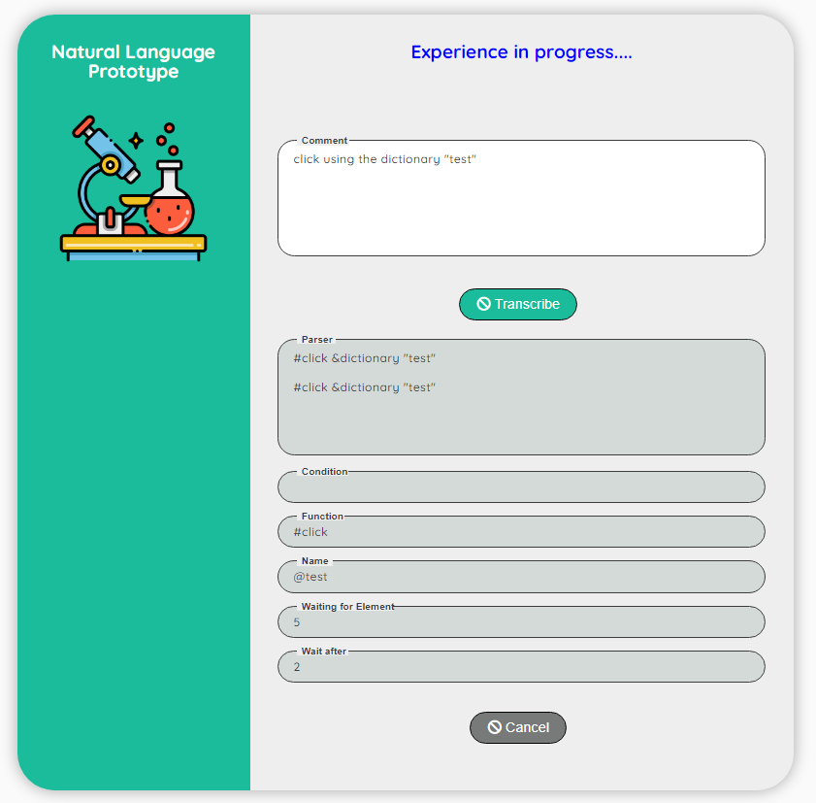

In the field parser, you can see how the sentence has been transposed.

# **Example of sentences**

* if the variable "exist" equal 1 then detect the field "EU amount"
* if the variable "exist" equal 1 then detect the hidden field "EU amount" at the second position
* if the variable "exist" equal 1 then detect the hidden field "EU amount" at the second position and wait for 10 seconds
* if the variable "exist" equal 1 then detect the hidden field "EU amount" at the second position and no need to wait
* click using the dictionary "test"
* click on the button and wait after 99 sec
* get data "EU amount" into the variable "test"
* get reference "status" into the variable "test"
* set reference "status" with the value "draft" and the comment "my comment"
* set reference from variable "status" with the comment in the variable "my comment" and the value in the variable "draft"
* set the reference "status" with the value in the variable "draft" and the comment in the variable "my comment"
* set the data "status" with the value in the variable "draft" and the comment in the variable "my comment"
* set the data from the variable "status" with the comment in the variable "my comment" and the value in the variable "draft"
* set variable "NbError" with the value "0"
* open the page from the dictionary "Prospect"
* say "hello word"
* pause 4 sec
* get the link into the variable "myLink"
* skip the tests when the variable "exist" is not equal 0 then display the message "skip: data not exist"
* skip the describe when the variable "exist" is not equal 0 then display the message "skip: data not exist"
* get the dummy information on "phil" into the variable "user"
* get the dummy information into the variable "user"
* execute the rule "login" using the parameter 1 as "myUser" and the parameter 2 as "ACC"
* wait for the "amount" waiting 5 sec. otherwise "Skip the IT"
* check if exist "amount" waiting 8 sec. and using the variable "exist"
* check the existence of "amount" waiting 8 sec. and using the variable "exist"
* set the value from "amount" with the value "1000" waiting for 9 sec
* set the value from the dictionary defined in the variable "amount" with the value "1000" waiting for 9 sec
* set the value from the variable "amount" with the value "1000" waiting for 9 sec
* click on the cell "table1" in the row 2 and column 5 and wait for 5 sec
* translate "amount" in "FR" and set the result into the variable "translated"
* wait a little bit
* display a message "hello" as an "info"
* print the screen in the slot "1"