**Note down those might be useful for the proposal**

Entanglement is the fundamental characteristic of quantum physics— much experimental effort is devoted to harnessing it between various physical systems. In particular, entanglement between light and material systems is interesting owing to their anticipated respective roles as ‘flying’ and stationary qubits in quantum information technologies (such as quantum repeaters and quantum networks).

[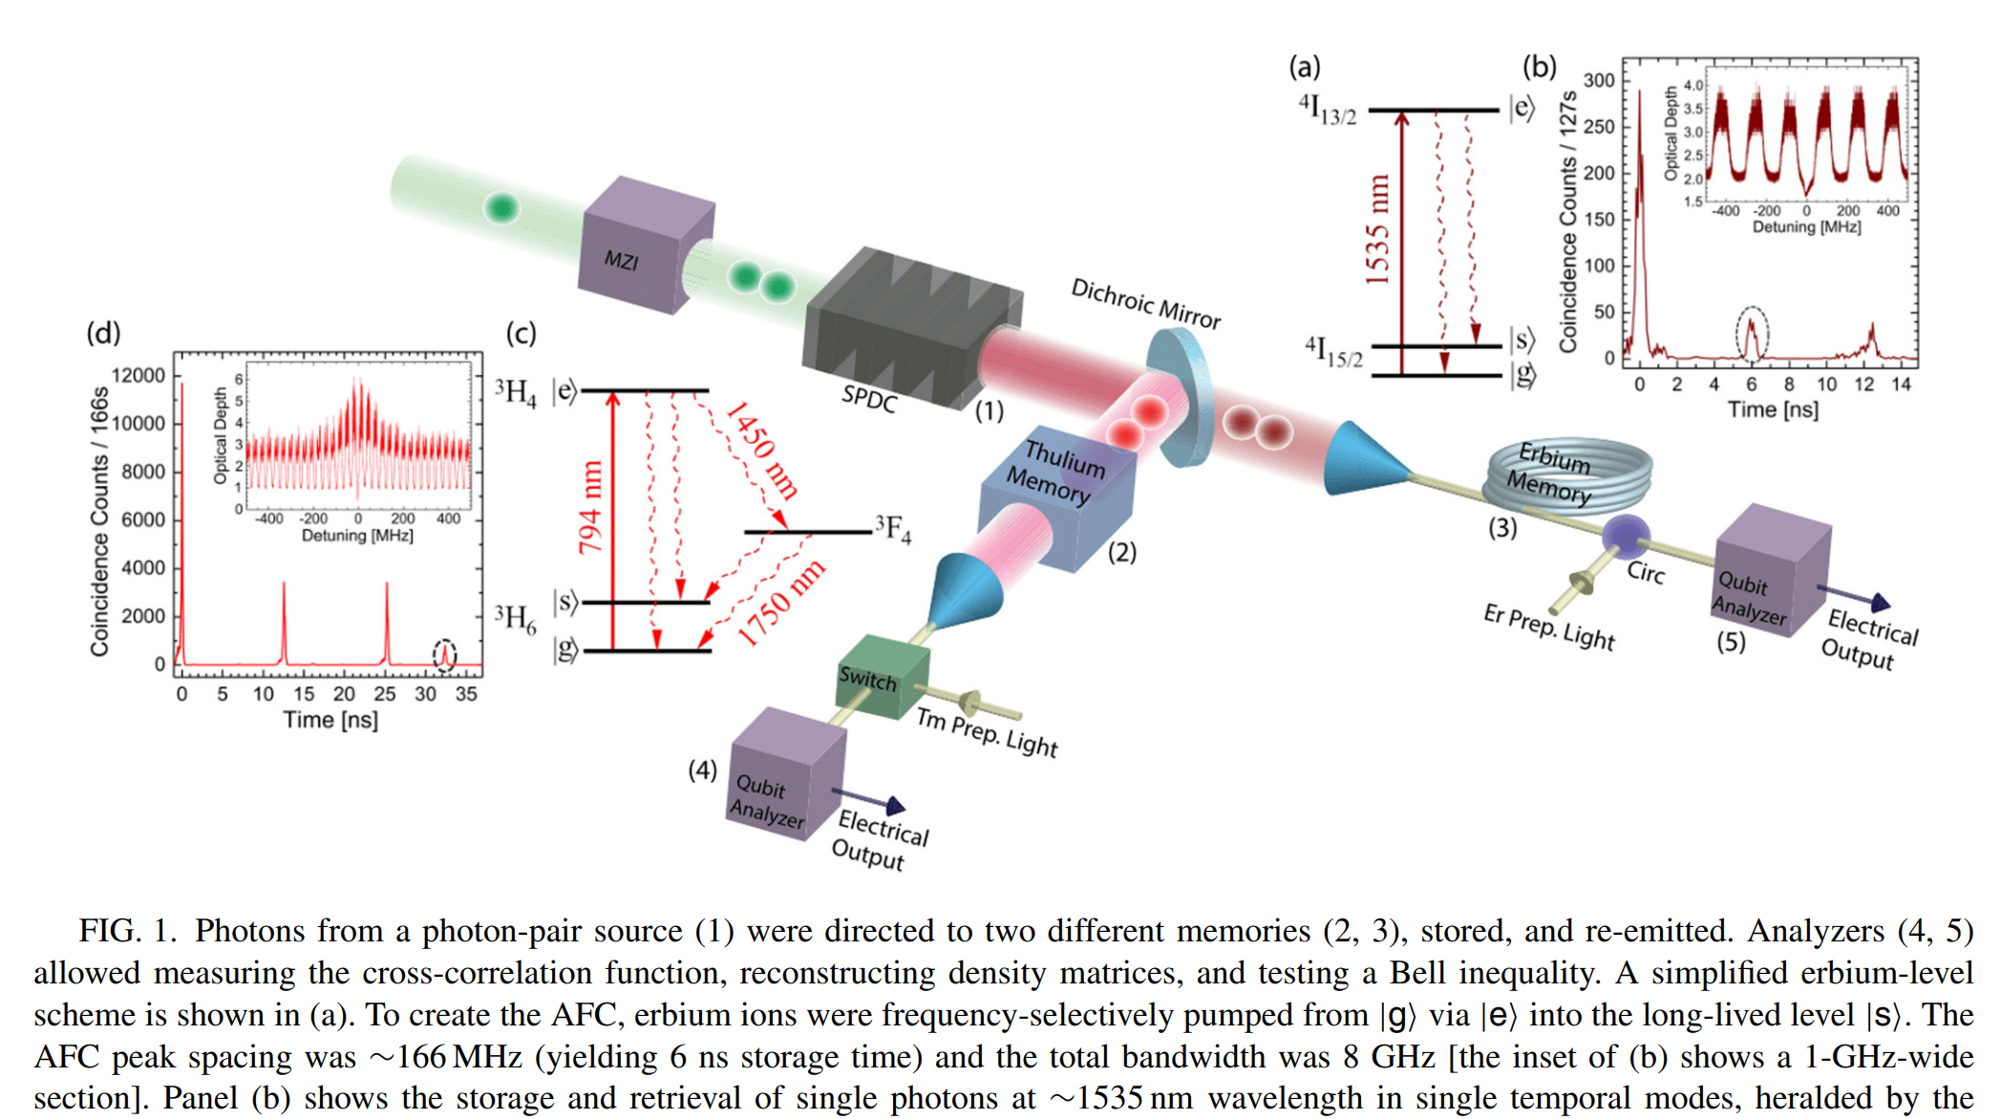](https://journals.aps.org/prresearch/pdf/10.1103/PhysRevResearch.2.013039)

794 nm & 1535 nm

**About coherence time & memory:**

For networks, the quantum coherence times of these transitions must be long compared to the network transmission times.

It (Er:Y2SiO5) also has 100 times larger hyperfine splittings than Pr, which means that it should have larger memory bandwidths and reduced noise from off-resonant excitation during the memory protocol.

Alternatively, spin-pumping allows for potentially GHz-bandwidth spin-wave storage using techniques already demonstrated in rare earth systems, such as GEM [19] and drastically improves the efficiency of AFC protocols. (Broadband spin-wave storage, Λ transitions enabling spin-wave storage)

The ability to efficiently pump the 167Er ensemble into a single hyperfine state is crucial for high-bandwidth quantum communication. It paves the way for broadband Raman memory techniques which, until now, have been limited to atomic vapor systems.

**About hybrid quantum system:**

Interfacing fundamentally different quantum systems is key to building future hybrid quantum networks