**On-chip telecom quantum memory based on a coherent Er: Si spin-photon interface**

**Motivation**: Long distance entanglement distribution is of central significance for modern quantum networks [1]. Quantum repeater protocols are proposed for extending the entanglement distribution to a global-wide distance, whose operation relies on an efficient, long-lived quantum memory [2]. A spin-photon interface coherently maps between the quantum states of local spins and propagating photons [3] and is extensively pursued for telecommunication-band optical accessibility and integrated-circuit capability, including nitrogen vacancy (NV−) centers in diamond [4], divacancy in silicon carbide (SiC) [5], and radiation damage centers in Si [6]. Among various efforts, rare earth ions (REIs) stand out as they possess long coherence times [7], rich selection of spin levels with optical addressability, and demonstrated on-demand storage of quantum state with optically controlled retrieval [8].

The 4I13/2 → 4I15/2 transition at 1532 nm of erbium (Er3+) is utilized as the most efficient way of obtaining telecom photons, and there have been considerable experimental attempts towards combining this telecom transition with long coherence spin levels, namely, 1.3 s hyperfine coherence time in 167Er3+: Y2SiO5 [9], and 23 ms electron spin coherence time in Er3+: CaWO4 [10] was observed. While yttrium-based hosts suffer from high residual paramagnetic impurities with noisy nuclear magnetic environment, and other low nuclear-spin density host materials lacking scalability, Er in semiconductors is investigated to achieve a fundamental understanding of the interaction between RE dopants and their semiconductor host [11]. Specifically, Er in Si links the coherence properties of Er to the integrated-circuit fabrication pedigree of silicon. With the evidence of spin dependent optical transitions from a photoluminescence (PL)-active Er center with orthorhombic symmetry [12], we propose an on-chip telecom quantum memory based on a coherent Er: Si spin-photon interface.

**Description**: Erbium in silicon was explored extensively in the beginning of twentieth century, with the interest of building a silicon-based on-chip optical source. As a poor photonic material, silicon suffers from fast non-radiative decay dominating over slower radiative routes, and indirect bandgap (band edge luminescence at 1.1 μm). It was hoped that implanting optical active centers into this material will allow PL at specific wavelengths determined by the RE optical transitions [13]. In experiments, co-implanting Er with O significantly increases the photoluminescence and leads to sharp lines in EPR spectroscopy [14], but associated with various sites and erbium–oxygen complexes. Sites properties have been studied with photoluminescence (PL) [15], photoluminescence excitation (PLE) [16] and electron paramagnetic resonance (EPR) [14]. However, only a small number of sites have been positively identified.

Quantum coherence is of key importance in the context of quantum memories. Combining the shielding of RE f-electrons with the low nuclear spin and processing pedigree of silicon offers a novel approach to quantum storage protocols. Further isotopic purification eliminates the coupling of dopants to nuclear spins and facilitates ultra-narrow optical linewidths and significantly improved coherence time. Er in Si has shown comparable spin coherence times in low magnetic fields to Er substitutional dopants [17], but it can occupy a large variety of possible sites in silicon, and the properties of these sites are not well known. It is essential that we carry out an in-depth study of site structures, measure coherence time, and engineer site symmetry to maximize the number of optically active centers and control decoherence [18].

**Methods:** We implement electron spin resonance (ESR) spectrometer operating at milli-Kelvin temperatures and apply Hahn echo sequence to study the spin properties of epitaxial rare-earth qubits [19]. Microwave is tailored in time domain and confined spatially within our superconducting resonator, coupling to rare-earth ensembles. This technique will not only address the difficulty of characterizing and identifying the large number of generated centers, but it will also take use of the large *g* factors of REI to achieve strong coupling.

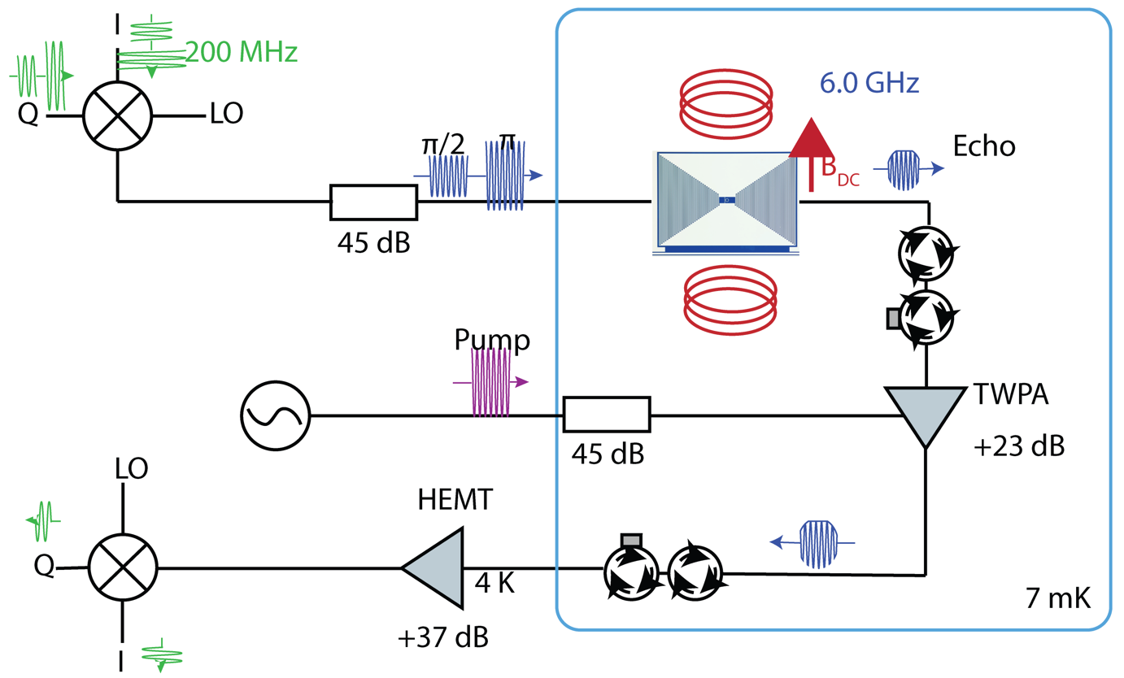 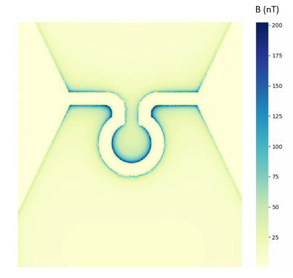

**Fig 1. ESR setup in Zhong lab** [19]. Frequency-modulated, enveloped pulses are sent through the spectrometer and echo signal containing information of spins is dispersively readout; Simulated magnetic field distribution inside loop inductance, showing confinement of perpendicular field.

We fabricated silicon-on-insulator (SOI) nano-beam waveguide, which evanescently couples to a tapered fiber, to study the photoluminescence spectroscopy at dilution temperatures [20]. This type of nano-confinement of light significantly enhances the light-matter interaction via collective effects and the emission rate of emitters via Purcell effect, thus overcome the small dipolar transition strength of erbium.

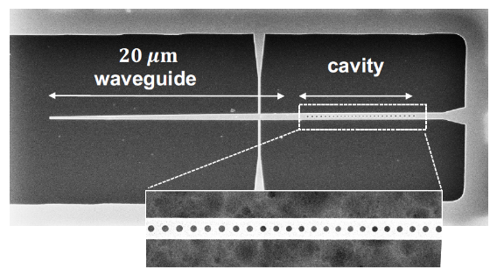 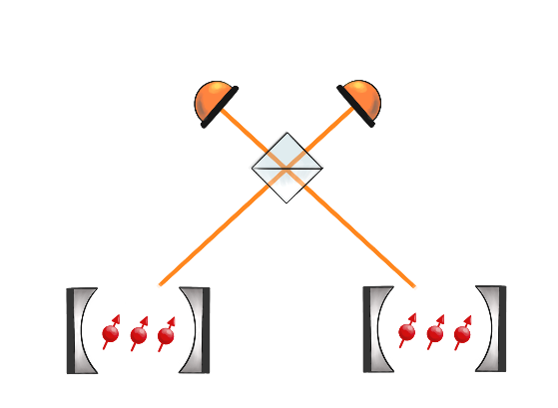

**Fig 2. Photonic cavity fabricated in Zhong lab** [21]. A tapered waveguide fabricated at scale using monolithic fabrication techniques to yield Purcell factor *F*~800; Heralded entanglement between two distant nodes of RE ensembles by Bell measurement.

**Timeline:** (1st year) Design and fabricate superconducting resonators on top of Er implanted SOI samples. Perform spin spectroscopy at milli-Kelvin temperatures. Identify and characterize the g tensors and symmetry of different sites. Measure and engineer spin coherence time. (2nd year) Perform dilution temperature PL spectroscopy. Compare between EPR results and figure out a center which is both PL-active and EPR-active. Figure out the energy level structures relative to conduction and valence band. Optimize implantation and annealing conditions to prioritize this particular kind of center over other centers. (3rd year) With ensembles of optical active centers combined with spin transitions, separate a Λ-type energy level configuration enabling spin-wave storage. Achieve a coherent telecom nanophotonic spin-photon interface. Setup optical paths for entanglement distribution. (4th year) Demonstrate indistinguishable emitted photons between two distant photonic cavities. Demonstrate heralded entanglement between two photonic cavities by Bell measurement. (5th year) Combine with superconducting circuits on chip. Gain microwave manipulation modalities.

**Ancillas:** The Er: Si platform possess potential for quantum computation applications. As is shown in a study of Er ion pairs using a hybrid electro-optical detection method [22], the Er pairs were identified and their interaction strength was characterized. Similar techniques could be utilized for entanglement generation and gate operations between neighboring Er ions.

**References:**

[1] Kimble, H. The quantum internet. Nature 453, 1023–1030 (2008).

[2] W. J. Munro, K. Azuma, K. Tamaki and K. Nemoto, "Inside Quantum Repeaters," in IEEE Journal of Selected Topics in Quantum Electronics, vol. 21, no. 3, pp. 78-90, May-June 2015.

[3] Awschalom, D.D., Hanson, R., Wrachtrup, J. et al. Quantum technologies with optically interfaced solid-state spins. Nature Photon 12, 516–527 (2018).

[4] Pompili, M., Hermans, S. L., Baier, S., Beukers, H. K., Humphreys, P. C., Schouten, R. N., Vermeulen, R. F., Tiggelman, M. J., dos Santos Martins, L., Dirkse, B., Wehner, S., &amp; Hanson, R. (2021). Realization of a multinode quantum network of remote solid-state qubits. Science, 372(6539), 259–264.

[5] Christle, D., Falk, A., Andrich, P. et al. Isolated electron spins in silicon carbide with millisecond coherence times. Nature Mater 14, 160–163 (2015).

[6] Bergeron, L., Chartrand, C., Kurkjian, A. T., Morse, K. J., Riemann, H., Abrosimov, N. V., Becker, P., Pohl, H.-J., Thewalt, M. L., &amp; Simmons, S. (2020). Silicon-integrated telecommunications photon-spin interface. PRX Quantum, 1(2).

[7] Zhong, M., Hedges, M., Ahlefeldt, R. et al. Optically addressable nuclear spins in a solid with a six-hour coherence time. Nature 517, 177–180 (2015).

[8] Zhong, T., Kindem, J. M., Bartholomew, J. G., Rochman, J., Craiciu, I., Miyazono, E., Bettinelli, M., Cavalli, E., Verma, V., Nam, S. W., Marsili, F., Shaw, M. D., Beyer, A. D., &amp; Faraon, A. (2017). Nanophotonic rare-earth quantum memory with optically controlled retrieval. Science, 357(6358), 1392–1395.

[9] Rančić, M., Hedges, M., Ahlefeldt, R. et al. Coherence time of over a second in a telecom-compatible quantum memory storage material. Nature Phys 14, 50–54 (2018).

[10] Le Dantec, M., Rančić, M., Lin, S., Billaud, E., Ranjan, V., Flanigan, D., Bertaina, S., Chanelière, T., Goldner, P., Erb, A., Liu, R. B., Estève, D., Vion, D., Flurin, E.; Bertet, P. (2021). Twenty-three millisecond electron spin coherence of erbium ions in a natural-abundance crystal. Science Advances, 7(51).

[11] Rare-earth defects in GaN: A systematic investigation of the lanthanide series. https://arxiv.org/abs/2201.03651

[12] Hughes, M.A., Li, H., Theodoropoulou, N. et al. Optically modulated magnetic resonance of erbium implanted silicon. Sci Rep 9, 19031 (2019).

[13] A J Kenyon 2005 Semicond. Sci. Technol. 20 R65

[14] Carey, J. D., Donegan, J. F., Barklie, R. C., Priolo, F., Franzò, G., &amp; Coffa, S. (1996). Electron paramagnetic resonance of erbium doped silicon. Applied Physics Letters, 69(25), 3854–3856.

[15] Przybylinska, H., Jantsch, W., Suprun-Belevitch, Y., Stepikhova, M., Palmetshofer, L., Hendorfer, G., Kozanecki, A., Wilson, R. J., &amp; Sealy, B. J. (1996). Optically active erbium centers in Silicon. Physical Review B, 54(4), 2532–2547.

[16] Sub-megahertz homogeneous linewidth for Er in Si via in situ single photon detection. https://arxiv.org/abs/2108.07090

[17] Hughes, M. A., Panjwani, N. A., Urdampilleta, M., Homewood, K. P., Murdin, B., &amp; Carey, J. D. (2021). Spin Echo from erbium implanted silicon. Applied Physics Letters, 118(19), 194001.

[18] M. Hughes, M. Lourenço, J. Carey, B. Murdin, and K. Homewood, "Crystal field analysis of Dy and Tm implanted silicon for photonic and quantum technologies," Opt. Express 22, 29292-29303 (2014).

[19] S Gupta, et al. Y33.00010, APS (2022)

[20] C. Wicker, Y. Huang, H. Qiao, and T. Zhong, "Telecom Spin-Photon Quantum Interface Based on Silicon Nanophotonics," in Conference on Lasers and Electro-Optics, OSA Technical Digest (Optica Publishing Group, 2021), paper FTh1P.6.

[21] C Wicker, et al. Y33.00011, APS (2022)

[22] Optical and Zeeman spectroscopy of individual Er ion pairs in silicon. https://arxiv.org/abs/2108.07442