WRITING TECHNIQUES OF RESEARCH ARTICLES START 2020

TITLE WRITTEN IN ENGLISH (UPPERCASE, TNR 11, BOLD, SPACE 1, CENTER) ( WRITE THE STUDY DESIGN USED)
Title Written in Indonesian (Capital Each Word except conjunction is lowercase, TNR 11, Bold, Space 1 center) (Write The Study Design Used)
(Do not include the name of the author, agency, and e-mail in the article. All three will be written in the title page article format)

ARTICLE INFO  Article History:  Received:  July, 5th , 2019  Revised:  From August, 30th , 2019  Accepted:  September, 2nd , 2019  Published online October, 4th 2019 |  | ABSTRACT  The abstract is written in two languages, English and Indonesian, a maximum of 250 words. The abstract is written in Times New Roman 10 letters, spaced 1 in 1 column format. Background: contains the background of the problem, some literature studies, identification of research problems. Purpose: Contains research objectives that are described in a concise, clear, and concise manner. Methods: It contains research designs, research objectives (population and samples), data sources, data collection techniques and instruments, and data analysis. Results: The results of the study can be explained with the sentence as an example "the study shows the relationship of environmental factors with the incidence of tuberculosis in children because p = 0.02 <α = 0.05". Conclusion: contains research findings in the form of answers to questions and research objectives in the form of the core of the research.  Keywords: must be written with 3-6 words  (example: behavior, pregnant women, nutritional status)  ABSTRAK  Abstrak ditulis dalam dua bahasa yaitu Bahasa Inggris dan Bahasa Indonesia maksimal 250 kata. Abstrak ditulis dengan huruf Times New Roman 10, spasi 1 dengan format 1 kolom. Latar Belakang: berisi latar belakang masalah, beberapa kajian pustaka, identifikasi masalah penelitian. Tujuan: Berisi tujuan penelitian yang dijabarkan secara padat, jelas, dan singkat. Metode: Berisi rancangan atau desain penelitian, sasaran penelitian (populasi dan sampel), sumber data, teknik dan instrumen pengumpulan data, dan analisis data. Hasil: Hasil penelitian dapat dijelaskan dengan kalimat sebagai contoh “penelitian menunjukkan adanya hubungan faktor lingkungan dengan kejadian Tuberkulosis pada anak karena p = 0,02 < α = 0,05”. Kesimpulan: berisi hasil temuan penelitian yang berupa jawaban dari pertanyaan dan tujuan penelitian yang berupa inti dari penelitian.  Kata kunci: kata kunci ditulis dalam 3-6 kata  (contoh: perilaku, ibu hamil, status gizi)

INTRODUCTION (bold, space 1)
The introduction contains background problems followed by several literature reviews, identification of problems with the inverted pyramid method starting from global, national, local and ending research objectives. Also write the state of art and novelty from your research here. The entire introduction is presented in an integrated manner in the form of paragraphs, with the length of the introduction 15% -20% of the total length of the article. Each paragraph starts with words that are indented into five digits.

METHOD (bold, space 1)
The method section contains an explanation in the form of paragraphs about the design or research design, research objectives (population and sample), data sources, data collection techniques and instruments, and data analysis conducted by researchers with a length of 10% -15% of the total length of the article. Please also write the ethical clearance of our research.
The paragraph starts with words that are indented into five digits. In the method section of this research, if there are ethical test results, they can be listed (number, location, and date of ethical testing).

RESULT (bold, space 1)
The results contain research output by describing authentic and valid findings and following the objectives and research methods The writing result is written with indented into five digits. Examples of writing statistical results in table format are:

Table 1. Risk of Exposure to Cigarette Smoke Against Incidence of Anemia in Pregnant Women Year X in the Work Area of ​​Health Center Y
Exposure to Cigarette Smoke | Anemia |  | Total | Odds Ratio
Exposure to Cigarette Smoke | Yes | No | Total | Odds Ratio
...................... | ..................... | ..................... | ..................... | 4,04
..................... | ..................... | ..................... | ..................... | 4,04
Total | ..................... | ..................... | ..................... | 4,04

Examples of explanation / narrative table is: The results showed a risk of

exposure to cigarette smoke to the incidence of anemia in pregnant women by 4.04 times because OR = 4.09; 95% CI (1.07 <OR <16.26).

Table 2. Relationship between Environmental Factors and the Occurrence of Tuberculosis in Year X Children in District Y
Environmental Factors | Tuberculosis in Children |  | Total | p value
Environmental Factors | Yes | No | Total | p value
..................... | ........................ | ........................ | ........................ | 0,02
...................... | ....................... | ........................ | ........................ | 0,02
Total | ........................ | ........................ | ........................ | 0,02

Example explanation / narrative table is: The results showed an association of environmental factors with the incidence of tuberculosis in children.
The descriptions or table titles are placed on the table. Each table must be numbered (such as: "Table 1"). The table is typed in 1 space with the letter size 11 pt and is numbered according to the appearance in the text. The table title is short and complete.
The table may not be clipped and must be made into one page. However, if it has to be continued on the next sheet, the table title will be returned and the information "cont’". Table writing cannot precede the narration. Table Title uses Capitalize Each Word (except the lowercase conjunctions).

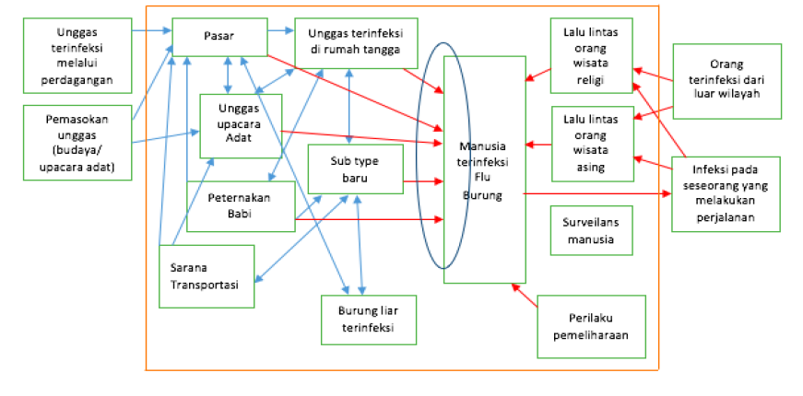
Then, the sample results in the form of figure are:
Figure 1. Risk Pathway Kejadian Flu Burung

The description or title of the image is placed under the picture. Each picture must be numbered (such as: "Figure 1"). The title of the image is made brief and complete. Images must not be cropped and must be made into one page and center position. Then, the image resolution must be high so that the image does not break. Table Title uses Capitalize Each Word (except the lowercase conjunctions). If the image is from a secondary data source, then the source is written below the image. Like the example below:
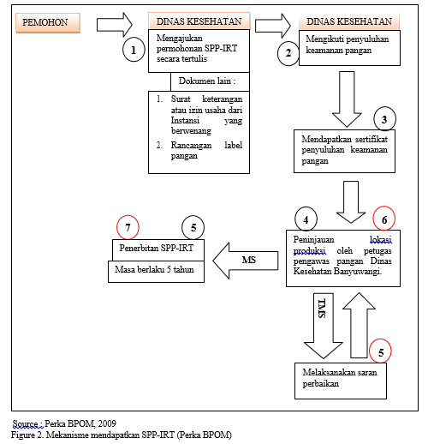

DISCUSSION (bold, space 1)
The discussion contains the interpretation of results and comparisons with the theory, literature, or the results of relevant previous research. The reference library looks at the proportion of issues published in the last 10 years. Each research result must be discussed as deeply as possible. The length of exposure is 20% -60% of the total article length. Each paragraph starts with words that are indented into five digits.

Research limitation (bold, capital each word, space 1) (if there are)
The research limitations contain about the limitations that exist in the study which limitations affect the research results. Writing research limitations is indented into five digits in 1-2 paragraphs only.

CONCLUSION (bold, space 1)
The conclusion contains research findings in the form of answers to questions and research objectives in the form of the core of the research. Conclusions do not repeat the results or discussion, but important points from the results of the study are presented in conclusions.
Conclusions are made in the form of paragraphs and not in the form of bullet or numbering. Writing a conclusion is indented into five digits in 1-2 paragraphs only.

SUGGESTIONS (bold, space 1)
Suggestions contain input or recommendations from the author for the reader or for those who want to research the same domain. Suggestions refer to the objective, logical, and effective and operational that the research needs to be continued.

ACKNOWLEDGMENTS (if there are)
The acknowledgments are mainly addressed to research funders or donors. Acknowledgments can also be conveyed to those who helped carry out the research. Each paragraph starts with words that are indented into five digits.

CONFLICT OF INTEREST
Write down if your article has a conflict of interest with other parties. If there is no conflict of interest, write that the author does not have a conflict of interest.
DECLARATION OF ARTIFICIAL INTELLIGENCE (AI)
Explain whether or not AI software was used during the writing of the manuscript. The following statements must be included in the manuscript:

If AI Tools Were Used:
"The author(s) acknowledge the use of [NAME OF AI TOOL/SERVICE, e.g., ChatGPT/Gemini/Copilot/Grammarly] for [SPECIFIC PURPOSE, e.g., language refinement, summarization, or data analysis] in preparing this manuscript. All AI-generated content was rigorously reviewed, edited, and validated to ensure accuracy and originality. Full responsibility for the manuscript’s final content rests with the author(s). To ensure transparency and support the review process, a comprehensive delineation of the tool’s application is provided in the 'Introduction' or 'Materials and Methods' section in compliance with the publisher’s ethical guidelines."

If No AI Tools Were Used:
"The author(s) affirm that no artificial intelligence (AI) tools, services, or technologies were employed in the creation, editing, or refinement of this manuscript. All content presented is the result of the independent intellectual efforts of the author(s), ensuring originality and integrity."

FUNDING SOURCE
Write down if your article has a source of funding from an agency or from another party. If there is none, it can be written that the article does not have a funding source.

AUTHOR CONTRIBUTION
Write down the duties and responsibilities of each writer in preparing the article.

REFERENCES (bold, space 1)
All references or citations in the article text must be in the bibliography. Writing references in the text according to Harvard Style rules. The maximum number of references is 30, which is at least 80% of references from the last 5 years of journals, while the remaining 20% comes from books published in the last 10 years or other relevant sources. Reference writing is recommended using the Mendeley application. Written without using a serial number. Enter the author's last name and initial first name sorted according to the author's initial name. A maximum of 2 people are written by all authors. If more than 2 people, followed by "dkk" or "et al".
The reference source must be a primary reference source and not a quote taken from another source (example: WHO, 1995 in the Ministry of Health Republic of Indonesia, 2015). Authors are not allowed to use references from blogspot.com, wordpress.com, or other articles that are not published in journals. The reference / issue list is arranged in the following manner and is sorted alphabetically and chronologically space 1 using two columns.

- Text Book
- Single author
Baxter, C. 1997. Race equality in health care and education. Philadelphia: Balliere Tindall.

- Two or three author
Cone, J.D., & Foster, S.L. 1993. Dissertations and thesesfrom start to finish:Psychology and related fields. Washington, DC: American Psychological Association.

- Author in the form of a team or goverment agency, organization, association
American Psychiatric Association. 1994. Diagnostic and statistical manual of mental disorders (4th ed.). Washington, DC: Author.
University of Waikato. 1967. First hall of residence (Information series No. 3). Hamilton, New Zealand: Author.

- Series/multi volume book (editor as writer)
Helber, L. E. 1995. Redeveloping mature resorts for new markets. In M. V. Conlin & T. Baum (Eds.), Island tourism: Management principles and practice (pp. 105-113). Chichester, England: John Wiley.
Koch, S. (Ed.). 1959-1963. Psychology: A study of science (Vols. 1-6). New York: McGraw-Hill. Terjemahan
Kotler, Philip. 1997. Manajemen pemasaran : Analisis, perencanaan, implementasi (Hendra Teguh & Ronny Antonius Rusli, Penerjemah.). Jakarta: Prenhallindo. Bab buku pada buku yang memiliki editor

- Papers
- Conference papers - online
Bochner, S. 1996, November. Mentoring in higher education: Issues to be addressed in developing a mentoring program. Paper presented at the Australian Association for Research in Education Conference, Singapore. Diakses dari http://www.aare.edu.au/96pap/bochs96018.txt

- Seminar papers, conferences, et al.
Crespo, C.J. 1998, March. Update on national data on asthma. Paper presented at the meeting of the National Asthma Education and Prevention Program, Leesburg, VA.
- Proceedings:
Hopkins, W. C., Horton, M. J., and Arnold, C. S. (1995) "Target-Independent High-Level Microprogramming." Proceedings of the 18th Annual Workshop on Microprogramming. IEEE Computer Society Press, Los Angeles, 137 - 144.

- Journal
- Journal – elektronic version with DOI
Hohepa, M., Schofield, G., & Kolt, G. S. 2006. Physical activity: What do high school students think? Journal of Adolescent Health, 39(3), pp. 328-336. doi:10.1016/j.jadohealth.2005.12.024

- Journal–elektronic version without DOI
Harrison, B., & Papa, R. 2005. The development of an indigenous knowledge program in a New Zealand Maori-language immersion school. Anthropology and Education Quarterly, 36(1), pp. 57-100. Diakses dari ProQuest Education Journals database.

- Journal – hardfile
Jagielo Paul J., Peter S. Thorne, Janet L. Watt, Kathy L. Frees, Timothy J. Quinn and David A. Schwartz. 1996. Grain Dust and Endotoxin Inhalation Challenges Produce Similar Inflammatory Responses in Normal Subjects. Chest. 110:263-70

- Journal (internet version)
Snell, D., & Hodgetts, D. (n.d.). The psychology of heavy metal communities and white supremacy. Te Kura Kete Aronui, 1. Available at: http://www.waikato.ac.nz/wfass/tkka.
Suparwati, K., Muliarta, I. dan Irfan, M. 2017. Senam Tai Chi Lebih Efektif Meningkatkan Fleksibilitas Dan Keseimbangan Daripada Senam Bugar Lansia Pada Lansia Di Kota Denpasar, Sport and Fitness Journal, 5(1), pp. 82–93. Diakses dari: https://ojs.unud.ac.id/index.php/sport/article/view/28880.
Pangemanan, D. H. C., Engka, J. N. A. dan Supit, S. 2013. Gambaran Kekuatan Otot Dan Fleksibilitas Sendi Ekstremitas Atas Dan Ekstremitas Bawah Pada Siswa/I Smkn 3 Manado, Jurnal Biomedik (Jbm), 4(3), pp. 109–118. doi: 10.35790/jbm.4.3.2012.1217.

- Undergraduated / Tesis / Disertasi
- Skripsi (undergraduated thesis) / Tesis (thesis) / Disertasi (dissertation – hardfile
Dewstow, R. A. 2006. Using the Internet to enhance teaching at the University of Waikato (Unpublished master’s thesis). University of Waikato, Hamilton, New Zealand.

- Skripsi (undergraduated thesis) / Tesis (thesis) / Disertasi (dissertation) – web version
Dewstow, R. A. 2006. Using the Internet to enhance teaching at the University of Waikato (Master’s thesis, University of Waikato, Hamilton, New Zealand). Diakses dari http://researchcommons.waikato.ac.nz/handle/10289/2241

- Web
Statistics New Zealand. 2007. New Zealand in profile 2007. Diakses dari http://www.stats.govt.nz

- Goverment Rules
Kementerian Kesehatan Republik Indonesia. 2001. Peraturan Pemerintah Republik Indonesia Nomor 81 Tahun 2001 tentang Alat dan Mesin Budidaya Tanaman. Jakarta: Kementerian Kesehatan RI.

