Software Requirements Specification

for

MEETSPACE Smart Conference Room
Version 1.2
28 October 2026

Submitted by
Phakhin Nantakarn 6831503064
Ratchata Suppattapan 6831503067
Witthawin Tanaset 6831503070
Siwakorn Jaronsak 6831503072
Thanaphathr Phutthiphiriya 6831503116

School of Applied Digital Technology, Mae Fah Luang University
Course: Software Requirements Analysis and Specification

Table of Contents
Table of Contents ii
Revision History iii
Document Approval iii
1. Introduction 1
1.1 Business Problem 1
1.2 Business Objective 1
1.3 Product Vision 1
1.4 Business Scope 1
1.5 Business Workflow 2
1.6 Definitions, Acronyms and Abbreviations 3
2. Overall Description 4
2.1 Product Perspective 4
2.2 User Classes and Characteristics 6
3. Software Specific Requirements 7
3.1 Overall Functional Requirements 7
3.2 Functional Requirements 8
3.3 Non-Functional Requirements 15
4. User Interface Requirements 17
4.1 Navigation Structure / Sitemap 17
4.2 User Interface Specifications 18
Appendix A: Data Dictionary 32
Revision History
No. | Name | Date | Description | Version
1 | MEETSPACE project team | 23/10/2026 | Initial document based on the project presentation, analysis diagrams and application source. | 1.0
2 | MEETSPACE project team | 27/10/2026 | Aligned FR-06, FR-09, FR-10, FR-12, sections 1, 4.1, 4.2 and Appendix A with the source. | 1.1
3 | Phakhin Nantakarn | 28/10/2026 | Restructured to the MFU SRS template (FR/NFR/UI tables). Re-verified every requirement against the source code; redrew workflow, use case, sitemap and ER diagrams; replaced UI screenshots; added UI-06 to UI-13, NFR-10 to NFR-13, input limits and error messages. | 1.2

Document Approval
The following Software Requirements Specification has been accepted and approved by the following:
Name | Role | Signature | Date
To be completed | Project Sponsor / Stakeholder
To be completed | Project Manager (team representative)

Introduction
This document specifies Release 1 of MEETSPACE, a web-based meeting room reservation system with a member website and a separate walk-in kiosk. Every requirement was checked against the application source code (Spring Boot ApiController, schema.sql and the browser application app.js) on 28 October 2026. Features that exist only as legacy fields in the code are listed as out of scope.

Business Problem
Staff who need a meeting room do not have complete information about each room's equipment and capacity, and the room status they see is not reliable: a room may look free while someone is already using it. Informal bookings (chat messages, verbal agreements) are kept in different places, so double bookings happen, staff lose time searching for a room for urgent or important meetings, and nobody can tell who is responsible for a reservation.
These problems affect employees who book rooms, people who arrive at a room without an account and want to use it immediately (walk-in), and the administrators who manage the rooms.

Business Objective
MEETSPACE aims to:
- Keep one shared reservation record for both advance (member) and walk-in bookings, so that no meeting room time slot is reserved twice.
- Show room facilities, capacity, photos and occupied time slots before a user books, and confirm a valid request immediately.
- Allow administrators to identify the booker and channel of every reservation and to cancel reservations when necessary.

Product Vision
For employees who need meeting rooms and the administrators who manage them, MEETSPACE will provide room discovery, shared real-time availability and immediately confirmed reservations through a member website and a separate walk-in kiosk, so that staff can find a suitable room quickly and conflicting bookings are prevented.

Business Scope
Release 1 includes:
- Public browsing of rooms, facilities, photos and occupied time slots (08:00-20:00) without signing in.
- Account registration, sign in, sign out and change password.
- Member reservations that are confirmed immediately (one room, one date, start and end time).
- Walk-in reservations from a separate kiosk page (/#walkin) using a declared name or employee ID, without an account.
- Server-side validation of every reservation (opening hours, 30-minute slots, maximum 4 hours, not in the past, at most one year ahead, no overlap, active room, no duplicate submission).
- My reservations, reservation history, cancellation and in-app notifications.
- Administration: booking management (date and room filters, separate walk-in and member lists), room management (add, edit, photo, soft delete) and members and roles.
- English and Thai interface, light and dark theme.
Release 1 does not include:
- Approval workflow (pending / approve / reject). Legacy fields and a server action remain in the code but are not reachable from the user interface.
- Recurring (weekly) reservations and participant count. The server fixes repeat = 1 and participants = 1.
- Editing an existing reservation. A user cancels and creates a new reservation instead.
- Email, SMS or Google Calendar notifications (only in-app notifications).
- Verification of a walk-in booker's identity against an employee directory.
- Physical occupancy sensors, payments and deleting user accounts.

Business Workflow
Member workflow: Sign in; browse rooms and inspect facilities and the availability timeline; choose a room, date, start and end time; review and submit. The server validates the request; if it is valid and the slot is free, the reservation is saved as Confirmed together with a confirmation event. The member sees the result in My reservations and Notifications and may cancel it before its end time. An invalid or conflicting request shows an error message and nothing is saved.
Walk-in booker workflow: Open the kiosk page (/#walkin) without signing in; choose a room, date and time; enter a name or employee ID; review and submit. The server applies the same validation and availability rules and records the reservation under the system walk-in account with the declared booker identity. The kiosk shows a booking reference.
Administrator workflow: Sign in; open Administration > Booking management; filter by date and room; inspect the booker and channel (walk-in or member) and cancel an active reservation if required. Room management and members and roles are also restricted to administrators.
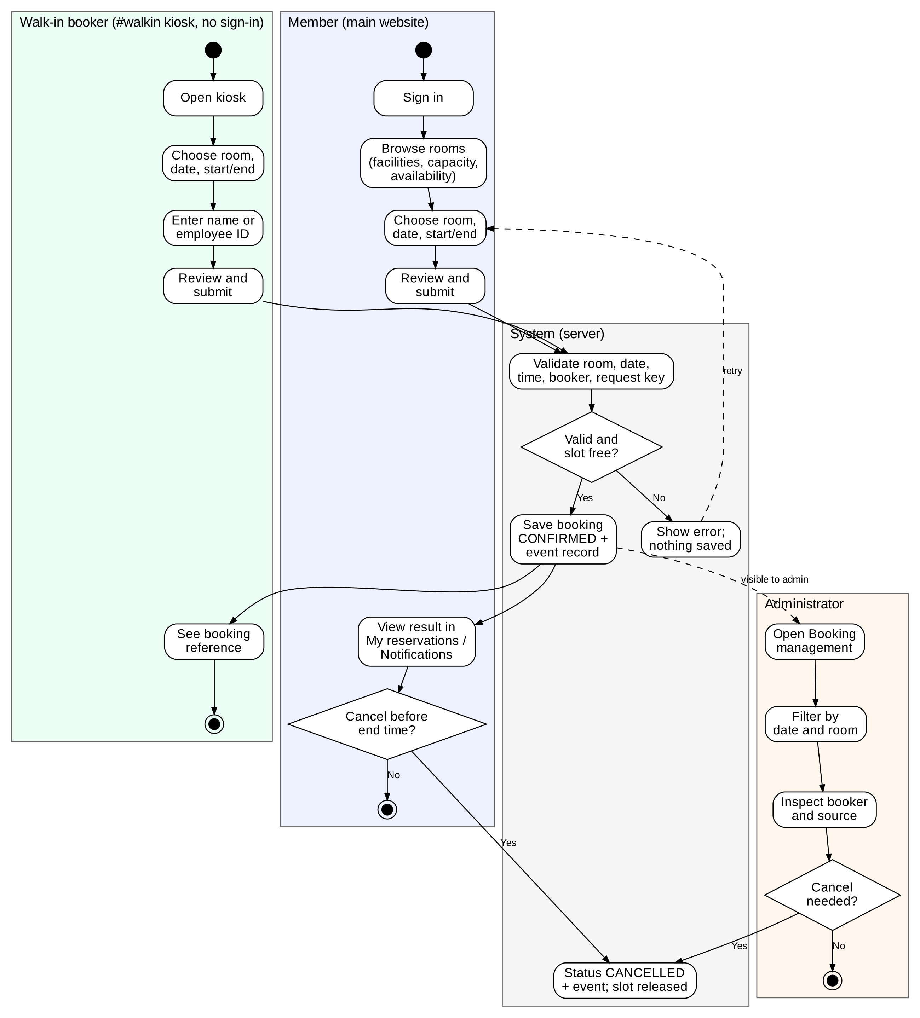
Figure 1 Business workflow (activity diagram with swimlanes)

Definitions, Acronyms and Abbreviations
Term | Description
SRS | Software Requirements Specification
BR / FR / NFR | Business requirement / functional requirement / non-functional requirement
UI | User interface
DB | Database
PK / FK / UK | Primary key / foreign key / unique key
API | Application programming interface; the REST endpoints under /api
H2 | Embedded relational database used to store MEETSPACE data in a file
BCrypt | One-way password hashing function used to store passwords
Visitor | A person who uses the main website without signing in
Member | A signed-in user with role user
Administrator | A signed-in user with role admin
Walk-in | Reservation channel on the separate kiosk page /#walkin that does not require an account
Booker | The name or employee ID typed by a walk-in user, or the member's account name
Confirmed | Reservation status that holds a room time slot
Cancelled | Reservation status after the owner or an administrator cancels it; the time slot is released
Pending / Rejected | Legacy approval statuses kept in the data model; not produced by the Release 1 user flow
Active reservation | A reservation whose status is Pending or Confirmed; used for availability and overlap checks
Request key | Random identifier sent with each booking submission to detect a duplicate submission
Soft delete | Marking a room as deleted (deleted = TRUE) so it is hidden but its reservation history is kept

Overall Description

Product Perspective
MEETSPACE is a stand-alone web application. The browser interface (HTML, CSS and JavaScript) calls Spring Boot REST endpoints under /api, and the server stores accounts, rooms, reservations, events and uploaded room photos in a file-based H2 database (data/meetspace.mv.db) that persists after a restart. The main website and the walk-in kiosk are two interfaces over the same data. All date and time validation on the server uses the Asia/Bangkok time zone.
The system is not integrated with an employee directory, email, Google Calendar or room sensors. A walk-in employee ID is recorded as a declaration and is not authenticated.
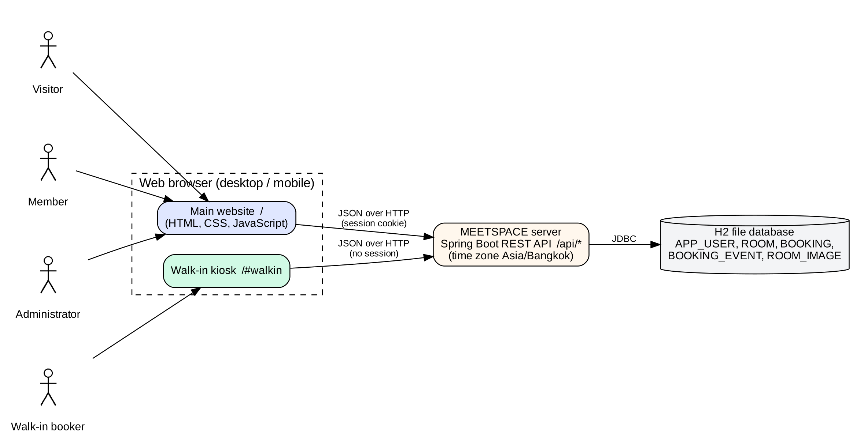
Figure 2 System context
Functions available to each user class:
Visitor
- Browse rooms, facilities and photos
- View anonymous occupied time slots
- Register an account
- Use the walk-in kiosk
Member
- Sign in / sign out
- Create a reservation
- View my reservations, history and notifications
- Cancel own reservation
- Change password
Walk-in booker
- Create a walk-in reservation with a name or employee ID
Administrator
- All member functions
- View and cancel all reservations
- Manage rooms and photos
- Add members and change roles
Constraints and assumptions
- [Constraint] Release 1 runs as a single server instance; reservation requests are serialized inside that instance.
- [Constraint] The prototype seeds a default administrator (admin@meetspace.local / admin123) and enables the H2 web console at /h2-console with an empty database password. Both shall be changed or disabled before production use.
- [Assumption] Users access the system with a current desktop or mobile web browser that has JavaScript enabled.
- [Assumption] Opening hours are 08:00-20:00 every day; the system does not model public holidays.

User Classes and Characteristics
User Class | Description | Role / Goal | Main Functions
Visitor | Occasional user who opens the main website without signing in. | To find a suitable room and see when it is free before deciding to register or book. | - Browse rooms and facilities (FR-03)  - View room availability (FR-04)  - Register an account (FR-01)
Member | Primary user: an employee with a self-registered or administrator-created account (role user). | To reserve a room in advance and keep track of own reservations. | - Sign in / sign out (FR-02)  - Create member reservation (FR-05)  - View own reservations and history (FR-08)  - Cancel own reservation (FR-09)  - View notifications (FR-13)  - Change password (FR-14)
Walk-in booker | A person at the room or a shared kiosk who has no account or does not want to sign in. Gets no member or administrator access. | To book a free room immediately with minimal steps. | - Browse rooms and availability on the kiosk (FR-03, FR-04)  - Create walk-in reservation (FR-06)
Administrator | Authorized operator (role admin). Most privileged and least frequent user class. | To keep room information correct, control access and resolve reservation problems. | - All member functions  - Manage rooms (FR-10)  - Manage users and roles (FR-11)  - View and manage all bookings (FR-12)

Software Specific Requirements

Overall Functional Requirements
FR-No. | Function name | User class | Priority | Dependency
FR-01 | Account registration | Visitor | High | None
FR-02 | Sign in and sign out | Member, Administrator | High | FR-01
FR-03 | Browse rooms and facilities | Visitor, Member, Walk-in booker, Administrator | High | None
FR-04 | View room availability | Visitor, Member, Walk-in booker, Administrator | High | FR-03
FR-05 | Create member reservation | Member, Administrator | High | FR-02, FR-04, FR-07
FR-06 | Create walk-in reservation | Walk-in booker | High | FR-04, FR-07
FR-07 | Validate reservation | Member, Walk-in booker, Administrator (performed by the system) | High | FR-03
FR-08 | View my reservations and history | Member, Administrator | Medium | FR-02, FR-05
FR-09 | Cancel reservation | Member (owner), Administrator | High | FR-08 or FR-12
FR-10 | Manage room information | Administrator | High | FR-02
FR-11 | Manage users and roles | Administrator | Medium | FR-02
FR-12 | View and manage all bookings | Administrator | High | FR-02, FR-05, FR-06
FR-13 | Record events and show notifications | Member, Administrator | Medium | FR-05, FR-06, FR-09
FR-14 | Change password | Member, Administrator | Low | FR-02

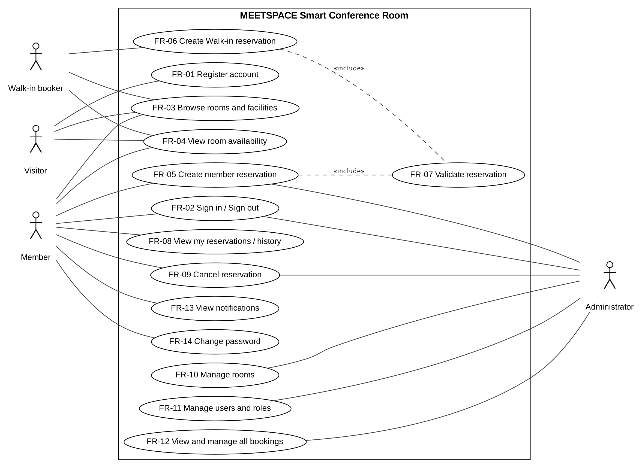
Figure 3 Use case diagram

Functional Requirements
FR-01 | Account registration
Description | The system shall allow a visitor to create a member account (role user) and shall sign the new member in after the account is created.
User Class (Actors) | Visitor
Priority | High
Input | - Name: text, 1-100 characters, required  - Email: valid email format (name@domain.tld), max 160 characters, unique (case-insensitive), required  - Password: 8-12 characters, required  - Confirm password: must equal Password, required (checked in the browser)
Output | - Success: account created, user signed in, message "Your account is ready. Welcome to MeetSpace." and the Dashboard or the page the user originally requested is shown.  - Error: "Please check the required fields." (invalid name or email), "An account with this email already exists.", "Use a password between 8 and 12 characters.", "The passwords do not match."
Workflow | - The visitor selects Sign in and then Create an account.  - The visitor enters name, email, password and confirm password and submits.  - The system validates the input.  - If any field is invalid, the system shows the related error message and creates no account.  - If the email already exists, the system shows "An account with this email already exists."  - The system stores the password as a BCrypt hash, saves the account with role user, and starts a session.  - The system shows the success message and opens the Dashboard (or the requested page).

FR-02 | Sign in and sign out
Description | The system shall verify the email and password of an account, start a session with the role of that account, and end the session when the user signs out.
User Class (Actors) | Member, Administrator
Priority | High
Input | - Email: text, required  - Password: 8-12 characters, required  - Remember me: checkbox, optional (sent to the server but not used in Release 1; every session expires after 30 days of inactivity)  - Sign out: button
Output | - Success: the user is signed in and returned to the requested page or the Dashboard; the menu shows Administration only for an administrator.  - Error: "The email or password is incorrect." (HTTP 401); no session is created.  - Sign out: session invalidated and the guest view is shown.
Workflow | - The user selects Sign in and enters email and password.  - The system finds the account by email (case-insensitive) and compares the password with the stored BCrypt hash.  - The system checks the result.  - If correct, the system creates a session and shows the requested page or the Dashboard.  - If incorrect, the system shows "The email or password is incorrect."  - When the user selects Sign out, the system invalidates the session and shows the guest Dashboard.

FR-03 | Browse rooms and facilities
Description | The system shall display the list of meeting rooms that are not deleted, with photo, room code, name (English or Thai), location, capacity, facilities, status and a daily timeline, and shall allow the user to search and choose a date.
User Class (Actors) | Visitor, Member, Walk-in booker, Administrator
Priority | High
Input | - Search text: free text matched against room name, location and room code, optional  - Date: date picker, default today, optional  - Language: English or Thai (Settings)
Output | - Room cards showing room code, photo, name, location, capacity, facility icons (Display, Wi-Fi, Whiteboard, Projector, Video conferencing, Audio, Computers), status badge (Available, Reserved, Unavailable, Outside opening hours) and the 08:00-20:00 timeline.  - If no room matches: "No rooms" empty state with a Clear filters button.
Workflow | - The user opens Meeting rooms (or the walk-in kiosk).  - The system loads all rooms and hides rooms marked deleted.  - The user types search text and/or selects a date.  - The system filters the cards and recalculates each room's status for the selected date.  - The user selects Book on a room to start FR-05 or FR-06.

FR-04 | View room availability
Description | The system shall show the occupied time slots of each room for the selected date from active reservations, without exposing another person's name, email, title or walk-in booker identity to visitors, walk-in users or ordinary members.
User Class (Actors) | Visitor, Member, Walk-in booker, Administrator
Priority | High
Input | - Room and date selected in the room list or booking form
Output | - Timeline 08:00-20:00 in 30-minute blocks: free blocks and occupied blocks (Pending or Confirmed reservations).  - Visitor / kiosk data: only room, date, start, end and status of active reservations.  - Member data: full details of own reservations; anonymous slots for others.  - Administrator data: full details including booker and channel.
Workflow | - The browser requests /api/data (main website) or /api/walk-in/data (kiosk).  - The system determines the caller (none, member or administrator); the kiosk endpoint is always treated as anonymous.  - The system returns reservations filtered according to the caller.  - The browser draws the timeline and refreshes the data before a booking is submitted.

FR-05 | Create member reservation
Description | The system shall allow a signed-in member or administrator to reserve one room for one date and time range, and shall save a valid request immediately as Confirmed.
User Class (Actors) | Member, Administrator
Priority | High
Input | - Room: selected active room, required  - Date: YYYY-MM-DD, required  - Start time and End time: HH:mm in 30-minute steps between 08:00 and 20:00, required  - Request key: generated automatically by the browser (max 80 characters)  - No meeting title, participant count or repeat option is requested; the server stores title "Room reservation" and participants = 1.
Output | - Success: reservation saved with status Confirmed, a confirmed event is created and the message "Reservation submitted successfully." / "Your reservation is saved. You can track it in My reservations." is shown.  - Error: the FR-07 error messages; if not signed in, the sign-in screen is shown and the user returns to the booking after signing in.
Workflow | - The member selects Book on a room (a visitor is asked to sign in first).  - The member chooses date, start time and end time; the form shows the timeline of the selected day.  - The member selects Review, checks the summary and selects Confirm.  - The system validates the request (FR-07).  - The system checks the result.  - If valid, the system saves the reservation as Confirmed and records a confirmed event.  - If invalid, the system shows the error message and saves nothing; the user's entries are kept.

FR-06 | Create walk-in reservation
Description | The system shall allow a person without an account to reserve a room from the separate kiosk page /#walkin by declaring a name or employee ID, and shall save a valid request as Confirmed under the system walk-in account.
User Class (Actors) | Walk-in booker
Priority | High
Input | - Room: selected active room, required  - Booker name or employee ID: text, 1-100 characters, required  - Date, Start time, End time: same rules as FR-05, required  - Request key: generated automatically
Output | - Success: reservation saved as Confirmed with the declared booker; the kiosk shows "Your room is booked. Save this reference before closing." and the booking reference.  - Error: "Enter a name or employee ID (max 100 characters)." or the FR-07 error messages.  - The kiosk does not sign the user in and never lists earlier walk-in bookers.
Workflow | - The user opens /#walkin (no sidebar link exists on the main website).  - The user selects Book on a room and enters a name or employee ID, date, start and end time.  - The user reviews and confirms.  - The system validates the request (FR-07) and the booker field.  - The system checks the result.  - If valid, the system saves the reservation under the walk-in account, stores the booker, records an event and shows the reference.  - If invalid, the system shows the error message and saves nothing.

FR-07 | Validate reservation
Description | The system shall validate every reservation request on the server before saving it, for both the member and the walk-in channel.
User Class (Actors) | Member, Walk-in booker, Administrator (performed by the system)
Priority | High
Input | - Room ID, date, start time, end time, request key and (walk-in only) booker
Output | - Valid: the request continues to FR-05 / FR-06.  - Errors: "This item could not be found." (room missing or deleted); "Unavailable" (room inactive); "Choose a valid time between 08:00 and 20:00, in 30-minute intervals. The end must be after the start."; "Choose a valid date."; "Reservations must be in the future."; "Reservations can be made up to one year ahead."; "This time overlaps another reservation. Please choose a different time."; "This submission has already been used. Please start a new reservation."
Workflow | - Check that the room exists, is not deleted and is active.  - Check that start and end are on 30-minute boundaries, start < end, start >= 08:00, end <= 20:00 and the duration is at most 4 hours.  - Check that the date is valid, not later than one year from today (Asia/Bangkok), and that the start time is later than the current time when the date is today.  - Check that the same account has not used the request key before.  - Check that no Pending or Confirmed reservation of the same room and date overlaps the interval (existing start < new end and existing end > new start).  - If any check fails, return the matching error and save nothing.

FR-08 | View my reservations and history
Description | The system shall show the signed-in user's own reservations split into My reservations (active and not yet ended) and Reservation history (cancelled or ended).
User Class (Actors) | Member, Administrator
Priority | Medium
Input | - Signed-in session
Output | - Table with room name, date, start-end time, status badge (Confirmed in green / Cancelled in red), Details and Cancel buttons.  - Details dialog: status, room, date, time, requester, reference, created and last updated time.  - Empty state when there are no reservations.
Workflow | - The user opens My reservations or Reservation history.  - The system returns the user's own reservations.  - The browser places active future reservations in My reservations and cancelled or ended ones in Reservation history.  - The user may open Details or start a cancellation (FR-09).

FR-09 | Cancel reservation
Description | The system shall allow the owner of a reservation or an administrator to cancel an active reservation that has not yet ended; the reservation becomes Cancelled and its time slot is released.
User Class (Actors) | Member (owner), Administrator
Priority | High
Input | - Reservation ID (selected from the list)  - Confirmation in the cancel dialog
Output | - Success: status Cancelled, updated time recorded, cancelled event created, message "Reservation cancelled."  - Error: "You don't have permission to perform this action." (not owner and not admin); "This reservation has changed. Refresh and try again." (already cancelled); "This reservation has already ended and cannot be cancelled."
Workflow | - The user selects Cancel on a reservation.  - The system shows "The room will become available for other people. This action cannot be undone."  - The user confirms.  - The system checks permission and state.  - If the user is not the owner or an administrator, the system rejects the request.  - If the reservation is not active or has ended, the system rejects the request.  - The system sets the status to Cancelled, records a cancelled event and refreshes the lists.  - A walk-in booker cannot cancel from the kiosk; an administrator cancels walk-in reservations (FR-12).

FR-10 | Manage room information
Description | The system shall allow an administrator to add, edit and delete meeting rooms, including choosing or uploading a room photo.
User Class (Actors) | Administrator
Priority | High
Input | - Room name (English) and Room name (Thai): 1-100 characters, required  - Location (English) and Location (Thai): 1-120 characters, required  - Capacity: whole number 1-1000, required  - Colour: indigo, teal, blue or violet  - Facilities: any of Display, Wi-Fi, Whiteboard, Projector, Video conferencing, Audio, Computers  - Active: yes/no  - Photo: a bundled photo or an uploaded PNG/JPG up to 3 MB, at most 6000 px per side and 16 megapixels  - Room ID: generated automatically (R001, R002, ...) for a new room
Output | - Success: "Meeting room saved successfully." or "Meeting room deleted."  - Error: "Please check the required fields."; "Choose a valid PNG or JPG, up to 3 MB and 16 megapixels."; "This change affects upcoming reservations. Cancel those reservations first or keep sufficient capacity." (deactivating a room with upcoming reservations); "This room still has upcoming reservations. Cancel them before deleting the room."
Workflow | - The administrator opens Administration > Room management.  - The administrator selects Add room or Edit, fills in the form and saves.  - The system validates the fields and the photo, and rejects deactivation when the room has upcoming active reservations.  - The system saves the room and refreshes the list.  - To delete, the administrator selects Delete and confirms; if the room has no upcoming active reservation the system marks it deleted and inactive (soft delete), hides it from room lists and booking, and keeps past reservation history.

FR-11 | Manage users and roles
Description | The system shall allow an administrator to add team member accounts and to change the role of other accounts between Member and Administrator.
User Class (Actors) | Administrator
Priority | Medium
Input | - Add member: Name (1-100 characters), Email (valid, unique), Password (8-12 characters), Role (Member or Administrator), all required  - Change role: target account, new role, previous role (sent automatically to detect concurrent changes)
Output | - Success: "Team member added. Share their credentials securely." / "Account permissions updated."  - Error: "You cannot change your own permissions or the workspace owner's permissions."; "These permissions have changed. Refresh and try again."; "An account with this email already exists."; password length and required-field messages.
Workflow | - The administrator opens Administration > Members and roles.  - To add, the administrator fills in the form; the system validates and creates the account with a BCrypt password hash.  - To change a role, the administrator selects Manage on an account and chooses the new role.  - The system checks the target.  - If the target is the administrator's own account or the seeded workspace administrator, the change is rejected.  - If the previous role no longer matches, the change is rejected.  - The system saves the change and refreshes the list. Accounts cannot be deleted in Release 1.

FR-12 | View and manage all bookings
Description | The system shall show administrators all reservations in two separate lists, Walk-in bookings and Member bookings, with booker, room, date, time and status, filterable by reservation date and room, and shall allow cancellation.
User Class (Actors) | Administrator
Priority | High
Input | - Reservation date: calendar date, optional  - Room: any room including deleted rooms (labelled), optional  - Selected reservation for Details or Cancel
Output | - Two panels with the number of bookings in each; rows sorted by start time when a date is selected, otherwise by newest creation time.  - Empty state "No bookings found" when nothing matches.
Workflow | - The administrator opens Administration > Booking management.  - The administrator chooses a date and/or room (Clear and Refresh buttons are available).  - The system shows walk-in and member reservations in separate lists with booker name and channel.  - The administrator opens Details or cancels an active future reservation (FR-09).

FR-13 | Record events and show notifications
Description | The system shall record an event each time a reservation is confirmed or cancelled, and shall show the signed-in user the events of their own reservations, newest first.
User Class (Actors) | Member, Administrator
Priority | Medium
Input | - Reservation ID, recipient account, event type (confirmed or cancelled), event time and actor name - created automatically by FR-05, FR-06 and FR-09
Output | - Notifications page listing "Reservation confirmed" or "Reservation cancelled" with room, date and time; the bell icon opens it.  - Note shown: "Updates appear in MeetSpace. Email and Google Calendar are not connected."
Workflow | - When a reservation is confirmed or cancelled, the system stores an event for the reservation owner.  - When the user opens Notifications, the system returns the user's events ordered by event time descending.  - Events of walk-in reservations are stored for the walk-in system account and are not shown to any person.

FR-14 | Change password
Description | The system shall allow a signed-in user to change their password after verifying the current password, and shall end the session so the user signs in again.
User Class (Actors) | Member, Administrator
Priority | Low
Input | - Current password: required  - New password: 8-12 characters, required
Output | - Success: "Password changed. Please sign in again." and the session ends.  - Error: "The email or password is incorrect." (wrong current password); "Use a password between 8 and 12 characters."; "Please sign in to continue." (no session).
Workflow | - The user opens Settings > Account security.  - The user enters the current and new password and submits.  - The system verifies the current password and the new password length.  - If a check fails, the system shows the error and keeps the old password.  - The system stores the new BCrypt hash, invalidates the session and asks the user to sign in again.

Non-Functional Requirements
NFR-No. | Name | Requirement Statement | Acceptance Criteria | Verification Method | Related FR
NFR-01 | Security - password storage | The system shall store every password as a BCrypt hash and shall not return password hashes in any API response. | No readable password exists in APP_USER.password_hash; /api/session, /api/data and login responses contain no password field. | Inspection of database and API responses | FR-01, FR-02, FR-11, FR-14
NFR-02 | Security - access control | The system shall return HTTP 401 for protected operations without a session and HTTP 403 when a non-administrator calls an administrator operation. | Calls to /api/book, /api/reservation and /api/password without a session return 401; a member calling /api/room, /api/room-delete, /api/user or /api/user-role receives 403. | Automated API test (ApiControllerTest) | FR-05, FR-09, FR-10, FR-11, FR-12
NFR-03 | Privacy | The system shall not include account names, email addresses, reservation titles or walk-in booker identities of other people in visitor, kiosk or ordinary-member availability data. | Responses of /api/data (no session or member session) and /api/walk-in/data contain only room, date, start, end and status for other people's reservations. | Automated API test and inspection | FR-04, FR-06
NFR-04 | Reliability - no double booking | The system shall not allow two active reservations of the same room to overlap, including when a member and a walk-in request arrive at the same time. | In a test that submits 10 simultaneous overlapping requests through both channels, exactly one reservation is saved and the others receive the conflict error. | Concurrency test | FR-05, FR-06, FR-07
NFR-05 | Correctness - time zone | The system shall evaluate past time, today, one-year limit and reservation end using the Asia/Bangkok time zone. | A request for today at a start time already passed in Bangkok is rejected; a request at the next 30-minute slot is accepted, regardless of the server's own time zone. | Boundary test | FR-07, FR-09
NFR-06 | Data integrity | A rejected reservation request shall leave no reservation and no event record. | After 20 invalid requests (each validation rule), the number of rows in BOOKING and BOOKING_EVENT is unchanged. | Automated test with row counts | FR-07, FR-13
NFR-07 | Persistence | The system shall keep accounts, rooms, reservations, events and uploaded photos after the server is restarted. | Data created before a restart is shown unchanged after the restart. | Restart test | FR-01, FR-05, FR-06, FR-10, FR-13
NFR-08 | Performance (target) | The system should complete 95% of /api/data and /api/book requests within 2 seconds with 20 concurrent users and 1,000 stored reservations. | 95th percentile response time <= 2 s in the documented test environment. | Performance test (planned; not yet executed) | FR-03, FR-04, FR-05
NFR-09 | Compatibility / responsive layout | Every screen shall be usable at 1366 x 768 (desktop) and 390 x 844 (mobile) viewports in a current Chrome, Edge or Safari browser. | No control is clipped or overlapped and no horizontal page scroll appears at either size. | Manual inspection at both viewports | FR-03, FR-05, FR-06
NFR-10 | Usability - status display | The system shall show each reservation status as a text label with colour: Confirmed in green and Cancelled in red, so that colour is not the only cue. | Every status badge shows the words Confirmed / Cancelled (or Thai equivalents) with the stated colour. | UI test (ui.test.cjs) and inspection | FR-08, FR-12
NFR-11 | Localization | The system shall provide the complete interface in English and Thai and shall remember the selected language and theme in the browser. | Switching language changes all labels, messages and room names; the choice is kept after reloading the page. | Inspection | FR-03, FR-05, FR-06
NFR-12 | Security - uploaded files | The system shall accept only PNG or JPEG room photos of at most 3 MB, 6000 px per side and 16 megapixels, and shall reject external URLs and SVG files. | Valid PNG/JPG files are saved; an SVG, a 4 MB file or a URL is rejected with the invalid image message. | Automated API test | FR-10
NFR-13 | Security - session | A signed-in session shall end after 30 days of inactivity, when the user signs out, or after a password change. | After sign-out or password change, a protected request with the old session returns 401. | Test and configuration inspection | FR-02, FR-14

User Interface Requirements

Navigation Structure / Sitemap
Main website: Dashboard, Meeting rooms (booking form, review, result), My reservations (details, cancel), Reservation history, Notifications and Settings (language, theme, change password, sign out); Sign in / Register; Administration (administrators only) with Booking management, Room management and Members and roles. The walk-in kiosk is a separate entry at /#walkin (room list, booking form with booker name or employee ID, review, result with reference) and has no link in the main sidebar. In Figure 4, one asterisk marks pages that require sign-in and two asterisks mark pages for administrators only.
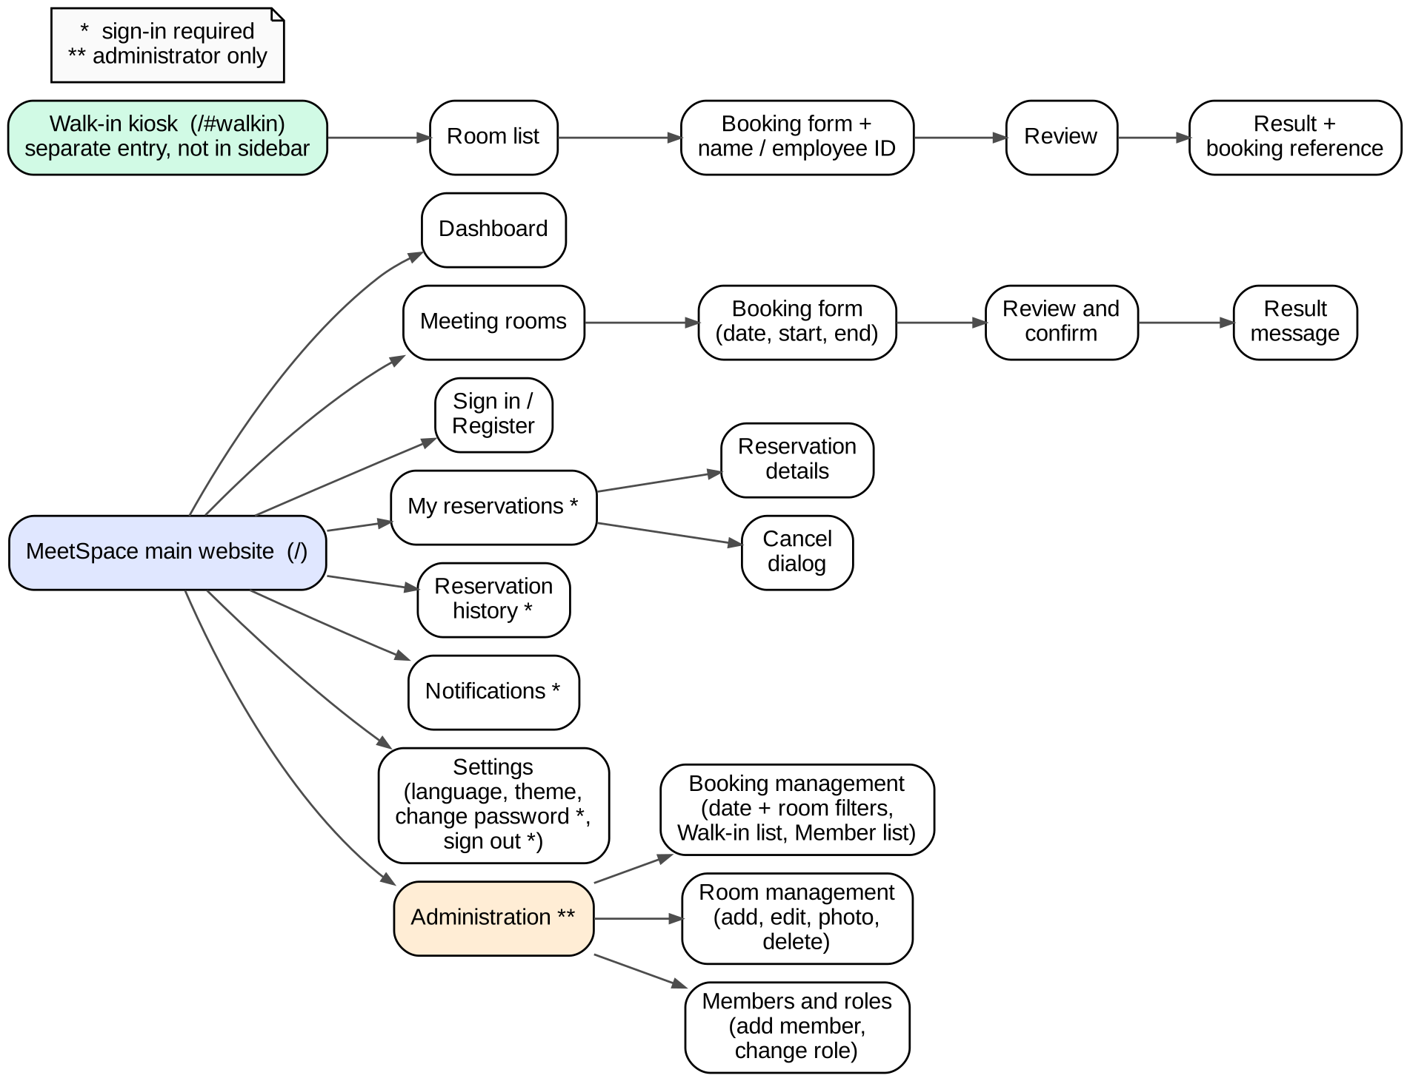
Figure 4 Navigation structure / sitemap

User Interface Specifications
Screens were captured from the current application (Thai interface, 1366 x 768). Visual design may evolve; the required information and behaviour are stated in each table.
UI-01: | Dashboard
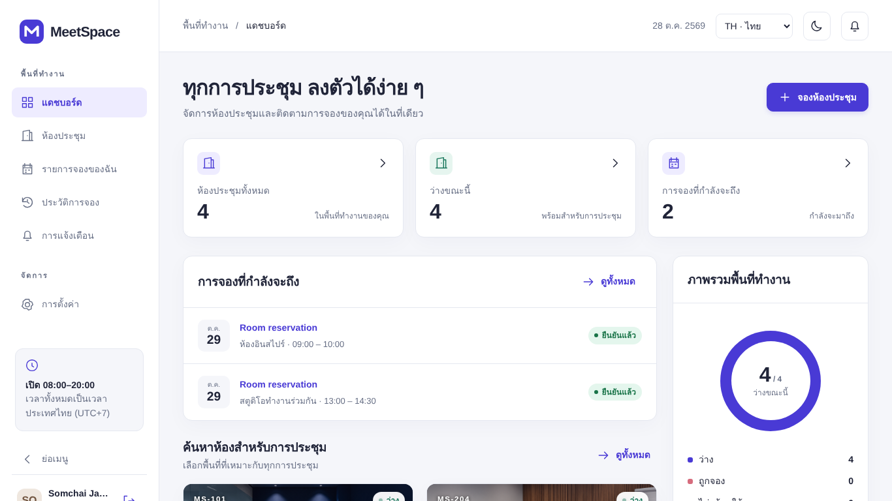
Purpose: | Give an overview of total rooms, rooms available now, the user's upcoming reservations, workspace occupancy and a quick link to book.
Prerequisite: | - The user opens the main website (/). Visitors see the same page without personal data.
Use case procedure: | - The user reads the three summary cards.  - The user opens an upcoming reservation or selects Book a room.
Acceptance Criteria | - Counts match the current data.  - Upcoming reservations list only the signed-in user's active future reservations.  - Visitors see no personal reservation data.
Related Function Requirement | FR-03, FR-04, FR-08

UI-02: | Sign in and registration
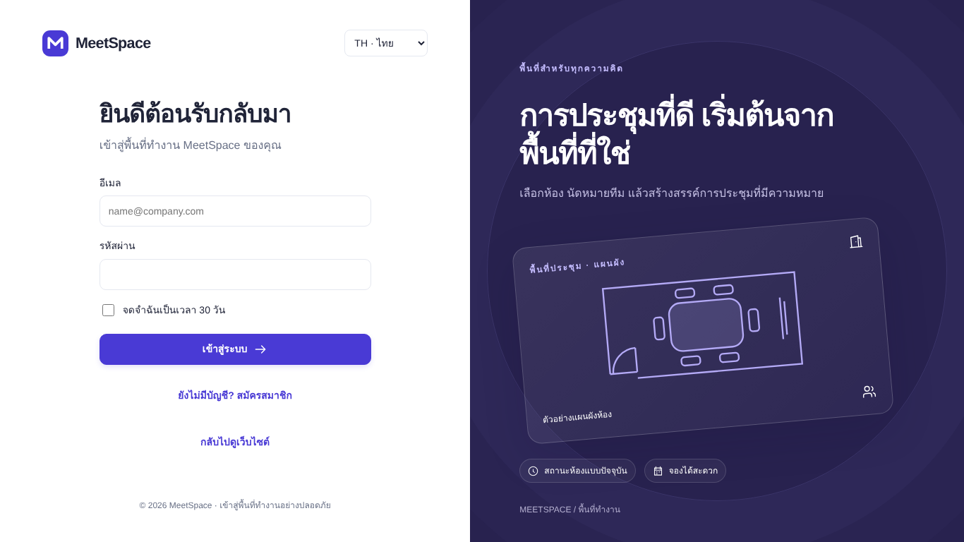
Purpose: | Allow a visitor to sign in or create an account.
Prerequisite: | - The visitor selects Sign in, or tries to open a page that requires sign-in.
Use case procedure: | - The user enters email and password (and Remember me) and selects Sign in.  - A new user selects Create an account and enters name, email, password and confirm password.
Acceptance Criteria | - Correct credentials open the requested page or the Dashboard.  - Wrong credentials show "The email or password is incorrect."  - Passwords outside 8-12 characters are rejected.
Related Function Requirement | FR-01, FR-02

UI-03: | Meeting rooms
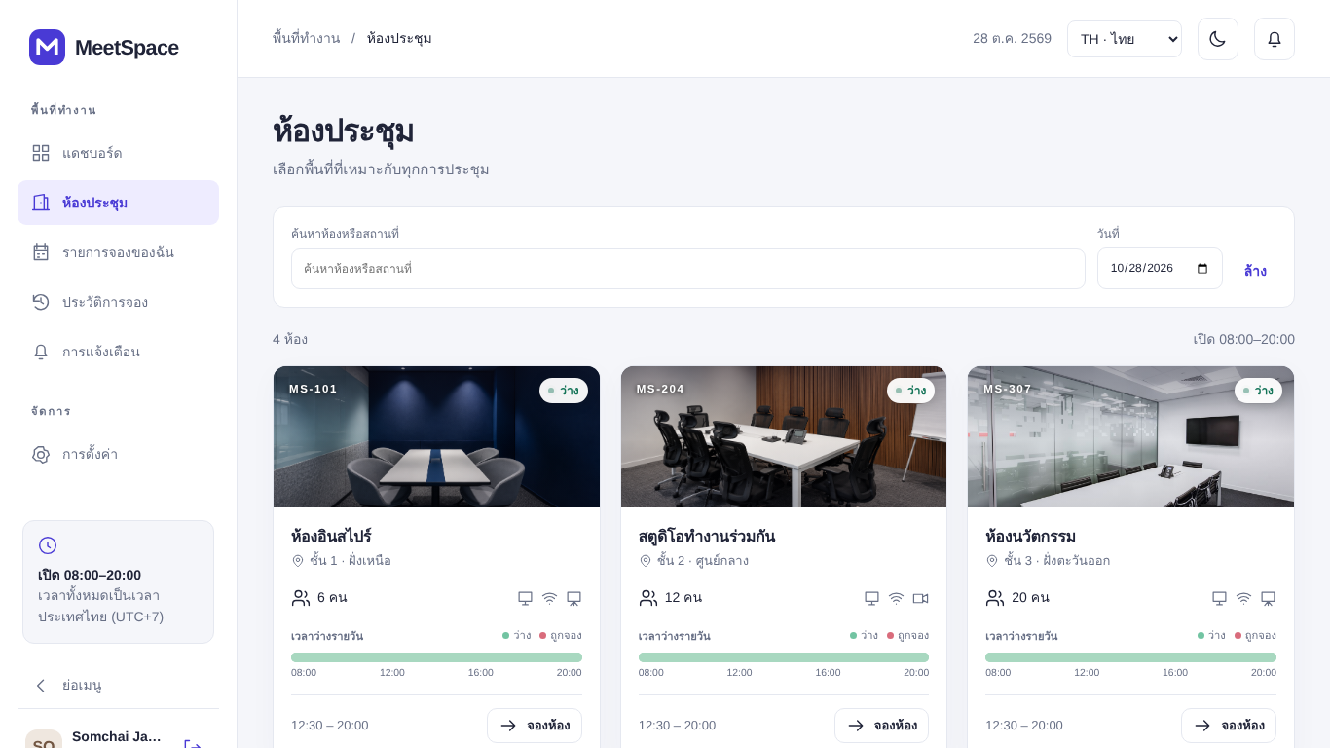
Purpose: | Search rooms and inspect photo, location, capacity, facilities, status and the daily timeline.
Prerequisite: | - Select Meeting rooms in the sidebar.
Use case procedure: | - The user types search text or selects a date.  - The user reads the timeline (green = free, red = occupied).  - The user selects Book on a room.
Acceptance Criteria | - Only rooms that are not deleted are shown.  - Search matches name, location or room code.  - Occupied slots show no identity of other users.
Related Function Requirement | FR-03, FR-04

UI-04: | Booking form (member)
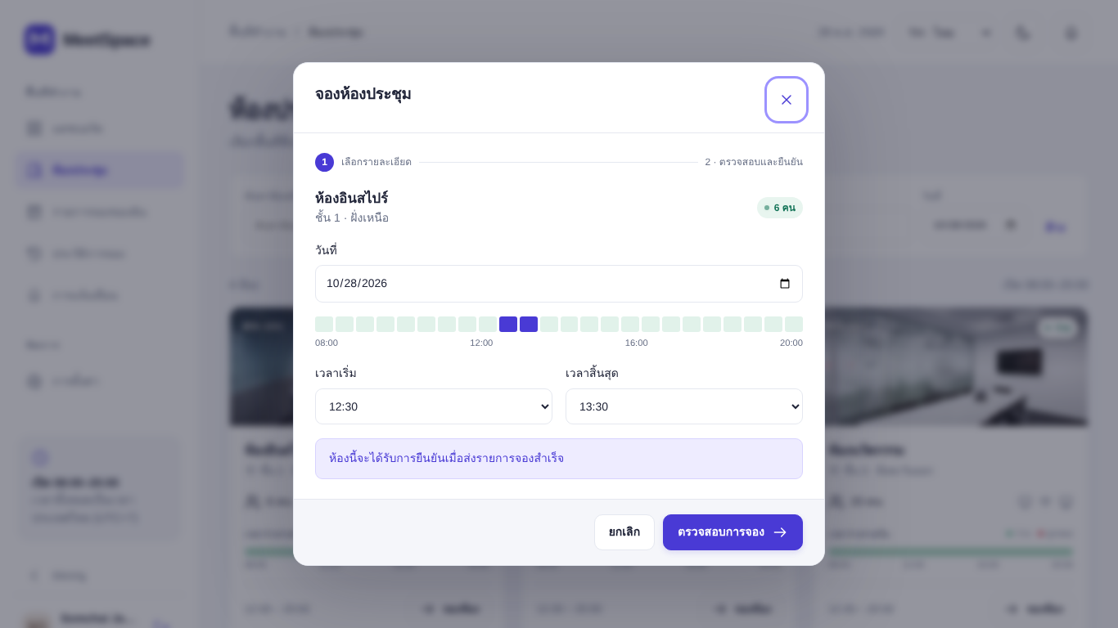
Purpose: | Choose date, start time and end time for the selected room.
Prerequisite: | - A signed-in user selects Book on a room (a visitor is asked to sign in first).
Use case procedure: | - The user selects a date; the timeline for that date is shown.  - The user selects start and end time (30-minute steps).  - The user selects Review booking.
Acceptance Criteria | - Times outside 08:00-20:00, longer than 4 hours or with end <= start cannot be submitted.  - No meeting title, participant or repeat field is shown.  - The note says the room is confirmed immediately.
Related Function Requirement | FR-05, FR-07

UI-05: | Booking review
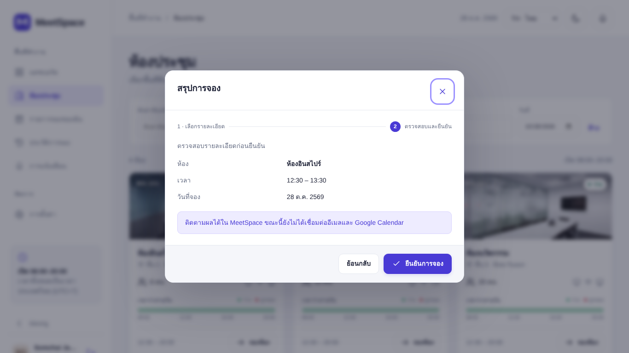
Purpose: | Show the summary of the request before it is submitted.
Prerequisite: | - The user completed UI-04.
Use case procedure: | - The user checks room, time and date.  - The user selects Confirm (or Back to edit).
Acceptance Criteria | - A valid request is saved as Confirmed and a success message is shown.  - A conflict or validation error is shown in the dialog and nothing is saved.
Related Function Requirement | FR-05, FR-07

UI-06: | My reservations and history
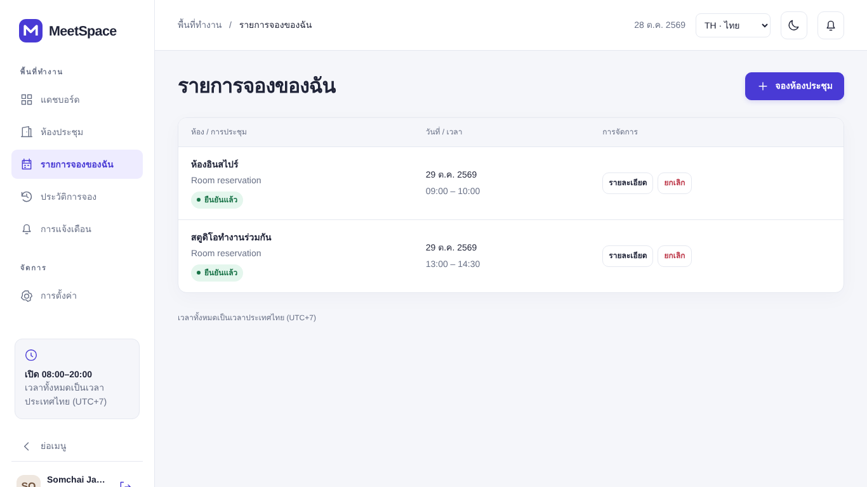
Purpose: | List the user's own reservations with status and actions.
Prerequisite: | - Signed-in user selects My reservations or Reservation history.
Use case procedure: | - The user views the list.  - The user selects Details, or Cancel and confirms.
Acceptance Criteria | - Active future reservations appear in My reservations; cancelled or ended ones in Reservation history.  - Status shows Confirmed (green) or Cancelled (red).  - Cancel is shown only for active reservations that have not ended.
Related Function Requirement | FR-08, FR-09

UI-07: | Notifications
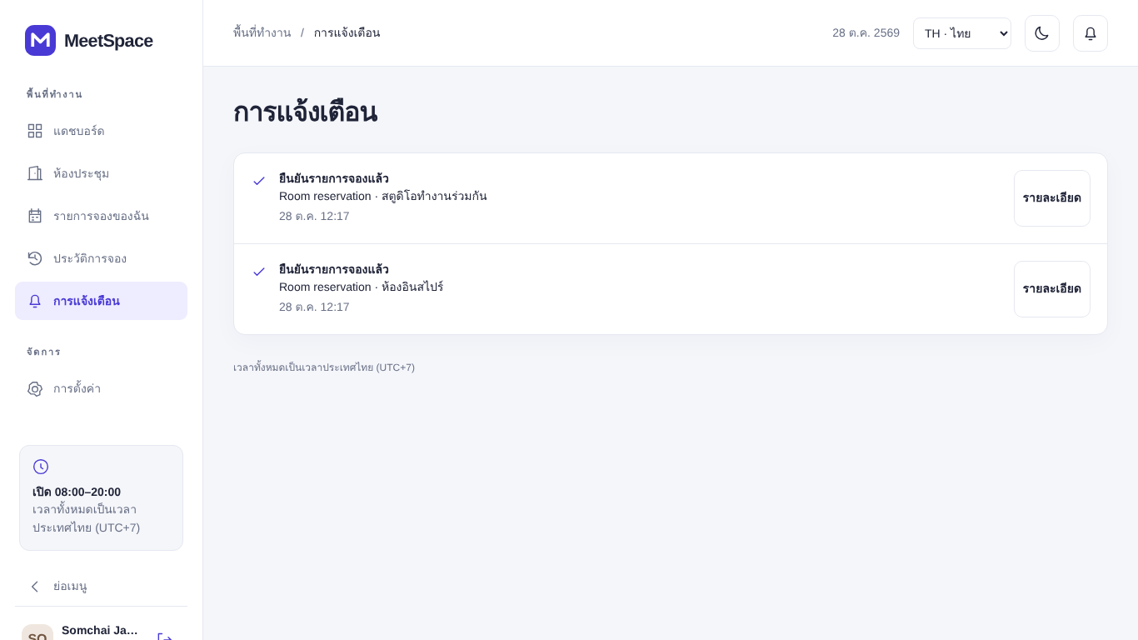
Purpose: | Show confirmation and cancellation events of the user's reservations.
Prerequisite: | - Signed-in user selects Notifications or the bell icon.
Use case procedure: | - The user reads the list and may open the related reservation.
Acceptance Criteria | - Events are ordered newest first.  - Each event shows type, room, date and time.  - The page states that email and Google Calendar are not connected.
Related Function Requirement | FR-13

UI-08: | Settings
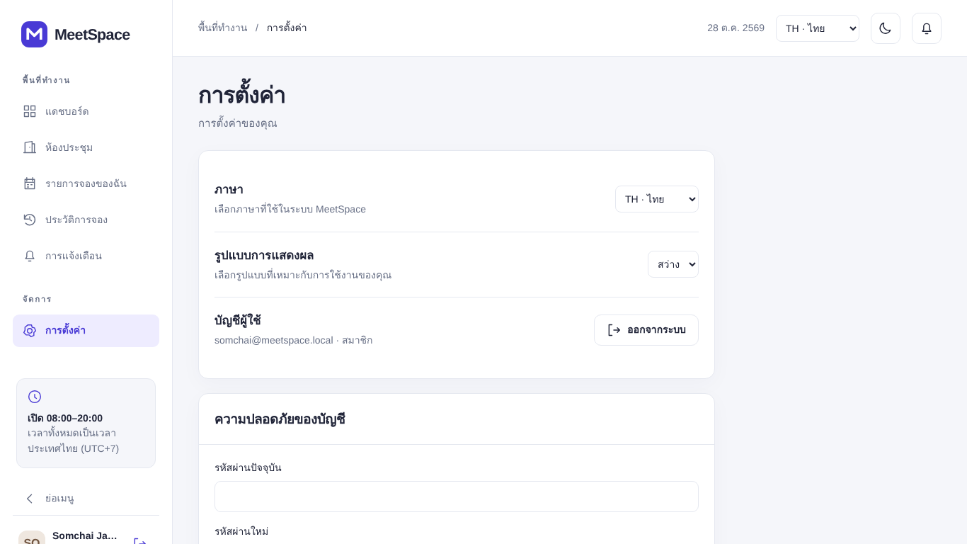
Purpose: | Change language and theme, sign out and change password.
Prerequisite: | - Select Settings in the sidebar (account section requires sign-in).
Use case procedure: | - The user changes language or theme.  - The user enters current and new password and saves.  - The user selects Sign out.
Acceptance Criteria | - Language and theme apply immediately and are remembered.  - A successful password change ends the session and shows "Password changed. Please sign in again."
Related Function Requirement | FR-02, FR-14

UI-09: | Walk-in kiosk - room list
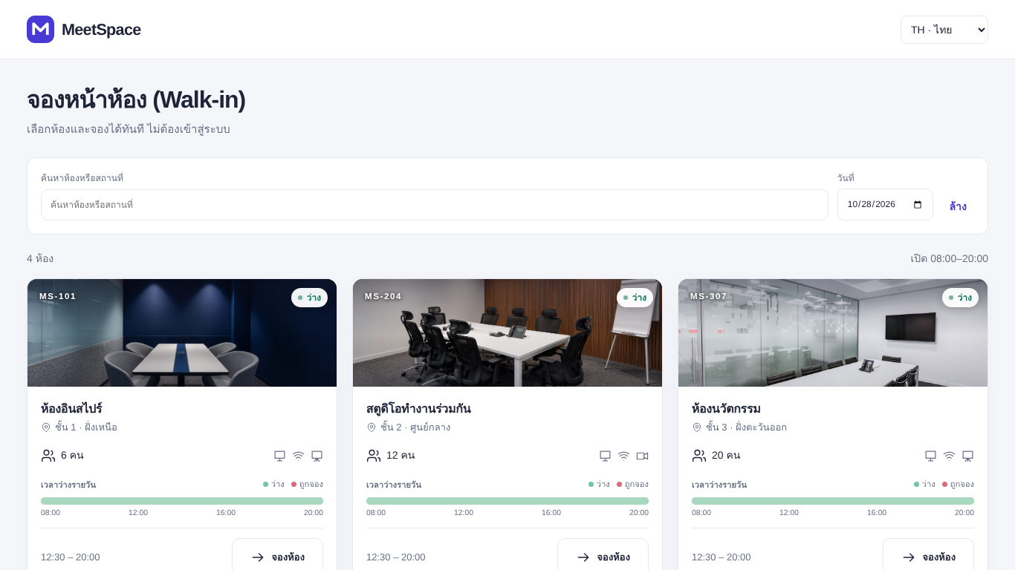
Purpose: | Let a person without an account choose a room on the separate kiosk page.
Prerequisite: | - Open /#walkin on a shared device. No sign-in is needed and the main sidebar is not shown.
Use case procedure: | - The user searches or selects a date.  - The user selects Book on a free room.
Acceptance Criteria | - The page works without a session and never shows earlier bookers.  - Occupied slots are shown anonymously.
Related Function Requirement | FR-03, FR-04, FR-06

UI-10: | Walk-in kiosk - booking form
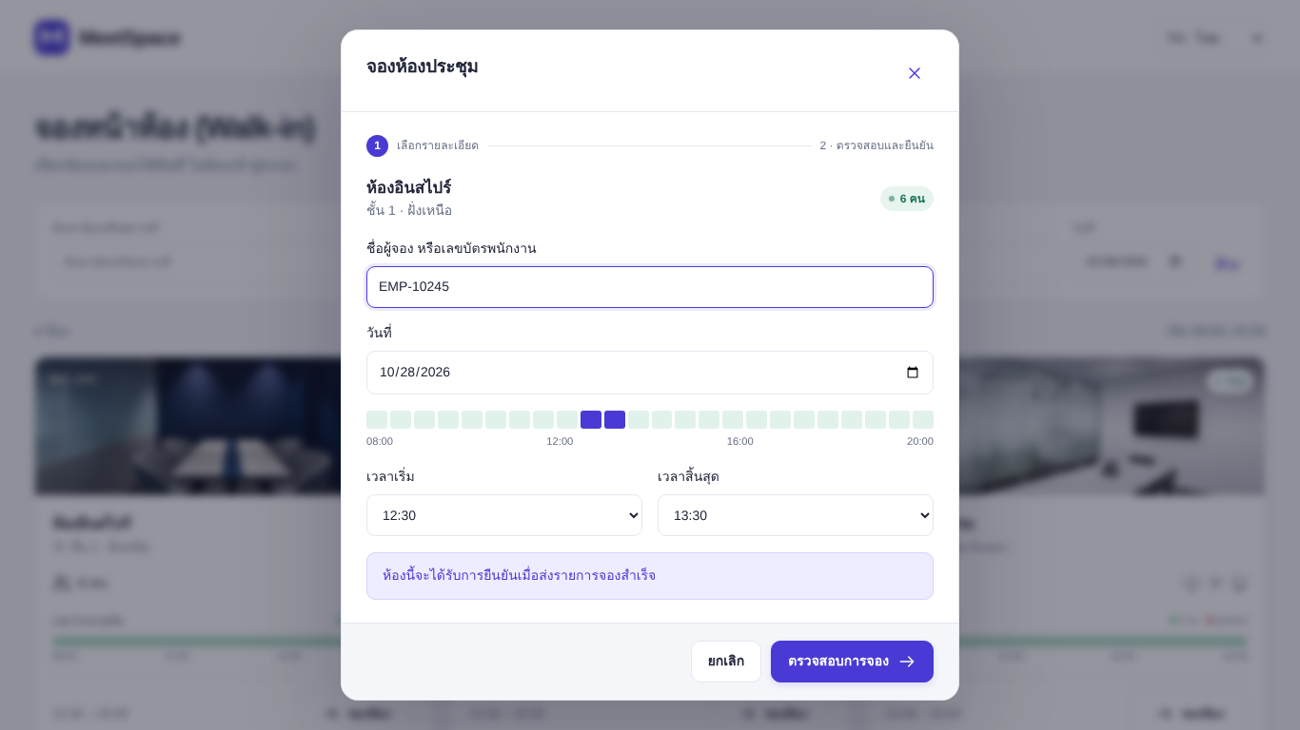
Purpose: | Enter booker name or employee ID and choose a time.
Prerequisite: | - The user selected a room in UI-09.
Use case procedure: | - The user enters a name or employee ID (required).  - The user selects date, start and end time.  - The user reviews and confirms.
Acceptance Criteria | - An empty name or more than 100 characters is rejected.  - A valid request is confirmed immediately and the booking reference is displayed.  - The user is not signed in after booking.
Related Function Requirement | FR-06, FR-07

UI-11: | Administration - Booking management
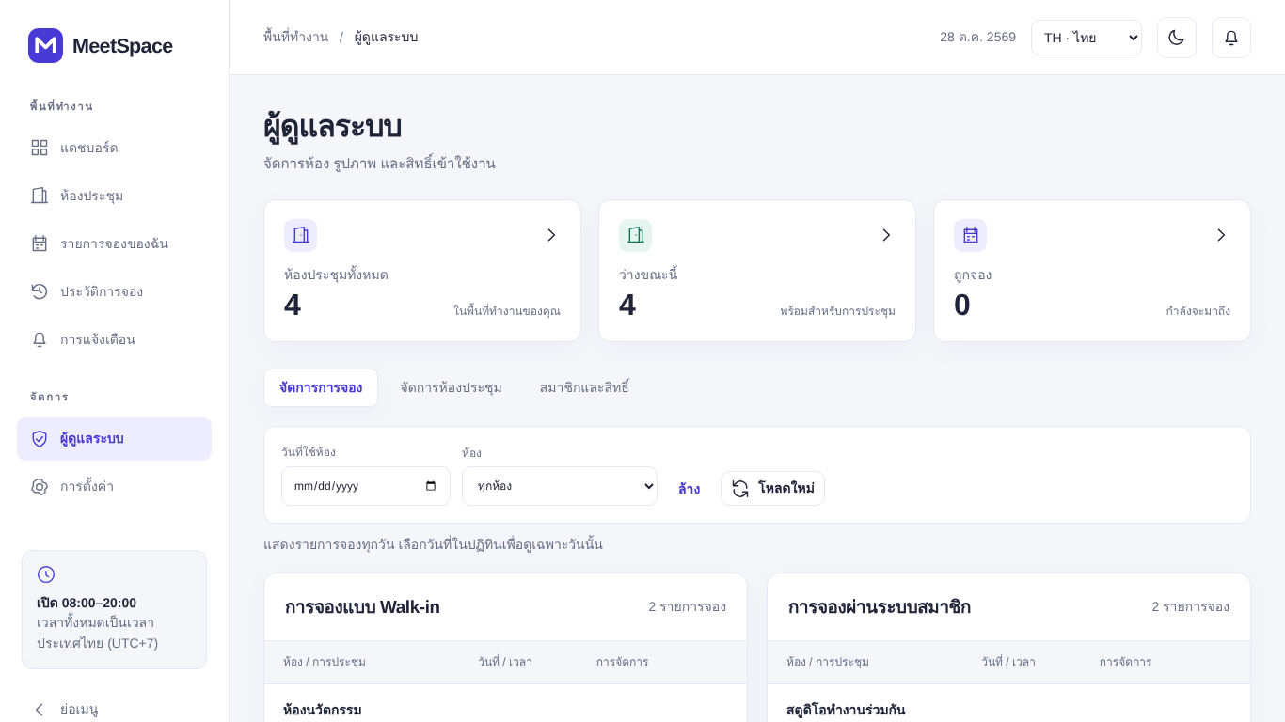
Purpose: | Let an administrator review and cancel all reservations.
Prerequisite: | - Administrator signs in and selects Administration > Booking management.
Use case procedure: | - The administrator selects a reservation date and/or room.  - The administrator reviews the Walk-in bookings and Member bookings lists.  - The administrator opens Details or cancels a reservation.
Acceptance Criteria | - Walk-in and member reservations are shown in separate lists with booker and channel.  - Filters by date and room work together; Clear resets them.  - Only administrators can open this page.
Related Function Requirement | FR-12, FR-09

UI-12: | Administration - Room management
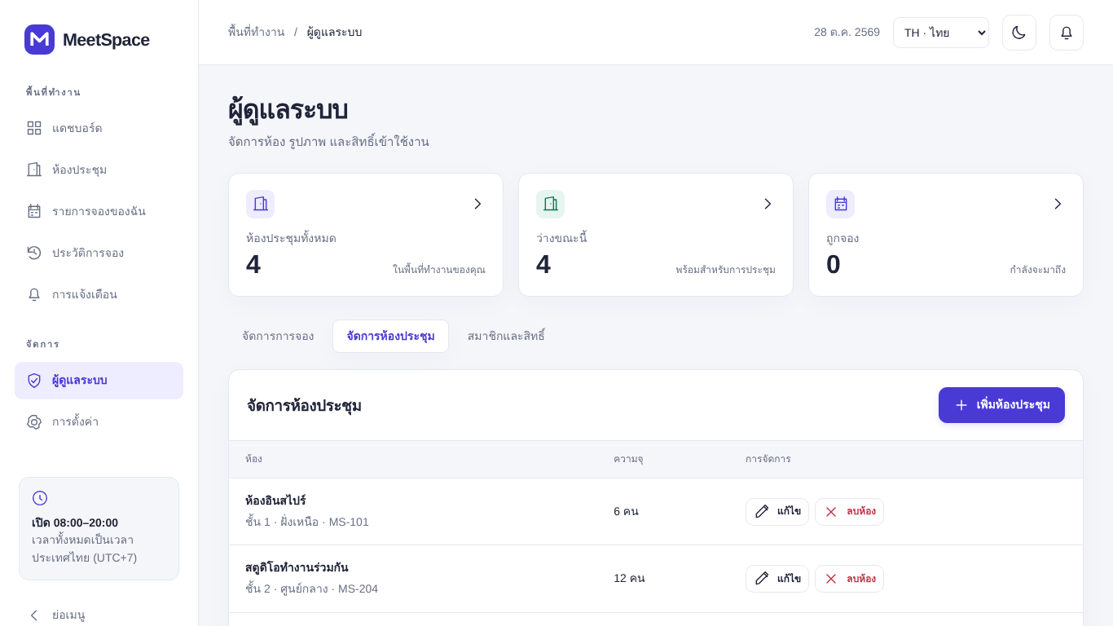
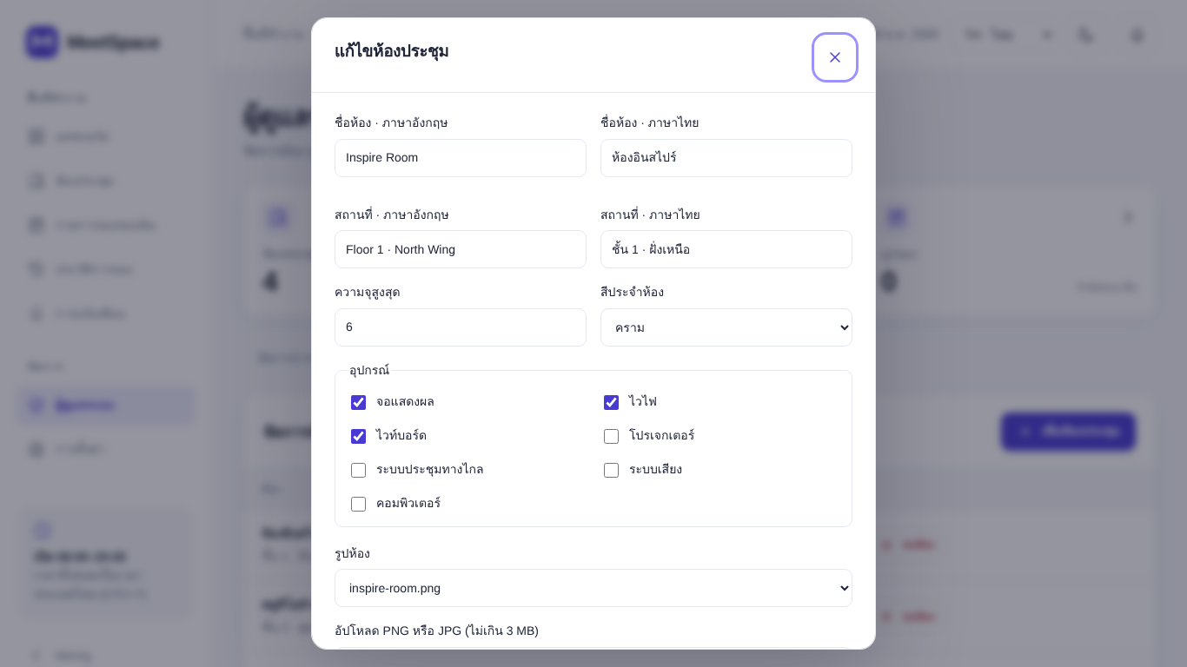
Purpose: | Let an administrator add, edit, change the photo of and delete rooms.
Prerequisite: | - Administrator selects Administration > Room management.
Use case procedure: | - The administrator selects Add room or Edit and fills in the room form (figure below).  - The administrator selects Delete and confirms the warning.
Acceptance Criteria | - Invalid fields or photos are rejected with a message.  - A room with upcoming reservations cannot be deactivated or deleted.  - A deleted room disappears from room lists but stays in booking history.
Related Function Requirement | FR-10

UI-13: | Administration - Members and roles
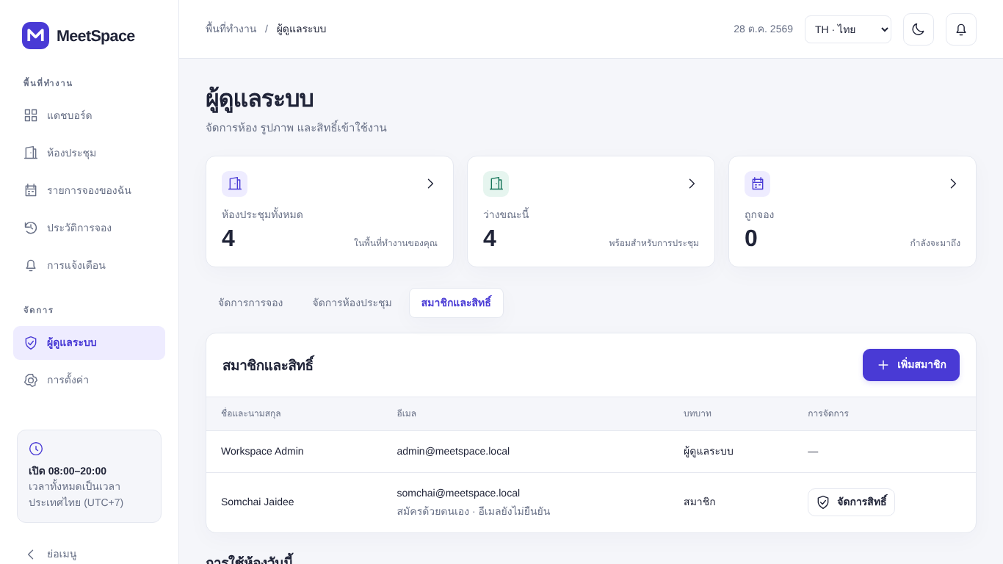
Purpose: | Let an administrator add accounts and change roles.
Prerequisite: | - Administrator selects Administration > Members and roles.
Use case procedure: | - The administrator selects Add member and fills in name, email, password and role.  - The administrator selects Manage on an account to change its role.
Acceptance Criteria | - New accounts can sign in immediately.  - The administrator's own account and the workspace administrator are protected.  - Duplicate emails are rejected.
Related Function Requirement | FR-11

Appendix A: Data Dictionary
The data dictionary follows src/main/resources/schema.sql. Figure 5 shows the entity relationship diagram.
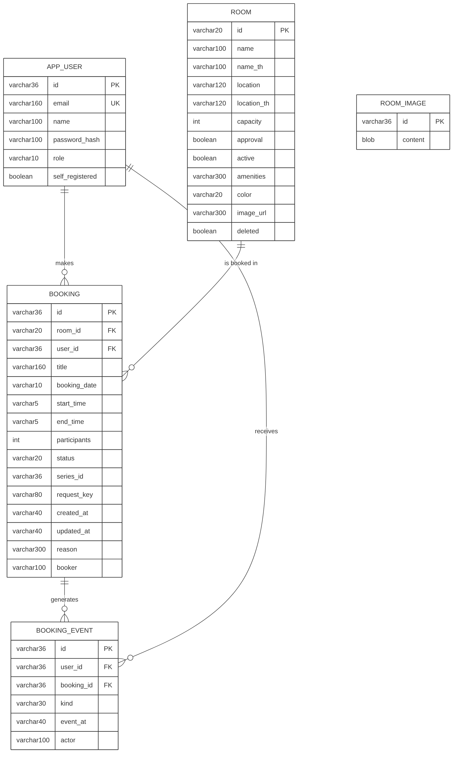
Figure 5 Entity relationship diagram
Table: APP_USER - User accounts, including the seeded workspace administrator and the internal walk-in account.
Attribute | Description | Data type | Key | Example
id | Account identifier (UUID; fixed IDs workspace-admin and walk-in for seeded accounts) | VARCHAR(36) | PK | workspace-admin
email | Sign-in email, unique, stored in lower case | VARCHAR(160) | UK | admin@meetspace.local
name | Display name | VARCHAR(100) |  | Workspace Admin
password_hash | BCrypt hash of the password | VARCHAR(100) |  | $2a$10$Qe...k2
role | user or admin | VARCHAR(10) |  | admin
self_registered | TRUE when created through registration; default FALSE | BOOLEAN |  | FALSE

Table: ROOM - Meeting rooms. Deleted rooms are kept (soft delete).
Attribute | Description | Data type | Key | Example
id | Room code (letters, digits, - or _, max 20) | VARCHAR(20) | PK | MS-101
name | Room name in English | VARCHAR(100) |  | Inspire Room
name_th | Room name in Thai | VARCHAR(100) |  | ห้องอินสไปร์
location | Location in English | VARCHAR(120) |  | Floor 1 · North Wing
location_th | Location in Thai | VARCHAR(120) |  | ชั้น 1 · ฝั่งเหนือ
capacity | Maximum number of people (1-1000) | INT |  | 6
approval | Legacy approval flag; always FALSE in Release 1 | BOOLEAN |  | FALSE
active | Room can be booked; default TRUE | BOOLEAN |  | TRUE
amenities | Comma-separated facility codes; default '' | VARCHAR(300) |  | display,wifi,whiteboard
color | Interface colour: indigo, teal, blue or violet | VARCHAR(20) |  | indigo
image_url | Bundled photo path or /api/room-images/{id} | VARCHAR(300) |  | /images/inspire-room.png
deleted | Soft-delete flag; default FALSE | BOOLEAN |  | FALSE

Table: BOOKING - Reservations from both channels. UNIQUE (user_id, request_key, booking_date).
Attribute | Description | Data type | Key | Example
id | Reservation identifier (UUID); first 8 characters shown as reference | VARCHAR(36) | PK | 3f6c2a91-...-d1e4
room_id | Reserved room | VARCHAR(20) | FK -> ROOM.id | MS-101
user_id | Owner account; walk-in reservations use walk-in | VARCHAR(36) | FK -> APP_USER.id | walk-in
title | Internal label, always "Room reservation"; not entered by users | VARCHAR(160) |  | Room reservation
booking_date | Date, YYYY-MM-DD | VARCHAR(10) |  | 2026-10-29
start_time | Start, HH:mm | VARCHAR(5) |  | 09:00
end_time | End, HH:mm | VARCHAR(5) |  | 10:00
participants | Compatibility field; always 1 | INT |  | 1
status | confirmed or cancelled (pending, rejected are legacy) | VARCHAR(20) |  | confirmed
series_id | Legacy recurring series ID; NULL in Release 1 | VARCHAR(36) |  | NULL
request_key | Duplicate-submission key | VARCHAR(80) | UK (with user_id, booking_date) | 6b1d...-9a0f
created_at | Creation time, ISO-8601 UTC | VARCHAR(40) |  | 2026-10-28T05:16:42Z
updated_at | Last update time, ISO-8601 UTC | VARCHAR(40) |  | 2026-10-28T05:16:42Z
reason | Legacy rejection reason; default '' | VARCHAR(300) |  | ''
booker | Walk-in name/employee ID or member name; default '' | VARCHAR(100) |  | EMP-10245

Table: BOOKING_EVENT - Confirmation and cancellation events used for notifications.
Attribute | Description | Data type | Key | Example
id | Event identifier (UUID) | VARCHAR(36) | PK | a8e0...-77c2
user_id | Recipient (reservation owner) | VARCHAR(36) | FK -> APP_USER.id | 5c1e...-02ab
booking_id | Related reservation | VARCHAR(36) | FK -> BOOKING.id | 3f6c...-d1e4
kind | Event type: confirmed or cancelled | VARCHAR(30) |  | confirmed
event_at | Event time, ISO-8601 UTC | VARCHAR(40) |  | 2026-10-28T05:16:42Z
actor | Name of the account that caused the event | VARCHAR(100) |  | Somchai Jaidee

Table: ROOM_IMAGE - Uploaded room photos stored as PNG bytes; referenced by ROOM.image_url (no declared FK).
Attribute | Description | Data type | Key | Example
id | Image identifier (UUID) | VARCHAR(36) | PK | c2d4...-8e11
content | PNG image bytes | BLOB |  | (binary)

Indexes: idx_booking_room_date (room_id, booking_date), idx_booking_user (user_id), idx_event_user (user_id). Relationships: one APP_USER has many BOOKING and many BOOKING_EVENT; one ROOM has many BOOKING; one BOOKING has many BOOKING_EVENT. Dates and times are stored as text in the formats shown.

