Monthly Sales Report
November 2024 | Prepared by the Business Data Analyst Agent | Data as of 30 Nov 2024
Revenue, Nov 2024  $184,200 | Change vs October  -12.0% | Top product, $31,400  Oak Dining Table

Summary
Revenue for November 2024 was $184,200, down 12.0% from October ($209,318). Revenue was fairly steady from June to October, so November is the first clear drop.
The management report for November (sample) mentions supply delays as a possible factor. The sales data alone does not show whether this caused the fall.

Revenue trend
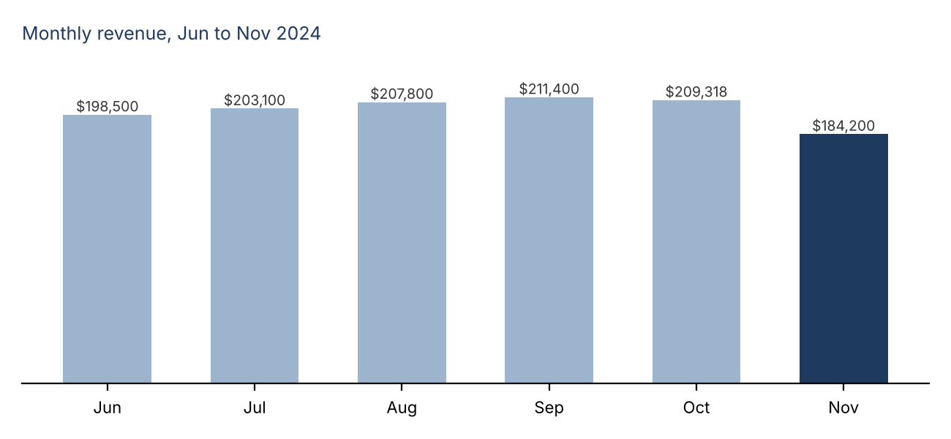

Top products in November
# | Product | Revenue | Share
1 | Oak Dining Table | $31,400 | 17.0%
2 | Ergonomic Office Chair | $27,950 | 15.2%
3 | Standing Desk | $24,600 | 13.4%
4 | Large Bookshelf | $19,800 | 10.7%
5 | 3-Seater Sofa | $18,350 | 10.0%

Findings and recommended actions
Finding | Evidence | Recommended action | Caveat
Revenue fell 12.0% in November. | October $209,318 to November $184,200, down $25,118. | Check stock and delivery records for November before drawing conclusions. | The November management report mentions supply delays. The data does not show that they caused the fall.
Five products make up 66.3% of November revenue. | Top five total $122,100 of $184,200. | Confirm stock levels for these five products are healthy. | Completed orders only. One month of data.
October was already slightly lower than September. | September $211,400 to October $209,318, down 1.0%. | Compare order counts for September to November to see when the dip began. | A 1.0% change is small and may be normal variation.

Sources and notes
- Figures come from run_analysis results: revenue_by_period, period_change and revenue_by_product.
- Revenue means quantity x unit price on completed orders only. Cancelled and returned orders are excluded.
- Explanations taken from documents are reported as stated and are not treated as proven causes.

