November 2024 Revenue Report
2024-11-01 to 2024-11-30 | Prepared by the Business Data Analyst Agent | Data as of 15 Jan 2025
Total Revenue  R40,179 | Units Sold  251 | Highest Category Revenue (Furniture)  R25,659 | Lowest Category Revenue (Office Supplies)  R2,075

Summary
Revenue for November 2024 totaled 4,017,949 cents from 251 units sold across completed orders, as measured by the revenue_by_period analysis.
Furniture was the top category at 2,565,948 cents, while Office Supplies was the lowest at 207,548 cents, a difference of 2,358,400 cents.

Revenue trend
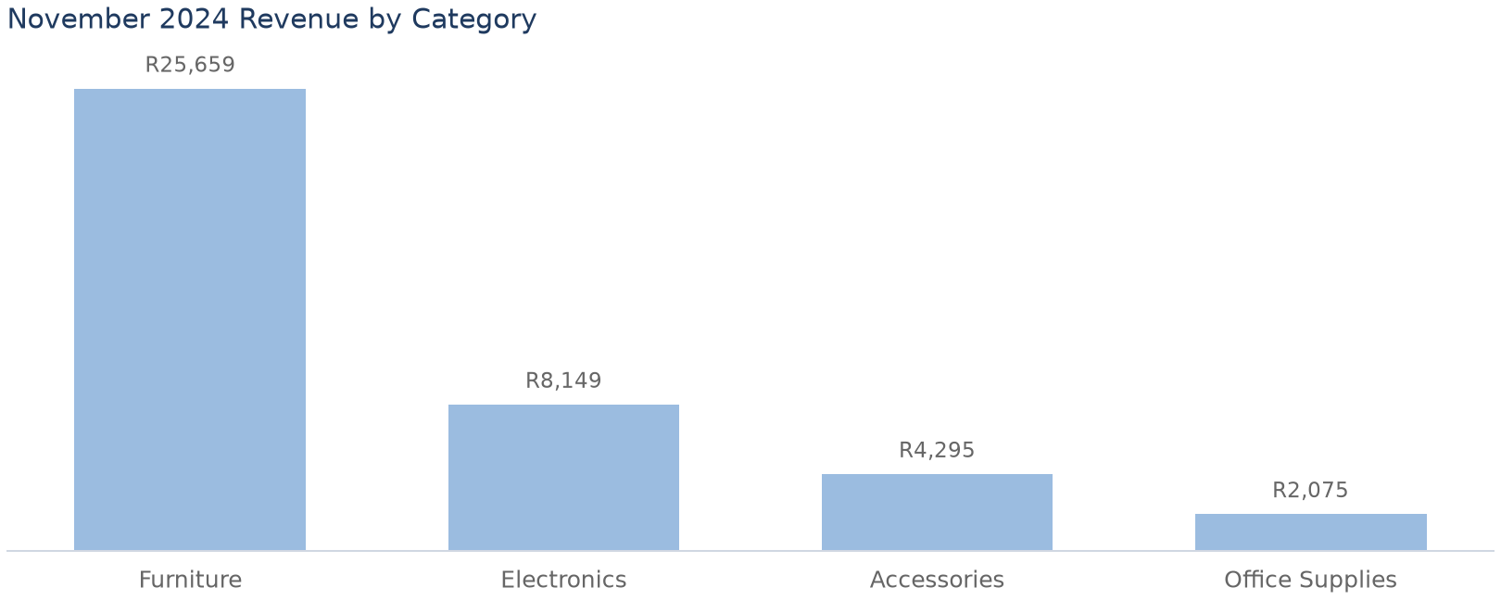

Revenue by Category
category | revenue_cents | units
Furniture | R25,659 | 52
Electronics | R8,149 | 69
Accessories | R4,295 | 78
Office Supplies | R2,075 | 52

Findings and recommended actions
Finding | Evidence | Recommended action | Caveat
Total November 2024 revenue was 4,017,949 cents from 251 units. | revenue_by_period analysis returned 4,017,949 cents and 251 units. | None. | Only completed orders included; cancelled/returned orders excluded.
Furniture was the highest revenue category at 2,565,948 cents. | revenue_by_category category_comparison highest_category = Furniture, highest_revenue_cents = 2,565,948. | None. | None.
Office Supplies was the lowest category at 207,548 cents; the difference is 2,358,400 cents. | revenue_by_category category_comparison lowest_category = Office Supplies, revenue_difference_cents = 2,358,400, difference_percent_of_lowest = 1136.3154. | None. | Percentage reflects difference relative to lowest category.

Sources and notes
- Revenue By Category
- Revenue By Period
- All monetary values are in integer cents.
- Revenue is quantity multiplied by unit price; sales exclude cancelled/returned orders.

