Customer Segments Analysis
2024-01-17 to 2025-01-15 | Prepared by the Business Data Analyst Agent | Data as of 15 Jan 2025
Customers counted  60 | Loyal revenue  R118,295 | At-risk revenue  R81,025

Summary
10 customers are classified as At risk.
The segment labels describe buying patterns, not predictions of customer departure.

Revenue trend
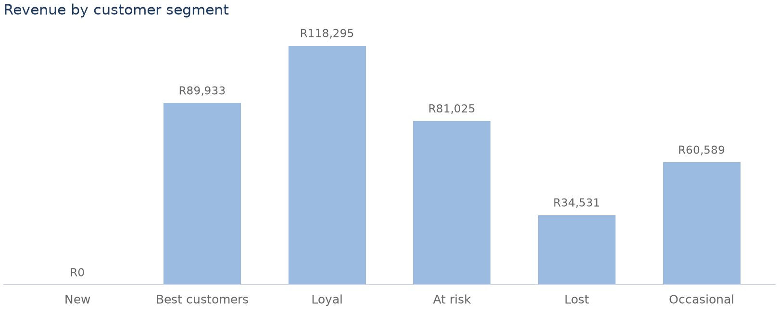

Customer segment summary
Segment | Customers | Revenue | Suggested next step
New | 0 | R0 | Welcome the customer and help them get a successful first experience.
Best customers | 9 | R89,933 | Recognize their value and maintain a proactive account relationship.
Loyal | 17 | R118,295 | Keep the relationship active with relevant service and offers.
At risk | 10 | R81,025 | Review the account history and contact the customer to understand what changed.
Lost | 9 | R34,531 | Choose carefully between a low-cost reactivation attempt and closing the account.
Occasional | 15 | R60,589 | Look for useful purchase patterns and encourage repeat buying where relevant.

Findings and recommended actions
Finding | Evidence | Recommended action | Caveat
At risk customers hold R81,025 of window revenue. | 10 customers meet the configured quiet-but-frequent pattern. | Review the account history and contact the customer to understand what changed. | A descriptive segment label does not predict whether a customer will leave.
Segments account for 60 customers. | Revenue at stake across at-risk and lost customers is R115,556. | Review the account history and contact the customer to understand what changed. | Revenue at stake is descriptive and excludes customers outside those configured segments.

Sources and notes
- Customer Segments
- Segments describe patterns, not predictions.
- Suggested next steps come from segments.json and are not model-generated recommendations.

