November 2024 Finance Report
2024-11-01 to 2024-11-30 | Prepared by the Business Data Analyst Agent | Data as of 15 Jan 2025
Total Revenue  R40,179 | Units Sold  251 | Highest Category Revenue (Furniture)  R25,659 | Top Product Revenue (Standing Desk)  R19,720

Summary
Total revenue for November 2024 was 4,017,949 cents from 251 units sold across completed orders, as measured by the revenue_by_period analysis.
Furniture was the top category at 2,565,948 cents, and the Standing Desk was the top product at 1,971,966 cents.

Revenue trend
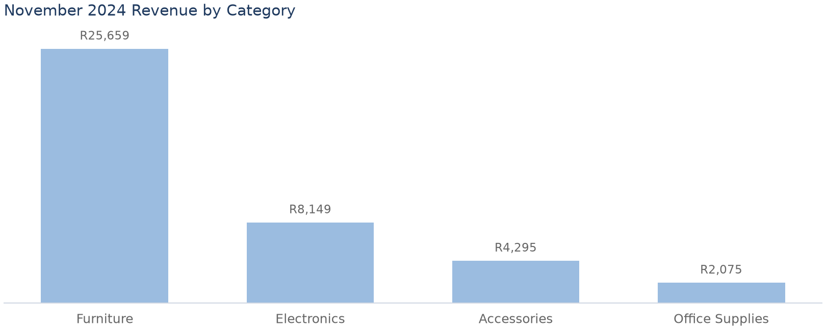

Top Products by Revenue
product_name | category | revenue_cents | units
Standing Desk | Furniture | R19,720 | 34
Ergonomic Chair | Furniture | R5,940 | 18
Noise-Cancelling Headphones | Electronics | R4,560 | 24
Mechanical Keyboard | Accessories | R1,980 | 22
Laptop Stand | Accessories | R1,978 | 43

Findings and recommended actions
Finding | Evidence | Recommended action | Caveat
Total November 2024 revenue was 4,017,949 cents from 251 units. | revenue_by_period analysis returned 4,017,949 cents and 251 units. | None. | Only completed orders included; cancelled/returned orders excluded.
Furniture was the highest revenue category at 2,565,948 cents, versus Office Supplies at 207,548 cents. | revenue_by_category returned Furniture at 2,565,948 cents; category_comparison difference vs lowest is 2,358,400 cents. | None. | None.
The Standing Desk was the top product at 1,971,966 cents from 34 units. | revenue_by_product returned Standing Desk at 1,971,966 cents. | None. | Ranking is by revenue, not volume or margin.

Sources and notes
- Revenue By Product
- Revenue By Category
- Revenue By Period
- All monetary values are in integer cents.
- Revenue is quantity multiplied by unit price; sales exclude cancelled/returned orders.
- No cost or profit data is available in the approved datasets, so this report covers revenue only.

