VisQA – benchmark for VN spoken question answering
- Multimodal – cope with transcription inaccuracies, disfluencies, subtle characteristics of spoken language that differ significantly from edited text
- SQUAD -> Spoken SQUAD – generating ASR transcripts
  - Limitation in Vietnamese spoken modal
- VisQA – converting UiT-ViQuAD dataset into spoken question answering resoung
  - Textual contexts first converted into audio using Google Cloud Text-to-Speech Chirp API
  - Supports multiple Vietnamese voices including variations in pitch and speed
  - Introduced recognition errors
  - Pipeline generates and re-transcribes speech with known parameters
- Reproducible setups for spoken QA can be established before scaling towards natural human speech
- Recognition errors could lead to loss, corruption or shift of original answer span -> additional pre-processing steps required to ensure answerability
  - Each QA pair was processed to re-align original textual answer with ASR-generated transcript using two-stage string-matching procedure
  - Candidate spans first located through direct substring matches, including normalized form where redundant whitespace was collapsed
  - If no direct match found, algorithm mapped normalized position back to original transcript and searched within fixed window of +-50 characters around estimated location
- Span was accepted as ‘confident match’ if original answer text was recovered exactly within the window, otherwise diecard the pair
  - In cases where plausible answers were defined in original dataset – these were treated equivalently to gold answer during matching
- Test set of UIT-ViQuAD does not provide ground-truth answers – validation set was used instead as base for generating ViSQA dataset
  - All examples had accessible gold and plausible answers necessary for realignment and filtering procedures
  - Word Error Rate metrics calculated for training and validation splits generated by Speech-to-Text
    - Need for careful preprocessing and alignment when constructing spoken QA tasks
    - Background noise also introduced into test set – noise augmentation strategy simulates moderate to high-noise conditions and offers more practical test scenario rather than only artificial white noise
    - Different noise condition – can vary transcription quality and observe downstream impact on question-answering model performance
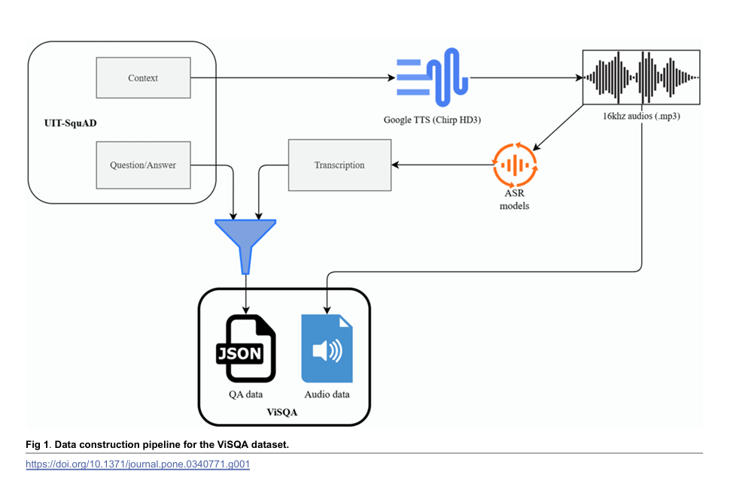
- Final dataset includes 10k QA pairs for training and 1507 QA pairs in test (clean and noise)
  - Extends QA into spken domain by incorporating audio synthesis and controlled noise variants
- Models included – compares monolingual vs multilingual designs and encoder-only vs. encoder-decoder architectures
  - PhoBERT
  - mBERT
  - BARTPho
  - ViT5
  - XLM-R
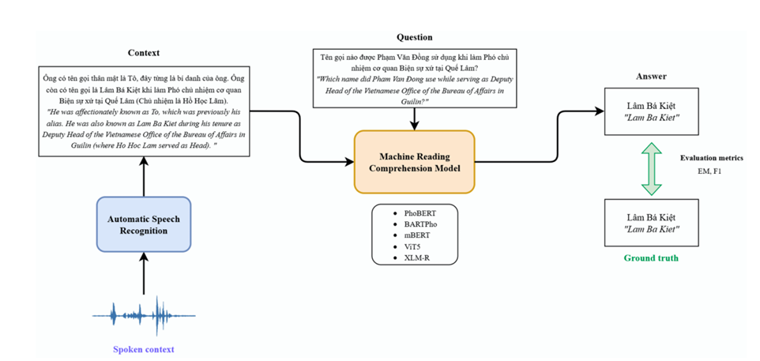
Results
- All models exhibit clear drop in both EM and F1 scores when evaluated on spoken ViSQA-test set compared to original UiT-ViQuAD-dev split
  - Impact of ASR errors and speech variability
- ViT5 consistently achieving highest scores across both conditions
  - Models trained solely on text face considerable challenges when applied to spoken question answering without additional adaptation
- Models fine-tuned on ViSQA’s spoken transcriptions outperform their counterparts trained on clean text
- Downstream QA accuracy tightly coupled to transcript fidelity
- Results emphasize that higher transcription quality at both training and evaluation stages tends to yield better QA performance
  - ASR-induced errors, such as deletions, substitutions or misalignments significantly impact model effectivess
    - Enhancing ASR fidelity through semantic-preserving error correction targeting entities, numbers or temporal markers directly strengthen SQA robustness
  - Weakness observed in causal and inferential question types -> transcription robustness alone is insufficient to ensure semantic readability
    - Explore mechanisms that stabilize and enrich high-level semantic representations ie. knowledge-grounded inference to compensate for missing textual evidence or structured attention designs that are resilient to omission of critical connective words
    - Incorporating human-recorded samples ie. crowd-sourced or scripted dialogues from diverse Vietnamese speakers to quantify performance degradation from spontaneous speech phenomena including hesitations, regional accents and code-switching
Question – if ASR introduce errors that makes

