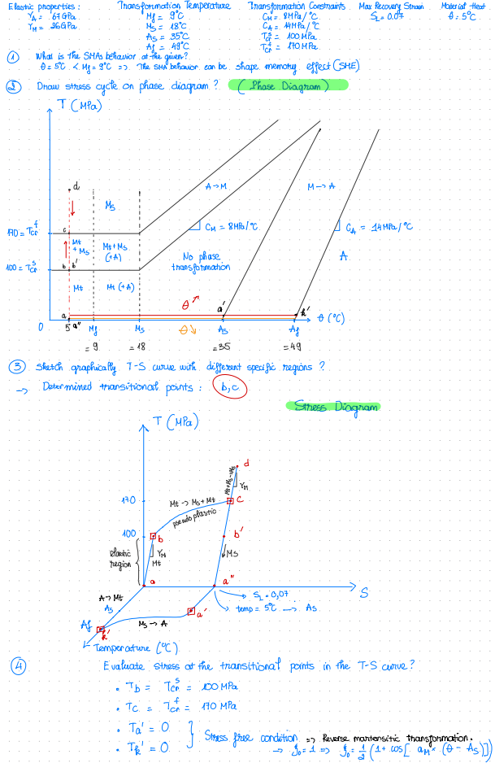Code File:

*import math*

*import numpy as np*

*import matplotlib.pyplot as plt*

*from mpl_toolkits.mplot3d import Axes3D*

*class Shape_Memory_Effect:*

*def __init__(self, YA, YM, Ms, Mf, As, Af, CM, CA, TCRS, TCRF, SL, temp, shiS0, shiT0):*

*self.YA = YA*

*self.YM = YM*

*self.Ms = Ms*

*self.Mf = Mf*

*self.As = As*

*self.Af = Af*

*self.CM = CM*

*self.CA = CA*

*self.TCRS = TCRS*

*self.TCRF = TCRF*

*self.SL = SL*

*self.temp = temp*

*self.shiS0 = shiS0*

*self.shiT0 = shiT0*

*self.shi_lst = []*

*def stress_calculated(self):*

*global Ta, Tb, Tc*

*Ta = 0*

*Tb = self.TCRS*

*Tc = self.TCRF*

*def predicted_through_stress(self):*

*global Tb_predicted, Tc_predicted, Td_predicted, Taf_predicted, Tkf_predicted, Ta_predicted*

*Tb_predicted = np.linspace(Ta, Tb, 20)*

*Tc_predicted = np.linspace(Tb, Tc, 20)*

*for i in Tc_predicted:*

*shiS = ((1 - self.shiS0) / 2) * math.cos((math.pi / (self.TCRS - self.TCRF)) * (i - self.TCRF)) + ((1 + self.shiS0) / 2)*

*self.shi_lst.append(shiS)*

*self.shi_lst = np.array(self.shi_lst)*

*Td_predicted = np.linspace(Tc,Ta,num=20, endpoint=True)*

*Taf_predicted = np.linspace(0,0, num=20, endpoint=True)*

*Tkf_predicted = np.linspace(0,0, num=20, endpoint=True)*

*Ta_predicted = np.linspace(0,0, num=20, endpoint=True)*

*def predicted_through_strain(self):*

*global Sb_predicted, Sc_predicted, Sd_predicted*

*Sb_predicted = Tb_predicted/self.YM*

*Sc_predicted = (Tc_predicted/self.YM) + self.SL*self.shi_lst*

*Sd_predicted = (Td_predicted/self.YM) + self.SL*

*def predicted_through_temp(self):*

*global temp_b_predicted, temp_c_predicted, temp_d_predicted, temp_a_f_predicted, temp_k_f_predicted, temp_a_predicted*

*temp_b_predicted = np.linspace(self.temp,self.temp,num=20, endpoint=True)*

*temp_c_predicted = np.linspace(self.temp,self.temp, num=20, endpoint=True)*

*temp_d_predicted = np.linspace(self.temp,self.temp, num=20, endpoint=True)*

*temp_a_f_predicted = np.linspace(self.temp, self.As, num=20, endpoint=True)*

*temp_k_f_predicted = np.linspace(self.As, self.Af, num=20, endpoint=True)*

*temp_a_predicted = np.linspace(self.Af, self.temp, num=20, endpoint=True)*

*def predicted_through_strain_by_temp(self):*

*global strain_a_f_predicted, strain_k_f_predicted, strain_a_predicted*

*# At a'*

*strain_a_f_predicted = np.linspace(self.SL,self.SL, num=20, endpoint=True)*

*# At k'*

*shi_M_ls = []*

*for i in temp_k_f_predicted:*

*shi_M = 1/2*(1 + math.cos((math.pi/(self.Af-self.As))*(i-self.As)))*

*shi_M_ls.append(shi_M)*

*shi_M_ls = np.array(shi_M_ls)*

*strain_k_f_predicted = self.SL*shi_M_ls*

*# At a*

*strain_a_predicted = np.linspace(0,0, num=20, endpoint=True)*

*def plot_T_S_Temp_curve(self):*

*strain_combined = np.concatenate((Sb_predicted, Sc_predicted, Sd_predicted, strain_a_f_predicted, strain_k_f_predicted, strain_a_predicted))*

*stress_combined = np.concatenate((Tb_predicted, Tc_predicted, Td_predicted, Taf_predicted, Tkf_predicted, Ta_predicted))*

*temp_combined = np.concatenate((temp_b_predicted, temp_c_predicted, temp_d_predicted, temp_a_f_predicted, temp_k_f_predicted, temp_a_predicted))*

*# Create a 3D plot*

*fig = plt.figure(figsize=(10, 8))*

*ax = fig.add_subplot(111, projection='3d')*

*# Plot the 3D curve*

*ax.plot(strain_combined, stress_combined, temp_combined, label='Stress-Strain-Temp Curve', color='blue')*

*# Set axis labels*

*ax.set_xlabel('Strain')*

*ax.set_ylabel('Temperature (°C)')*

*ax.set_zlabel('Stress (MPa)')*

*ax.set_title('Stress-Strain-Temperature Relationship')*

*# Add legend and grid*

*ax.legend()*

*ax.grid(True)*

*# Show plot*

*plt.show()*

*def main():*

*Mf = 9 # °C*

*Ms = 18 # °C*

*As = 35 # °C*

*Af = 49 # °C*

*CM = 8 # MPa/°C (slope for martensite)*

*CA = 14 # MPa/°C (slope for austenite)*

*YM = 26000*

*YA = 67000*

*TCRS = 100 # MPa (start transformation stress)*

*TCRF = 170 # MPa (finish transformation stress)*

*shiT0 = 1*

*shiS0 = 0*

*SL = 0.07*

*temp = 5*

*proc = Shape_Memory_Effect(YA, YM, Ms, Mf, As, Af, CM, CA, TCRS, TCRF, SL, temp, shiS0, shiT0)*

*proc.stress_calculated()*

*proc.predicted_through_stress()*

*proc.predicted_through_strain()*

*proc.predicted_through_temp()*

*proc.predicted_through_strain_by_temp()*

*proc.plot_T_S_Temp_curve()*

*if __name__ == "__main__":*

*main()*

**Result:**

