MINISTRY OF EDUCATION & TRAINING
HO CHI MINH CITY UNIVERSITY OF ECONOMICS AND FINANCE


FINAL REPORT
MOBILE DEVICE PROGRAMMING

FINAL REPORT
TOPIC : RENTAL PROPERTY MANAGEMENT APP

Ho Chi Minh City – 2026
MINISTRY OF EDUCATION & TRAINING
HO CHI MINH CITY UNIVERSITY OF ECONOMICS AND FINANCE

FINAL REPORT
MOBILE DEVICE PROGRAMMING

TOPIC : RENTAL PROPERTY MANAGEMENT APP

Member: Võ Tấn Đạt – 235057130
Phạm Bá Đạt - 235057244

SUPERVISOR(S): Tran Thi Huong, Msc.

Ho Chi Minh City – 2026

ACKNOWLEDGEMENT

First and foremost, we would like to express our sincere gratitude to our lecturer, [Lecturer’s Name], for providing us with valuable knowledge, guidance, and support throughout the Mobile Device Programming course. The lecturer’s instructions and feedback have helped us gain a better understanding of mobile application development and apply the knowledge we have learned to our project.
We would also like to thank our university for providing us with the necessary learning environment and resources to complete this project. The knowledge and practical experience gained during this course have contributed significantly to our understanding of Android application development using Android Studio.
Furthermore, we would like to express our appreciation to our teammates for their cooperation, responsibility, and contributions throughout the process of analyzing requirements, designing interfaces, implementing features, and testing the application. Working together has helped us improve not only our technical skills but also our teamwork, communication, and problem-solving abilities.
Although we have made every effort to complete this project to the best of our abilities, there may still be limitations and shortcomings due to our limited experience and knowledge. We would be grateful for any comments and suggestions from our lecturer to help us improve our work in the future.
Finally, we would like to extend our sincere thanks to everyone who has supported and encouraged us throughout the completion of this project.

LETTER OF GUARANTEE
We hereby declare that this project report, entitled “[Project Title],” submitted as part of the requirements for the Mobile Device Programming course, is our own work, completed under the guidance of our lecturer.
We guarantee that the information, analysis, system design, implementation, and evaluation presented in this report are truthful and reflect the actual work carried out during the development of the project using Android Studio. All materials, references, and sources used in this report have been properly acknowledged and cited where appropriate.
We take full responsibility for the content of this report and confirm that it has not been submitted, in whole or in part, for assessment in any other course or academic program without appropriate acknowledgment.
We understand the importance of academic integrity and accept responsibility for any inaccuracies or violations of academic standards found in this report.

TABLE OF CONTENTS
TABLE OF CONTENTS i
LIST OF ASSIGNMENTS iv
LIST OF ABBREVIATIONS v
LIST OF TABLES vi
LIST OF FIGURES vii
INTRODUCTION 1
Chapter 1 . INTRODUCTION 5
1.1 Background and Problem Statement 5
1.2 Objectives 6
1.2.1 General Objective 6
1.2.2 Detailed Objectives 6
1.3 Scope and Limitations 7
1.3.1 Project Scope 8
1.3.2 Project Limitations 9
Chapter 2 . LITERATURE REVIEW & REQUIREMENTS 10
2.1 Technologies 10
2.1.1 Android Studio 10
2.1.2 Java Programming Language 11
2.1.3 XML for User Interface Design 11
2.1.4 Spring Boot 12
2.1.5 RESTful API 12
2.1.6 Retrofit and Gson 13
2.1.7 MySQL Database 13
2.1.8 JSON Data Format 13
2.2 Requirement analysis 14
2.2.1 Functional Requirement 14
2.2.2 Non-Functional Requirements 17
Chapter 3 . SYSTEM DESIGN 20
3.1 Database Design 20
3.1.1 Entity Relationship Diagram (ERD) 20
3.1.2 Database Table Description 22
3.1.3 Relationship Description 24
3.2 UI/UX Design 27
3.2.1 Design Principles 28
3.2.2 Wireframes and Mockups 29
3.3 Use-Case Diagram 31
3.3.1 Actors 31
3.3.2 Main Use Cases and Interactions 33
3.4 System Architecture 34
3.4.1 Layered Architecture 34
3.4.2 Project Folder Structure 37
Chapter 4 . IMPLEMENTATION & RESULTS 44
4.1 Implementation Environment 44
4.1.1 Development Tools and Technologies 44
4.1.2 System Configuration 45
4.2 Application Implementation 46
4.2.1 Admin App Implementation 46
4.2.2 Tenant App Implementation 48
4.2.3 Backend Implementation 51
4.2.4 Integration Between the Applications and Backend 52
4.3 Testing and Results 53
4.3.1 Testing Approach 53
4.3.2 Test Cases 54
4.3.3 Test Execution and Results 57
4.3.4 Implementation Results 59
4.3.5 Limitations and Future Improvements 59
4.4 Chapter Summary 60
CONCLUSIONS 61
REFERENCES 62

LIST OF ASSIGNMENTS
Member | Student ID | Assignments

LIST OF ABBREVIATIONS
Num. | Abbreviation | Explanation

LIST OF TABLES

LIST OF FIGURES

INTRODUCTION
- Overview
The rapid development of mobile technology has created opportunities to improve the way information is managed and daily activities are performed. Mobile applications are increasingly used in various fields because they provide convenient access to information, support data management, and allow users to perform tasks through smartphones and other mobile devices.
Rental property management is one area that can benefit from the application of mobile technology. Landlords and property managers must handle various tasks, including managing rental rooms, maintaining tenant information, monitoring rental contracts, recording electricity and water consumption, and tracking rental payments. An effective management system can help organize these activities and make important information easier to access.
RENTALY – Rental Property Management Application is developed as a mobile application project to support the management of rental properties. The project focuses on applying the knowledge acquired in the Mobile Device Programming course to analyze requirements, design user interfaces, implement application functions, and connect the mobile application with backend services where applicable.
The system aims to provide a more systematic approach to rental property management by organizing relevant information and supporting common management operations. Through the development of RENTALY, the project demonstrates how Android application development can be applied to a practical problem while improving the development team's technical knowledge and software engineering skills.
- Problem Statement
Managing rental properties involves multiple activities that require accurate information and regular updates. When these activities are performed manually or through separate records, landlords and property managers may encounter difficulties in maintaining consistent information and monitoring the current status of their properties.
One major challenge is managing room information, including room availability, rental prices, and occupancy status. Without an organized system, it may take additional time to identify available rooms or retrieve information about existing tenants. Similarly, maintaining tenant records and rental contracts can become complicated when information is stored in different locations.
Another challenge is monitoring electricity and water consumption and calculating monthly rental expenses. Property managers must record meter readings, determine consumption, apply the appropriate rates, and track payment status. Errors in data entry or calculations may lead to inaccurate charges and difficulties in managing payments.
In addition, information about contract expiration dates, room maintenance, and outstanding payments needs to be monitored regularly. The absence of a centralized management solution may increase administrative workload and make it more difficult to obtain an overview of rental operations.
Therefore, the main problem addressed by this project is the need for a convenient and organized solution that supports essential rental property management activities. RENTALY aims to address this need through an Android-based application that provides access to relevant management information and supports the operations included in the project's scope.
- Objectives of the Study Methodology
The main objective of this project is to develop an Android application that supports rental property management and demonstrates the practical application of mobile programming technologies. The project seeks to improve the organization of rental-related information and provide convenient access to essential management functions.
The specific objectives include:
- Analyzing the requirements of a rental property management system.
- Designing user interfaces that are clear, consistent, and easy to navigate.
- Implementing the main functions for managing rooms, tenants, and rental contracts.
- Supporting electricity and water meter recording and rental expense management where included in the implementation.
- Applying suitable techniques for data storage, data processing, and communication with backend services.
- Testing the implemented functions to identify errors and evaluate whether the application meets its requirements.
Improving practical skills in Android development, interface design, application architecture, and problem-solving.
To achieve these objectives, the project follows a systematic development methodology.
First, requirement analysis is conducted to identify the problems associated with rental property management and determine the functions required by the intended users.
Second, system design is performed to establish the application structure, database design where applicable, user interface layouts, and interactions between system components.
Third, implementation is carried out using Android Studio and the programming technologies selected for the project. The application functions are developed according to the defined requirements, with backend integration where applicable.
Finally, testing and evaluation are conducted to verify the application's functions, examine its behavior under different conditions, and identify areas that require improvement.
This methodology provides a structured approach to developing the application and helps ensure that the final product is consistent with the project's objectives and scope.
- Thesis Structure
This report is organized into four main chapters, in addition to the introductory section, conclusion, and references.
Chapter 1: Introduction presents the background of the project, the problem statement, the general and specific objectives, and the scope and limitations of the application.
Chapter 2: Literature Review and Requirements discusses the technologies used in the project and presents the functional and non-functional requirements of the system.
Chapter 3: System Design describes the database design, entity relationship diagram, database table structures, user interface and user experience design, use-case diagram, system architecture, and project folder structure.
Chapter 4: Implementation and Results explains the implementation of the application, introduces its main functions and user interfaces, and presents the testing process and evaluation results.
Finally, the Conclusions section summarizes the achievements of the project, identifies the remaining limitations, and proposes potential directions for future development. The References section lists the materials and documentation consulted during the development and preparation of this report.

INTRODUCTION

Background and Problem Statement
In recent years, the development of mobile technology has significantly changed the way people manage information and perform daily tasks. Mobile applications have become increasingly popular due to their convenience, accessibility, and ability to provide users with essential services anytime and anywhere. In particular, mobile applications can help simplify administrative tasks, improve information management, and reduce the time required to perform repetitive operations.
Rental property management is one area where the application of information technology can provide significant benefits. Landlords and property managers are often responsible for managing multiple rooms, maintaining tenant information, monitoring rental contracts, recording electricity and water consumption, calculating monthly expenses, and tracking payments. When these activities are handled manually using paper records or separate spreadsheets, the management process can become time-consuming and complicated. Information may be inconsistent, records may be misplaced, and calculating monthly rental expenses may lead to errors.

Furthermore, keeping track of contract expiration dates, unpaid rental fees, and room availability can be challenging when information is not organized in a centralized system. These difficulties may affect management efficiency and make it harder for landlords to access accurate information when making decisions.
To address these problems, the RENTALY – Rental Property Management Application is proposed as a mobile-based solution that supports the management of rental properties. The application aims to provide a more organized and convenient approach to handling rental information through a mobile interface. Its intended functions include room management, tenant information management, rental contract management, electricity and water meter readings, monthly expense calculations, payment tracking, and basic management statistics.
The project focuses on applying the knowledge and practical skills acquired in the Mobile Device Programming course to the development of an Android application using Android Studio. Through this project, the development team aims to create an application that improves the accessibility of rental management information and demonstrates the practical application of mobile programming concepts in solving a real-world problem.

Objectives
The main objective of this project is to analyze, design, and develop the RENTALY mobile application to support rental property management. The project applies mobile application development techniques to organize rental-related information and provide convenient access to essential management functions.
The objectives are divided into a general objective and several detailed objectives to establish a clear direction for the development process.

General Objective
The general objective of this project is to develop an Android-based rental property management application that helps landlords and property managers manage rooms, tenants, rental contracts, utility consumption, and payment information more efficiently.
The application is intended to provide a user-friendly interface, organize information systematically, and reduce the effort required to perform common rental management tasks. In addition, the project aims to strengthen practical knowledge of Android application development, interface design, data management, and communication between mobile applications and backend services, where applicable.

Detailed Objectives
To achieve the general objective, the project establishes the following detailed objectives:
- Analyze system requirements: Identify the needs of landlords and property managers and determine the functional and non-functional requirements of the application.
- Design the user interface: Develop an intuitive and consistent mobile interface that allows users to navigate between management functions easily.
- Manage rental rooms: Support the organization of room information, including room codes, rental prices, areas, and occupancy statuses.
- Manage tenant information: Provide functions for viewing and maintaining tenant details in accordance with the application's implemented features.
- Manage rental contracts: Organize contract information and support the monitoring of contract statuses and expiration dates.
- Manage utility consumption and expenses: Support the recording of electricity and water meter readings and the calculation of related charges where these functions are implemented.
- Support payment tracking: Provide a way to monitor rental charges, payment records, and outstanding balances within the scope of the system.
- Apply Android development technologies: Use Android Studio and the selected programming technologies to implement the application's interface, navigation, business logic, and data handling.
- Test and evaluate the application: Verify the implemented functions, identify potential errors, and evaluate the application's ability to meet the defined requirements.
Through these objectives, the project seeks to produce a practical mobile application while improving the development team's technical skills, analytical thinking, and problem-solving abilities.

Scope and Limitations
This section defines the boundaries of the RENTALY project, including the functions covered by the application and the limitations that may affect its implementation and evaluation.

Project Scope
The project focuses on developing a mobile application for rental property management using the Android platform. The primary target users are landlords and property managers who need to organize information and monitor the daily operations of rental properties.
The functional scope of the project includes the following areas:
1. Room Management
The application is designed to organize information about rental rooms, including room identification, rental prices, room areas, and occupancy statuses. This information helps property managers identify available rooms and monitor the current condition of their rental properties.
2. Tenant Management
The application supports the organization of tenant information to help property managers maintain records associated with individuals renting the rooms. The specific information and operations depend on the functions implemented in the system.
3. Rental Contract Management
The system is designed to organize rental contract information and support the monitoring of contract statuses, including active contracts, contracts approaching expiration, and completed contracts, where supported by the implementation.
4. Electricity and Water Meter Management
The application aims to support the recording of previous and current electricity and water meter readings. Based on the recorded consumption and applicable unit prices, the system can calculate utility charges to support monthly rental expense management.
5. Invoice and Payment Management
The application is intended to assist in organizing monthly rental charges, utility expenses, payment records, and outstanding balances. These functions aim to make financial information easier to review and monitor.
6. Repair Request Management
Where implemented, the system can support the recording and monitoring of maintenance or repair requests related to rental rooms, helping property managers keep track of issues that require attention.
7. Dashboard and Statistics
The application may provide an overview of important management information, such as the number of rooms, room occupancy, payment status, and other relevant statistics supported by the system.
8. Mobile Application Development
The project uses Android Studio as the primary development environment. The application interface, navigation, data processing, and communication with external services are implemented according to the selected technologies and the actual system architecture.
The project scope is limited to the functions developed for the academic assignment. Advanced features such as online payment gateway integration, automated notifications through external services, and large-scale deployment are not considered part of the project unless explicitly implemented.

Project Limitations
Although the RENTALY application aims to improve rental property management, several limitations may remain due to the project's academic scope, development time, and available resources.
First, the range of supported functions may be limited compared with commercial rental management platforms. Certain advanced management operations may not be included in the current version of the application.
Second, the user experience and application performance may vary depending on the Android device, operating system version, network conditions, and available device resources.
Third, if the application relies on a backend server and remote database, some functions may depend on the availability of the server and network connectivity. Network interruptions or server errors may affect data retrieval and updates.
Fourth, the accuracy of rental expense calculations depends on the correctness of the recorded meter readings, rental prices, utility rates, and other relevant input data. Incorrect input may result in inaccurate calculations.
Finally, the application is developed primarily for educational purposes. Its testing and evaluation may be limited to a controlled development environment and a relatively small number of test cases. Further testing, security improvements, usability evaluation, and performance optimization may be required before the application can be deployed for extensive real-world use.
Despite these limitations, the project provides an opportunity to apply mobile programming knowledge to a practical management problem and establishes a foundation for future improvements to the RENTALY application.

LITERATURE REVIEW & REQUIREMENTS

Technologies
The RENTALY project is developed to support rental property management through Android mobile applications. The system consists of an administrative application for managing rental properties and a tenant application for providing tenants with access to relevant information and services. A backend server processes requests from the mobile applications and communicates with the database to store and retrieve information.
Several technologies are used in the development process, including Android Studio, Java, XML, Spring Boot, RESTful APIs, Retrofit, Gson, and MySQL. Each technology serves a specific purpose in the system architecture and contributes to the overall functionality of the application.

Android Studio
Android Studio is the official integrated development environment (IDE) for Android application development. It provides tools for writing code, designing user interfaces, managing dependencies, debugging applications, and testing software on physical devices or Android emulators.
In the RENTALY project, Android Studio is used to develop both the Admin and Tenant applications. It supports source code management, XML layout design, Gradle configuration, and application deployment. The development environment also allows developers to inspect application behavior and identify errors during implementation and testing.

Java Programming Language
Java is an object-oriented programming language widely used in Android application development. Its object-oriented features allow developers to organize application logic into classes and objects, making the source code easier to maintain and extend.
In RENTALY, Java is used to implement application logic, handle user interactions, process data returned by the backend, and manage navigation between screens. Classes can be organized according to their responsibilities, such as activities, adapters, models, API services, and utility classes.
Using Java also allows the project to apply fundamental programming concepts, including encapsulation, inheritance, exception handling, and modular software design.

XML for User Interface Design
Extensible Markup Language (XML) is used to define the structure and appearance of Android user interfaces. XML layout files describe interface components such as text fields, buttons, text views, images, and lists.
In the RENTALY project, XML is used to construct the screens of the Admin and Tenant applications. Separating interface layouts from Java logic makes the application easier to organize and maintain. Developers can modify the appearance of a screen without placing all interface definitions directly inside Java source files.
XML resources can also be used to define colors, strings, dimensions, styles, and themes to maintain a consistent visual design throughout the applications.

Spring Boot
Spring Boot is a Java-based framework used to develop standalone backend applications and web services. It simplifies server configuration and supports the development of RESTful APIs for communication between clients and server-side components.
In RENTALY, Spring Boot provides the backend services required by the mobile applications. It receives client requests, validates input data, executes business logic, and returns responses to the applications. It also handles communication with the MySQL database through the backend's data-access components.
The backend architecture separates server-side business logic from the Android interface. This separation helps centralize data processing and allows multiple client applications to use the same services.

RESTful API
A Representational State Transfer (REST) API enables different software components to communicate over HTTP. Mobile applications can send requests to a server and receive structured responses without directly accessing the server's database.
Common HTTP methods include:
- GET: Retrieve information from the server.
- POST: Create a resource or submit data for processing.
- PUT: Update an existing resource.
- DELETE: Remove a resource when permitted.
In RENTALY, RESTful APIs provide communication between the Android applications and the Spring Boot backend. For example, the Admin application can request user information, retrieve room data, or submit updates to the server. The Tenant application can use the endpoints provided for tenant-related operations.
Using an API-based architecture prevents mobile clients from connecting directly to MySQL and allows the backend to control data validation, access permissions, and business rules.

Retrofit and Gson
Retrofit is an HTTP client library that simplifies communication between Android applications and RESTful web services. It allows developers to define API endpoints through Java interfaces and convert HTTP responses into Java objects.
Gson is a library used to convert Java objects to JSON and deserialize JSON data into Java objects. JSON provides a structured format for transferring data between the Android applications and the backend.
In RENTALY, Retrofit is used to send HTTP requests to the Spring Boot server. Gson is used to process JSON request bodies and responses. Data models and Data Transfer Objects (DTOs) help represent information exchanged between the client and server.
These technologies reduce the amount of networking code required and make API communication easier to organize and maintain.

MySQL Database
MySQL is a relational database management system used to store structured information. It organizes data into tables consisting of rows and columns and supports relationships through primary keys and foreign keys.
In RENTALY, MySQL is used to manage persistent application data, including user accounts, tenant information, room information, rental locations, and other entities required by the system.
The relational database structure helps maintain data consistency and reduce unnecessary duplication. Constraints and relationships also help prevent invalid references between related records.
The Android applications communicate with the database through the Spring Boot backend rather than connecting to MySQL directly. This approach allows database operations to be controlled by server-side logic and access permissions.

JSON Data Format
JavaScript Object Notation (JSON) is a lightweight data-interchange format that represents information using objects, arrays, and key-value pairs. It is commonly used in web services because it is readable and supported by many programming languages.
In RENTALY, JSON is used to exchange information between the Android clients and the backend. For example, a server response may contain a user's identifier, name, email address, or role. Retrofit and Gson help convert this information into Java objects for use within the application.
The use of JSON provides a consistent data format for communication between the Android applications and the backend services.

Requirement analysis
Requirement analysis identifies the functions and quality attributes that the RENTALY system must provide. It establishes the expected behavior of the applications and serves as a basis for system design, implementation, and testing.
The system is designed around two primary user groups: administrators and tenants. Administrators are responsible for managing rental property information and related records, while tenants use the tenant application to access the functions made available to them.
The requirements are divided into functional and non-functional requirements.

Functional Requirement
Functional requirements describe the operations that the system must support. The following requirements represent the main functions of RENTALY and should be finalized according to the features implemented in the actual project.
A. Authentication and User Access
FR01 – User Login
The system shall allow users to submit their login credentials through the appropriate application. The backend shall process the authentication request and return a response indicating whether the login attempt is successful.
FR02 – Role-Based Access
The system shall distinguish between administrators and tenants. Each user shall be provided with access to the functions permitted for their role.
FR03 – User Information Management
The Admin application shall allow authorized administrators to retrieve and manage user information. The system shall support the relevant operations for viewing, creating, updating, and deleting user records where these operations are implemented and permitted.
B. Rental Location Management
FR04 – View Rental Locations
The system shall allow authorized users to retrieve information about rental locations from the backend.
FR05 – Manage Rental Locations
The Admin application shall support the creation, viewing, updating, and deletion of rental location records according to the system's business rules.
C. Room Management
FR06 – View Room Information
The system shall retrieve and display room information, including relevant details such as room identifiers, rental prices, room status, and associated rental locations when available.
FR07 – Manage Rooms
The Admin application shall provide the supported operations for adding, updating, viewing, and deleting room records.
FR08 – Validate Room Data
The system shall validate required room information before submitting changes. Invalid or incomplete input should be handled appropriately, and the user should receive meaningful feedback.
D. Tenant Information Management
FR09 – View Tenant Information
The system shall allow authorized users to retrieve tenant information associated with the rental management process.
FR10 – Manage Tenant Records
The system shall support the tenant-related operations implemented in the backend and exposed through the corresponding mobile application.
E. API Communication and Data Handling
FR11 – Retrieve Data from the Backend
The Android applications shall send requests to the backend to retrieve the information required by their respective screens.
FR12 – Submit Data Changes
When a user performs an authorized operation, the application shall submit the required information to the backend and process the returned response.
FR13 – Handle Errors
The applications shall handle common errors, including invalid input, unsuccessful authentication, network failures, and server errors. Appropriate messages should be displayed to help users understand the result of their actions.
FR14 – Display Updated Information
After a successful data modification, the application should refresh or update the relevant information to reflect the latest data returned by the backend.
Summary of Functional Requirements
Requirement ID | Requirement | Primary User
FR01 | User login | Admin and Tenant
FR02 | Role-based access | Admin and Tenant
FR03 | User information management | Admin
FR04 | View rental locations | Admin
FR05 | Manage rental locations | Admin
FR06 | View room information | Admin
FR07 | Manage rooms | Admin
FR08 | Validate room data | Admin
FR09 | View tenant information | Authorized users
FR10 | Manage tenant records | Authorized users
FR11 | Retrieve backend data | Admin and Tenant
FR12 | Submit authorized data changes | Authorized users
FR13 | Handle errors | Admin and Tenant
FR14 | Display updated information | Admin and Tenant

Non-Functional Requirements
Non-functional requirements describe the quality attributes and operational constraints of the system. They specify how the applications should behave rather than defining individual business operations.
A. Usability
The applications should provide clear navigation, readable content, and consistent interface components. Buttons, input fields, and messages should be designed to help users complete tasks with minimal confusion.
The Admin application should organize management functions logically, while the Tenant application should focus on the information and operations relevant to tenants.
B. Performance
The applications should process user interactions and display retrieved information within a reasonable amount of time under normal operating conditions.
Network requests should be handled asynchronously where appropriate to prevent lengthy operations from blocking the user interface. Large datasets should be displayed efficiently, and unnecessary requests should be minimized.
C. Reliability
The system should handle unexpected situations without terminating unexpectedly. These situations may include network disconnections, unavailable servers, invalid server responses, and incorrect user input.
The applications should provide appropriate error messages and allow users to retry operations when suitable. Data changes should be considered successful only after the backend confirms the operation.
D. Security
The system should protect user information and restrict operations according to the authenticated user's permissions.
Authentication and authorization should be enforced by the backend rather than relying only on restrictions in the mobile interface. Passwords should not be stored in plain text, sensitive information should not be exposed unnecessarily in application logs, and production communication should use HTTPS.
E. Maintainability
The source code should be organized into logical components according to their responsibilities. Separating interface logic, data models, API services, and supporting utilities helps simplify debugging and future development.
Shared configurations and reusable components should be used where appropriate to reduce code duplication between related functions.
F. Compatibility
The Android applications should operate on Android versions supported by the project's SDK configuration. Layouts should remain usable across supported screen sizes and device resolutions.
The application should also be tested on an Android emulator or physical device to identify compatibility and runtime issues.
G. Data Integrity
The system should maintain consistent relationships between users, tenants, rental locations, rooms, and other related records.
Required fields and database constraints should prevent invalid data from being stored. Operations involving related records should respect the foreign-key constraints and business rules defined by the backend and database.
H. Network Communication
The applications should communicate with the backend through the configured API base URL and supported HTTP endpoints. They should process successful responses, validation errors, authentication failures, and connectivity problems appropriately.
The system should not require the Android applications to connect directly to the MySQL database.
Summary of Non-Functional Requirements
Requirement ID | Category | Description
NFR01 | Usability | Provide clear and consistent user interfaces
NFR02 | Performance | Respond within a reasonable time under normal conditions
NFR03 | Reliability | Handle errors and unexpected conditions appropriately
NFR04 | Security | Protect user information and enforce access permissions
NFR05 | Maintainability | Organize source code into manageable components
NFR06 | Compatibility | Support the Android versions and devices targeted by the project
NFR07 | Data Integrity | Maintain valid and consistent database relationships
NFR08 | Network Communication | Handle API requests and responses reliably

Chapter Summary
This chapter has presented the technologies and requirements underlying the RENTALY rental property management system. Android Studio, Java, and XML are used to develop the mobile applications, while Spring Boot provides backend services and RESTful APIs. Retrofit and Gson support communication between the Android clients and the backend, and MySQL provides persistent data storage.
The requirement analysis identifies the principal functional requirements for authentication, user management, rental location management, room management, tenant information, and API communication. It also establishes non-functional requirements related to usability, performance, reliability, security, maintainability, compatibility, data integrity, and network communication.
These technologies and requirements provide the foundation for the system design presented in Chapter 3 and the implementation and evaluation described in Chapter 4.

SYSTEM DESIGN

Database Design
The database design is an essential part of the RENTALY system because it determines how information about users, rental locations, rooms, contracts, services, invoices, and maintenance requests is stored and managed. The system uses MySQL as its relational database management system. The database schema defines primary keys, foreign keys, unique constraints, and data validation rules to maintain data integrity and consistency.
The database is designed to support two main user groups: landlords or property managers, who manage rental operations, and tenants, who access information related to their rental arrangements. The database also supports operational activities such as recording electricity and water readings, generating invoices, managing announcements, and tracking maintenance requests.

Entity Relationship Diagram (ERD)
The Entity Relationship Diagram (ERD) illustrates the entities in the RENTALY database and the relationships between them. The database schema contains 18 main tables, which can be organized into four functional groups:
- User and access management: role, user, and tenant.
- Rental property management: location, room, room_image, rental_contracts, and contract_tenants.
- Services and billing management: service, room_service, meter, meter_reading, invoice, and invoice_item.
- Communication and maintenance management: announcement, user_announcement, maintenance_requests, and request_image.
The role table defines the roles available in the system, while the user table stores login credentials and account status. The tenant table stores personal information about tenants. Rental locations contain rooms, and each room can be associated with rental contracts, service assignments, and utility meters. Contracts connect tenants to rented rooms, while invoices record the charges associated with a contract.
The communication and maintenance entities allow the system to store announcements, track their reading status for individual users, and record maintenance requests together with related images.
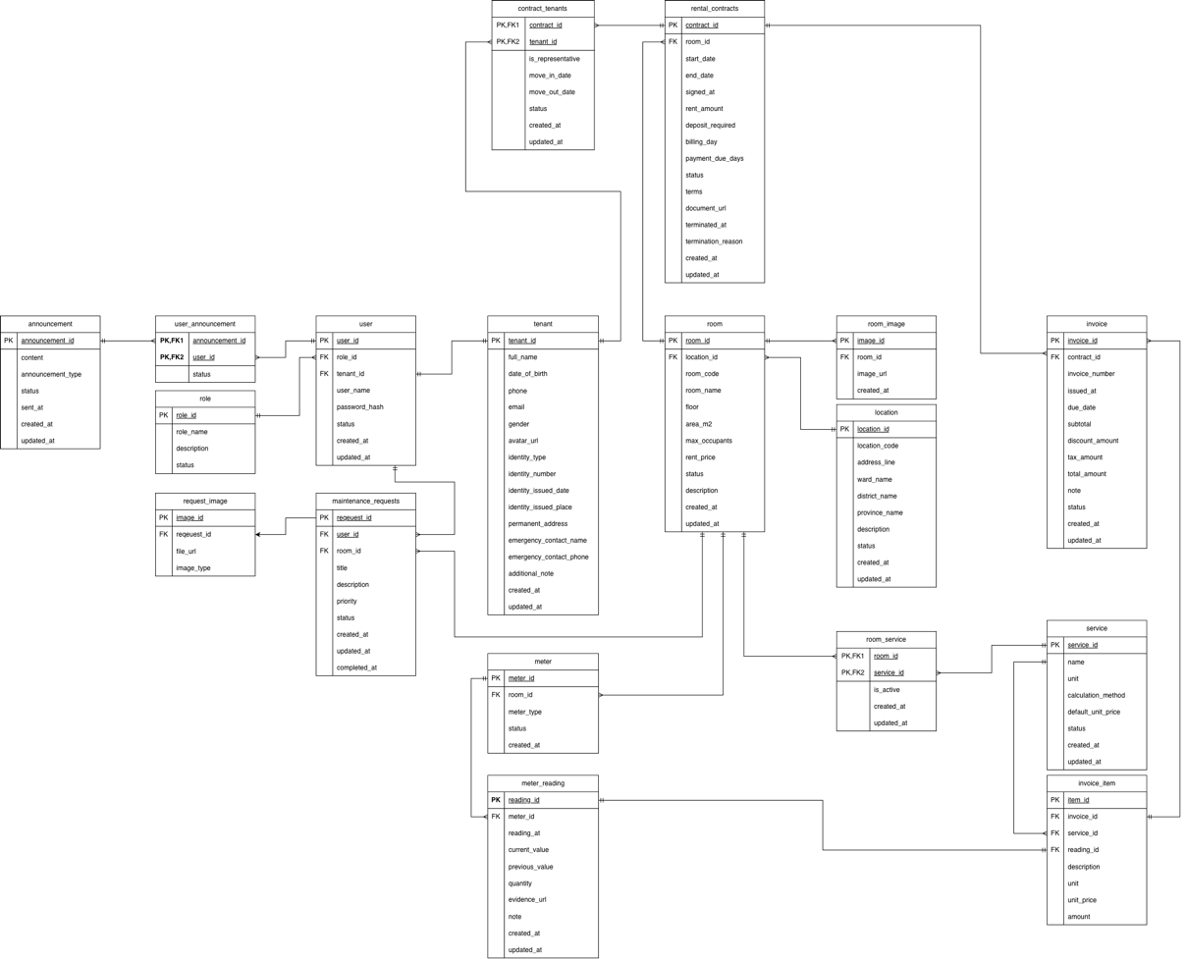
Figure 3.1. Entity Relationship Diagram of the RENTALY database.
The ERD should be generated from or checked against the actual SQL schema, db_initial_schema.sql. Because the database contains 18 tables, the diagram may be presented as one overall ERD or divided into several detailed diagrams to improve readability. If separate diagrams are used, the overall diagram should still show the main relationships between the functional groups.

Database Table Description
The following table summarizes the main purpose of each database table.
No. | Table | Description
1 | role | Stores role names, descriptions, and role status.
2 | user | Stores user accounts, usernames, password hashes, roles, and account status.
3 | tenant | Stores tenant profiles, contact details, identity information, and emergency contacts.
4 | location | Stores rental property or location information, including address and status.
5 | room | Stores room codes, names, floors, areas, occupancy limits, rental prices, and status.
6 | room_image | Stores image references associated with rental rooms.
7 | rental_contracts | Stores rental contract information, including dates, rent, deposits, terms, and contract status.
8 | service | Stores available services, units, calculation methods, and default prices.
9 | room_service | Associates services with rooms and records whether each assignment is active.
10 | meter | Records meter readings, previous and current values, consumption quantities, and supporting evidence.
11 | meter_reading | Records meter readings, previous and current values, consumption quantities, and supporting evidence.
12 | invoice | Stores invoice numbers, issue dates, due dates, amounts, and invoice status.
13 | contract_tenants | Associates tenants with rental contracts and records their participation in each contract.
14 | invoice_item | Stores individual invoice line items, including service references, meter-reading references, unit prices, and amounts.
15 | announcement | Stores announcement content, type, status, and sending information.
16 | user_announcement | Associates announcements with users and records whether each user has read an announcement.
17 | maintenance_requests | Stores maintenance request details, the requester, the related room, priority, and processing status.
18 | request_image | Stores image references attached to maintenance requests.
The user table references role and can optionally reference a tenant record. This design allows the system to represent accounts that do not belong to tenants, such as landlord accounts. A unique constraint on the optional tenant reference helps prevent the same tenant profile from being assigned to multiple user accounts.
The room table references location, so each room belongs to a rental location. The rental_contracts table references room, while contract_tenants connects contracts and tenants. This arrangement supports a contract involving one or more tenants without duplicating the contract information for every tenant.
For billing, an invoice belongs to a rental contract, and each invoice can contain multiple invoice items. An invoice item may reference a service and, where applicable, a meter reading. This structure allows the system to represent different charge types, such as rent, utilities, and additional services.
The database also includes constraints to improve data quality. Examples include unique usernames and invoice numbers, unique location codes, room-code uniqueness within a location, and checks on values such as room area, maximum occupancy, rental amounts, and meter readings. Foreign keys help prevent records from referencing nonexistent related entities.

Relationship Description
The principal database relationships are described below.
1. Role and User
A role can be assigned to multiple user accounts, while each user account references one role. This relationship is represented by the foreign key user.role_id.
Relationship: role (1) — (N) user
2. User and Tenant
A user account may reference a tenant profile through user.tenant_id. The relationship is optional because not every account represents a tenant. The schema's unique constraint on user.tenant_id supports a one-to-one association when the field is populated.
Relationship: tenant (1) — (0..1) user, from the tenant-profile perspective, subject to the schema's uniqueness and nullability constraints.
3. Location and Room
A rental location can contain multiple rooms. Each room references its location through room.location_id.
Relationship: location (1) — (N) room
4. Room and Room Image
A room can have multiple associated images. The room_image table stores the image references and uses room_id as a foreign key.
Relationship: room (1) — (N) room_image
5. Room and Rental Contract
A room can be associated with multiple rental contracts over time. Each contract references one room through rental_contracts.room_id. Whether a room can have overlapping active contracts is a business rule that should be enforced by application logic or additional database constraints if required.
Relationship: room (1) — (N) rental_contracts
6. Rental Contract and Tenant
A rental contract can involve multiple tenants, and a tenant can participate in multiple contracts over time. The contract_tenants table resolves this many-to-many relationship. Its composite primary key consists of contract_id and tenant_id. The table also stores information such as representative status and move-in or move-out dates.
Relationship: rental_contracts (N) — (N) tenant, through contract_tenants.
7. Room and Service
A room can use multiple services, and a service can be assigned to multiple rooms. The room_service table resolves this many-to-many relationship and records whether the service assignment is active.
Relationship: room (N) — (N) service, through room_service.
8. Room and Meter
A room can have multiple utility meters. The meter table references a room and records meter information, including its type and status.
Relationship: room (1) — (N) meter
9. Meter and Meter Reading
A meter can have multiple readings recorded over time. Each reading references one meter and stores its reading time, current value, previous value, and consumption quantity.
Relationship: meter (1) — (N) meter_reading
10. Rental Contract and Invoice
A rental contract can have multiple invoices over its duration. Each invoice references one rental contract through invoice.contract_id.
Relationship: rental_contracts (1) — (N) invoice
11. Invoice and Invoice Item
An invoice can contain multiple invoice items. Each item belongs to one invoice, and an item can optionally reference a meter reading and reference a service according to the database schema.
Relationship: invoice (1) — (N) invoice_item
12. Announcement and User
An announcement can be associated with multiple users, and a user can receive multiple announcements. The user_announcement table resolves this many-to-many relationship and records each user's reading status.
Relationship: announcement (N) — (N) user, through user_announcement.
13. User and Maintenance Request
A user can create multiple maintenance requests, while each request references one user as the requester through maintenance_requests.user_id.
Relationship: user (1) — (N) maintenance_requests
14. Room and Maintenance Request
A room can have multiple maintenance requests over time. Each maintenance request references the relevant room through maintenance_requests.room_id.
Relationship: room (1) — (N) maintenance_requests
15. Maintenance Request and Request Image
A maintenance request can have multiple associated images. The request_image table references the maintenance request and stores file URLs and image types.
Relationship: maintenance_requests (1) — (N) request_image
These relationships reduce unnecessary duplication and make it possible to retrieve related information through foreign-key relationships. For example, the system can retrieve a tenant's contracts through contract_tenants, calculate invoice details through invoice_item, or display maintenance images through request_image.

UI/UX Design
The user interface and user experience (UI/UX) design of RENTALY aim to make rental management convenient for both property managers and tenants. The system provides two separate Android applications because the two user groups have different responsibilities and information needs.
The Admin App focuses on management tasks, including rental locations, rooms, tenants, contracts, services, utility meters, invoices, announcements, and maintenance requests. The Tenant App focuses on viewing rental information and accessing tenant-related functions, such as room information, contracts, invoices, electricity and water readings, announcements, profile information, and maintenance requests.
Both applications are developed using native Android technologies with Java and XML layouts. The interfaces are organized into activities, fragments, adapters, and layout resources according to their respective responsibilities.

Design Principles
The UI/UX design follows the principles below.
1. Simplicity and clarity
The interface should present information in a clear and understandable way. Each screen should focus on a specific task, such as viewing a room, checking an invoice, or managing a contract. Important information should be visible without requiring users to navigate through unnecessary screens.
2. Consistency
Related screens should use consistent navigation patterns, text styles, spacing, colors, and component behavior. Consistency helps users understand how to interact with different parts of the application and reduces the learning effort required.
3. Task-oriented navigation
The two applications organize functions according to the needs of their users. Property managers require access to management functions, while tenants primarily need access to their own rental information. Separating the applications helps avoid presenting every management function to tenants.
4. Readability and information hierarchy
Information such as room numbers, rental prices, contract dates, invoice totals, and request statuses should be presented with a clear visual hierarchy. Headings, labels, lists, and grouped information can help users identify important details quickly.
5. Feedback and status visibility
The interface should provide feedback after operations, such as submitting a maintenance request, updating a record, or retrieving invoice details. Status labels should help users distinguish between different states, for example, a pending maintenance request and a completed request.
6. Data validation and error prevention
Input screens should help prevent incomplete or invalid data. Examples include checking required fields, validating numeric amounts, and displaying understandable error messages when an operation fails. Important operations that may affect existing rental records should be handled carefully.
7. Accessibility and usability
Text should remain readable on common mobile screen sizes, interactive elements should be easy to select, and screens should avoid unnecessary visual complexity. Lists and forms should be organized so that users can complete tasks on mobile devices efficiently.

Wireframes and Mockups
Wireframes and mockups represent the intended arrangement of interface elements before or during implementation. They help define screen structure, navigation, information hierarchy, and the placement of interactive components.
The RENTALY system contains two main interface groups: the Admin App and the Tenant App.
A. Admin App
The Admin App provides management-oriented screens. The source code includes a login activity, a home activity, and fragments for different management functions.
The main interface areas include:
- Login screen: allows a property manager to enter account credentials.
- Home screen: provides access to the main management sections.
- Location and room management: displays rental locations and room information.
- User management: displays and manages tenant-related account information.
- Contract management: supports viewing and working with rental contracts and contract-related tenant information.
- Service and utility management: provides screens for services, meters, and meter readings.
- Invoice management: displays invoice records and related details.
- Announcement management: provides functions for announcements and recipients.
- Maintenance management: displays maintenance requests and their information.
The management interfaces should prioritize efficient access to lists, detailed records, and data-entry forms. Where appropriate, adapters are used to display collections of records in Android list components.
Figure 3.2. Main screen of the RENTALY Admin App.
Figure 3.3. Room or location management interface.
B. Tenant App
The Tenant App provides a tenant-oriented interface. Its source code includes a login activity, a main activity, fragments, and separate activities for tenant-related information.
The main interface areas include:
- Login screen: allows a tenant to sign in.
- Home screen: provides access to the main tenant functions.
- Room information: displays information about the tenant's rental room.
- Contract screen: displays rental contract information.
- Invoice screens: displays invoice lists and invoice details.
- Electricity and water screen: provides access to meter-reading information.
- Announcement screen: allows tenants to view announcements.
- Maintenance screens: allows tenants to view maintenance requests and access the request-creation interface.
- Profile screen: displays tenant profile information.
The Tenant App should emphasize convenient access to personal rental information and clearly present financial amounts, contract dates, and request statuses.
Figure 3.4. Home screen of the RENTALY Tenant App.
Figure 3.5. Example of the tenant information interface.
C. Wireframe and Mockup Documentation
Actual screenshots from the implemented applications should be used to demonstrate the completed interfaces. If Figma wireframes or mockups are available, they can be presented before the corresponding implementation screenshots to show how the design was translated into the application.
If no separate wireframe or mockup artifacts were created, the implemented screens should be described as interface screenshots rather than as Figma mockups. This distinction keeps the report consistent with the project's actual development process.

Use-Case Diagram
A Use-Case Diagram illustrates the interactions between external actors and the system's main functions. In RENTALY, the two principal actors are the Landlord/Property Manager and the Tenant. They use separate Android applications but interact with the same backend services and database.
The Landlord/Property Manager is responsible for managing rental operations. The Tenant uses the system to access information related to their rental arrangements and submit requests when necessary.
Figure 3.6. Use-Case Diagram of the RENTALY system.

Actors
1. Landlord/Property Manager
The Landlord/Property Manager is the primary management actor. This actor uses the Admin App to manage rental data and operational activities. The main use cases include:
- Log in to the system.
- Manage rental locations.
- Manage rooms and room information.
- Manage user and tenant-related information.
- Manage rental contracts and contract tenants.
- Manage services and utility meters.
- Record and review meter readings.
- Manage invoices and invoice items.
- Create and manage announcements.
- View and process maintenance requests.
The exact permissions depend on the access-control rules implemented by the backend. The report uses the term Landlord/Property Manager to describe the management actor; it should not be interpreted as proof that the database contains a role literally named ADMIN.
2. Tenant
The Tenant is the user who rents a room and accesses the Tenant App. The main use cases include:
- Log in to the system.
- View profile information.
- View rental room information.
- View rental contract information.
- View invoices and invoice details.
- View electricity and water readings.
- View announcements.
- View maintenance requests.
- Create a maintenance request.
Some functions listed in the project requirements, such as changing a password, requesting contract termination, or sending feedback after maintenance, should only be included as completed use cases if they are supported by the current implementation.

Main Use Cases and Interactions
The use cases can be grouped according to the business responsibilities of each actor.
A. Authentication
Both actors use the login function to access the system. The backend receives authentication requests and processes them according to the configured security rules. The Android applications communicate with the backend through API requests instead of connecting directly to MySQL.
B. Rental Property Management
The Landlord/Property Manager manages rental locations and rooms. Location information is associated with rooms, and room information can be used by contract, utility, and maintenance functions.
C. Contract and Tenant Management
The Landlord/Property Manager manages contract records and tenant associations. The database supports contracts involving tenants through the contract_tenants relationship table. The Tenant can view contract information made available to their account.
D. Service, Meter, and Invoice Management
The management actor works with service assignments, meter records, meter readings, and invoices. The Tenant App provides screens for accessing relevant invoice and electricity/water information. Invoice items can represent individual charges associated with an invoice.
E. Announcement Management
The Landlord/Property Manager manages announcements, while tenants can access announcements intended for them. The user_announcement table supports user-specific announcement status, including whether an announcement has been read.
F. Maintenance Requests
The Tenant can access the maintenance-request screens and submit a request through the application. The management actor can access the maintenance management interface to review requests and their statuses. The database stores the requester, related room, request description, priority, status, and associated images.
The Use-Case Diagram should show the two actors outside the system boundary and the use cases inside it. Connections should represent only interactions supported by the implemented system. If the diagram becomes crowded, management functions can be grouped into logical areas while retaining the key actor-to-function relationships.

System Architecture
RENTALY follows a client-server architecture. Two Android applications provide the user interfaces, while a Spring Boot backend exposes API endpoints and accesses the MySQL database.
The Admin App and Tenant App do not need to connect directly to the database. Instead, they send HTTP requests to the backend. The backend processes these requests, applies business logic, interacts with database repositories, and returns responses to the appropriate application.
This architecture separates the presentation layer from the business and data-access layers. It also provides a common backend for the two applications, reducing the need to duplicate database operations and business rules in each mobile client.

Layered Architecture
The system can be described using the following logical layers.
Figure 3.7. Overall system architecture of RENTALY.
1. Presentation Layer — Android Applications
The presentation layer consists of two separate Android applications.
The Admin App uses Java and XML layouts. Activities and fragments provide the screens for management tasks, while adapters display collections of data. DTO classes represent request and response data exchanged with the backend.
The Tenant App also uses Java and XML layouts. Its activities and fragments display tenant-related information. Repository classes organize data operations for functions such as authentication, rooms, contracts, invoices, meters, announcements, and maintenance requests. The networking package contains the API client, API service, request utilities, callback handling, and authentication-related components.
The two applications provide different interfaces but communicate with the same backend API.
2. Communication Layer — REST API and Retrofit
The Android applications use Retrofit and Gson to communicate with the backend. Retrofit defines API interfaces, while Gson converts JSON data into Java objects and converts Java objects into JSON when required.
The Tenant App also contains an authentication interceptor and a session manager, which support authentication-related request handling and session information. These components help organize communication between the application and the backend.
The applications send HTTP requests to the backend endpoints. The backend returns responses that the applications can use to update their screens. Network failures and unsuccessful responses should be handled by the applications so that users receive appropriate feedback.
3. Backend Controller Layer
The controller layer receives HTTP requests and exposes the system's API endpoints. The source code contains controllers for functions such as users, roles, locations, rooms, rental contracts, contract tenants, meters, meter readings, invoices, announcements, and maintenance requests.
Controllers coordinate incoming requests and outgoing responses. They also work with request and response DTOs so that the API data structure is separated from the internal entity representation.
4. Backend Service Layer
The service layer contains business operations used by the controllers. The source code includes service interfaces and implementations for several functional areas, including user management, locations, rooms, rental contracts, contract tenants, roles, room utilities, and related resources.
This layer provides a place for business rules and validation before changes are persisted. For example, contract operations can be coordinated through contract services, while room-related operations can be handled by room services.
5. Repository and Persistence Layer
The repository layer uses Spring Data JPA to access database entities. Repository interfaces are available for entities such as users, tenants, roles, locations, rooms, rental contracts, invoices, meters, announcements, and maintenance requests.
The persistence layer maps Java model classes to the corresponding MySQL tables. JPA and the configured database connection allow the backend to retrieve, create, update, and delete records according to the operations supported by the application.
6. Database Layer — MySQL
MySQL stores the system's persistent information. The rental_manage_db schema contains the entities needed for account management, rental properties, contracts, utilities, invoices, announcements, and maintenance requests.
Primary keys identify records, foreign keys represent relationships, and database constraints help maintain data integrity. The backend is responsible for interacting with this database; the Android applications access data through the API rather than connecting to MySQL directly.
7. Supporting Services and Security
The backend includes a security configuration and a configuration for Cloudinary. Cloudinary integration supports image or file resource handling where it is used by the application. The exact behavior depends on the corresponding implementation and configuration.
The backend also contains an API exception handler and custom exception classes. These components support consistent handling of errors, such as missing resources or conflicting operations. Security rules determine which requests are permitted and how authentication or authorization is handled.
Request Flow
A typical request follows these steps:
1.The user performs an action in the Admin App or Tenant App.
2.The relevant activity, fragment, or repository initiates an API request.
3.Retrofit sends the HTTP request to the Spring Boot backend.
4.A controller receives the request and delegates the operation to the relevant service.
5.The service applies the relevant business logic and calls a repository when database access is required.
6.The repository accesses MySQL through Spring Data JPA.
7.The backend returns a response to the Android application.
8.The application processes the response and updates the user interface.
This structure separates responsibilities and makes the system easier to maintain. For example, changes to database-access logic can be handled in the repository or service layer without requiring every screen to contain SQL operations.

Project Folder Structure
The project is organized into three major codebases: the Admin App, the Tenant App, and the Spring Boot backend. Each codebase has its own responsibilities and internal package structure.
A. Admin App Folder Structure
The Admin App is an Android project developed with Java and XML resources. Its main source packages are organized as follows:
Package or directory | Responsibility
Apis/ | Contains API service definitions and API client configuration.
DTO/ | Contains data-transfer objects used for API requests and responses.
Adapter/ | Contains adapters for displaying collections of data in Android UI components.
Fragment/ | Contains fragments for management screens and related interface logic.
HomeActivity.java | Provides the main activity of the application.
LoginActivity.java | Provides the login interface and related authentication flow.
res/layout/ | Contains XML layout files for activities, fragments, and other interface components.
res/drawable/ and other resource directories | Contain drawable resources and other Android assets where applicable.
AndroidManifest.xml | Declares application components and relevant Android configuration.
Gradle build files | Define Android build configuration and dependencies.
This structure separates API communication, data representation, list presentation, and screen-level logic. For example, API classes handle communication with the backend, DTO classes represent data, and fragments provide the interface for management functions.
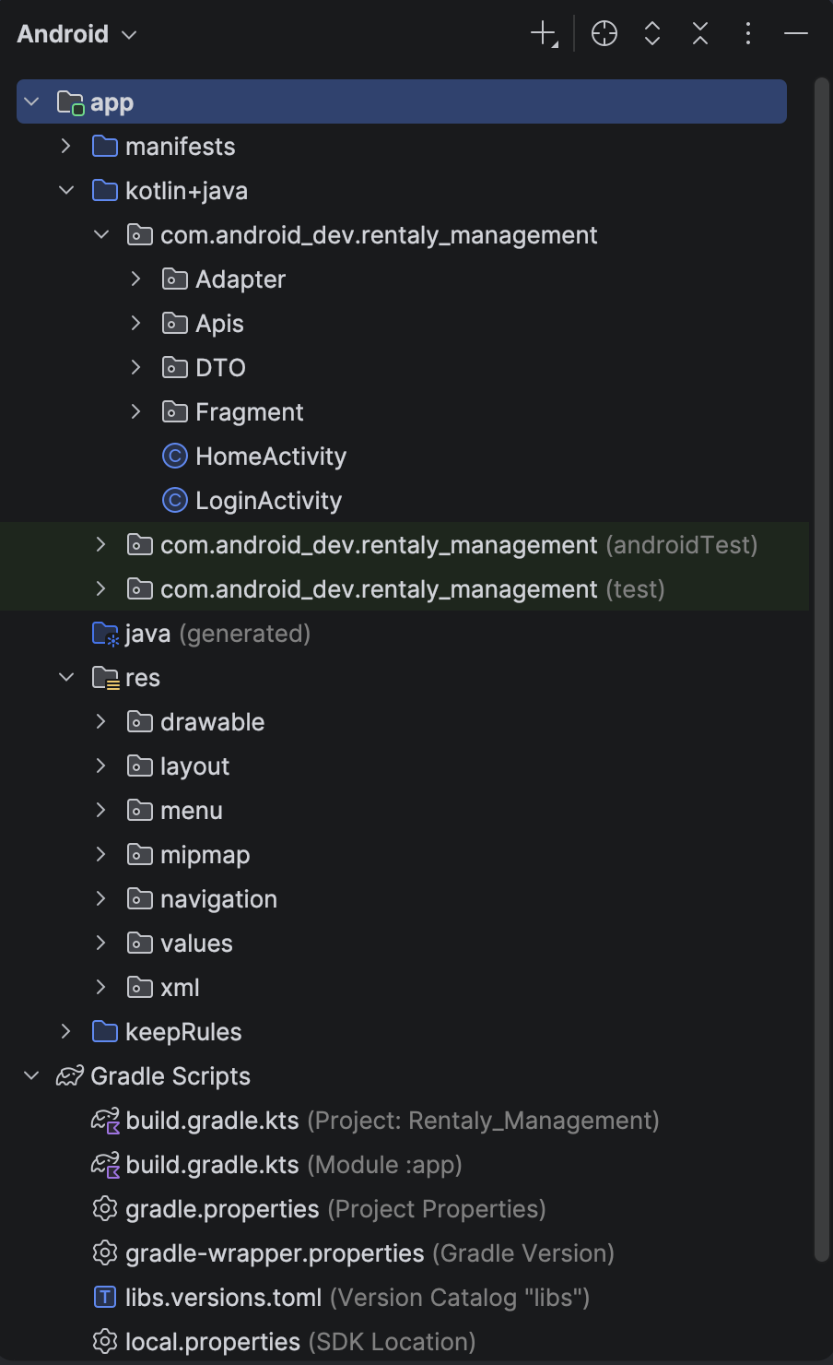
Figure 3.8. Project structure of the Admin App.
B. Tenant App Folder Structure
The Tenant App uses Java, XML layouts, Retrofit, and Gson. Its source code is organized into packages for networking, data models, repositories, adapters, activities, fragments, and utilities.
Package or directory | Responsibility
network/ | Contains ApiClient, ApiService, ApiRequests, ApiCallback, and AuthInterceptor for API communication and request handling.
models/ | Contains Java model classes for users, rooms, contracts, invoices, meters, announcements, maintenance requests, and related data.
adapters/ | Contains adapters for presenting lists, including invoices, maintenance requests, announcements, and meter readings.
repository/ | Organizes data operations for authentication, rooms, contracts, invoices, meters, users, announcements, and maintenance.
activities/ | Contains screens such as login, room information, contracts, invoices, electricity and water, profile, announcements, and maintenance.
fragments/ | Contains reusable screen sections, including home, room, profile, and invoice fragments.
utils/ | Contains supporting classes such as constants, session management, and date utilities.
res/layout/ | Contains XML files defining the user interface.
AndroidManifest.xml | Declares Android application components and configuration.
Gradle build files | Define Android build configuration and dependencies.
The Tenant App's package structure separates networking from repository operations and interface components. This organization helps screen classes focus on user interaction while repository and network classes handle data retrieval and API communication.
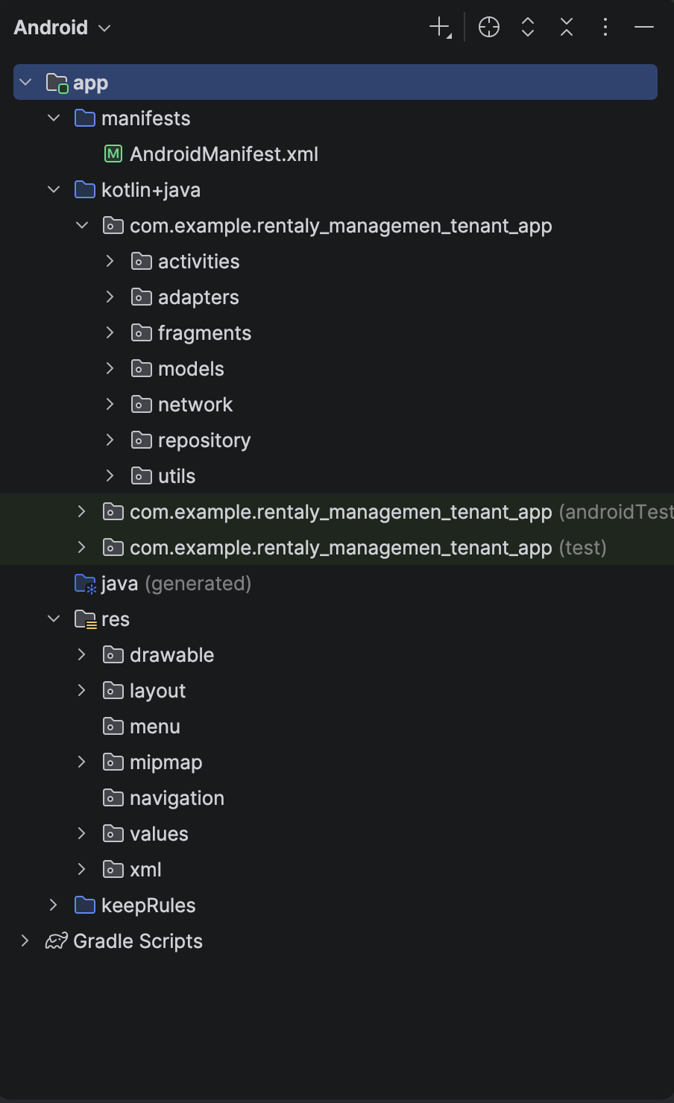
Figure 3.9. Project structure of the Tenant App.
C. Spring Boot Backend Folder Structure
The backend is a Maven-based Spring Boot project. Its Java source code is organized under the rentalpropertymanagementapp.be package.
Package or directory | Responsibility
Controller/ | Defines REST API endpoints and handles incoming HTTP requests.
Service/ | Contains service interfaces and implementations for business operations.
Repository/ | Contains Spring Data JPA repository interfaces for database access.
Model/ | Contains entity and model classes grouped by functional areas such as contracts, rooms, invoices, meters, announcements, services, and maintenance.
DTO/ | Contains request and response classes used for communication through the API.
Configuration/ | Contains configuration classes, including security and Cloudinary configuration.
Exception/ | Contains custom exception classes for error handling.
BeApplication.java | Main application class used to start the Spring Boot application.
src/main/resources/ | Holds application configuration and other runtime resources.
pom.xml | Defines Maven dependencies, project configuration, and build settings.
The backend's Controller, Service, and Repository packages implement the main separation of responsibilities. The Model package represents persistent data and domain objects, while DTO classes define the data exchanged through the API. The Configuration package centralizes supporting configuration, and the Exception package provides application-specific error handling.

The backend uses Spring Web MVC for web endpoints, Spring Data JPA for persistence, Spring Security for security configuration, Bean Validation for validating data, and the MySQL connector for database connectivity. The project also includes dependencies for API documentation and Cloudinary integration.
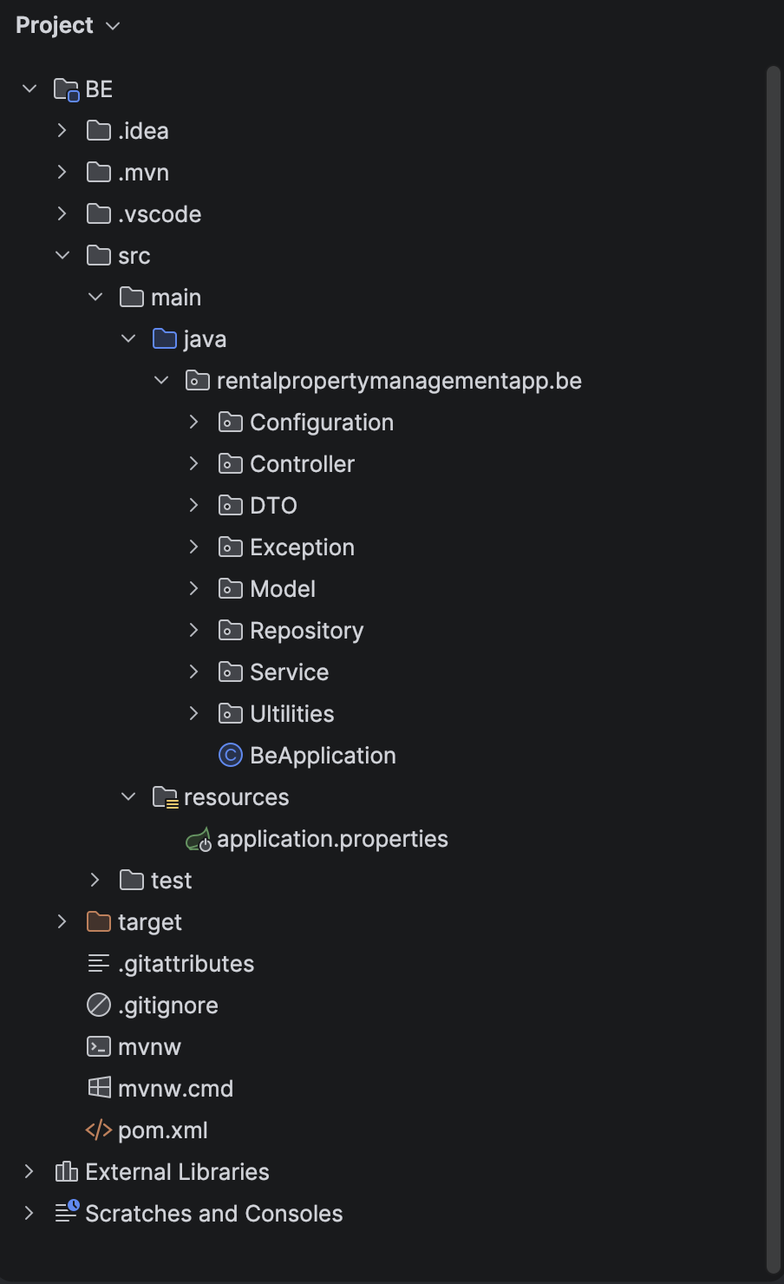
Figure 3.10. Project structure of the Spring Boot backend.
D. Summary of Project Organization
The separation into three codebases enables the Admin App and Tenant App to provide different user experiences while sharing a common backend and database. The Android projects focus on presentation, local application logic, and API communication. The backend centralizes business operations and database access, while MySQL stores the system's persistent data.
This organization improves maintainability by separating interface code from data-access logic and business rules. It also provides a foundation for extending the system with additional functions while keeping the responsibilities of each component clear.

IMPLEMENTATION & RESULTS

Implementation Environment
The RENTALY system was implemented using Android development technologies, a Spring Boot backend, and a MySQL relational database. The system consists of two separate Android applications: the Admin App and the Tenant App. Both applications communicate with the backend through REST APIs to retrieve and update information.

Development Tools and Technologies
The following tools and technologies are used in the project.
Component | Technology | Purpose
Admin App | Android Studio, Java, XML | Implements the property management interface.
Tenant App | Android Studio, Java, XML | Implements the tenant-facing interface.
Android UI | Android Activities, Fragments, Adapters | Organizes screens, reusable interface sections, and lists of data.
API communication | Retrofit and Gson | Sends HTTP requests and converts JSON data into Java objects.
Backend | Spring Boot and Java | Implements REST endpoints and business logic.
Persistence | Spring Data JPA | Maps Java entities to database records and provides database access.
Database | MySQL | Stores users, rental properties, contracts, invoices, and related records.
Backend security | Spring Security | Provides the framework for configuring authentication and access control.
Image and file support | Cloudinary integration | Supports image or file operations where used by the application.
Build management | Gradle and Maven | Manages Android and backend build configurations and dependencies.
The Tenant App configuration specifies Java 11 source and target compatibility, Android minimum SDK 24, and target SDK 37. The backend Maven configuration specifies Java 25. These are the configurations recorded in the submitted source projects and should be checked against the actual runtime environments used during the final demonstration.

System Configuration
The system requires the following components to operate together:
- A MySQL server containing the rental_manage_db database.
- A Spring Boot backend configured to connect to MySQL.
- An Admin App installed on an Android emulator or physical device.
- A Tenant App installed on an Android emulator or physical device.
- A network connection between the Android applications and the backend API.
The backend must be started before API-dependent operations can be tested. The Android applications must use the correct backend base URL. When an emulator is used, the configured URL must be reachable from the emulator; when a physical device is used, the backend must be reachable over the relevant network.
Database credentials, API keys, and other sensitive configuration values should be maintained in configuration files or environment variables as appropriate and should not be included in the report.

Application Implementation
The implementation phase converts the system design into working application components. RENTALY separates management functions from tenant functions while sharing a common backend and database.

Admin App Implementation
The Admin App is developed using Java and XML layouts in Android Studio. Its package name is com.android_dev.rentaly_management.
The application uses activities and fragments to organize the interface, adapters to display collections of records, DTO classes to represent API data, and API client classes to communicate with the backend.
A. Authentication and Main Navigation
The application contains a LoginActivity for the login interface and a HomeActivity for the main application area. After authentication, users can access the available management sections.
The API client and API service classes define communication with the backend. Request and response DTOs represent the data exchanged during operations.
[Insert Figure 4.1: Admin App Login Screen]
Figure 4.1. Login interface of the Admin App.
[Insert Figure 4.2: Admin App Home Screen]
Figure 4.2. Main interface of the Admin App.
B. Location and Room Management
The application contains PropertiesFragment, LocationDetailFragment, and RoomDetailFragment for working with property locations and rooms.
The location interface organizes property information, while the room interface provides access to room-related records. The application also contains adapters for displaying property information.
Location and room data are retrieved through the API layer rather than being maintained only in the mobile interface. The backend is responsible for processing the corresponding requests and persisting changes.
[Insert Figure 4.3: Admin App Location and Room Management]
Figure 4.3. Location and room management interface.
C. Tenant and Contract Management
The UserManageFragment and UserDetailFragment provide interfaces for user-related management. Contract-related functions are organized through components such as ContractsFragment and ContractDetailFragment.
The application contains DTOs and adapters for rental contracts and contract tenants. These components support the representation of contract data and the association between contracts and tenants.
The implementation also includes contract-related validation and display logic. For example, the source contains tests for filtering contracts by room code and rejecting invalid contract values.
[Insert Figure 4.4: Admin App Tenant and Contract Management]
Figure 4.4. Tenant and rental contract management interface.
D. Service, Meter, and Invoice Management
The Admin App contains fragments and adapters for services, meters, meter readings, and invoices. These components allow management information to be organized into lists and detail screens.
Meter-reading-related components handle data such as meter identifiers and consumption values. Contract and invoice components use DTOs to represent the data returned by the backend.
The source also contains validation tests for negative meter-reading values and tests for displaying consumption information. These tests demonstrate that validation and data-presentation behavior are considered in the implementation.
[Insert Figure 4.5: Admin App Utility Meter and Invoice Management]
Figure 4.5. Utility meter and invoice management interface.
E. Announcement and Maintenance Management
The application contains AnnouncementFragment, AnnouncementRecipient, and MaintenanceFragment, together with related adapters and DTOs.
These components support the organization of announcement and maintenance data in the management interface. Announcement-related logic includes recipient handling, while maintenance-related components display maintenance records and their information.
[Insert Figure 4.6: Admin App Announcement and Maintenance Screens]
Figure 4.6. Announcement and maintenance management interfaces.

Tenant App Implementation
The Tenant App is developed using Java and XML layouts. Its package name is com.example.rentaly_managemen_tenant_app.
The application separates interface components, model classes, repository operations, and network communication. This structure allows the application to retrieve data from the backend without embedding database operations directly into each screen.
A. Authentication and Navigation
The application contains LoginActivity for authentication and MainActivity as the main application entry point. TenantBaseActivity provides a shared activity structure for tenant-related screens.
The AuthRepository, ApiClient, and ApiService classes support the authentication and communication flow. The application also contains SessionManager and AuthInterceptor components for session-related information and authentication-related request handling.
[Insert Figure 4.7: Tenant App Login Screen]
Figure 4.7. Login interface of the Tenant App.
[Insert Figure 4.8: Tenant App Home Screen]
Figure 4.8. Main interface of the Tenant App.
B. Room and Contract Information
The RoomFragment and RoomInfoActivity provide the interface for displaying room-related information. The ContractActivity provides a separate screen for rental contract information.

The application contains model classes for rooms, locations, contracts, rental contracts, and contract tenants. These models represent information received through the API and allow the interface to display related records.
The RoomRepository and ContractRepository organize data operations for these functional areas.
[Insert Figure 4.9: Tenant App Room Information and Contract Screens]
Figure 4.9. Room information and rental contract interfaces.
C. Invoice Management
The application contains InvoiceFragment, InvoiceListActivity, and InvoiceDetailActivity for invoice-related screens. InvoiceAdapter presents invoice records in a list, while model classes such as Invoice and InvoiceItem represent invoice information and individual charges.
The InvoiceRepository organizes invoice data operations. The list and detail screens provide separate views for browsing invoices and inspecting the information associated with a selected invoice.
[Insert Figure 4.10: Tenant App Invoice List and Invoice Details]
Figure 4.10. Invoice list and invoice detail interfaces.
D. Electricity and Water Information
The ElectricityWaterActivity displays utility-related information. The application contains Meter and MeterReading model classes, together with MeterRepository and MeterReadingAdapter.
These components organize meter data and reading records for presentation. The information can include previous and current readings and consumption values, depending on the data returned by the backend.
[Insert Figure 4.11: Tenant App Electricity and Water Screen]
Figure 4.11. Electricity and water information interface.
E. Announcements and Maintenance Requests
The application contains AnnouncementActivity for announcements and MaintenanceListActivity for maintenance-request records. CreateMaintenanceActivity provides an interface for creating a maintenance request.
The application also includes AnnouncementAdapter, MaintenanceAdapter, AnnouncementRepository, and MaintenanceRepository. These components organize announcement and maintenance data and their associated presentation or data operations.
[Insert Figure 4.12: Tenant App Announcement and Maintenance Screens]
Figure 4.12. Announcement and maintenance request interfaces.
F. Profile Management
The application contains ProfileFragment and ProfileActivity for displaying profile-related information. The UserRepository organizes user-related data operations.
The profile interface provides a dedicated location for tenant information. The availability of editing operations depends on the functions exposed by the backend and connected to the corresponding interface.
[Insert Figure 4.13: Tenant App Profile Screen]
Figure 4.13. Tenant profile interface.

Backend Implementation
The backend is implemented using Spring Boot and Java. It provides REST API endpoints that connect the Android applications to the MySQL database.
The source code separates API controllers, business services, repositories, model classes, DTOs, configuration, and exception handling.
A. REST API Controllers
The backend contains controllers for the principal functional areas, including:
- User and role management.
- Location and room management.
- Rental contracts and contract tenants.
- Utility meters and meter readings.
- Services and room utilities.
- Invoice and invoice-item operations.
- Announcements.
- Maintenance requests.
The controllers receive HTTP requests and return responses to the client applications. Request and response DTOs are used to represent API data for supported operations.
B. Business Services
The service layer organizes business operations. It contains service interfaces and implementations for several areas, including user management, locations, rooms, roles, rental contracts, contract tenants, and room utilities.
The service layer is responsible for coordinating application logic and repository operations. This separation makes business rules easier to maintain than placing all processing logic directly in the controller layer.
C. Database Access
The repository layer uses Spring Data JPA to access persistent entities. Repository interfaces are available for users, tenants, roles, locations, rooms, contracts, invoices, services, meters, announcements, and maintenance requests.
The model classes represent the domain entities and their relationships. JPA maps these entities to the corresponding MySQL tables.
D. Validation and Exception Handling
The backend includes request validation, custom exception classes, and an API exception handler. The source contains tests for cases such as invalid contract dates, invalid tenant move-out dates, attempts to create a room with a missing location, and attempts to delete a room that has a contract.
These checks help prevent invalid operations and provide a basis for returning appropriate errors to the client applications.
E. Security and File Support
The backend includes a Spring Security configuration and Cloudinary-related configuration and file-upload utility classes. These components provide the implementation framework for security and file operations.
The precise security rules, authentication behavior, and file-upload restrictions should be evaluated against the actual runtime configuration before they are described as fully verified.
[Insert Figure 4.14: Backend API and Controller Structure]
Figure 4.14. Backend implementation structure.

Integration Between the Applications and Backend
The two Android applications communicate with the backend through API requests. Retrofit defines the client-side API interfaces, while Gson handles JSON serialization and deserialization.
The general integration process is as follows:
- A user selects a function or submits information through an Android screen.
- The relevant activity, fragment, or repository prepares the API request.
- The API client sends the request to the Spring Boot backend.
- The corresponding controller receives the request and delegates processing to the service layer.
- The service calls the repository when database access is required.
- Spring Data JPA interacts with MySQL to retrieve or update data.
- The backend returns an HTTP response to the Android application.
- The application processes the response and updates the displayed information.
For example, when the Tenant App requests invoice information, the request is sent to the backend. The backend retrieves the relevant invoice data and returns a response that can be represented by the application's invoice models and displayed through the invoice list or detail screen.
[Insert Figure 4.15: Data Flow Between Android Apps, Backend, and MySQL]
Figure 4.15. Data flow and integration of the RENTALY system.

Testing and Results
Testing is necessary to verify that the implemented components behave as expected and that invalid data or requests are handled appropriately. The RENTALY source projects contain unit tests and backend controller or resource tests that address selected functional and validation scenarios.
The test results presented in this section should be based on the actual execution of those tests and manual tests performed with the applications. The presence of a test case in the source code alone does not establish that it passed in the current environment.

Testing Approach
The project uses the following testing categories.
1. Unit Testing
Unit tests examine individual methods or components in isolation. Examples in the Admin App include tests for contract display logic, room and location filtering, meter-reading validation, announcement recipient handling, and contract-tenant mapping.
2. Backend Controller Testing
Backend controller tests examine HTTP request and response behavior. The submitted backend project includes tests for user login and resource controllers, including response content and request validation.
3. Validation Testing
Validation tests check whether the system rejects invalid values or inconsistent data. Examples include contract end dates that precede start dates, move-out dates that precede move-in dates, room creation with a missing location, and attempts to delete a room when a contract exists.
4. Integration Testing
Integration testing verifies that the Android applications, backend API, and MySQL database work together. This requires starting the backend, configuring a reachable database, and sending requests through the application or an API testing tool.
5. Manual UI Testing
Manual testing verifies navigation, displayed information, user input, error messages, and the behavior of the applications on an emulator or physical device.

Test Cases
The following tables define representative test cases for the implemented system. The actual result and status columns should be completed after running each test in the target environment.
A. Authentication and API Tests
ID | Test scenario | Expected result | Actual result / Status
TC-01 | Submit valid login credentials. | The backend returns an appropriate successful response, and the application handles the authenticated result correctly. | To be verified
TC-02 | Submit malformed or invalid login data. | The request is rejected with an appropriate error response. | To be verified
TC-03 | Submit credentials that do not authenticate a user. | The backend returns an unauthorized response without exposing user data. | To be verified
TC-04 | Request a resource using a valid identifier. | The backend returns the corresponding resource when it exists and the request is permitted. | To be verified
TC-05 | Submit an invalid room request. | Validation prevents invalid data from being accepted. | To be verified

The backend source includes tests for login requests, unauthorized login behavior, resource responses, and invalid room requests.
B. Rental and Utility Tests
ID | Test scenario | Expected result | Actual result / Status
TC-06 | Submit a contract whose end date precedes its start date. | The invalid assignment is rejected. | To be verified
TC-07 | Submit a tenant assignment whose move-out date precedes its move-in date. | The request is rejected with an appropriate error response. | To be verified
TC-08 | Create a room with a nonexistent location. | The operation is rejected because the referenced location is missing. | To be verified
TC-09 | Delete a room that has an associated contract. | The operation is blocked according to the implemented business rule. | To be verified
TC-10 | Enter a negative meter-reading value. | The validation logic rejects the negative value. | To be verified
The submitted source contains backend tests for contract-date validation, contract-tenant date validation, missing room locations, and room deletion constraints. The Admin App also contains meter-reading validation tests.
C. User Interface and Data Display Tests
ID | Test scenario | Expected result | Actual result / Status
TC-11 | Search for a location by its code or address. | Matching location records are displayed according to the implemented filter. | To be verified
TC-12 | Filter contract records by room code. | Matching contracts are displayed, and unrelated records are excluded. | To be verified
TC-13 | View contract-tenant assignments. | The interface displays the associated tenant information when available. | To be verified
TC-14 | Filter announcement recipients by room or tenant name. | The recipient list reflects the selected filter. | To be verified
TC-15 | Open an invoice from the Tenant App invoice list. | The corresponding invoice details are displayed when the data is available. | To be verified
TC-16 | Open a maintenance request from the Tenant App. | The interface displays the available request information. | To be verified
The Admin App source contains tests for property filtering, contract display, tenant mapping, and announcement recipients. The Tenant App includes the relevant screens and adapters for invoices and maintenance requests; the corresponding end-to-end behavior should be confirmed through execution.

Test Execution and Results
The source projects include automated tests, but the final test results must be recorded after executing them in a suitable development environment.
For the final report, the following procedure is recommended:
- Start MySQL and verify that the rental_manage_db schema is available.
- Configure the backend database connection and required environment variables.
- Start the Spring Boot backend and verify that the application initializes successfully.
- Run the backend tests using the project's Maven wrapper or the configured Maven environment.
- Run the Admin App unit tests using the Android project's Gradle test configuration.
- Launch the Admin App and Tenant App on an emulator or physical device.
- Test login, data retrieval, navigation, validation, and relevant management or tenant operations.
- Record the actual result of each test case and capture screenshots of successful operations and any errors found.
A test should be marked Pass only when the observed result matches the expected result. If a test fails, the report should record the failure and, where applicable, explain the correction made and the result after retesting.
Table 4.4. Summary of Test Execution
Test category | Evidence available in source | Execution status
Admin App unit tests | Tests for filtering, contract display, tenant mapping, announcement recipients, and meter readings | Requires execution
Tenant App unit tests | A basic example unit test is present | Requires execution
Backend tests | Tests for login, controller responses, request validation, and rental-resource constraints | Requires execution
Android-to-backend integration | API client, API service, repository, and backend endpoint implementations are present | Requires end-to-end verification
Full system testing | Requires both applications, backend, and database to run together | Requires execution
The final report should replace the execution-status descriptions with the actual results after the tests have been performed. Numerical claims, such as the number of passed tests or the percentage of successful test cases, should only be added when they can be supported by the test output.

Implementation Results
The submitted source projects demonstrate the implementation of the main structural components of RENTALY: two Android applications, a Spring Boot backend, and a relational database schema.
The Admin App contains interface components for managing locations, rooms, users, contracts, services, utility meters, invoices, announcements, and maintenance records. The Tenant App contains interfaces for login, room information, contracts, invoices, electricity and water information, announcements, maintenance requests, and profile information.
The backend provides controllers, service implementations, repository interfaces, model classes, DTOs, configuration, and exception-handling components for the principal rental-management functions. The database schema stores the corresponding records and relationships.
The implementation is therefore organized around the project's main architectural objective: providing separate interfaces for management users and tenants while centralizing data processing through the backend.
However, the final evaluation of the system's operational completeness requires running the applications against the configured backend and database. Successful compilation, successful API communication, correct persistence, and correct role-based access should be verified before the report claims that the entire system has passed end-to-end testing.

Limitations and Future Improvements
Although the project includes the main components of a rental management system, several areas should be considered during further development and evaluation.
1. End-to-End Verification
The applications, backend, and database must be tested together using representative accounts and data. This helps identify issues that isolated unit tests may not detect, such as mismatched API fields, incorrect server addresses, or inconsistent authentication behavior.
2. Security Verification
Authentication, authorization, password handling, and access to tenant-specific information should be verified carefully. The backend security configuration should be checked to ensure that each user can access only the operations and records permitted by the system's rules.
3. Error Handling and Network Reliability
The applications should provide understandable messages when the backend is unavailable, a request times out, or the server returns an error. Additional testing can improve the handling of intermittent network connections and incomplete responses.
4. Data Validation and Business Rules
Further verification should cover overlapping rental contracts, invoice calculations, duplicate records, meter-reading consistency, and deletion of records that are referenced by other entities. Important business rules should be enforced consistently in the backend and, where appropriate, supported by database constraints.
5. Usability and Interface Evaluation
The interface should be tested with representative management users and tenants. Feedback can help improve navigation, readability, form validation, and the presentation of financial information.
6. Automated Testing Coverage
Additional automated tests can be introduced for repository behavior, business services, API integration, and tenant-specific data access. Running the test suite regularly can reduce regression risks when the system is extended.

Chapter Summary
This chapter has described the implementation of the RENTALY Admin App, Tenant App, and Spring Boot backend. It has outlined the development environment, the organization of the major application modules, and the communication flow between the Android applications, backend API, and MySQL database.
The chapter has also identified the automated tests included in the submitted source projects and proposed test cases for authentication, rental data validation, utility readings, and interface behavior. The final test results must be completed using actual execution evidence.
Overall, the implementation establishes the main software structure required for a rental property management system. Further end-to-end testing and security verification are necessary to evaluate the reliability and completeness of the system under realistic operating conditions.

CONCLUSIONS
The RENTALY project was developed to support the management of rental properties and improve communication between property managers and tenants. The system consists of an Android application for administrators, an Android application for tenants, a Spring Boot backend, and a MySQL database. By combining these components, the project provides a centralized approach to managing rental-related information and supporting common property management activities.
During the development process, the project applied several technologies and tools, including Java, XML, Android Studio, Retrofit, Spring Boot, Spring Data JPA, Spring Security, and MySQL. The Android applications provide user interfaces for accessing relevant functions, while the backend processes requests, applies business rules, and communicates with the database. This architecture separates the user interface, application logic, and data storage, making the system easier to maintain and extend.
The project covers important rental management areas, including user and role management, property locations, rooms, rental contracts, utility meter readings, invoices, announcements, and maintenance requests. The administrator application is intended to support property management operations, while the tenant application focuses on helping tenants access their rental information and interact with property management. The use of REST APIs enables the mobile applications to communicate with the backend without connecting directly to the database.
The project also established a foundation for software testing through backend controller tests, validation tests, and selected Android application tests. However, the existence of test cases does not by itself confirm that every function operates correctly in all situations. Further execution of the test suite, end-to-end integration testing, and verification on physical devices are necessary to evaluate the system comprehensively.
Despite the progress achieved, RENTALY still has opportunities for improvement. Future development could include more comprehensive automated tests, stronger security measures, improved error handling, more detailed reporting, and performance optimization. Additional features such as payment gateway integration, automated reminders for contract expiration and unpaid invoices, and more advanced analytics could also increase the system's practical value. The project should additionally undergo broader usability testing to ensure that both administrators and tenants can use the applications efficiently.
In conclusion, RENTALY provides a foundation for a mobile-based rental room management system that integrates Android applications, a RESTful backend, and a relational database. The project demonstrates how these technologies can be combined to organize rental information and support property management workflows. With further testing, refinement, and feature development, RENTALY could be improved into a more reliable and comprehensive solution for rental property management.

REFERENCES
[1] Google. (n.d.). Android Developers Documentation. Available at: https://developer.android.com/docs
[2] Square, Inc. (n.d.). Retrofit: A Type-safe HTTP Client for Android and Java. GitHub. Available at: https://github.com/square/retrofit
[3] Google. (n.d.). Gson: A Java Serialization/Deserialization Library. GitHub. Available at: https://github.com/google/gson
[4] VMware, Inc. and the Spring community. (n.d.). Spring Boot Reference Documentation. Available at: https://docs.spring.io/spring-boot/reference/
[5] VMware, Inc. and the Spring community. (n.d.). Spring Data JPA Reference Documentation. Available at: https://docs.spring.io/spring-data/jpa/reference/
[6] VMware, Inc. and the Spring community. (n.d.). Spring Security Reference Documentation. Available at: https://docs.spring.io/spring-security/reference/
[7] Oracle Corporation. (n.d.). MySQL 8.4 Reference Manual. Available at: https://dev.mysql.com/doc/refman/8.4/en/
[8] The Apache Software Foundation. (n.d.). Maven Documentation. Available at: https://maven.apache.org/guides/
[9] Cloudinary. (n.d.). Cloudinary Java SDK Documentation. Available at: https://cloudinary.com/documentation/java_integration
[10] Oracle Corporation. (n.d.). Java Documentation. Available at: https://docs.oracle.com/en/java/
[11] The RENTALY Project Team. (2026). Rental Room Management System: Project Requirements, Database Schema, Source Code, and System Design Diagrams. Unpublished project materials.

