Criterion B: Design

Design Overviews

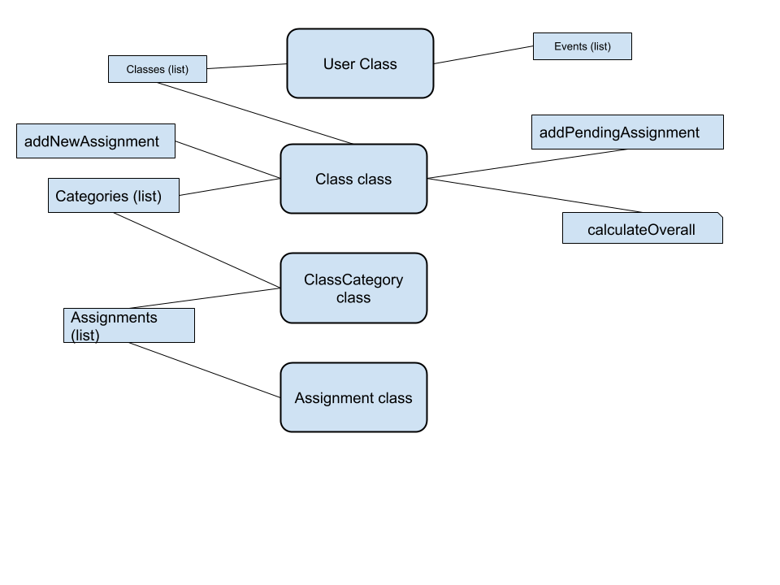

The following chart shows the 2 planned classes I will be creating for this project. There will almost certainly be more components added as the project proceeds with development, but these are the most essential classes, methods, and instance variables that will be required for the creation of this process.

User class objects will be created for each individual user on each device, with its information stored inside one or more text files. Specifically, the user class will contain a name instance variable, a list of events (possibly another class), as well as the classes of the user, which is the second class in this diagram. The Class class objects will have the overall grade in the class, which will be calculated with the calculate overall method, which is based on an assignments and tests list as well as the category weights list. The difference between the addNewAssignment and addPendingAssignment methods is that the naddNewAssignment will require the grade and factor it into the gradebook while addPendingAssignment will not require the user to input the grade, as the assignment will not have been completed.

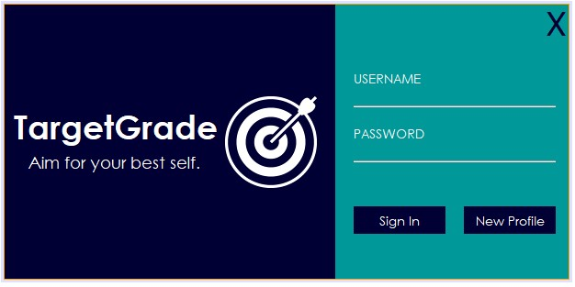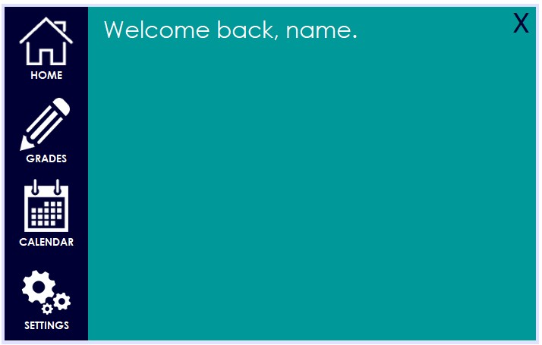

Above are screenshots of the user interface prototype I created for my client. The first is a concept I created for the login screen, where the user will select their profile by signing in. The second picture is a basic dashboard I created, which shows the four main screens of the application. I plan to have the home screen display basic user information as well as motivational messages and upcoming events. The grades section will be the bulk of content in the application, helping the user manage their grades. The calendar section will give the user a fuller planning experience that the home screen can provide, and the settings page will allow the user to adjust various features of the application.

In order to test the application, I will run a combination of tests with my client as well as tests run by myself. This will depend on the scale of the test. I will likely speak with and run tests with my client for features that are larger and more complicated, while I will test smaller features on my own. To test the sign in process, I have created a variety of accounts with varying usernames and passwords. I tested the different accounts to verify that the class serialization and deserialization would work for any account created. I also allowed my client to create his own test account to make sure that the entire process was satisfactory.