**Slide 1_X-ray imaging overview Radiography & Mammography:**

X-ray imaging page 2

History of X-ray page 4

What is X-ray and X-ray tube? page 6

Attenuation Coefficient page 7



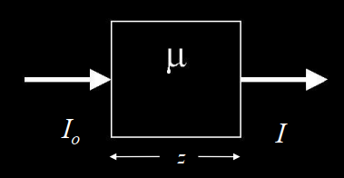

Advantage and disadvantage of Computed Digital radiography  
+ No maintenance of chemical use & dark room & storage space of films

+ Image processing capability  
- Spatial resolution is a bit lower than analog film  
- Contrast resolution is better than analog film

Dynamic Range (Analog Film) page 10

Evaluate the film characteristic curve?

Dynamic Range (Digital Detector) page 11

Digital Detector Characteristic Curve

Radiography (Rad) page 12

What is Radiography?

Profile of General Radiography? page 15

What *Procedure, Reimb, Diseases, Challenges* for Spine/head/neck/abdominal/thoracic/extremities and hip?

Radiography is used for? page 16

Radiation Dose in X-Ray exams page 18

What Effective radiation dose and comparable to natural background radiation for?

Advanced Applications of X-ray page 19

Dual Energy (two technologies, bone or soft-tissue images may be obtained…) page 20

Single exposure page 21

Dual exposure page 22

Auto Image Paste page 23

Computer Aided Detectioni (CAD) page 24

Clinical Performace Terms page 27 – page 31

What is the percentage/the formula for estimating the Sensitivity, Specificity, positive/negative predictive value, accuracy?

What is P-value?

Temporal Subtraction (highlight change between previous and current, potential applications) page 34

RAD Tomosynthesis (Goal, Acquisition,…) page 35

Radiography and Fluoroscopy (R&F) page 37 – 38

How many types of geometry? What is the major application? What substance is used?

Mammography

What is breast cancer? page 41

How many breast cancer types? page 41

Breast cancer statistics in 2013 page 43

Breast imaging modalities page 45

What is mammography? Most common technology in mm? New technology? page 46

History + Sign of breast cancers page 47-48

How to procedure performed? page 49

Digital Breast Tomosynthesis (DBT) page 50

SOTA of DBT reconstruction (advantage) page 53

**Slide 2_X-Ray CT Fundamentals 2021-2022:**

* CT: Computed Tomography
* CAT: Computerized Axial Tomography
* CAT: Computer Assisted Tomography

Beer’s law page 9

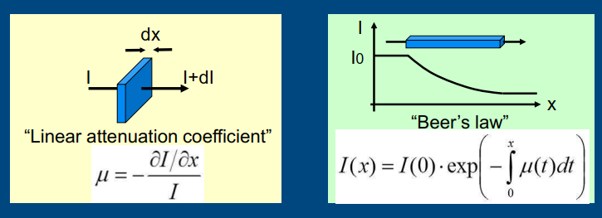

Sinogram page 11

Filtered Backprojection page 16 – 17

Why iterative reconstruction? page 21

What is CT system and component, X-ray tube? page 28 – 29

Spatial resolution (How to increase spatial resolution by; Uniform spatial resolution; Boost page 35

Spatial resolution and reduce allasing artifacts by?

Temporal resolution (cardiac CT) page 36

Image noise: page 38

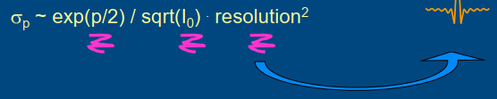

Slow-gantry cardiac CT page 43

Multi-tube multi-detector CT (Benefit, challenges,…) page 46

Multi-source inverse-geometry CT (X-ray source, detector, recon&cal) page 48

Spectral CT ; Dual kVp CT page 53

