**PRICE:** $29.99

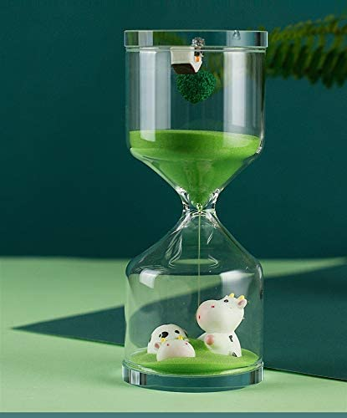

**ID:** DHC-07

**Color:** Farm

**Brand:** Falytemow

**Material:** Silicone

**Product Dimensions:** 2.79"D x 2.79"W x 6.92"H

**Number of settings:** 2

* Measure: 17.6cm / 6.92inch (high）x 7.1cm / 2.79inch (diameter)
* Timing: 30 Minutes. It can be used as an easygoing timer rather than an accurate clock
* Material: Hourglass sand timers Made By high borosilicate glass ,100% hand-blown made clear glass, the interior decoration is made of silicone.
* Enhance Personal Aesthetic: Unique and creative shape bring beautiful enjoyment to you while flowing sand guide your heart into peace.
* Ideal for office Study, Meeting, Cooking, Exercising and Playing Games