**PRICE:** $30.99

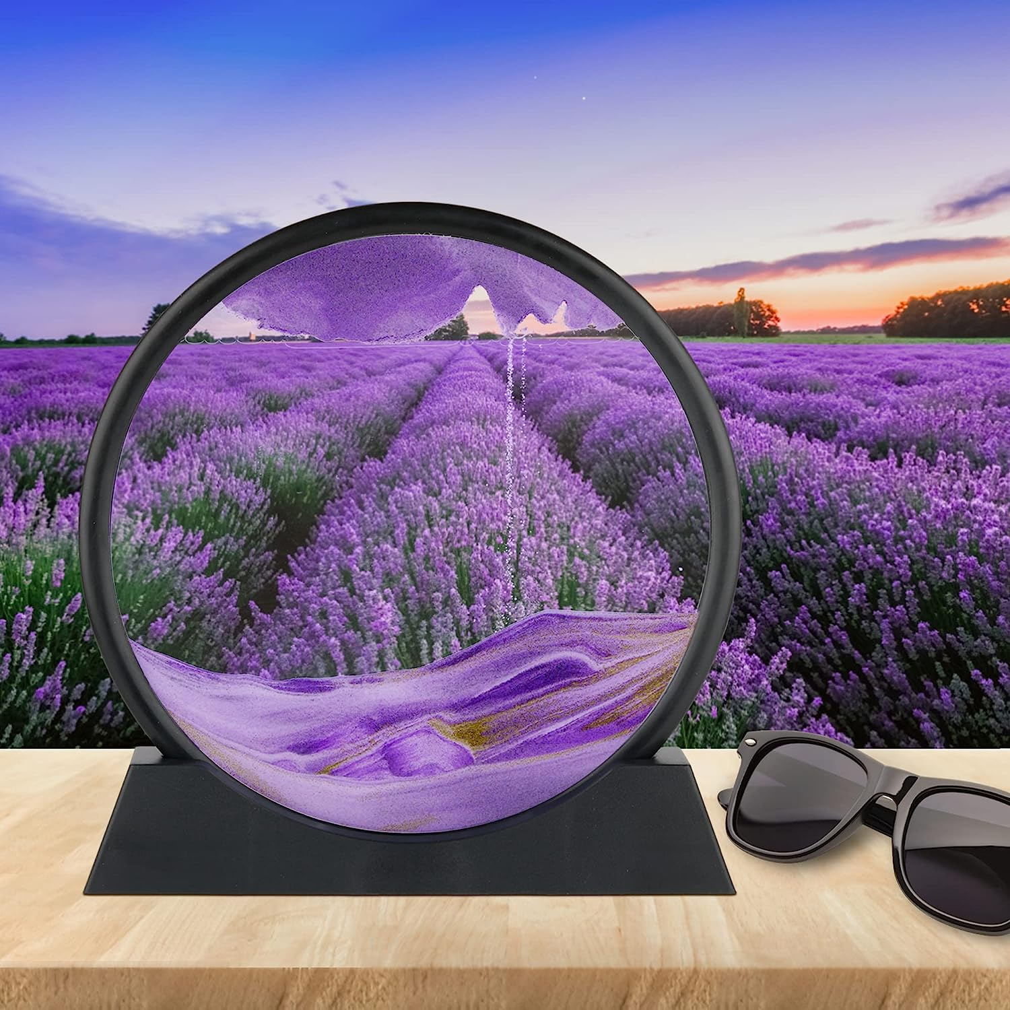

**ID:** DHC-10

**Brand:** HUIHUATUOWEILSQ

**Color:** Purple

**Theme:** Ocean,Sand

**Item Dimensions:** 12 x 0.47 x 10 inches

* 【Quality Details】Meticulously screened sand, lead-free high-transparency glass, bright colors, distinct layers, and excellent 3D effect of flowing patterns. It is not easy to deform and break, the workmanship is meticulous, the edges and corners are clear, the color is fresh and beautiful,
* 【visual design】When you rotate the dynamic sand picture frame, each action will present you a different picture, and you will get an unexpected and unique beauty. Such as waves, deserts, mountain paintings, etc. It will make you feel very soothing, calming and relaxing.
* 【Suitable for decoration】Dynamic decorative ornaments, very suitable for living room, bedroom, dresser, study, desk, work or next to the computer, sand movement can relieve stress, relieve emotions, relax eyes, cultivate patience, I believe you will like it
* 【Art Decorations】It is very suitable for office workers, youth, adults, the elderly, colleagues, friends, etc. Unique moving sand art. Every action brings you joy. Each action presents a different picture for you, making everyone a quicksand painter.
* 【Gift Box】The beautiful 3D quicksand paintings are great gifts, not only for couples, but also for boyfriend and girlfriend, Easter, Birthday, Mother's Day, Thanksgiving, Graduation, Valentine's Day, Christmas and other important days. We give away gift boxes
* 【After-sales service】: We attach great importance to customers and are committed to creating exquisite service, if you are not satisfied for any reason, please contact our customer service, we will solve it for you within 24 hours.