**PRICE:** $19.99

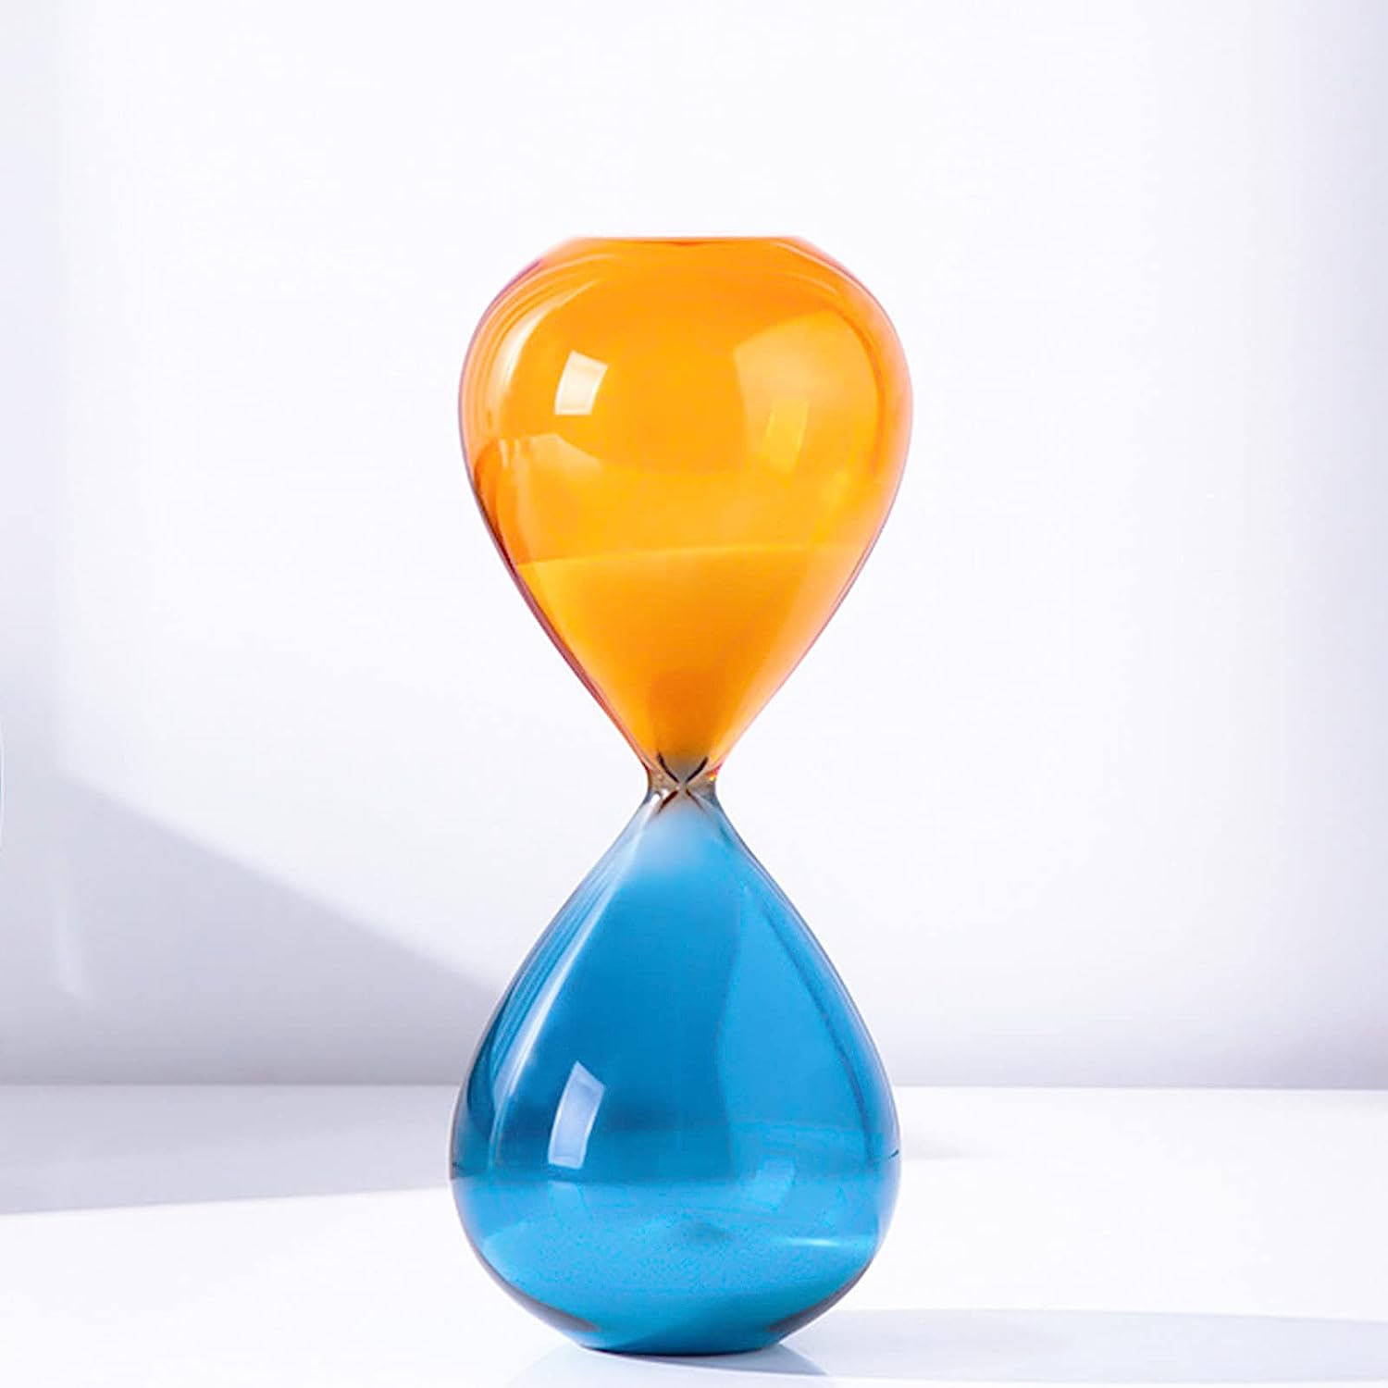

**ID:** DHC-12

**Color:** 30min

**Brand:** SANOSY

**Material:** Metal

**Item Weight:** 380 Grams

**Number of settings: 2**

* 30 Minute Sand Timer: Relax and relieve stress at work. By flipping the hourglass, you'll get 30 minutes of uninterrupted workflow, staying focused and productive longer.
* Precise time: The metal hourglass is engineered in the USA to the highest quality ±3 minute industry standard. The vintage 60 minute sand timer can help you to follow up on the work easily, and to prevent the fatigue caused by overtime working.
* Improve your productivity: When you dedicate a set time period to a task, you are more likely to focus and complete the activity. Get over your procrastination.
* Fashionable and modern design: bright colors bring you visual impact, and can be used as a beautiful decoration for living room, dining room, bedroom, office.
* Perfect gift:this timer makes an excellent gift for kids, students, and adults alike. It can also be given as a housewarming present, mindfulness tool, or as a gift for a loved one who is decorating their home.