**PRICE:** $49.99

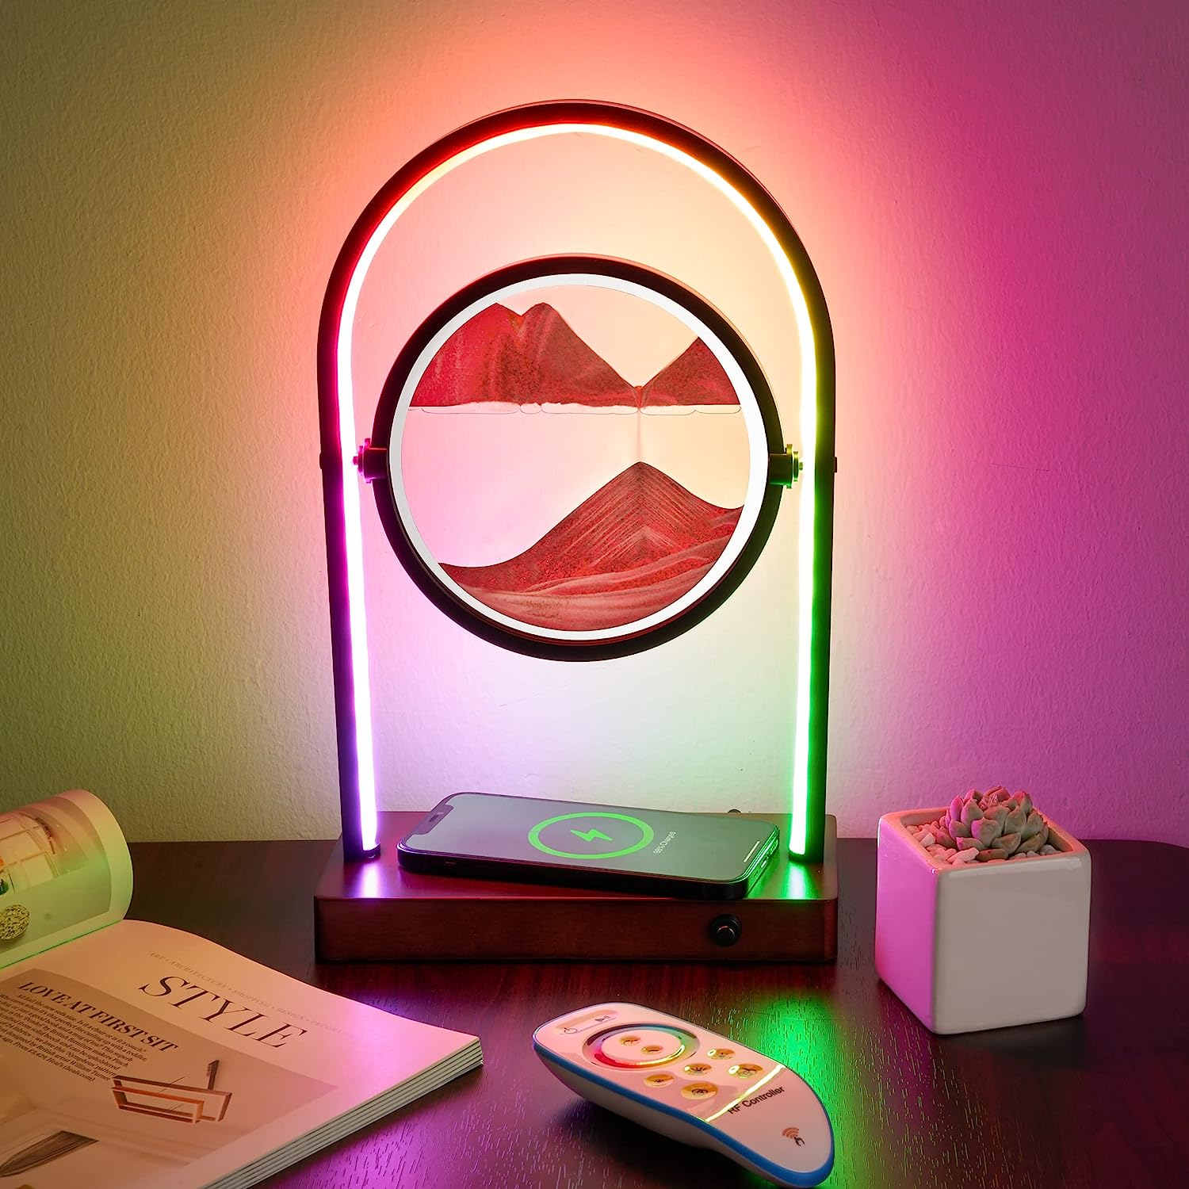

**ID:** CL-02

**Style:** Art Deco

**Brand:** E.P. Light

**Color:** RGBW

**Product Dimensions:** 5"D x 2"W x 10"H

**Special Feature:** Corded

* Suitable Size and Energy Efficiency Disign:Compared with those on the market, our size design is more reasonable, and it is suitable for most people. Durable and adjustable brightness RGBW-LED light strip design, more energy-saving.
* USB Port with 10W Wireless Charging: This LED desk lamp has a 5V 2.1A USB port and 10W wireless charging. It can charge a mobile phone or watch that supports wireless charging and other devices that support USB charging at the same time. Solve the trouble of using multiple plugs when charging.
* 3 Kinds of Reading White Light and 256 Types of RGB Color Light: This dimmable table lamp can adjust 3 types of white light and brightness with different color temperatures, and it also has 258 different RGB entertainment light modes. You can switch the corresponding mode according to your actual needs.
* Modern and Unique Appearance Design: Durable retro wooden base, metal curved frame, soft light silicone strip, rotatable moving sand art painting disc, which has the functions of home lighting and art decoration.
* Perfect Gift for Your Family and Friend:It is suitable as a gift for festivals, anniversaries, birthdays, as a stress relief toys, night light, desk lamp, bedside lamp, table lamp, sand painting toys for kids, and room decorations for adults. When you or your family and friends receive this multifunctional samll led night light, maybe they will be very happy!