**PRICE:** $27.99

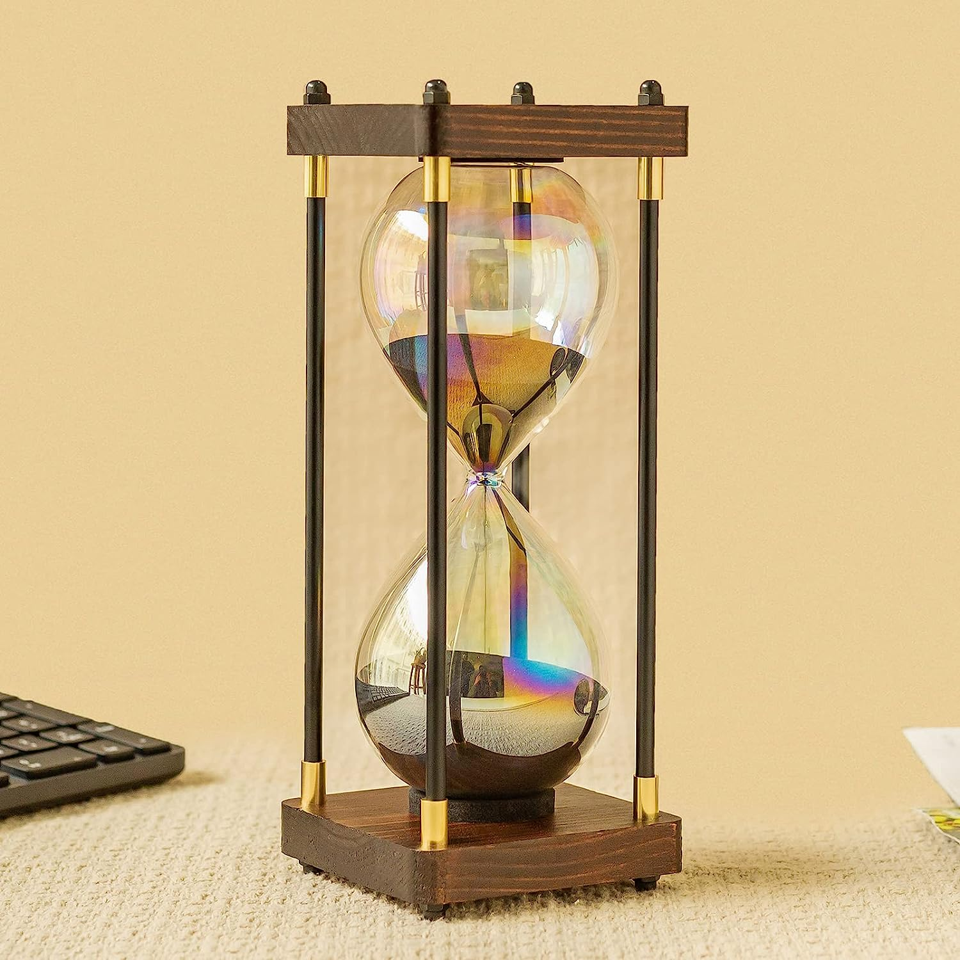

**ID:** DHC-03

**Color:** Black

**Brand:** Bvkotent

**Material:** Glass

**Product Dimensions:** 3.95"D x 3.95"W x 10"H

**Item Weight:** 1.3 Pounds

* Large Size】This hourglass perfectly combines aesthetics and function.Its outer packing size is 5*5.5*11.5 in.
* Design Excellence】The The soft rainbow glass body reflects different colors with different light.which complement each other in a unique and beautiful fashion way.
* 60 Minutes for Working Productivity】The 60 minute sand clock is engineered in the USA to the highest quality ±5 minute industry standard. can help you to follow up on the work easily, and to prevent the fatigue caused by overtime working.
* Modern Decor & Great Gift Choice】You can also use this noble hourglass timer as an ornament in the living room, bedroom or desk to beautify your family and create a comfortable atmosphere.
* Why Choose Our Hourglass】We will supply friendly after-sale service, free replacement hour glasses with 24 hours if any shipping broken. 100% customer satisfaction and quality guarantee. We are sure it is an amazing gift to your lover!