**PRICE:** $16.99

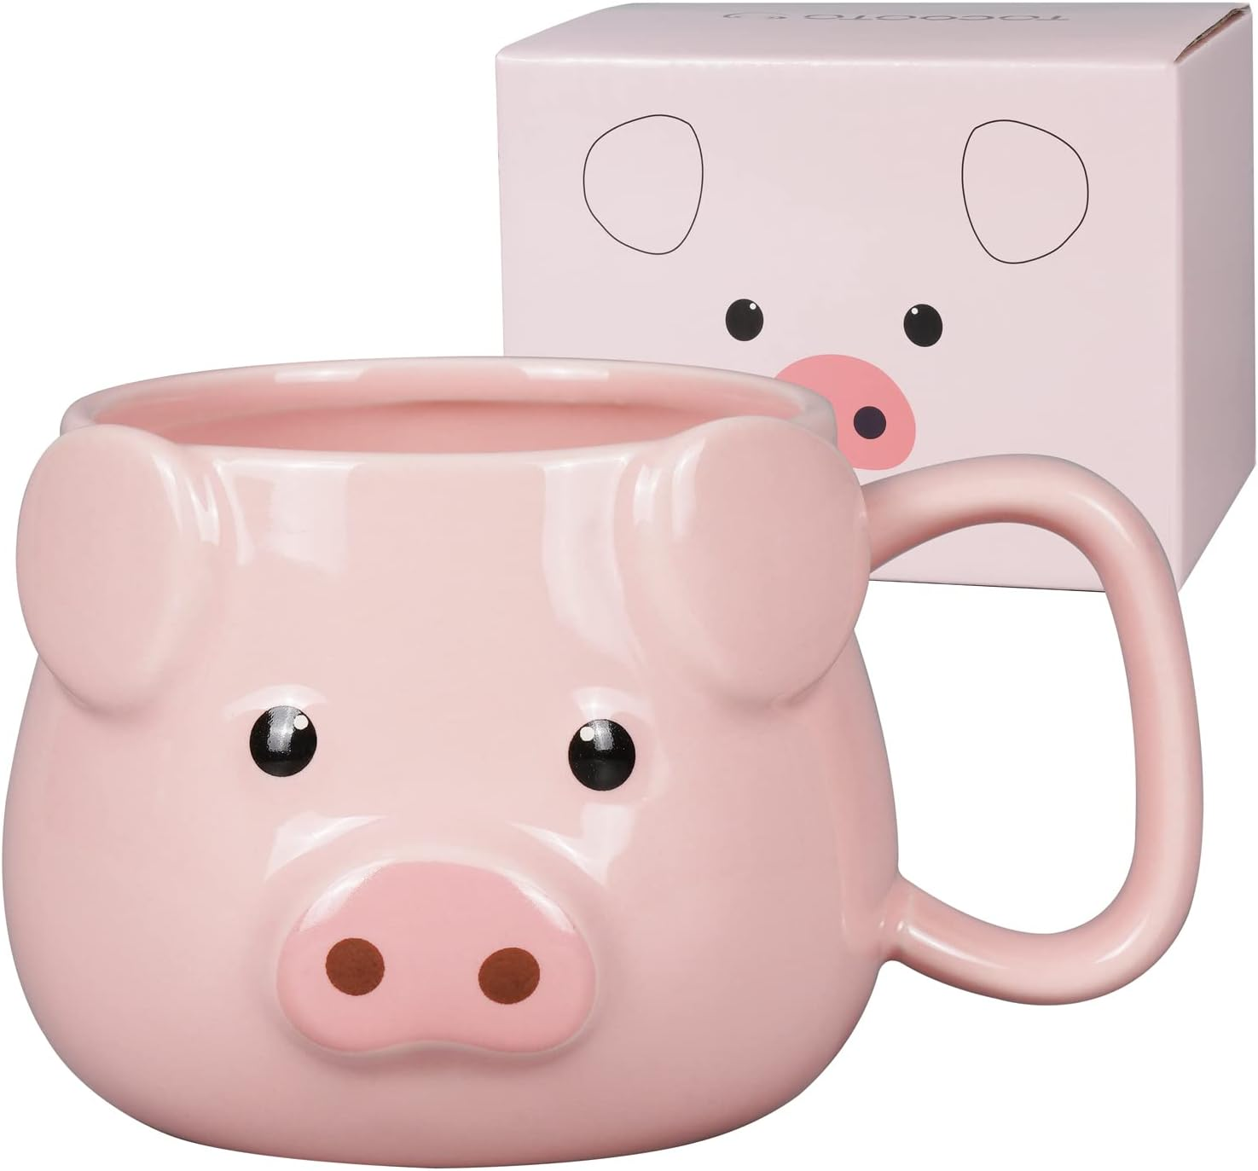

**ID:** MUG-05

**Brand**: ToCooTo

**Color:** Pink

**Material:** Porcelain

**Capacity:** 14 Ounces

**Style**: Tableware,Fine

**Theme:** Birthday,Christmas,Holiday,Thanksgiving,New Year,Mother's Day,Father's Day,Women's Day,Wedding, Anniversary,Valentine's Day,Teacher's Day,Children's Day,Halloween,Home Furnishing decoration,Garden dec…

* Reative & Unique Design】 Inspired from our love for pigs, ToCooTo designed this pig mug, which are cool and cute, will become a new cute supplement on your desktop, arouse your imagination and inspire you to start a beautiful day. This pig coffee mug can be given as a unique gift to your friends, family, animal lover and pig lovers.
* Good-quality Material】 The pig cup is made of high quality ceramics, strong structure, smooth mouth, no scratch or fading,and high safety. Perfect for both hot and cold beverages. Dishwasher and Microwave Safe.
* Perfect Gift】 With beatiful gift box, this ceramic coffee mug is suitable for ideal birthday gift for kids, women, men, mom, dad, lovers, best friend and boss. The pig ceramic mug makes best gifts for Christmas day, Thanksgiving, Halloween, Housewarming, Mother's Day, Father's Day, Valentine's Day, Anniversary, Teacher's Day, Children's Day, Women's Day and other special day.
* Benefit Your Need】 Exquisite fashion, Comfortable handle, suitable for hot and cold drinks，Such as coffee, tea, milk, juice, cappuccino, water, hot chocolate, sports drinks, smoothies and milkshakes, cocoa, beer, wine, party cocktails, etc. The pink coffee mug can meet your needs of office and home.
* Size and Package】 This pig mug is 4 inches(D), 3.3inches(H), 13 ounces(capacity). Package included: a pig coffee cup, a beautiful gift box. The pig gifts for pig lovers allows you to enjoy more fun when drinking coffee or your favorite drink.