**PRICE:** $28.99

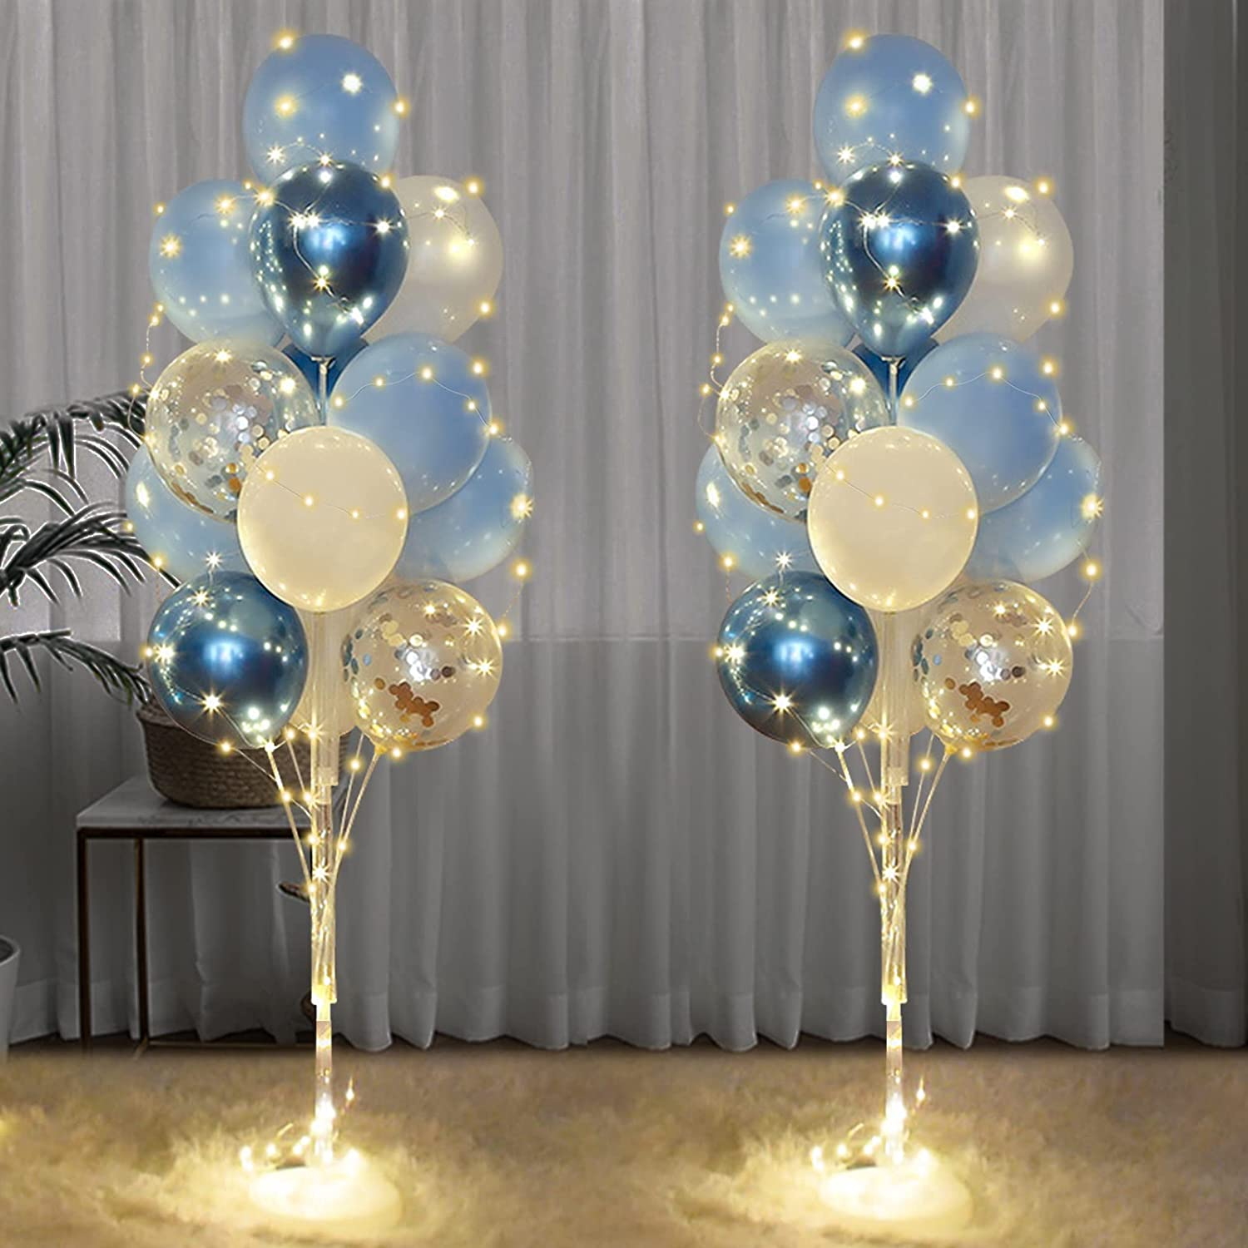

**ID:** DC-01

**Occasion:** Anniversa

**Color:** Baby Blue

**Included:** Balloon Arch

**Material:** Latex,Metal

* Floor Balloon Stand Sets: You will receive 2 reusable balloon holder bases, 44 sticks, 26 balloon cups, 32 multi-color metal balloons (12 light blue, 8 blue, 6 white, 6 silver confetti balloons ), 2 light strings and 1 glue dot. Let beautiful balloons table decorations for party give you a wonderful party experience.
* Exquisite Design: The ingenious balloon can add surprise and romance to your gift, party balloons is made of natural latex, and the material is safe and reliable. Blue balloons help you create unforgettable memories that enhance the party experience.Let this unique and attractive floor balloon stand set create a surprise party for you！
* Easy to Assemble: After receiving the product, connect two thick rods together, and connect three short rods with three long rods. Then connect the cup to the head of the balloon stick. Place the thick stick in the middle of the base and insert the remaining balloon stick into the base. Finally, stick the balloon on the top of the balloon stick, and then wrap the string of lights around the balloon. You can easily complete the beautiful balloon column kit party decoration.
* Applicable Scenarios: Party floor balloon can convey emotions such as happiness and blessing, and they can decorate party scenes, suitable for baby shower birthday party, bachelorette party, weddings for men, women and boys.
* After-sales Guarantee: We are committed to providing you with good products and services, if you have any questions about our products, please feel free to contact us, we will reply to your email within 24 hours.