**PRICE:** $24.99

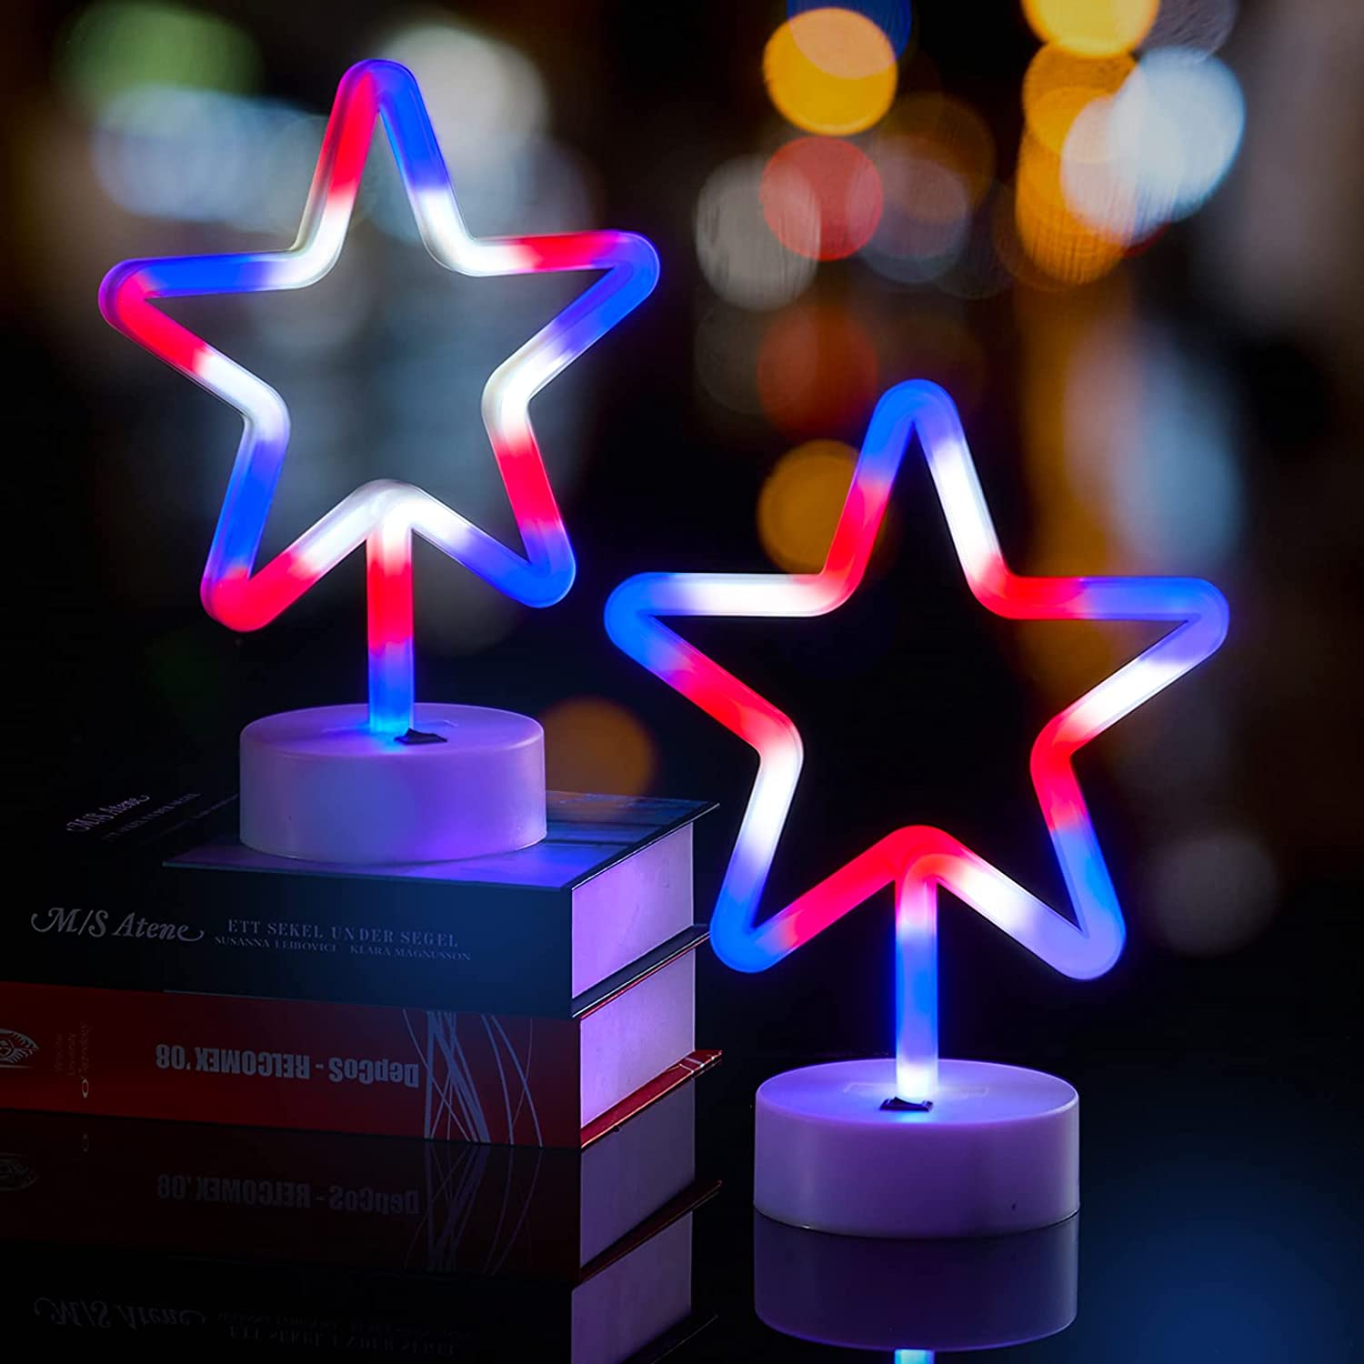

**ID:** DC-05

**Color**: Red White Blue

**Brand:** Wbao

**Indoor/Outdoor:** Outdoor, Indoor

**Light Source Type:** LED

**Power Source:** Battery Powered

**Light Color:** Red White Blue

**Theme:** Independence Day,Patriotic

**Occasion:** Christmas

**Style:** Modern

**Controller Type:** Remote Control

* 𝗦𝘂𝗶𝘁𝗮𝗯𝗹𝗲 𝗳𝗼𝗿 𝗙𝗼𝘂𝗿𝘁𝗵 𝗼𝗳 𝗝𝘂𝗹𝘆 𝗰𝗲𝗹𝗲𝗯𝗿𝗮𝘁𝗶𝗼𝗻𝘀: These 4th of July tabletop lights are the perfect decoration to add a patriotic touch to any celebration this Fourth of July that you are hosting for your friends and family members.
* 𝗦𝘁𝘆𝗹𝗶𝘀𝗵 𝗮𝗻𝗱 𝗟𝗼𝗻𝗴-𝗹𝗮𝘀𝘁𝗶𝗻𝗴: Made of super high-brightness neon lights embedded in a hard and delicate shell, these patriotic lights will last for years to come and can be reused for future 4th of July celebrations.
* 𝟮 𝗧𝘆𝗽𝗲𝘀 𝗼𝗳 𝗣𝗼𝘄𝗲𝗿 𝗦𝘂𝗽𝗽𝗹𝗶𝗲𝘀: Our July 4th lights are powered by both batteries and USB, you can decorate anywhere without worrying about power outlet. And its base come with a simple on/off switch, making them convenient and hassle-free.
* 𝗪𝗶𝗱𝗲 𝗥𝗮𝗻𝗴𝗲 𝗼𝗳 𝗔𝗽𝗽𝗹𝗶𝗰𝗮𝘁𝗶𝗼𝗻𝘀: The 4th of July tabletop lights can be used in multiple settings and occasions, you could put them on a mantle, table or even when using the batteries, as part of a dining table centerpiece (outdoor BBQs or indoor dinner parties)
* 𝗦𝗮𝗳𝗲 𝘁𝗼 𝗨𝘀𝗲: With low-voltage LED bulbs, our tabletop lights are safe for children and pets.
* 𝗔𝗳𝘁𝗲𝗿-𝘀𝗮𝗹𝗲𝘀 𝗦𝗲𝗿𝘃𝗶𝗰𝗲: A 12-month warranty is provided on all WBao brand products, including any issues that may arise. Should you require support, please do not hesitate to reach out to us. You can always count on us.