**PRICE**: $ 16.99

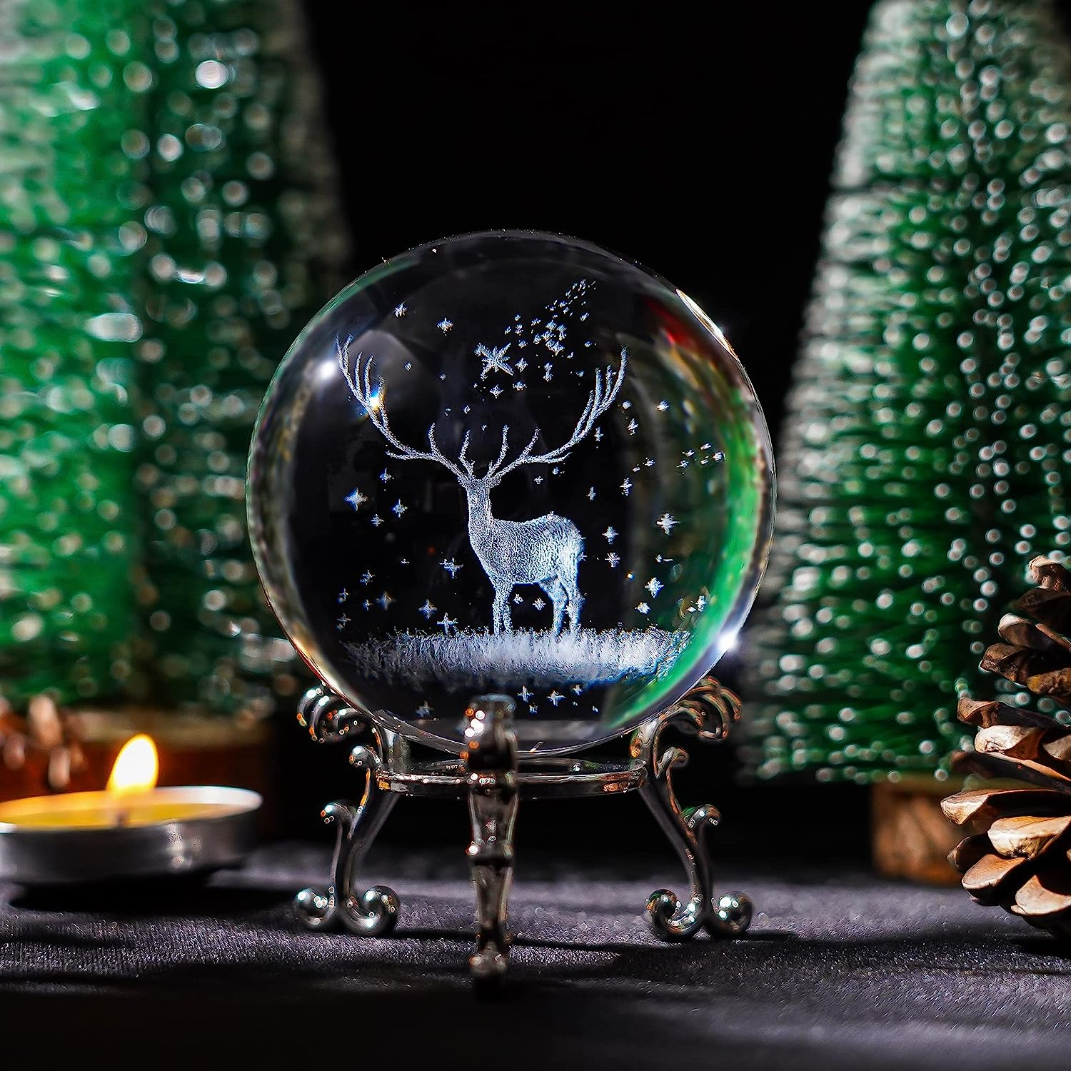

**ID:** SN-03

**Brand**: H&D HYALINE & DORA

**Color:** 70mm Deer

**Occasion:** Mothers Day, Christmas,, Car, Wedding, Anniversary, Birthday,, Office Table, Living Room, Dressing Table,Mothers Day, Christmas,, Car, Wedding, Anniversary, Birthday,, Office Table, Living Room, Dressing Table,

**Material:** Crystal

**Theme:** Christmas

* Size:70mm/2.75"
* 3d engraved crystal ball,comeing with a stand and a free gift bag,easy to carry
* 3d laser gifts for friends, family, and child's best gift,Give you a happy mood
* Can be decorate your Home, Office, Living Room, Bedroom, KTV, Cafes Store, Hotel etc.
* Great for Birthdays, Party, Valentine's day, Christmas, Graduations, Mother's Day, Father's Day or as Bridesmaids gift, Maid of honor gifts, Mother of the brides gifts, Girl friend gifts or Thanks presents.