**PRICE:** $23.99

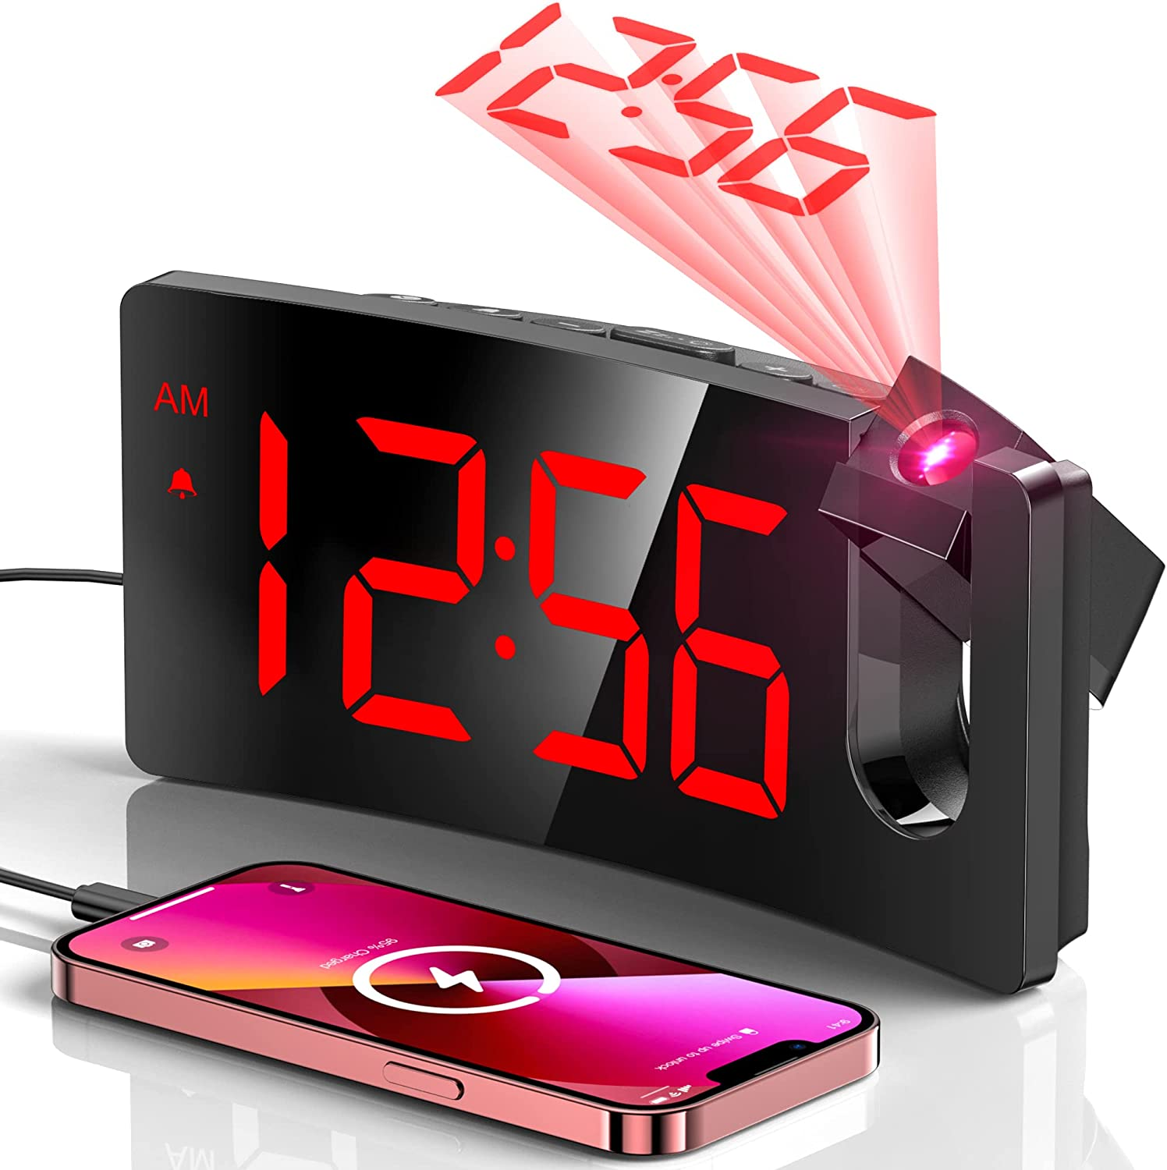

**ID:** CL-02

**Brand:** GOLOZA

**Color:** Red Digit+red Projection

**Display Type:** Digital

**Style:** Modern/Stylish/Minimalist

**Special Feature:** Built-in Button Battery, Curved Screen, Integrated Design, Progressive Volume, Super Clear ProjectionBuilt-in Button Battery, Curved Screen, Integrated Design, Progressive Volume, Super Clear Projection

**Product Dimensions:** 6.9"W x 3.15"H

**Power Source:** Corded Electric

**Shape:** Rectangular, Curved Screen

* INTEGRATED PROJECTOR WITH A SHARP AND CLEAR IMAGE -- The arm of this digital clock swivels 180 degrees for optimum positioning, getting the fine and smooth time figure image on the wall or ceiling at the appropriate distance of 1.64-11.4ft(0.5-3m). The edges of the projected numerals are surprisingly sharp and clear without having to fiddle with a focus adjustment offered on some other projection clocks.
* LARGE LED DISPLAY & 3 BRIGHTNESS LEVELS -- The curved screen with 3.4*1.7inch large digits is easy to read in the dark, even when you are not quite awake or without your glasses. With 3 adjustable levels, you can dial down it to a level that is readable in the daytime but unobtrusive at night. It allows you to separately adjust the brightness of the face display and the projection display.
* CHARGE USB PORT AND MICRO USB CABLE -- This digital alarm clock includes a 5V/1A USB output interface that will allow you to still charge your phone or other mobile devices while the clock occupies an outlet, very good for phone battery health.
* ALARM WITH PROGRESSIVE BUZZER VOLUME -- This particular clock for bedroom comes with a progressive buzzer volume(75dB), the sound will get louder and faster, which is friendly for heavy sleepers who won't get used to the sudden loud sound. And pressing the big SNOOZE button at the top, you can get extra precious 9 minutes of sleep till the next loop of this alarm.
* BIG BUTTONS & EASY TO USE -- This digital clock has large control buttons which are conveniently lined up along the top of the case and are clearly marked with easily understood icons. Therefore, it is easier to reach and use without changing all the other settings. Friendly to operate for kids, seniors or the elder.
* BUILT-IN BACKUP BATTERY -- The package contains an AC adapter(AC100-240V,50/60Hz) to power the digital clock. When the power is off unexpectedly, the button cell battery(CR2032) built into the bedside clock can automatically save time & alarm settings (the time is not displayed and the alarm won't go off), no need to reset it again when the power is on.
* STYLISH AND UNIQUE CURVED DESIGN -- A curved screen mimics your eyes’ curvature for a more comfortable viewing experience and also can improve your health, too. Research Gate reports that a Harvard Medical School study found curved screens are better at reducing eyestrain and blurred vision and improving focus compared to regular screens.
* A GIFT FOR ANY OCCASION -- This digital clock is a great choice to show your care, and an unusual idea to surprise. A perfect gift for everyone, no matter for old or young, men or women, boy or girl. Also suitable for any festival like birthdays, Christmas, New Year's Day, Thanksgiving Day, Valentine’s Day, Father's Day, Mother's Day, etc.