**PRICE:** $26.99

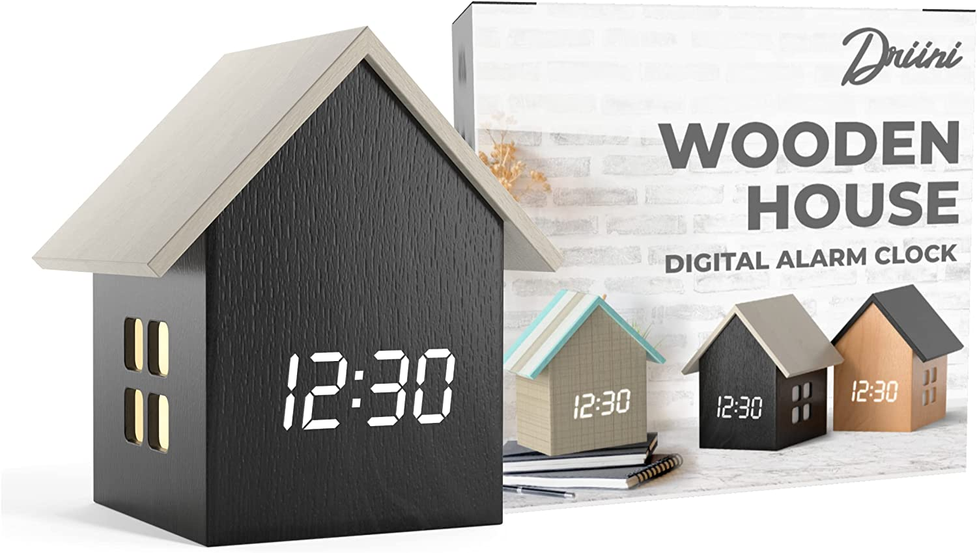

**ID:** CL-04

**Brand**: Driini

**Color**: Dark Wood; White Roof

**Display Type:** Digital

**Style:** Modern

**Special Feature:**   
Silent Clock, Illuminated, Adjustable Brightness, Alarm, Temperature Display

**Product Dimensions:** 3.75"W x 4.25"H

**Power Source:** Corded Electric

**Shape**: Square

* FORM AND FUNCTION: This small digital clock is the perfect addition to your daily routine. Combining form and function, this modern, minimalist clock features an innovative illuminating window light that can be easily toggled on or off. Its cute and cool design makes it the perfect digital alarm clock for any room in your home - from bedrooms and living rooms to offices and kitchens. Stay on schedule with this mini cube block table clock from Driini.
* BRIGHTEN UP YOUR DAY: Your decorative Driini Mini House Wooden Alarm Clock features a dimmable LED display that allows you to adjust the brightness according to your preference. The clock also comes equipped with a fully functional alarm, and can display your choice of temperature or time for added convenience.
* CUTE AND COMPACT: These small, cute wood alarm clocks measure in at just 4.25’’x3.75’’x2.7’’. Their sleek and compact size makes them the perfect nightstand clocks for bedsides, or perhaps on living room bookshelves or mantles.
* FITS IN ANYWHERE: These aesthetic desk clocks come in 3 unique colors that will complement any style of home decor. Collect all three clocks and display them together to create a cozy ambience on your living room mantle, desktop, or windowsill. Impress your friends by setting one clock to display the time, and another to display the temperature!
* PLUG N’ PLAY: Your new Driini Mini House Wooden Alarm Clock comes with a USB power cable and a USB wall adapter for seamless setup. Simply plug in your electric clock to any power outlet for uninterrupted function. In the event of a power outage, the shelf clocks backup battery provides a memory setting for the clock, saving the time and all of your other settings until power is restored. Please note that this clock requires a power source and IS NOT battery operated.