**PRICE:** $49.99

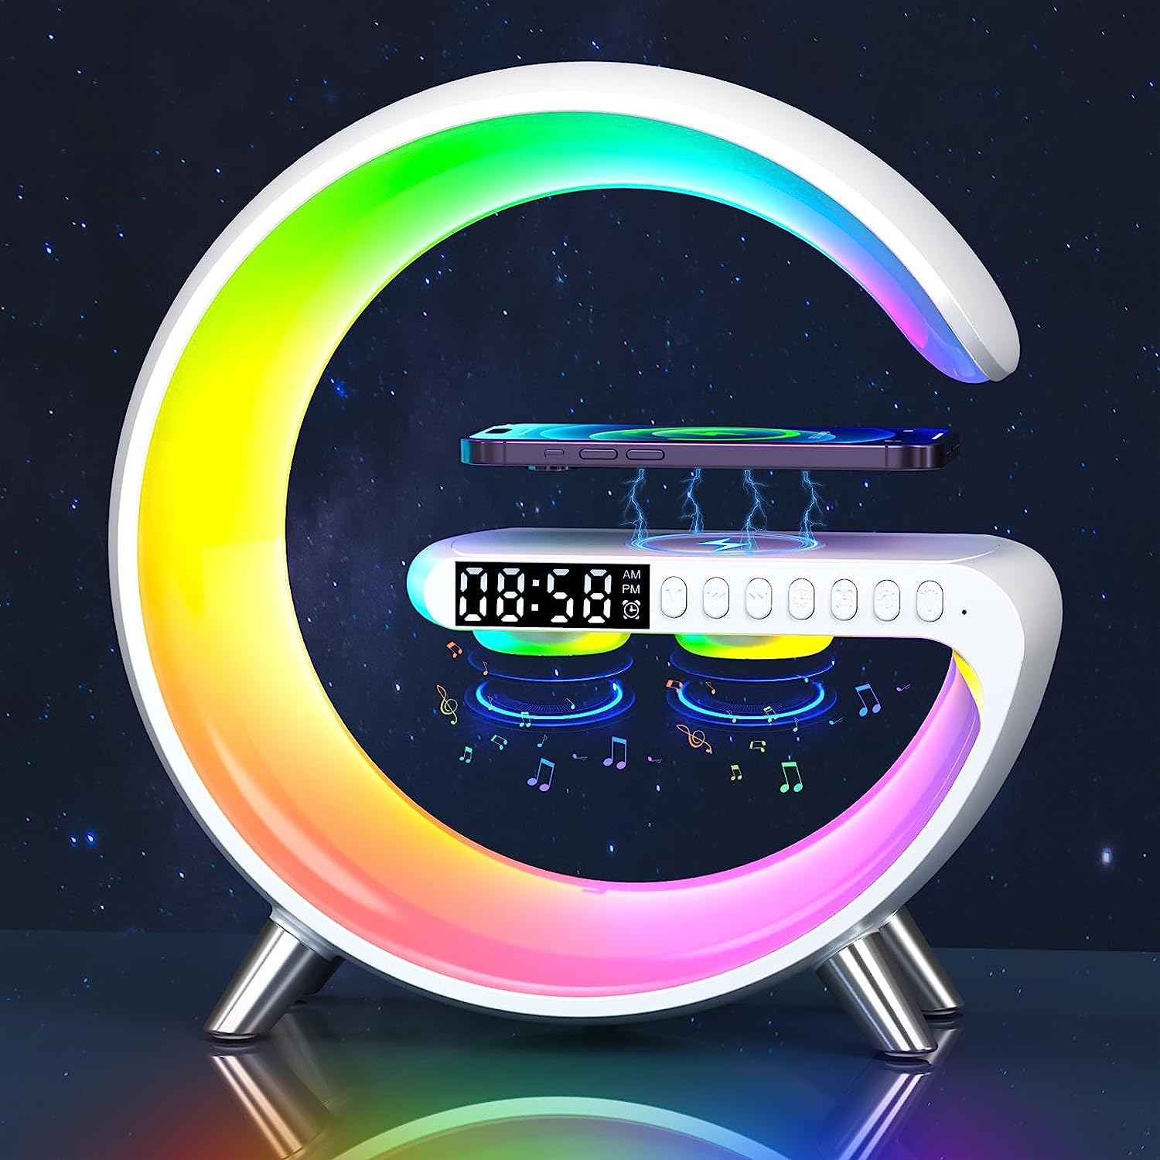

**ID:** CL-06

**Style:** Art Deco

**Brand:** BXGG

**Color:** White

**Product:** 9"D x 9.13"W x 3.3"H

**Special Feature:** Corded

* Enhanced 4-in-1 Wireless Charger Light Alarm Clock: Wake up light, 15W fast wireless charging, Bluetooth speaker, versatile lighting, alarm clock.
* Gradual Alarm Clock Wake Up Light: Wake up more relaxed and energetic with our Sleep Aid Alarm Clock. Simulate sunrise and gradually turn on from 0% brightness to 100% over 3 minutes. enjoy a satisfying wake-up experience with the . Perfect for adults and kids.
* Perfect Sleep Light: Our night light provides 16 million colors, 256 light types, and 8 music sync modes to fit all your lighting needs, such as bedside lamp, night light, reading light, bedrooms light etc. Pursue the uniformity and softness of light mixing, and enjoy delicate and moving light rhythms.
* APP & Button Control: Unlock more functions without touching via HappyLighting APP, such as turn on or off, change colors, adjust brightness, speed control, Wake Up Light settings, music sync, and choose from 16 million colors and 256 modes to decorate your home. Partial control is also available via buttons on the device.
* Alarm Clock with Wireless Charging & Worry Free Shopping: Our wake up light is equipped with a new upgraded G design with 15W fast wireless charging. 12 months warranty and 24 hours online help to offer high quality products and services for you. The white noise machine is the perfect gift for friends and family. Now click "Add to Cart" and start enjoying a good sleep.